**W3D4**

1. What is the adjacency matrix of the graph G = (V,E) displayed below

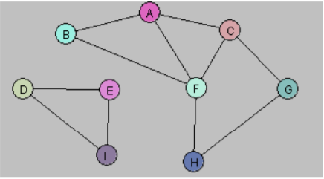

|  |  |  |  |  |  |  |  |  |  |
| --- | --- | --- | --- | --- | --- | --- | --- | --- | --- |
|  | A | B | C | D | E | F | G | H | I |
| A | 0 | 1 | 1 | 0 | 0 | 1 | 0 | 0 | 0 |
| B | 1 | 0 | 0 | 0 | 0 | 1 | 0 | 0 | 0 |
| C | 1 | 0 | 0 | 0 | 0 | 0 | 1 | 0 | 0 |
| D | 0 | 0 | 0 | 0 | 1 | 0 | 0 | 0 | 1 |
| E | 0 | 0 | 0 | 1 | 0 | 0 | 0 | 0 | 1 |
| F | 1 | 1 | 1 | 0 | 0 | 0 | 1 | 1 | 0 |
| G | 0 | 0 | 1 | 0 | 0 | 0 | 0 | 1 | 0 |
| H | 0 | 0 | 0 | 0 | 0 | 1 | 1 | 0 | 0 |
| I | 0 | 0 | 0 | 1 | 1 | 0 | 0 | 0 | 0 |

2. Create a Java program to find all components of a graph given the adjacency

matrix through DFS. Test your program on the above graph.

3. Create a Java program to find all components of a graph given the adjacency

matrix through BFS. Test your program on the above graph.