<Car auction>

Solomon Meles
Batbileg Dorj
Amartuvshin Bold

Revision History
Date | Issue | Description | Author
16/JULY/18 | IDE difference | We use different IDE as a team. And it create a huge problem for me at the first day | Solomon
17/JULY/18 | Case problem | I use capital latter for the name of the variables and go my get method were in small letter and I couldn’t access them on my JSP | Solomon
17/JULY/18 | Spring security | Login | Amartuvshin
17/JULY/18 | Tiles | All pages | Amartuvshin
17/JULY/18 | I18N | Menus | Amartuvshin
18/JULY/18 | Upload | Multipart upload on car | Solomon
17/JULY/18 | Web Socket | Car Bid | Batbileg
18/JULY/18 | REST/Ajax | Car bid date finished | Batbileg
18/JULY/18 | Custom formatter | Email formatter | Amartuvshin
18/JULY/18 | Test | User test | Amartuvshin
18/JULY/18 | Exception | SaveError | Amartuvshin

Table of Contents
1. Introduction 4
1.1 Purpose 4
2. Requirements - Use-Case – Usage Scenarios 4
3. High Level Design 4
4. Detailed Design 5
4.1 <Object.Name> Usage 5
4.2 Interaction Diagram 5
5. Issues, Risk and Dependencies 5
6. Design Alternatives 5
7. References 5

Introduction
[A design document is a way for you to communicate to others what your design decisions are and why your decisions are good decisions. The biggest factor that determines if your design document is good is whether or not it clearly explains your intentions.]
The application we develop is mainly focused on cars auction. The design is for any individual to login if he’s already registered before. If not, he can be registered with his valid email address and chosen password. The Application will save his password and username which can be his email.
Design starts from giving permission of as a user or admin. A user can add car set expiration date for bid and forced to provide info about his car he’s selling. The admin has a little more privilege on adding and removing car. Reason for making different user is to control in appropriate sale, to strength update system user and for security reason.

Purpose
[Describe what the project or sub-system does. What is the problem it is trying to solve? Why does it need to exist? Who will use it?]
United team first come up the idea of car application which was main purpose was on renting cars letter on we come up with different idea of Car Auction. The application is simple to use and with clear usage path.
An individual can sign in or register (if he’s visiting the web-site for first time) after he sign in he has the choice to add car or see the list of cars for sell. This is the task developed by our team in order to make the application user friendly and easy to move around. We have the Web Flow design also implemented which basically mean whenever the user tries to break either intentionally or not the application won’t break apart we have an Error exception handler for that purpose. The application will just take the user back to the home page and he can start over. And in the time of the user submitters a form we have use error handler and validation to confirm the user input valid data. If not, we notify him to correct his wrong input and try again and we also control double summation of data using PRG technique.
A customer can follow the car he’s interested in buying and can follow the bid and can react instantly to any change in value. After the car expiration date reach his expiration date the higher the bid will win the car. If no one make a bid on the car we can have it deleted automatically or the admin can remove it manually using his admin privilege.
So, the application is easy to use and can be used by any individual who is willing to sell his car or buy a car online. The existence of the application can be sustained by having cars to sell and buy on the market which mean having customers to participate in the online market.

Requirements - Use-Case – Usage Scenarios
Describe the set of scenarios and/or use cases that represent some significant, central functionality.

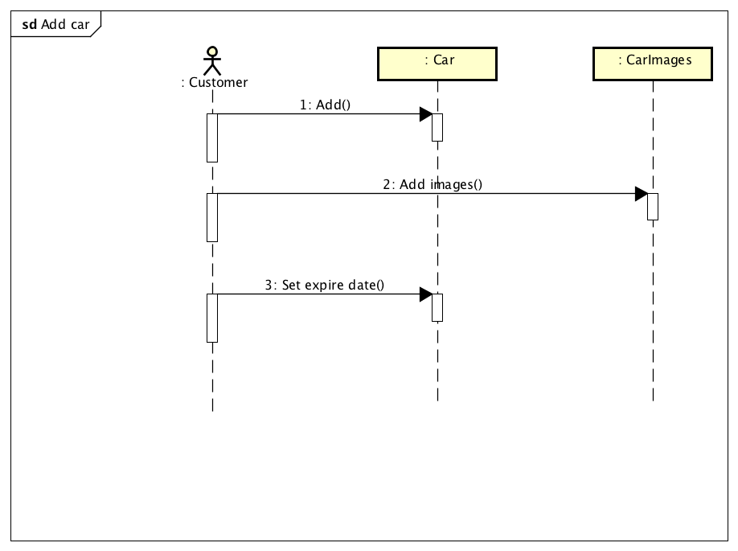
This is a simple use case for adding a car for a customer. After he login he can add car and add image(Multiple) of his car. And set the expiration date for his car very essential for bid processes.

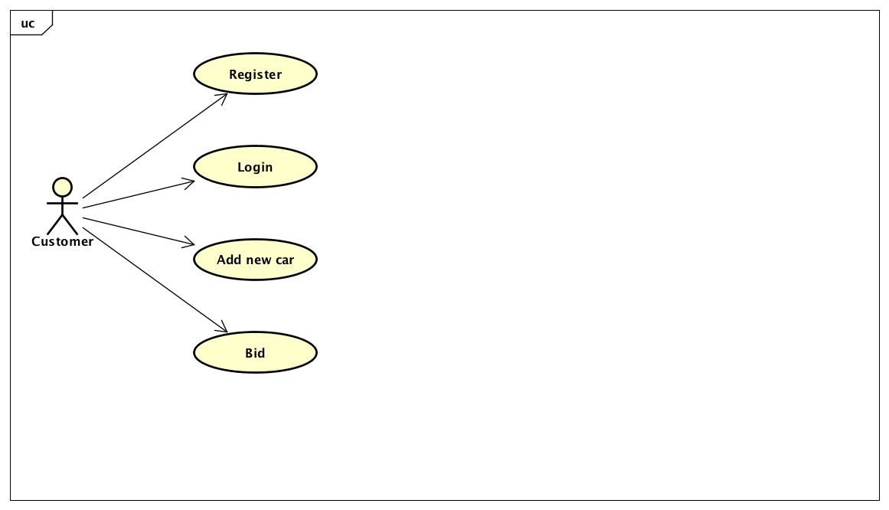

The use case in this application is a customer can register with unique email Id then login to add and bid as he wishes to do whatever he wants. He can old add car if want to sell it.

High Level Design
[In this section, explain in a few sentences what each entity does. Describe your reasoning for defining the entities in your diagram and what their roles are.]

Figure 1 < High Level Design Diagram >
For the HLDD we can talk about the security levels. On the log in process we can’t have a duplicated email used the system will not allow you to have that.
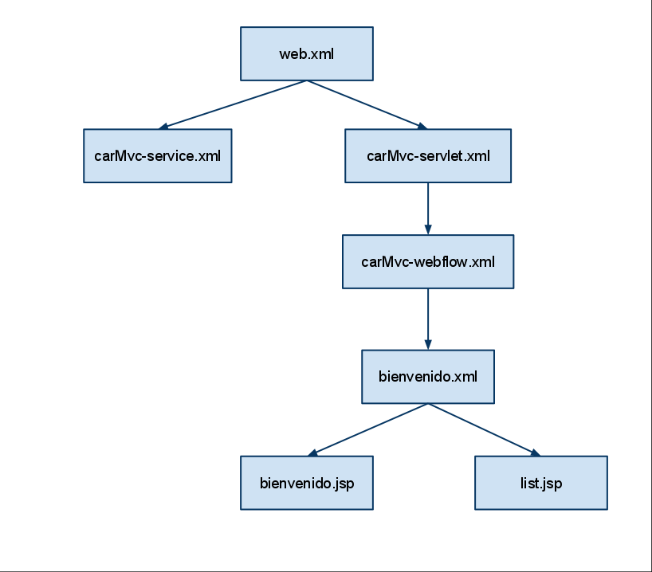

Detailed Design
[This section is where your objects and object relationships are defined.
The objects of the application are a car, user, bid, car Image, role, address domain classes. User can have one single address but multiple cars to add and sell also can upload multiple pictures at the same time bid can be participated with in multiple users the higher the bidder won the price.

<Object.Name> Usage
[This section is where your objects and object relationships are defined. Describe how the object is used and what function it serves. If an object will interface with an external object or system, it is a good idea to show the interface for the object. Most importantly, you must again describe your thought process for defining the object as you did. List the benefits and risks. If an object provides an encapsulation, describe in a sentence why the encapsulation adds value. Use your descriptions to give meaning to the diagrams.
Figure 2 <Car Auction > 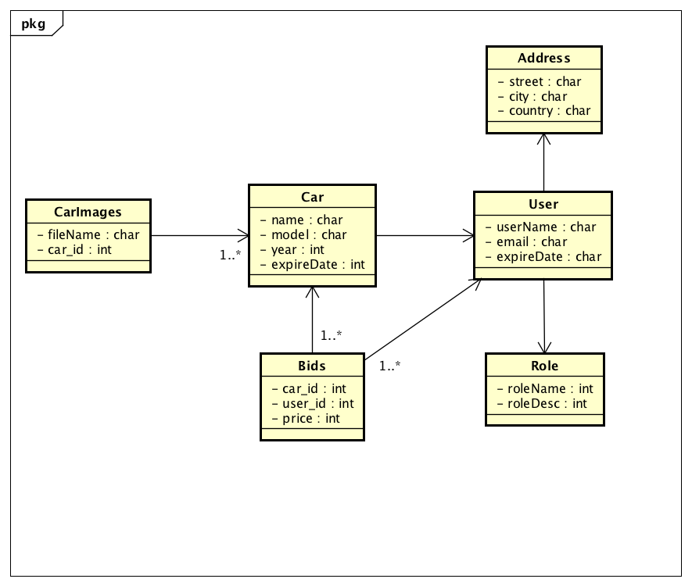

This diagram (class diagram) represents the domain of our application in short. We have a car class in our domain which we can add a car all the necessary info to make the bidding system work correctly. Example we have the expire date variable which allow us a to terminate the bidding for a particular car once the expiration date reaches same time with the current date. And of course, the user once he’s registering a car for sale he can use the car Image class which allow him to upload multiple car images. The relation is one to many and they will share same Id in the Database.
In the user class domain, we can save users who already once they register but if not, we can register them a new customer. As we register a customer we are also going to register his info (address and Role). The relation to Address and Role is also one to one a single customer can have one role and address we can save in the database with his randomly generated id.
Bid is a class domain which have a one to many relations to User and Car classes. A single user can bid in multiple Cars at once and same as multiple users can still participated on single car bid.
Using multiple relationship between cars and Bid we have the advantage of list of cars for a single Bid which is supporting the market reality and same is true for having multiple users in the Bid, can help to have multiple participants in a single bid.

Interaction Diagram
[An interaction diagram shows how a set of objects or entities communicate with each other to perform a complex task. ]
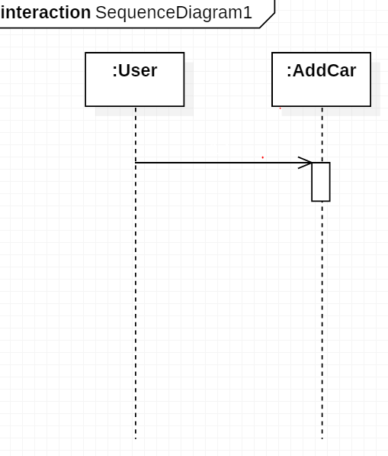
Figure 3 <InteractionDiagram.Name>

Design Alternatives
[This section describes alternative designs that were considered. ]
Alternative design could be used but due to time shortage we didn’t. We could have use other car edit method were you can edit your car on sell and also accept feedback from your clients (Likes and comments).

Issues, Risk and Dependencies
[All known risks/issues and a list of all assumptions/Dependencies. Some of this may simply be rehashing what you wrote in a previous section of the document.
What’s important is getting all of these items into one section so that the reader doesn’t have to read the whole document to understand what the benefits, risks and assumptions are. ]
As a team we haven’t had much problem but in the process, I (solomon) personally run in to couple of problems. When I download the project from Git Lap my team meets where using intellij IDE so it creates some problems with my IDE. This was the worst one and took me long time to figure it out

Future Considerations
[This section describes next steps, functionality-wise as well as design improvements]
Future considerations are to add more user-friendly interfaces like and comments and even send private message for the car owner. Also having a notification to remind you if you are over bid by someone while you are still interested in the item.

References
[This subsection provides a complete list of all documents referenced. Identify each document by title, report number (if applicable), date, and publishing organization. Specify the sources from which the references can be obtained. This information may be provided by reference to an appendix or to another document.]

Whenever we run in to a problem we use to refer:
- Stackflow
- Git hub
- Git Lap
- VIRALPATEL.NET
- And other internet open sources

