CustomDKGMonitor Operation Manual

Introduction

The use of RAINBOW-MONITOR software, that was provided by Datakom company - the manufacturer of Automatic Mains Failure Unit (AMFU) DKG-207, for monitoring of DGS (Diesel-Generator Set) as first described in the document “Project for monitoring system using Datakom DKG-207”* raised some significant concerns in the software. Specifically:
- When the DGS gets started no sound warning is given by RAINBOW-MONITOR.
- When the connection between the DKG-207 AMFU and the PC used for monitoring is lost, no notification is given and the values shown on gauges get frozen at last working position. So the only way to notice the lost connection is by value of the time on the device displayed in small field on the RAINBOW-MONITOR’s form.
Having several other monitoring tools for different parts of the complex, and therefore dispersion of attention of the specialist on duty, described problems might lead to events associated with them being unnoticed.
To solve the problems an attempt to contact the RAINBOW-MONITOR’s software developer Datakom was taken, but lead to no success. So, the decision was made to create and implement an addition by ourselves to the system developed earlier in order to overcome the problems and improve the use of DGS monitoring system – CustomDKGMonitor program. Due to not having access to the data frame format, some prior reverse-engineering of data passed over serial port was had to be done to determine parameters which would help to decide if the DGS was started. “Coolant temperature”, that will grow once the DGS is started and warms up, and “AMFU’s Date and Time” were determined.
CustomDKGMonitor listens to the data on specified serial port. It tries to catch a 108 byte sequence passed from DKG-207 AMFU and parse it to determine separate values corresponding to parameters gotten from the DGS. When the sound warning setting is enabled and parsed parameters pass specified boundaries a sound warning from specified file is given. Also, a sound warning will be given once the data on the serial port is absent longer than specified allowed period of time.

Initial setup

DGS monitoring system operates in one of two modes:
- DGS is monitored using solely CustomDKGMonitor instead of RAINBOW-MONITOR, therefore no additional software is required. The prior setup is performed as described in “Project for monitoring system using Datakom DKG-207” to page 22 inclusive. Then CustomDKGMonitor.exe should be launched with the COM-port and its settings corresponding to DKG-207 AMFU’s setup as per “Project for monitoring system using Datakom DKG-207”. This way CustomDKGMonitor is used right in place of RAINBOW-MONITOR.
- DGS is monitored with both programs RAINBOW-MONITOR assisted by CustomDKGMonitor, then additional setup is required as described further in this document. In this mode additional software is used: com0com and hub4com. com0com is used to create a pair of virtual COM-ports. hub4com is used to organize the transparent flow of data and commands between DKG-207 and RAINBOW-MONITOR while also forking data flow from DKG-207 to CustomDKGMonitor, as shown on figure 1.

* “Project for monitoring system using Datakom DKG-207” describes how to organize interaction between DKG-207 and monitoring PC via local network using Moxa NPort 5110 and Moxa NPort administrator, so it has no effect on this document. Consider DKG-207 connected to monitoring PC directly via serial port COM2.
NPort Administrator

com0com
COM5
COM6
hub4com
CustomDKGMonitor
com0com
COM3
COM4
RAINBOW-MONITOR
Commands
COM2
Data

Fig. 1.

This connection scheme organizes data mirroring. It allows DKG-207 and RAINBOW-MONITOR to interact as usual as described in “Project for monitoring system using Datakom DKG-207” without any disruption from CustomDKGMonitor, while allowing CustomDKGMonitor to process all received data at the same time. The only difference is COM-port number change when launching RAINBOW-MONITOR.
com0com and hub4com software can be downloaded from the following web page http://sourceforge.net/projects/com0com/files/ (GPLv2 license, project web page: http://sourceforge.net/projects/com0com/).
Perform a typical installation of com0com. Rename the folder containing hub4com.exe to “hub4com” and copy it to C:\Program Files\. Launch C:\Program Files\com0com\setupg.exe and press “Add Pair”, as shown on figure 2, to create one more pair of virtual COM-ports, i.e. COM5-COM6, considering the first pair COM3-COM4 was created automatically during typical installation. Wait till the operation is completed and new ports are added to the system.

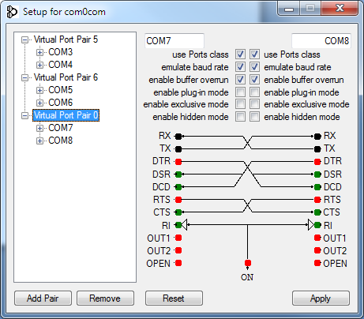

Fig. 2.
Then set created virtual COM-ports’ parameters to make them work more like real COM-ports. To accomplish this, select a pair in the field on the left side of the window and then on the right side of the window tick the boxes corresponding to “use Port class”, “emulate baud rate”, “enable buffer overrun” as shown on figure 2. This must be done for both pairs of COM-ports, then save the changes by clicking the “Apply” button. Now this program’s window may be closed.
After the serial port pairs are created and set as above, their interaction must be organized as shown on figure 1. In order for this to be done, every time before launching RAINBOW-MONITOR and CustomDKGMonitor hub4com program has to be launched with the following arguments:
--baud=2400 --octs=off COM2 --baud=2400 --octs=off COM3 --baud=2400 --octs=off COM5
, which command hub4com to organize the interaction scheme from figure 1. To simplify this task a script “hub4com_route_setup.bat” is created, which contains:
start C:\"Program Files"\hub4com\hub4com.exe --baud=2400 --octs=off COM2 --baud=2400 --octs=off COM3 --baud=2400 --octs=off COM5
The scripts are launched as any other executable applications.
(which is launched as any other executable application)

Important note: When hub4com is launched a console window is open, as shown on figure 3, which must not be closed while the monitoring is operating. Closing this window will lead to hub4com stop working and the interaction scheme will be broken.

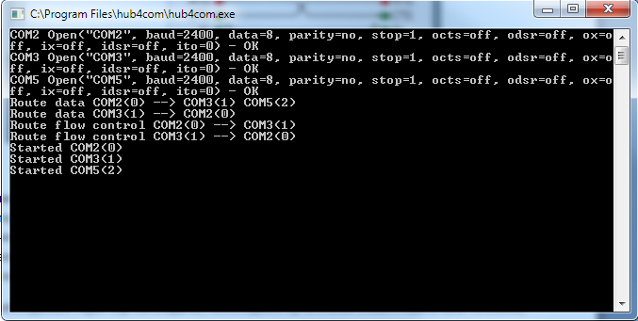

Fig. 3.

Further usage of CustomDKGMonitor is the same for both mentioned DGS monitoring system operation modes.

CustomDKGMonitor usage

In case of using CustomDKGMonitor together with RAINBOW-MONITOR for DGS monitoring, before launching these programs the “hub4com_route_setup.bat” script must be run, and only then these programs started. To automate this task “CustomDKGMonitor_Launch_Script.bat” is already created and shipped with CustomDKGMonitor. Assuming CustomDKGMonitor folder is copied to C:\CustomDKGMonitor, the script should be inside. For convenience a link on the desktop may be created pointing to this script, so that all three programs for monitoring could be easily launched. The script contains the following commands:

cd C:\"Program Files"\hub4com\
start hub4com.exe --baud=2400 --octs=off COM2 --baud=2400 --octs=off COM3 --baud=2400 --octs=off COM5
cd C:\CustomDKGMonitor\CustomDKGMonitor\
start CustomDKGMonitor.exe
cd C:\RAINBOW\RAINBOW-MONITOR\
start RAINBOW.exe

Important note: When hub4com is launched a console window is open, as shown on figure 3, which must not be closed while the monitoring is operating. Closing this window will lead to hub4com stop working and the interaction scheme will be broken.

In order for RAINBOW-MONITOR to work as expected and as described in “Project for monitoring system using Datakom DKG-207”, in its settings a COM-port receiving both data and control flows must be set. Considering prior setup it must be COM4 instead of COM2 used in “Project for monitoring system using Datakom DKG-207”, otherwise everything stays the same as described in that document.
After launching CustomDKGMonitor, a window with settings will be shown as on figure 4. Depending on monitoring PC’s locale settings English or Russian text will be used.

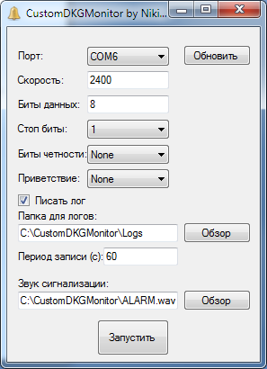

Fig. 4.

In this window the COM-port to which the data flow coming from DKG-207 will be forked needs to be specified with corresponding settings. Considering prior setup it is COM6 with the following parameters:
“Baud rate”: 2400,
“Data bits”: 8,
“Stop bits”: 1,
“Parity”: None,
“Handshake”: None.

Clicking “Refresh” button will initialize the fields with default values or values from saved settings, if they were already created earlier.
Ticking the box “Log data and actions” will lead to logging the data received to files, by default in “Logs” folder, created automatically in CustomDKGMonitor folder.
“Log folder” field allows changing folder used for storing logs. Use “Browse” button to choose desired folder using standard Windows interface.
“Log period (s)” field allows changing time period in seconds between writing the data received via COM-port to the log file. Changing this value doesn’t affect event logging, i.e. sound alarm, etc. Data via COM-port is received every second, so it’s advised to not choose small values for this field, as that would lead to fast log file growth.
Note: Log file might contain messages starting with “Data receive error.” or “Skipping data with InnerBuffer flush.” – it’s expected behavior, due to not knowing the full exchange protocol some data could not be handled. This is more likely to occur when CustomDKGMonitor is used together with RAINBOW-MONITOR, because DKG-207 transfers data about periodic service in response to RAINBOW-MONITOR requests that are not handled by CustomDKGMonitor.
“Alarm Sound File” field allows to specify a sound file (only .wav is supported), which will be played as alarm sound when parsed parameters pass beyond specified boundaries, or when no data has been received for a specified period of time. Use “Browse” button to choose desired file using standard Windows interface.
“Start” button initiates a connection to specified COM-port and starts the process of receiving and parsing the data. If all the settings were made correct a connection will be successfully made and all the settings will get saved to CDM.conf file placed in the directory near the CustomDKGMonitor executable file. Next time the program is launched this settings will be loaded automatically and to start using CustomDKGMonitor it will be enough to just press “Start” button.
After pressing the “Start” button the program is switched to monitoring mode and the window will change it appearance as show on figure 5.

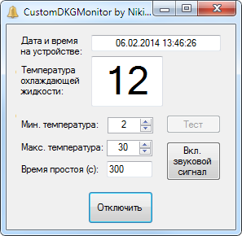

Fig. 5.

In monitoring mode the window shows the values for date and time on DKG-207 AMFU in “DKG Date Time” field and DGS coolant temperature in Celsius - “Coolant Temp” field in real time. The values are parsed every second from the data received on specified COM-port.

Right after the monitoring is started “DKG Date Time” and “Coolant Temp” fields might have a “n/a” value, because the program needs to determine where is the start of data frames in received data. Wait for 7-15 second and if nothing changes, then there might be problems in your setup, refer to “FAQ” section to for help in this case.
“Min. Coolant Temp” and “Max. Coolant Temp” fields allow to set the lower and upper boundaries for DGS coolant temperature in Celsius to control. After the actual coolant temperature passes any of these values and if the sound alarm is enabled, the sound file specified in settings will be played. The lower boundary is especially useful in cold climate. If the temperature will fall below expected value and the DGS will have to be started, it may fail to do so, that’s why it’s important to control this value. The upper boundary should be set a little higher than the current actual coolant temperature value when the DGS is stopped and cold. When the coolant temperature passes the upper boundary it means that the DGS started and is warming up. So specifying it too close to normal temperature may trigger false alarms due to outside temperature instability, and specifying it too far from stopped and cold DGS value will postpone alarm sounding from the moment of the start for the time of coolant temperature growth.
“No Data Period (s)” field allow to specify the time period in seconds to wait for data on specified COM-port before sounding the alarm in case the alarm is enabled and no data have been received. If no data is received for this period before the alarm is played the values in the fields will freeze at last received values and the boundary passing is not controlled.
Note: If everything is working as expected the data is received every second, so not getting the data even for a short period of time may indicate that there’re connection problems, or the AMFU is turned off.
“Stop” button allows to safely disconnect from COM-port and stop receiving and parsing the data. Pressing “Stop” will interrupt monitoring mode and the program will return to settings window.
“Enable Alarm” button enables alarm mode in which the specified coolant temperature boundaries are controlled, and if actual parsed value pass the specified boundaries, the alarm will sound. After pressing the “Enable Alarm” button the specified boundary values are saved, and the program windows changes as shown on figure 6.

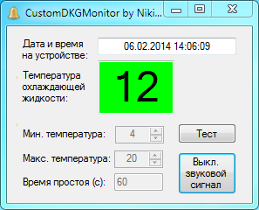

Fig. 6.

In this mode, the boundary values’ fields are disabled. If the actual coolant temperature value parsed from real time data is between the boundaries, then the background color of the field with this value is green. If the actual value will pass any boundary, the background color of the field with this value will change to red, as shown on figure 7, and the alarm sound will be played.
In case if no data is received on COM-port for a period longer, than that is specified, then the sound alarm will be played and all the fields with actual parameters will have red background color, as shown on figure 8. In this case also a message to the user will be displayed, as shown on figure 9. After the “OK” button on the message window is pressed, the alarm will stop playing, but the fields will keep having red background color. Sound alarm will not be played again until the connection is restored and then lost again for a period longer than specified, or the alarm mode is disabled and enabled again.
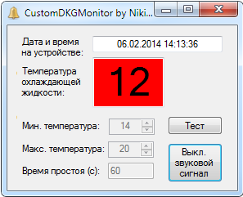

Fig. 7.

“Disable Alarm” button allows disabling alarm mode and returning to monitoring mode, where the boundaries can be changed. Pressing this button also stops active alarm sound playback.
“Test Alarm” button allows checking that alarm mode is successfully enabled, if pressed a single playback of the specified alarm sound file will be performed.

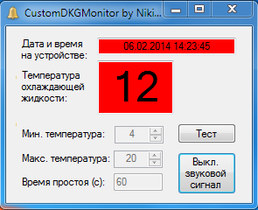

Fig. 8.

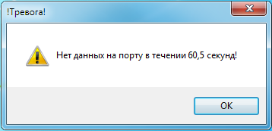

Fig. 9.

Pressing minimize button in the upper right corner of the program puts it to system tray (“bell” icon) and not to task bar. This doesn’t affect alarm or monitoring mode in any way, if alarm mode is enabled and an event that triggers alarm sound occurs, the alarm sound will be played as usual.
Single-clicking on the CustomDKGMonitor’s icon in system tray will bring up the pop-up window with information on program’s state, as shown on figure 10. Double-clicking the icon in system tray or single-clicking the pop-up window will maximize the program’s main window.

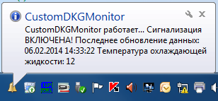

Fig. 10.

FAQ

1. When launched CustomDKGMonitors shows an error about loading the settings, what to do?
Probably the settings file is corrupt. Delete the settings file CDM.conf, which can be found in program’s directory near the CustomDKGMonitor.exe. Restart the program and set the desired settings anew.
2. After pressing “Start” the fields “DKG Date Time” and “Coolant Temp” display “n/a” value and after waiting for 15 seconds nothing changes, what to do?
CustomDKGMonitor doesn’t receive expected data even if it connected successfully to specified COM-port. Ensure that you provided the right COM-port number, the one providing data from the DKG-207 AMFU, and connection settings. If everything is right, but still no success, then try to connect to the same COM-port with RAINBOW-MONITOR instead of CustomDKGMonitor and ensure that RAINBOW-MONITOR displays actual real time data from the AMFU.
If CustomDKGMonitor is used together with RAINBOW-MONITOR, then make sure that hub4com is launched and working as expected when you try to use the program, specifically hub4com window is open as shown on figure 3. If everything is as described, but still no success, then close hub4com window and try to connect with CustomDKGMonitor or RAINBOW-MONITOR directly to the main COM-port used by AMFU, considering this manual – COM2, and check that the data is received and displayed this way.
If the data is received, but the values don’t change, then try to restart the program or reboot the PC. If the error still exists, fallback to using RAINBOW-MONITOR.
If no data is received, then there’s a problem with connection between DKG-207 AMFU and the monitoring PC or the AMFU itself might be turned off or broken.
3. The sound alarm started to play unexpectedly, what to do?
Disable the alarm by pressing the “Disable Alarm” button, after the problem is solved don’t forget to turn it back on by pressing the “Enable Alarm”.
Check which values deviate from normal, if need be use RAINBOW-MONITOR for this, and act according to “DGS Monitoring Instructions”.
If no deviation is noticed, then the alarm might have been caused by absence of data on COM-port. In this case message as shown on figure 9 should have been shown, search for it on the task pane at the bottom of the screen. If CustomDKGMonitor is used together with RAINBOW-MONITOR, then the only way to check it with RAINBOW-MONITOR is to see if seconds change in small field with date and time on the AMFU, other gauges will just freeze with the last actual value received.
4. The sound alarm started to play, all fields have red background color, but “Disable Alarm” button doesn’t react when I press it to stop the alarm, what to do?
This is most likely caused by absence of data on COM-port about which the message is displayed, as shown on figure 9. This message window blocks the main window interaction. Probably the message window is hidden behind other windows on the desktop. Search the taskbar for the window with the message and press the “OK” button on it. This will stop alarm sound playback.

