**Simple Get Time and Print**

*#include <sys/time.h>*  
*#include <stdio.h>*  
  
int main() {  
  struct timeval current_time;  
  gettimeofday(&current_time, NULL);  
  [printf](http://www.opengroup.org/onlinepubs/009695399/functions/printf.html)("seconds : %ld\nmicro seconds : %ld",  
    current_time.tv_sec, current_time.tv_usec);  
  
  return 0;  
}

**Output:**

[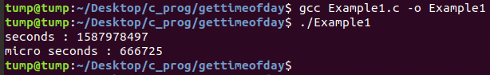](https://linuxhint.com/wp-content/uploads/2020/05/1-3.png)