How to install OpenIoT

Table of Contents

Prepare the following before installing OpenIoT 3

Set Environmental Path 3

Download the OpenIoT code 4

Deploy from source code 4

# Prepare the following before installing OpenIoT

* Install Java SDK 1.7+ - Latest Version

OpenIoT recommends you to install Sun/Oracle Java, not the OpenJDK. check if u have done it correctly by typing in terminal: java -version

* Install JBOSS AS 7.1.1 (Please use only this version)

(<https://www.digitalocean.com/community/tutorials/how-to-install-jboss-on-ubuntu-12-10-64bit> )

* Install Maven 3.1 (Or Latest)
* Install Virtuoso-Opensource7 and start Virtuoso (<https://github.com/OpenIotOrg/openiot/wiki/InstallingVirtuosoOpensource7Ubuntu> )

## Set Environmental Path

* The following variables needs to be set for successful running of maven, JBOSS and java
  + JAVA_HOME
  + MAVEN_HOME
* The following path needs to be set
  + Java bin directory
  + Maven bin directory

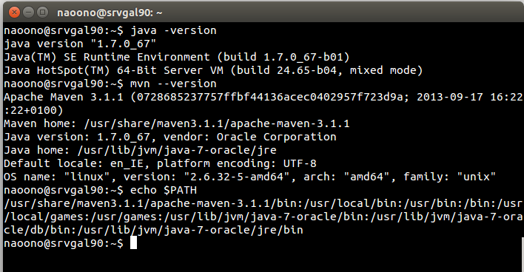

# Download the OpenIoT code

<https://subversion.deri.ie/lion2urq/CiscoTP/DevCode/ciscoioe_oldOpenIoTwithLocation/>

## Deploy from source code

1. **utils.commons**

* Copy **openiot.properties** file from **utils/utils.commons/src/main/resources/properties** to the location: **jboss-as-7.1.1.Final/standalone/configuration**
* Modify the **openiot.properties** file

(<https://github.com/OpenIotOrg/openiot/wiki/Openiot-Commons-Library#properties>)

* Go to **utils/utils.commons**/directory from a terminal, then run the following command

**mvn clean package install**

**Start Jboss server**

1. **LSM – Server**

* Change the following:

**CQELSHOME** directory: Go to modules/lsm-light/lsm-light.server/src/main/java/org/openiot/lsm/websocket/server and open Constant.java

Go to modules/lsm-light/lsm-light.server/src/main/java/org/openiot/lsm/reasoning/data and open Constants.java , then change **aspURI**, **queryServerURI** and **virtuosoURI**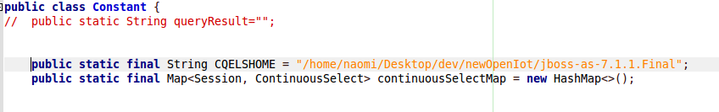

* modules/lsm-light/lsm-light.server/Reasoning directory needs chmod 777
* Deploy additional jars

Additional jars required for query processing are stored in **ciscoioe_oldOpenIoTwithLocation/additionalJars/QueryProcessin**g directory

Then run deployJars.sh script

* Go to /modules/lsm-light/lsm-light.server directoy and run the following command

**mvn clean package jboss-as:deploy or mvn jboss-as:deploy**

* To make sure that everything is working, go to link: <http://localhost:8080/lsm-light.server>

1. **LSM – Client**

* Go to /modules/lsm-light/lsm-light.client directoy and run the following command

**mvn clean package install**

1. **Scheduler Core**

* Go to modules/scheduler/scheduler.core directory and run the following command

**mvn clean package jboss-as:deploy or mvn jboss-as:deploy**

* To make sure that everything is working, go to link:<http://localhost:8080/scheduler.core/rest/services>

1. **SDUM Core**

* Go to modules/sdum/sdum.core directory and run the following command

**mvn clean package jboss-as:deploy or mvn jboss-as:deploy**

1. **ui.requestCommons**

* Go to ui/ui.requestCommons directory and run the following command

**mvn clean package install**

1. **ui.requestDefinition**

* Go to ui/ui.requestDefinition directory and run the following command

**mvn clean package jboss-as:deploy or mvn jboss-as:deploy**

* To make sure that everything is working, go to link:<http://localhost:8080/ui.requestDefinition/>

1. **requestPresentation**

* Go to ui/requestPresentation directory and run the following command

**mvn clean package jboss-as:deploy or mvn jboss-as:deploy**

* To make sure that everything is working, go to link:<http://localhost:8080/ui.requestPresentation/>

1. **scheduler.client and sdum.client**

You may need to deploy...

* **sdum.client:** Go to modules/sdum/sdum.client and run  **mvn clean package install**
* **scheduler.clien:** Go to modules/scheduler/scheduler.client and run **mvn clean package install**

1. **X-GSN**

* Go to **/modules/x-gsn** directory and run the following command

**mvn clean package install**

**or**

**mvn package**

Deploying jansi jar has some issue (server is down??) so you will fail to deploy X- GSN for the first time.

* 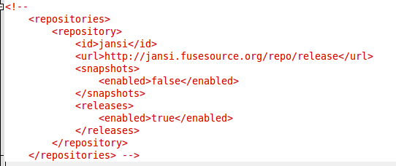After failing to deploy X-GSN, go to .m2/repository/org/codehaus/groovy/groovy-all/1.7.1 directoy and open groovy-all-1.7.1.pom file and comment the following

and changed the following 1.1 to 1.11

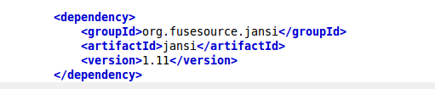

* Run the following command again.

**mvn clean package install**

**or**

**mvn package**

* After success to deploy X-GSN, Change LSM server settings in lsm_config.properties (/x-gsn/conf)

See more details in **how to use X-GSN** documentation.

* Change appropriate HTTP Lisnter wrapper port in httplistener_config.properties (modules/x-gsn/conf)

See more details in **how to use X-GSN** documentation.

* Go to modules/x-gsn then run ./gsn-start.sh from a terminal
* Go to mobile app setting and change the following

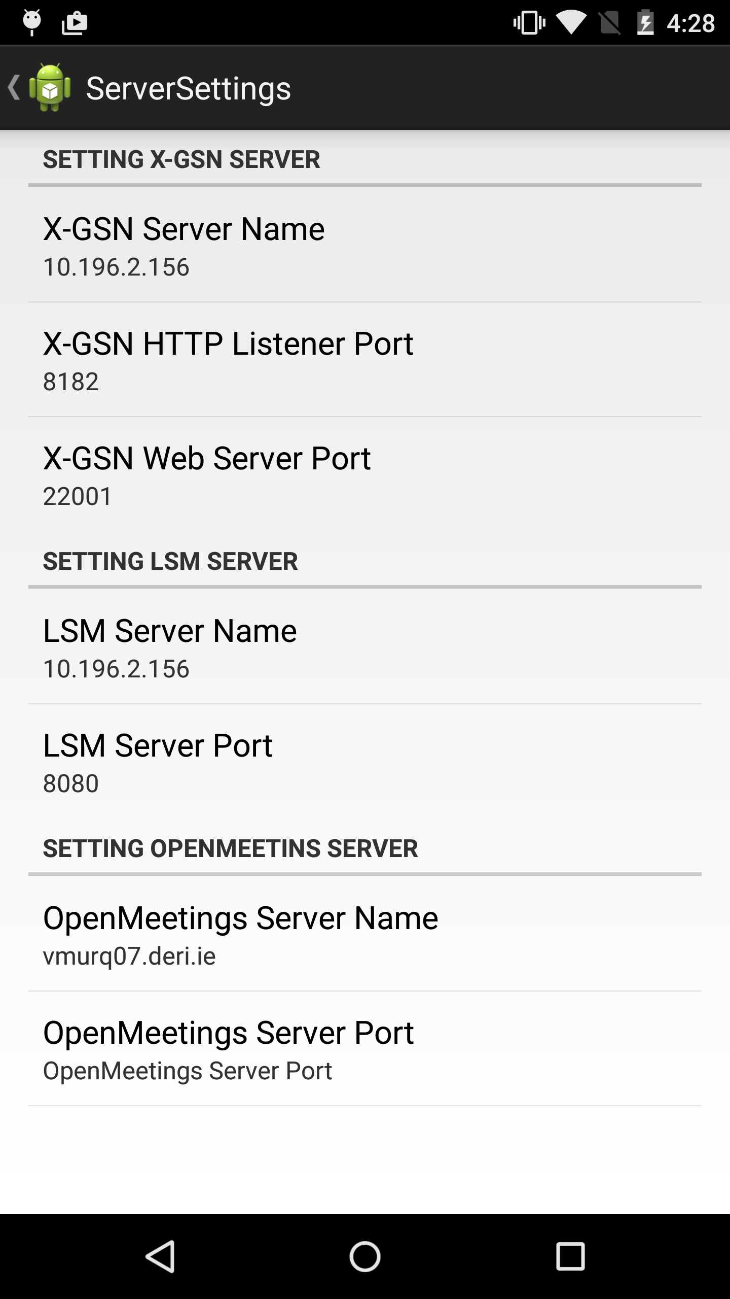

then login with om user

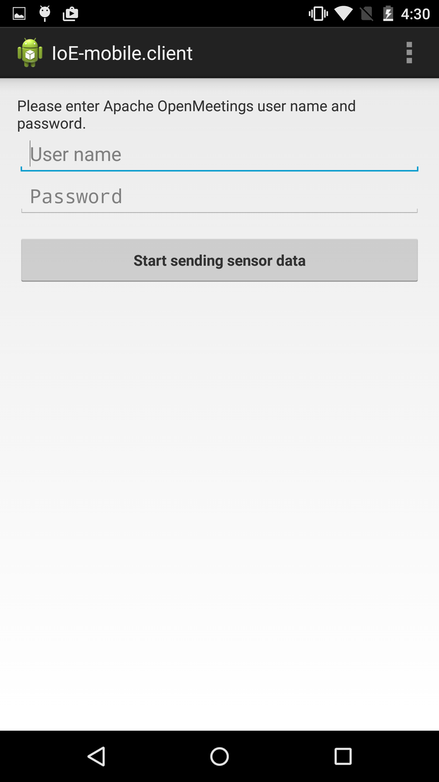

Then send sensor data

