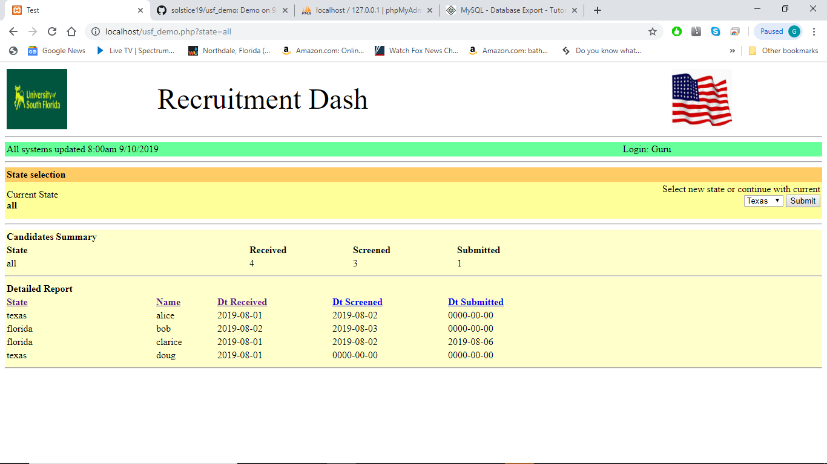

Form

Selector

Uses GETs

Sortable columns