**The xampp Stack**

Xampp can be downloaded from :

<https://www.apachefriends.org/download.html>

A standard install results in the following dir structure.

Dir htdocs contains the php file called from the requesting page.

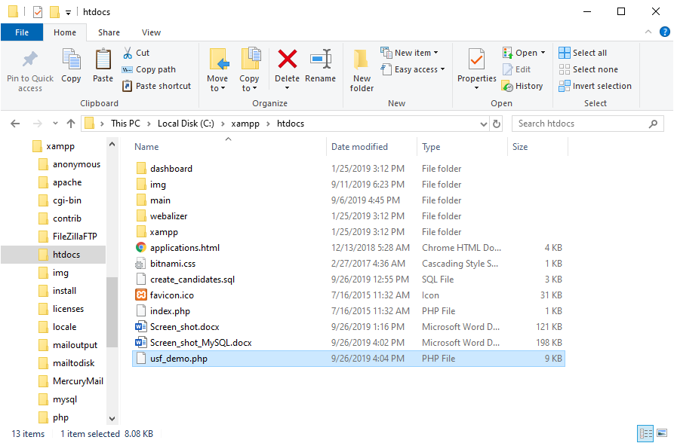

Xampp Start:

Use the following files to start or control xampp:

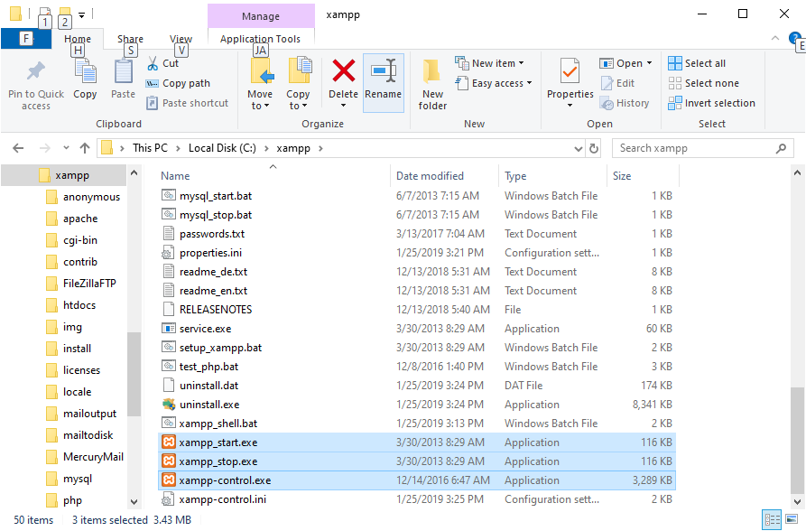

The xampp interface:

This results in starting xampp:

