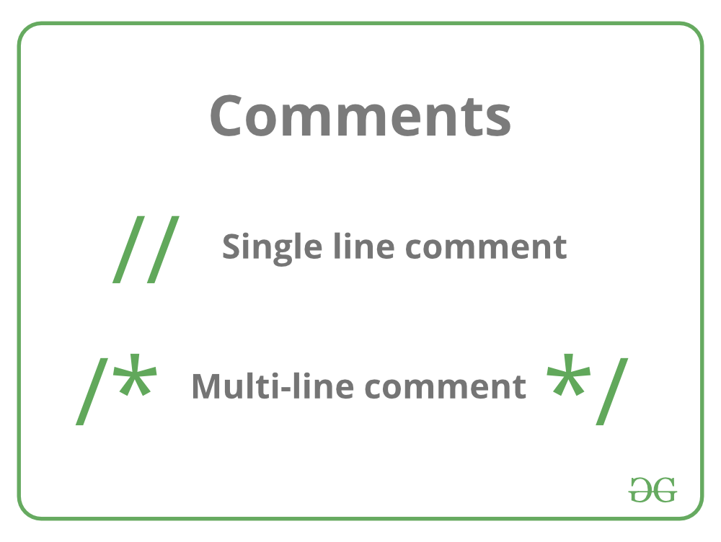

The **comments in C** are human-readable explanations or notes in the source code of a C program.  A comment makes the program easier to read and understand. These are the statements that are not executed by the compiler or an interpreter.

It is considered to be a good practice to document our code using comments.

## **When and Why to use Comments in C programming?**

1. A person reading a large code will be bemused if comments are not provided about details of the program.
2. C Comments are a way to make a code more readable by providing more descriptions.
3. C Comments can include a description of an algorithm to make code understandable.
4. C Comments can be used to prevent the execution of some parts of the code.

## **Types of comments in C**

In C there are two types of comments in C language:

* **Single-line comment**
* **Multi-line comment**