E-Statement Enrollment

- Log in to your online banking. 2. Select the account you wish to enroll.
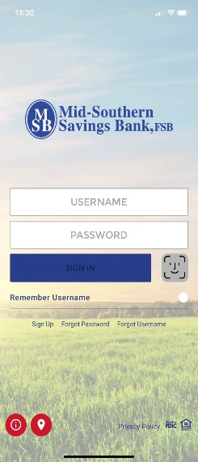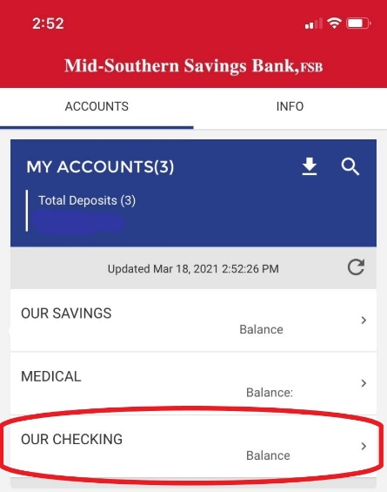

- If you are logged in on a computer, you will click on “Statements” on the lower right. If you are logged in on a mobile device, you will go to Services and click on “Statements”.
Computer
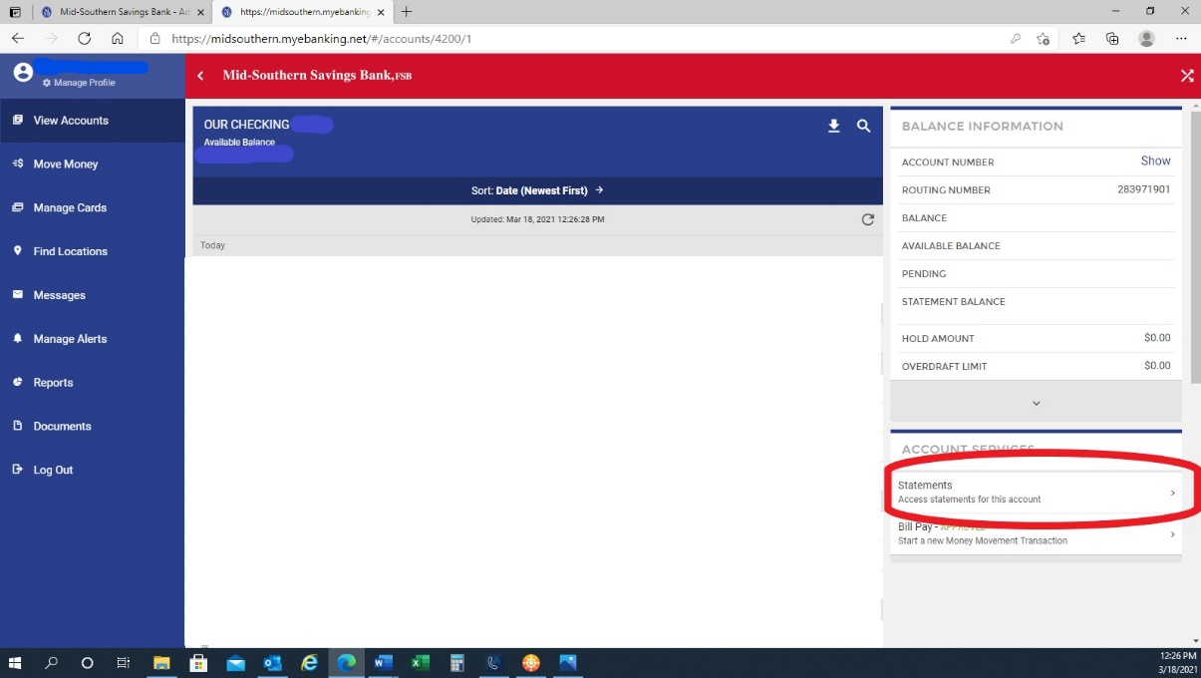

Mobile
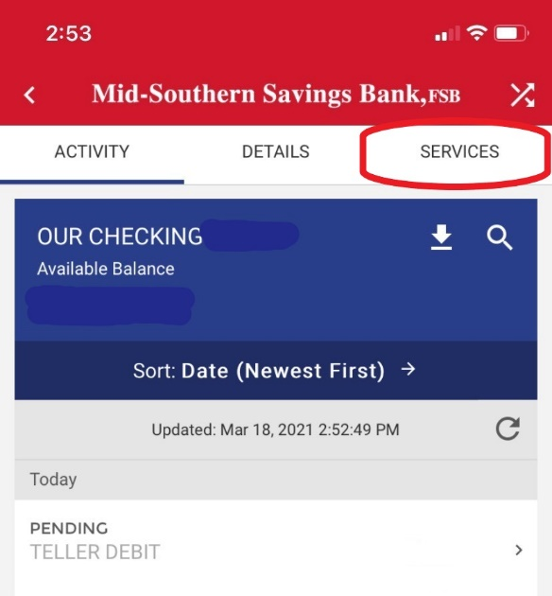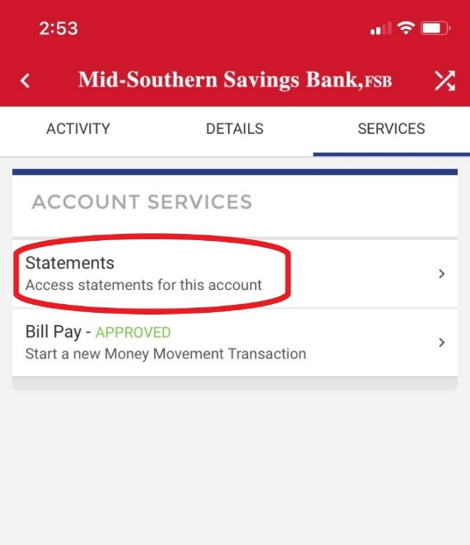

- The terms and conditions for the e-statements will come up and you will have to scroll through and read those.

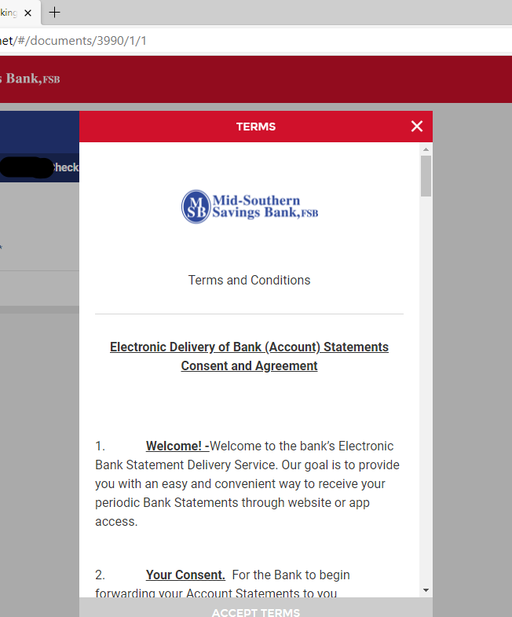

- After the terms and conditions there will be a test document for you to click on and open to make sure your device has the capabilities to pull up your statements before you can continue. If the test document pops up and you can read the message, close the document and proceed. If the test document does not pop up, your device is unable to access your statements. You may need to adjust your device settings to allow the document to come up.

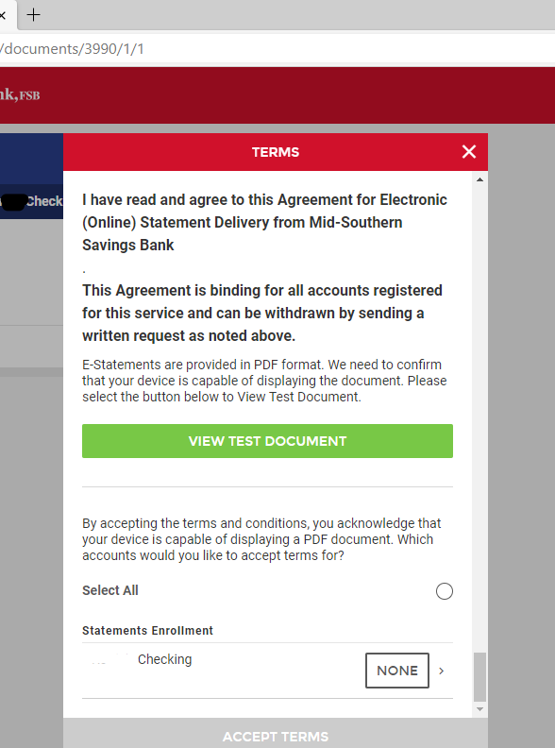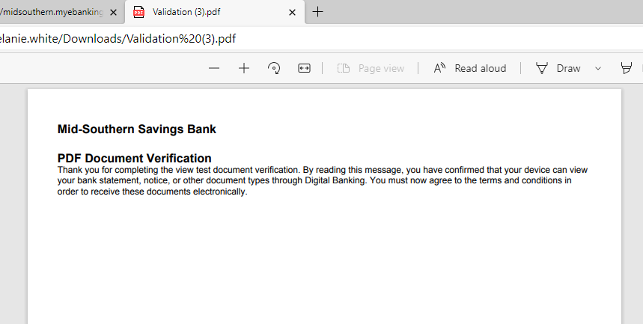

- Next, check “Select All” and Accept Terms. This completes the enrollment.
