MoU for Academic and Research Cooperation between the Department of Political Science and International Relations (DPSIR), University of Management and Technology (UMT), Lahore and Consortium for Asia Pacific and Eurasian Studies (CAPES)
The Department of Political Science and International Relations (DPSIR), University of Management and Technology (UMT), Lahore, and the Consortium for Asia Pacific and Eurasian Studies (CAPES) have signed a Memorandum of Understanding (MoU) to enhance academic collaboration and research development on September 5, 2025, at UMT Lahore.
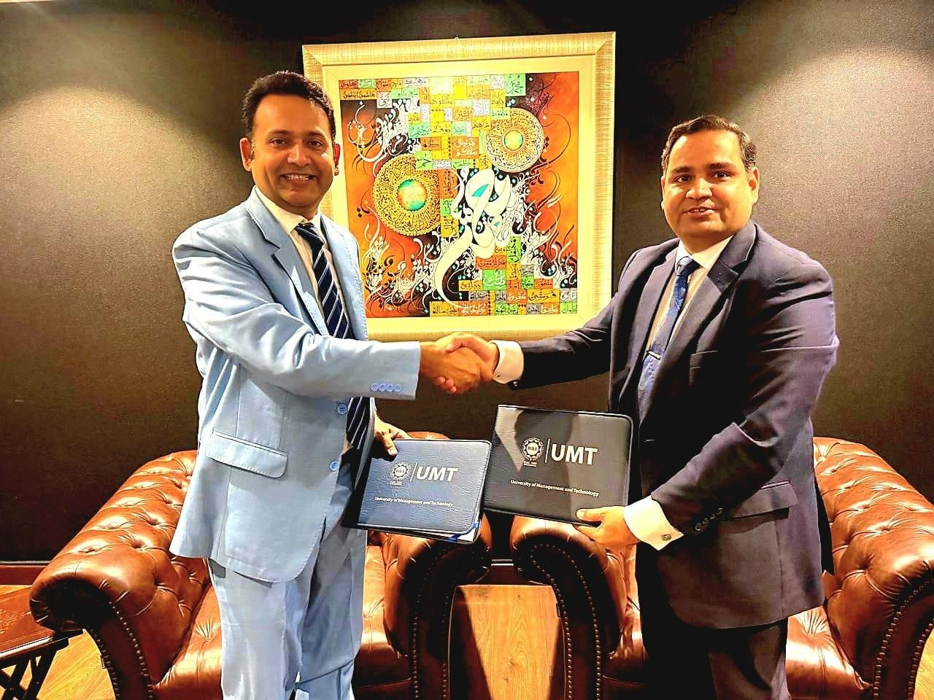
The agreement was signed by Dr. Muhammad Usman Askari, Chairperson, Department of Political Science and International Relations, UMT, Lahore, and Dr Khuram Iqbal, President CAPES, underscoring both institutions' commitment to advancing joint initiatives in research, education and policy engagement. Under the MoU, DPSIR, UMT and CAPES will collaborate in diverse areas, including Asia Pacific, geopolitics, international relations, security and strategy policy development, capacity building, internships, seminars, and academic conferences.
Dr. Usman Askari, while speaking at the signing ceremony, said the partnership would open new avenues for research and intellectual exchange. The university is dedicated to strengthening academic linkages that contribute to a deeper understanding of regional and global issues.
Dr. Khuram Iqbal, President of CAPES, lauded the initiative, saying it would bring together scholars and researchers to examine the evolving dynamics of the Asia Pacific region.

