# United States Army Corps of Engineers (USACE) Lock Usage Data Exploration with a Focus on the Ohio River and McAlpine Locks at Louisville, KY

Prepared by Bill Harper, 18 February 2018

## Introduction

The starting question for this brief study was, “How much commercial barge traffic flows through Louisville, KY?” We measure Louisville traffic by using the measures collected at the McAlpine Lock and Dam in the west end of the city.

## Discussion

Using the Microsoft SQL Server Analysis Server (SSAS) project developed for this GitHub example, we have some answers and more questions. Here are summary 2016 statistics:

|  |  |  |
| --- | --- | --- |
| Location | Lock Operations | Loaded Barges (up and down river) |
| All USACE | 576,616 | 1,317,597 |
| Ohio River | 93,143 | 439,138 |
| McAlpine | 4,979 | 27,972 |

Examining the lockage counts by month, we can see the variations in traffic from left to right, which corresponds to increasing lock number. With an assumption that traffic increases going downstream, the trough on the right side is troubling.

Do lock numbers increase going downstream? The answer is no. A quick check of Wikipedia (<https://en.wikipedia.org/wiki/List_of_locks_and_dams_of_the_Ohio_River>) shows that lock numbers (the sort order on the chart) are not in geographical order. This observation means that we should add the river mile to the LockChamber dimension if we want to do any modeling based on relative river position.

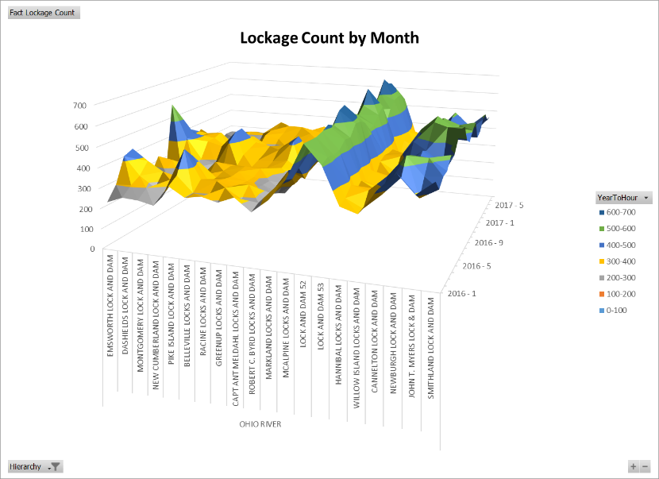

Let’s look at other stories in the data. Since processing time in the lock is mostly a function of gravity and water flow, processing time at a lock should be consistent. What do the data show?

For most of the locks on the Ohio River, processing time is consistent over time. Lock 52 is especially problematic. Investigation of the spikes and inconsistencies might be an avenue of deeper analysis.

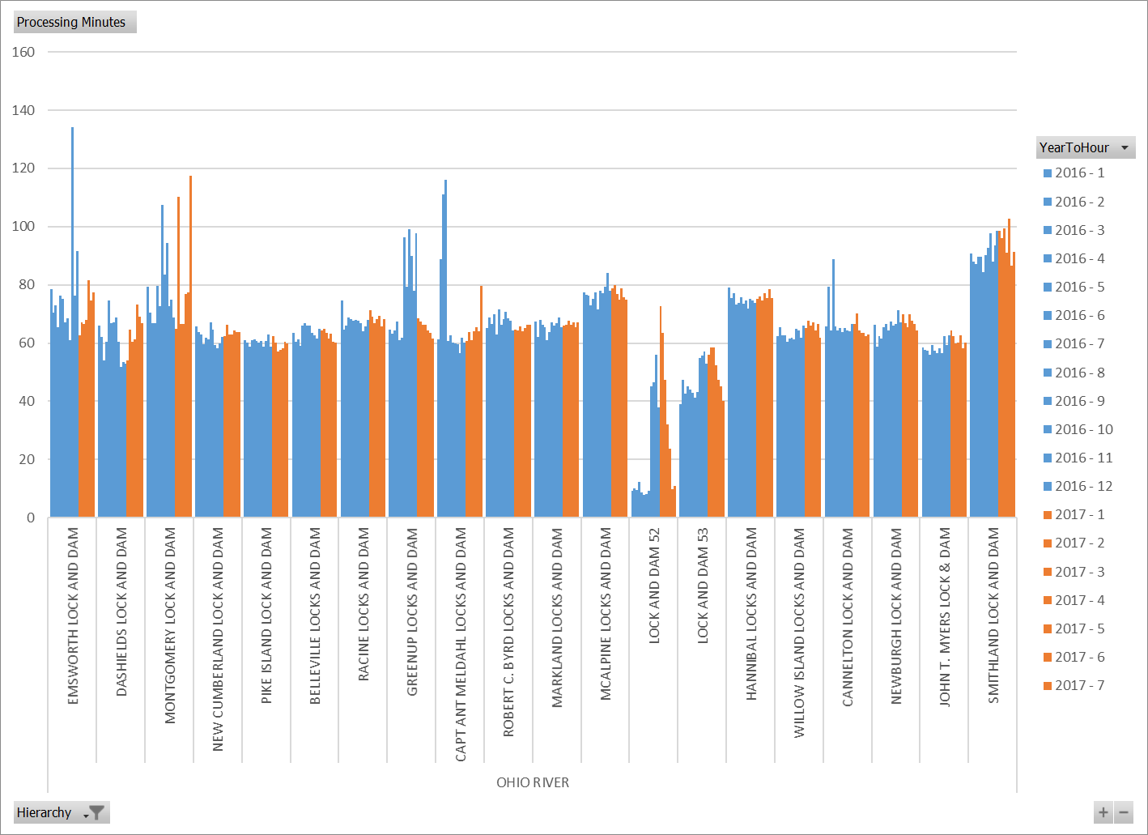

Finally, we look at delay times just to see if there is anything interesting. It looks like more trouble at Locks 52 and 53. As a matter of fact, Locks 52 and 53 are supposed to be replaced during 2018 with the new Olmsted lock complex in order to reduce delays. Some other locks show individual months with long delays. Those delays could be a subject of further investigation to determine if the delays are a few bad days, or something systemic.

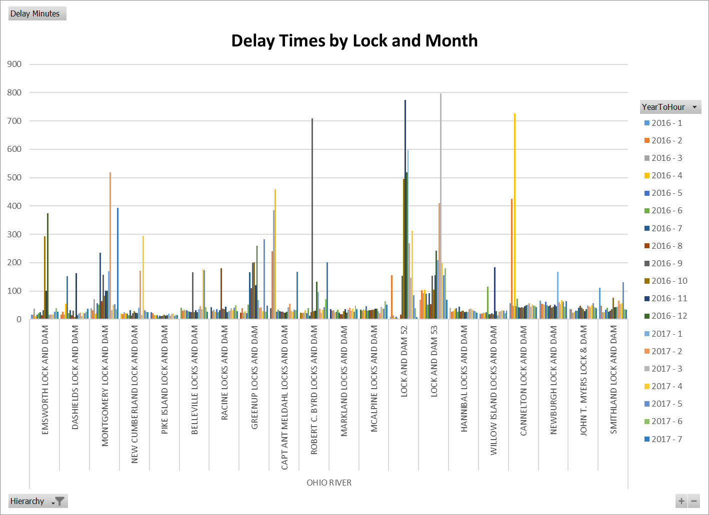

## Conclusion

This brief data exploration answered the core question of how much commercial barge traffic flows on the Ohio River. The study also showed some data deficiencies and potential areas of further study:

* The LockChamber dimension should have the river mile added in order to allow study of traffic flows up and down stream.
* The processing times at the “spiky” locks could stand further analysis, especially against delay times during the same time period to determine if there are operational problems.
* Delay times other than those on locks 52 and 53 may warrant further study.