Get Ready to Solve the Mystery

Rule Book

Contents

Game Setup 2

Website 3

Roles 4

Cards 5

Start your mission 6

# Game Setup

Before you begin your investigation, follow these steps to set up the game:

1. **Set up the game board first:** 
   * **Location Token:** Place it on the **HQ** mark on the **board**. Move this token as your team travels.
   * **Money Token:** Start with **1000 S**. Adjust your budget as you spend money on hints, investigations, or travel.
   * **Investigation Stage Token:** Place it on **"Location"** to mark the first phase of your investigation. Update it as the game progresses.
2. **Arrange the Storyline & Clue Cards:**
   * Place the **Storyline Cards (SC1, SC2, …, SC X)** and **Clue Cards (CC A, CC B, …, CC X)** face down on the board.
3. **Arrange the Mystery Word & Hint Cards:** 
   * Place the **Mystery Cards (MC1, MC2, …., MC X)** face down on the board, which can be accessed only by the expert. Do not peak at them, they are only for the expert.
4. **Assign a Board Manager:** 
   * Choose one player to be in charge of managing the tokens throughout the game.
5. **Assign an Expert:** 
   * Choose one player to play the role of the expert at the game.
6. **Log in to the Website:**
   * Ensure at least one player is logged in to access digital game components.

Here's a visual reference for how the board game should be set up. **Detectives, stay flexible!** This is just an example—your team can choose different roles based on your strategy. Pick wisely and adapt to the case at hand!

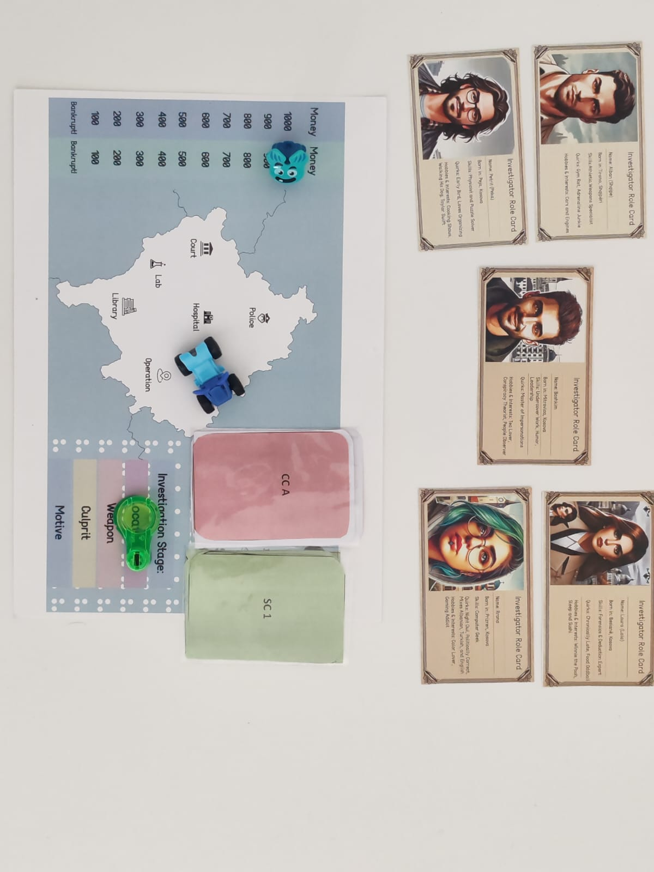

Figure 1: Visual reference for how the board game should be set up.

# Website

Open the SolveIT Website. Now, follow these steps:

1. **Assign** **a Website Navigator:**
   * Choose one player to handle the website throughout the game. Only one account is needed to player.
2. **Register or Log In:**
   * The assigned player should register or log in to the website.
3. **Choose Your Game:**
   * Once logged in, choose the storyline you want to play.
4. **Check Your Email!** 
   * You’ve received an urgent email—read it carefully and discuss it with your team. It may contain vital clues! Watch the video to navigate the SolveIT Website.

# Roles

Pick 5 Roles: Out of 8 available roles, choose 5 based on the skills you’ll need to solve the case. Read your mission first (email)!

Work as a Team: Some skills are crucial—choose wisely to unlock key clues.

Select the Expert: One player will be the Expert, responsible for special hint cards if your team needs help.

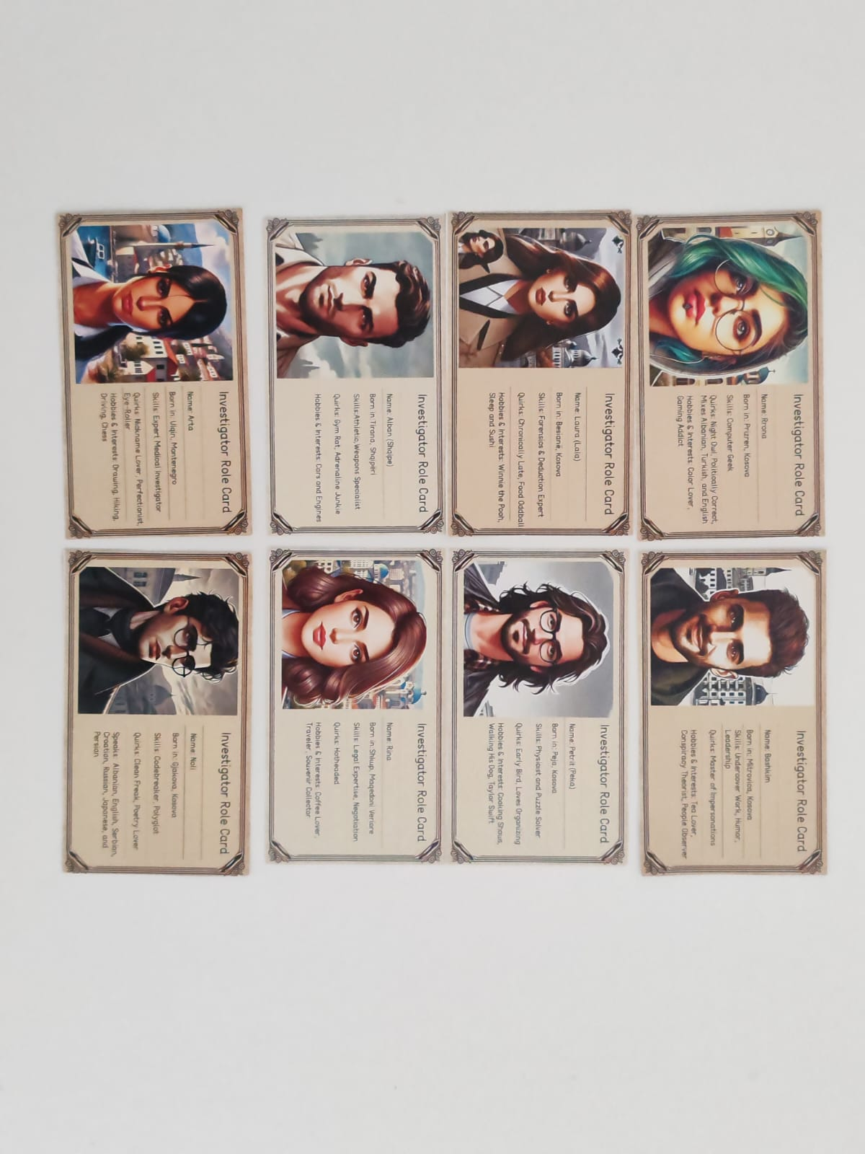

Figure 2: Choose 5 roles. Pay attention to the skills you might need to solve the mystery!

# Cards

**Storyline Cards (SC1 – SC X)** – These green cards guide your investigation. One player should read them aloud.

Make sure to start the game by with SC1, after which you only open/discard cards when the game instructs you to do so.

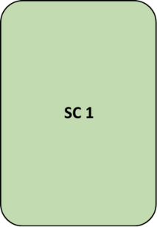

**Clue Cards (CC A – CC X)** – These pink cards contain puzzles and codes. Use your detective skills to solve them **only when the game instructs you to open them.** If these cards hold this symbol “+?” it means you need more cards with the same symbol to solve that clue.

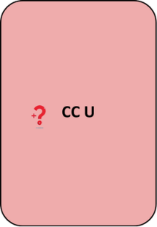

⚫ **Mystery Cards (MC 1 – MC X)** – Only for the Expert. You decide when to use them as a team, but you can only use them when you see this symbol “🔎” in the storyline & clue cards.

* Can be opened **for free** **3 times** during the game.
* After that, each card costs **100 S** to open.
* The expert must explain the **mystery word** **without using forbidden words**.
* On the **SolveIT website**, go to the **Card Section** and find the matching **MC number (e.g., MC1)**.
* After guessing the Mystery Word, **enter it in the box** labeled **"Please enter the Mystery Word"** to unlock a hint. You can decide to make the game more challenging by adding time pressure with this rule: “You have 60 seconds to guess the word”.

 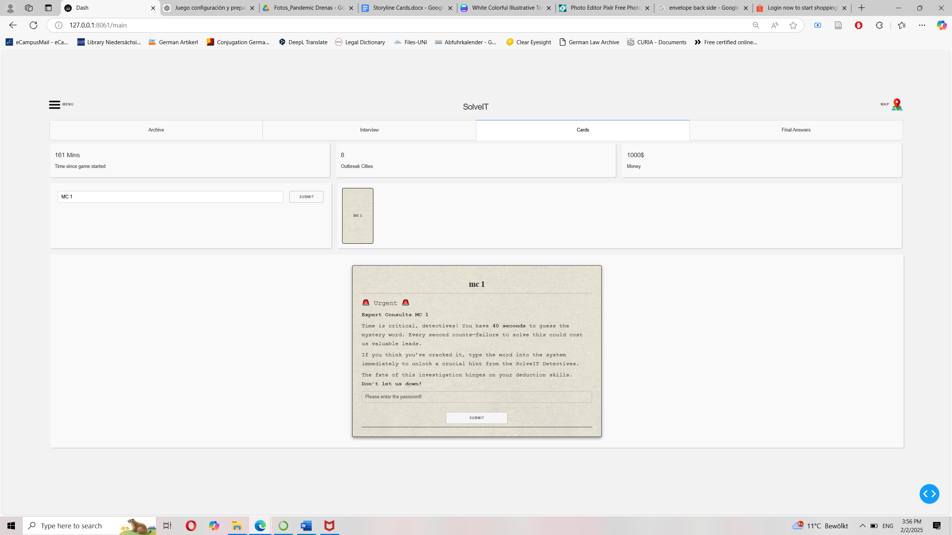

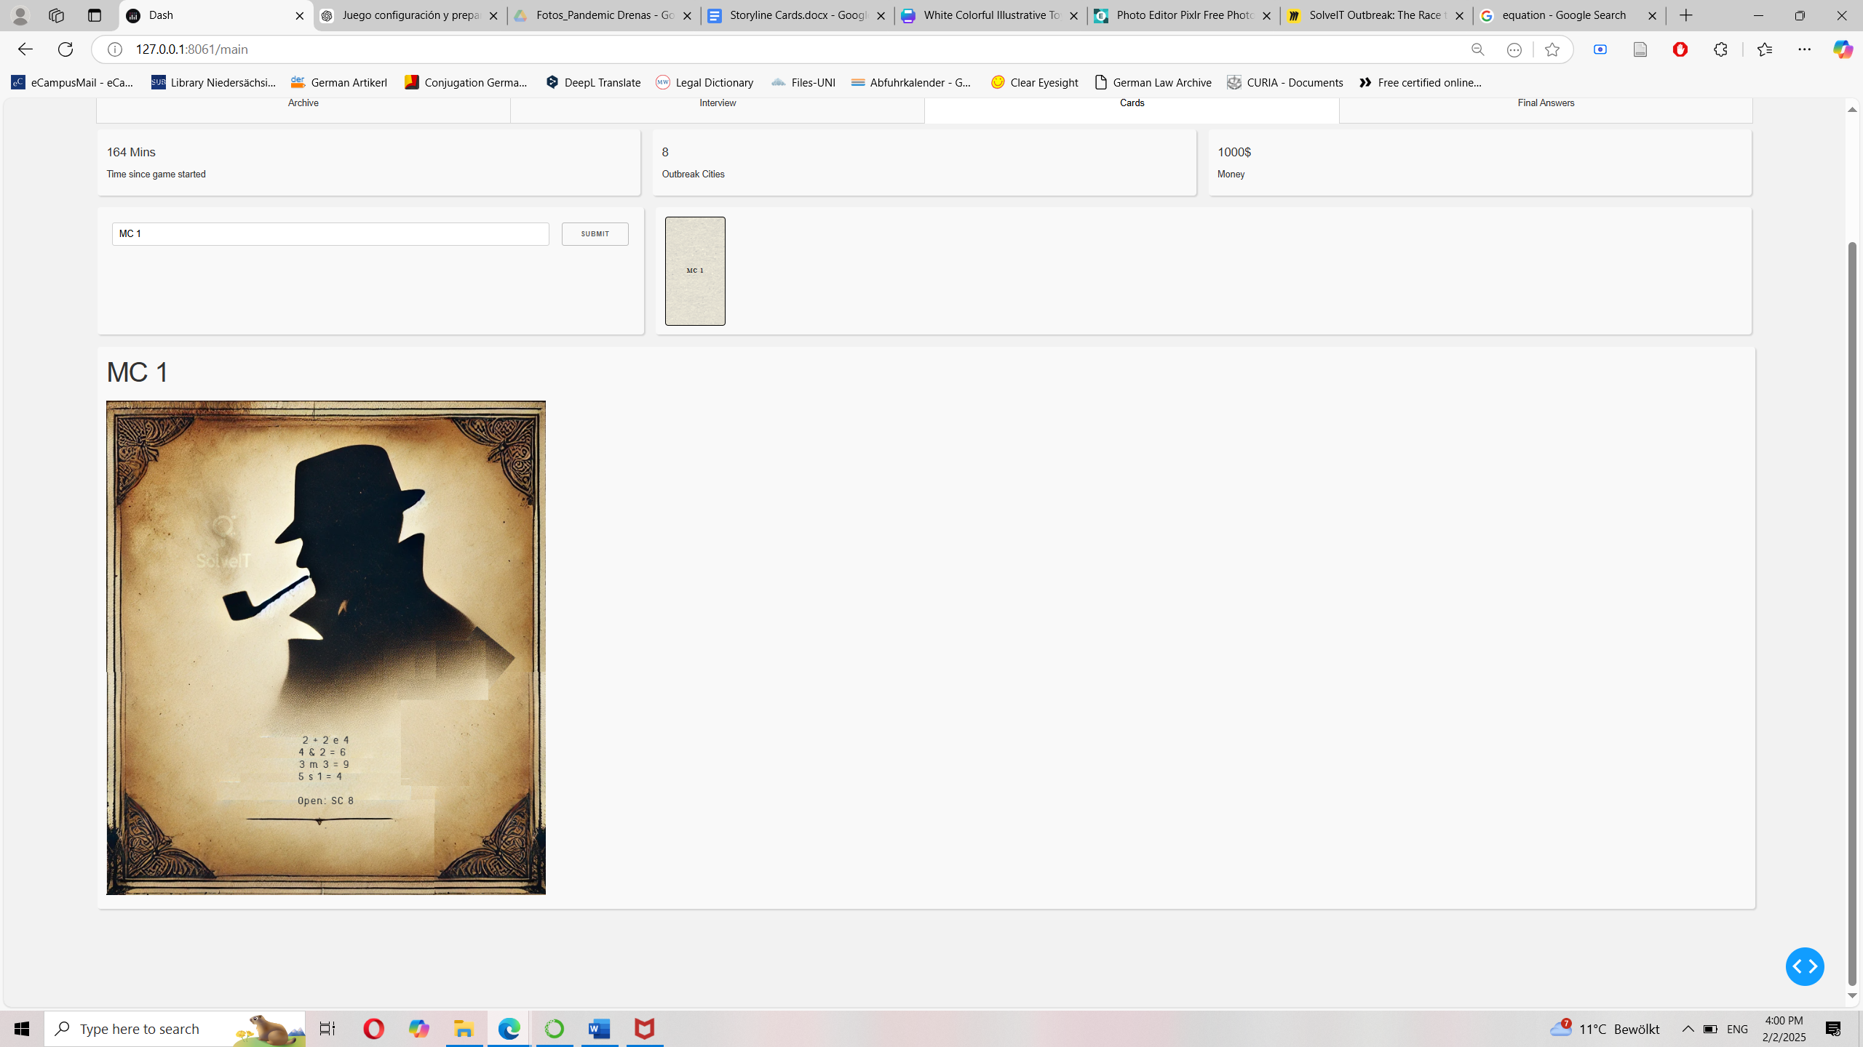

Congratulations Agents! Now you know how to use hints.

# Start your mission

Good luck agents. Start the game by opening SC 1!