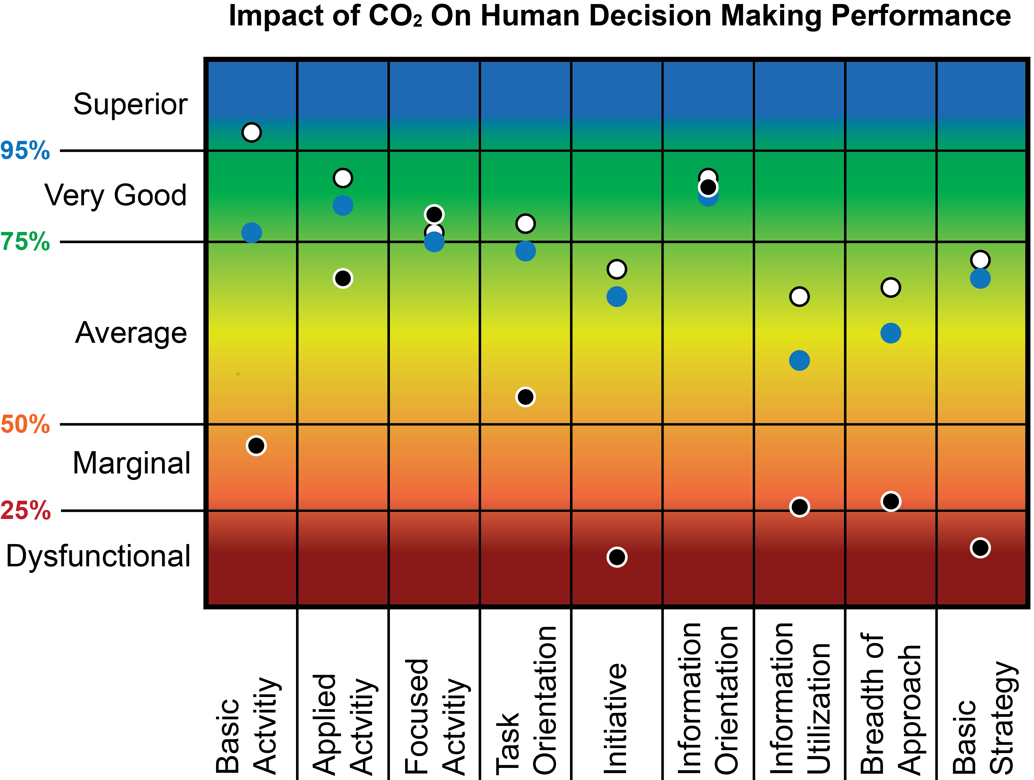




CO₂ Concentration
 | 600 ppm |  | 1000 ppm |  | 2500 ppm
Calibration
1. Refresh the room very well
2. Press and hold the top button until led light will be blue

