AI-assisted manuscript drafting in clinical epidemiology
Workshop participant
2026-05-13

Background
Clinical epidemiology projects often require repeated rewriting of the same core ideas for protocols, abstracts, manuscripts, and responses to reviewers. Large language models can support this process, but uncontrolled use may introduce fabricated citations or wording that overstates the evidence. Reporting guidelines such as PRISMA and STROBE remain useful anchors when researchers use AI during drafting^{1,2}.

Objective
This short demonstration shows how a manuscript draft can be managed as a project folder in an IDE. The goal is to separate the human decisions about structure, evidence, and interpretation from the AI-assisted work of revising language and generating document outputs.

Methods
The draft is written in Markdown. References are stored in refs.bib, and citations are rendered with pandoc using a CSL file. Figures are stored under assets/ and embedded by relative path.
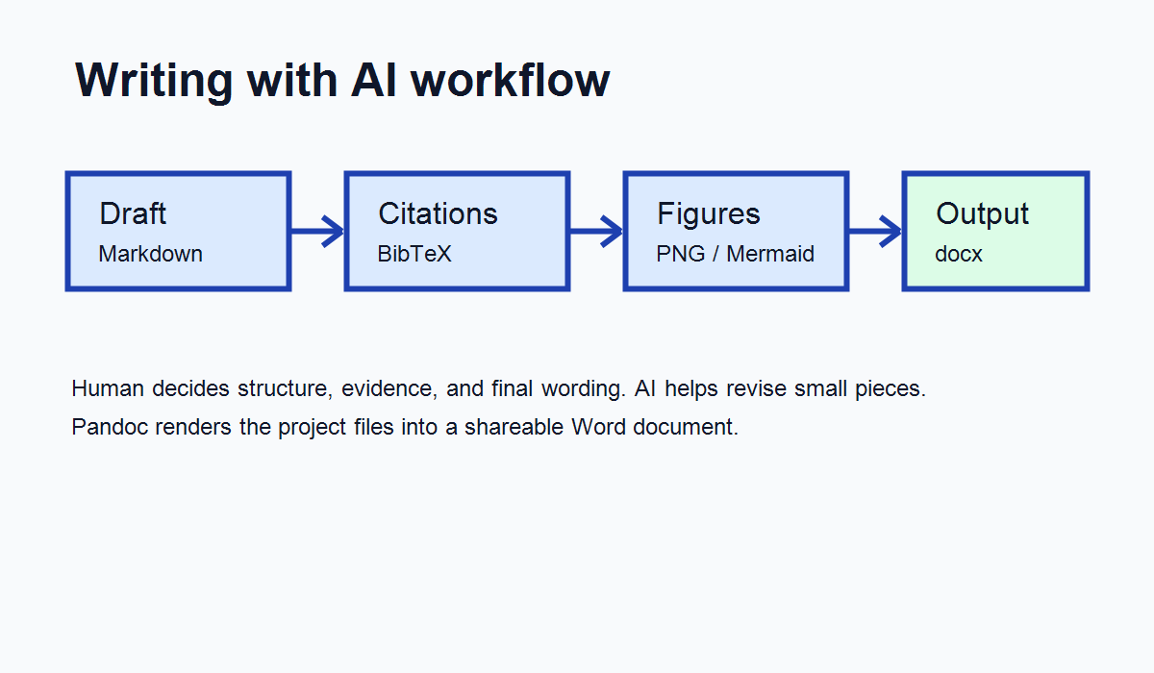
Figure 1. Workflow for writing with AI.
The workflow has four steps:
- Write or paste a rough draft into draft.md.
- Ask the AI to revise one section at a time.
- Keep citations restricted to entries in refs.bib.
- Render the document to Word with pandoc.

Results
The main output is a Word document generated from the Markdown file. The generated document should be checked manually, especially citation placement, figure captions, and any claim about study design or interpretation.

Discussion
AI-assisted writing is most useful when the project files are explicit and the revision target is narrow. For example, asking the AI to revise only the Background section is easier to review than asking it to rewrite the whole manuscript. The researcher remains responsible for the argument, the evidence, and the final wording.

AI disclosure example
We used an AI coding and writing assistant to support editing of this draft and to prepare document-rendering commands. All AI outputs were reviewed and revised by the author.
1. Page MJ, McKenzie JE, Bossuyt PM, et al. The PRISMA 2020 statement: An updated guideline for reporting systematic reviews. BMJ. 2021;372:n71. doi:10.1136/bmj.n71
2. Elm E von, Altman DG, Egger M, Pocock SJ, Gotzsche PC, Vandenbroucke JP. The strengthening the reporting of observational studies in epidemiology (STROBE) statement: Guidelines for reporting observational studies. Journal of Clinical Epidemiology. 2008;61(4):344-349. doi:10.1016/j.jclinepi.2007.11.008

