**COMSATS University Islamabad,   
Park Road, Chak Shahzad, Islamabad Pakistan**

SOFTWARE DESIGN DESCRIPTION   
(SDD DOCUMENT)

for

**COMFORT ZONE**   
Version 1.0

***By***

**Muhammad Osama CIIT/FA16-BSE-088/ISB**

**Rana Waqar Tufail CIIT/FA16-BSE-117/ISB**

**Haris Mehmood CIIT/FA16-BSE-154/ISB**

***Supervisor*Mr. Muzaffar Iqbal**

*Bachelor of Science in Computer Science (2016-2020)*

**Table of Contents**

Revision History iii

1. Introduction 1

2. Design Methodology and software process model 1

3. System Overview 1

3.1 Architectural Design 1

3.2 Process Flow/Representation 1

4. Design Models [along with descriptions] 1

5. Data Design 2

5.1 Data Dictionary 2

6. Algorithm & Implementation 2

7. Software Requirements Traceability Matrix 2

8. Human Interface Design 3

8.1 Screen Images 3

8.2 Screen Objects and Actions 3

9. Appendix I 3

Revision History

|  |  |  |  |
| --- | --- | --- | --- |
| **Name** | **Date** | **Reason for changes** | **Version** |
|  |  |  |  |
|  |  |  |  |

**Application Evaluation History**

|  |  |
| --- | --- |
| **Comments (by committee)**  **\*include the ones given at scope time both in doc and presentation** | **Action Taken** |
|  |  |
|  |  |

Supervised by

Mr. Muzaffar Iqbal

Signature______________

# Introduction

Briefly explain scope of the project covered till now including modules.

# Design methodology and software process model

Explain and justify the choice of design methodology being followed. (OOP or procedural). Also explain which process model are you following and why.

# System overview

Give a general description of the functionality, context and design of your project. Provide any background information if necessary.

## Architectural design

Develop a modular program structure and explain the relationships between the modules to achieve the complete functionality of the system. This is a high-level overview of how the system’s modules collaborate with each other in order to achieve the desired functionality.

Don’t go into too much detail about the individual subsystems. The main purpose is to gain a general understanding of how and why the system was decomposed, and how the individual parts work together.

Provide a diagram showing the major subsystems and their connections. **Use a simple Line-Box-Diagram for simpler systems and detailed diagrams (MVC, Client-Server, Layered, Multi-tiered) for complex systems.**

## Process flow/Representation

Provide a representation of the flow of **MAJOR processes** of your system in the form of an activity diagram. **DO NOT CREATE ACTIVITY DIAGRAMS FOR LOGIN OR SIGN-UP UNLESS THEY INVOLVE SIGNIFICANT COMPLEXITY**. Include only the major processes.

# Design models [along with descriptions]

**The applicable models may include:**

* Class Diagram
* Sequence Diagram
* State Transition Diagram
* Data Flow Diagram
* Schematic diagram (Hardware projects only)
* Timing diagram (Hardware projects only)

Insert ***applicable*** system models here.

You should be clear about all the concepts used in your diagrams for example for class diagram you should know about aggregation, composition, inheritance/generalization. Also ensure visibility of all diagrams.

Class diagram and associated models shall only be necessary for object-oriented approach. In case of procedural, create a DFD. Data flow diagram should be extended to 2-3 levels. It should clearly list all processes, their sources/sinks and data stores.

**Note: System design should be complete in all aspects. Create any/all diagrams if you need to. A DFD can also be supplemented by a State Transition Diagram depending on the nature of the project.**

**Hardware projects can include Schematic diagram, System block diagram, timing diagram, Flow charts as replacement of sequence diagram/ Data flow diagram AFTER CONSULTATION WITH THEIR SUPERVISORS. Choice of models must be properly justified.**

## Class Diagram:

## Activity Diagram:

### Billing System:

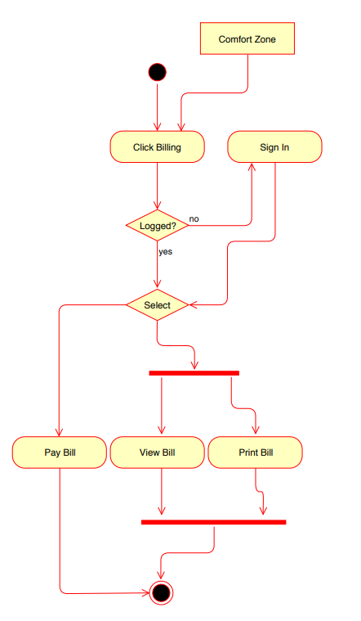

### Chat Forum:

### Fundraising System:

### Complaint Portal:

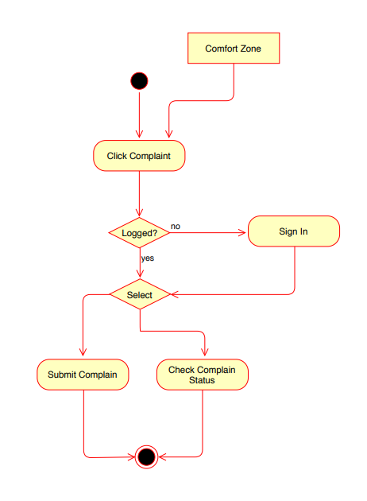

### Facility Corner:

### Election System:

### Tender and Auction

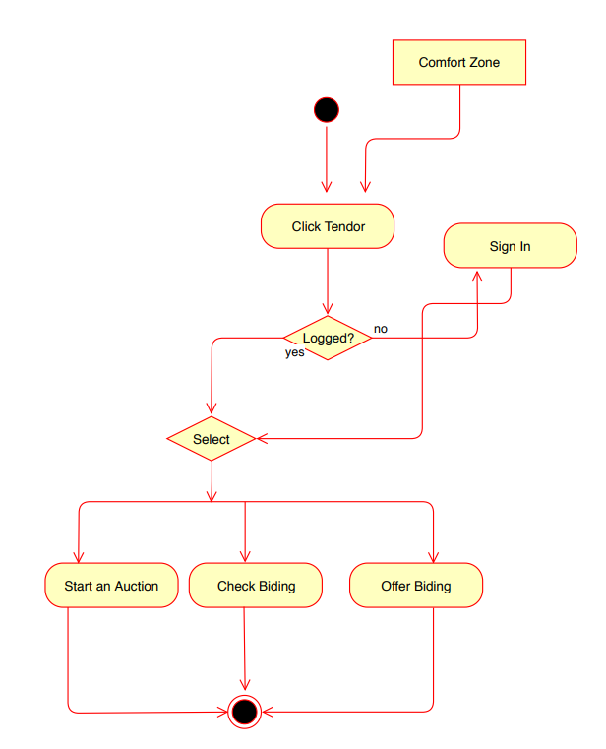

### Advertisement Corner:

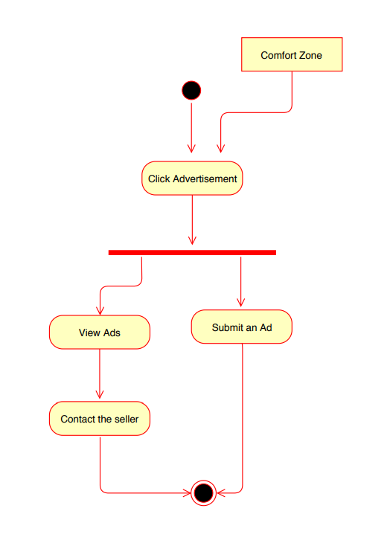

### Garbage Tracking:

### Security System:

## Sequence Diagram:

### Billing System

### Chat Forum:

### Fundraising:

### Complaint Portal:

### Facility Corner:

### Election System:

### Tender and Auction:

### Advertisement Corner:

### Garbage Tracking:

### Security System:

# Data design

Explain how the information domain of your system is transformed into data structures. Describe how the major data or system entities are stored, processed and organized.

List any databases or data storage items.

## Data dictionary

Alphabetically list the system entities or major data along with their types and descriptions. If you provided a functional description, list all the functions and function parameters. If you provided an OO description, list the objects and its attributes, methods and method parameters.

# Algorithm & Implementation

In this section, we take a closer look at what each component does in a more systematic way. Provide a summary of your algorithm for each function listed in procedural description language (PDL) or pseudo code.

If you gave an OO description, summarize each object member function for all the objects listed in PDL or pseudocode. Describe any local data when necessary.

# Software requirements traceability matrix

This section should contain a table that summarizes how each software requirement has been met in this document. The tabular format permits one-to-one and one-to-many relationships to be shown.

Table 1 Requirements Traceability Matrix

|  |  |  |  |
| --- | --- | --- | --- |
| **Req. Number** | **Ref. Item** | **Design Component** | **Component Items** |
| FR01 | Class Diagram | Class Name | Function Name(s) |
| OR | | | |
| FR01 | DFD | Diagram Number/Level | Function Name(s) |

# Human interface design

Describe the functionality of the system from the user’s perspective. Explain how the user will be able to use your system to complete all the expected features and the feedback information that will be displayed for the user.

## Screen images

### Landing Page:

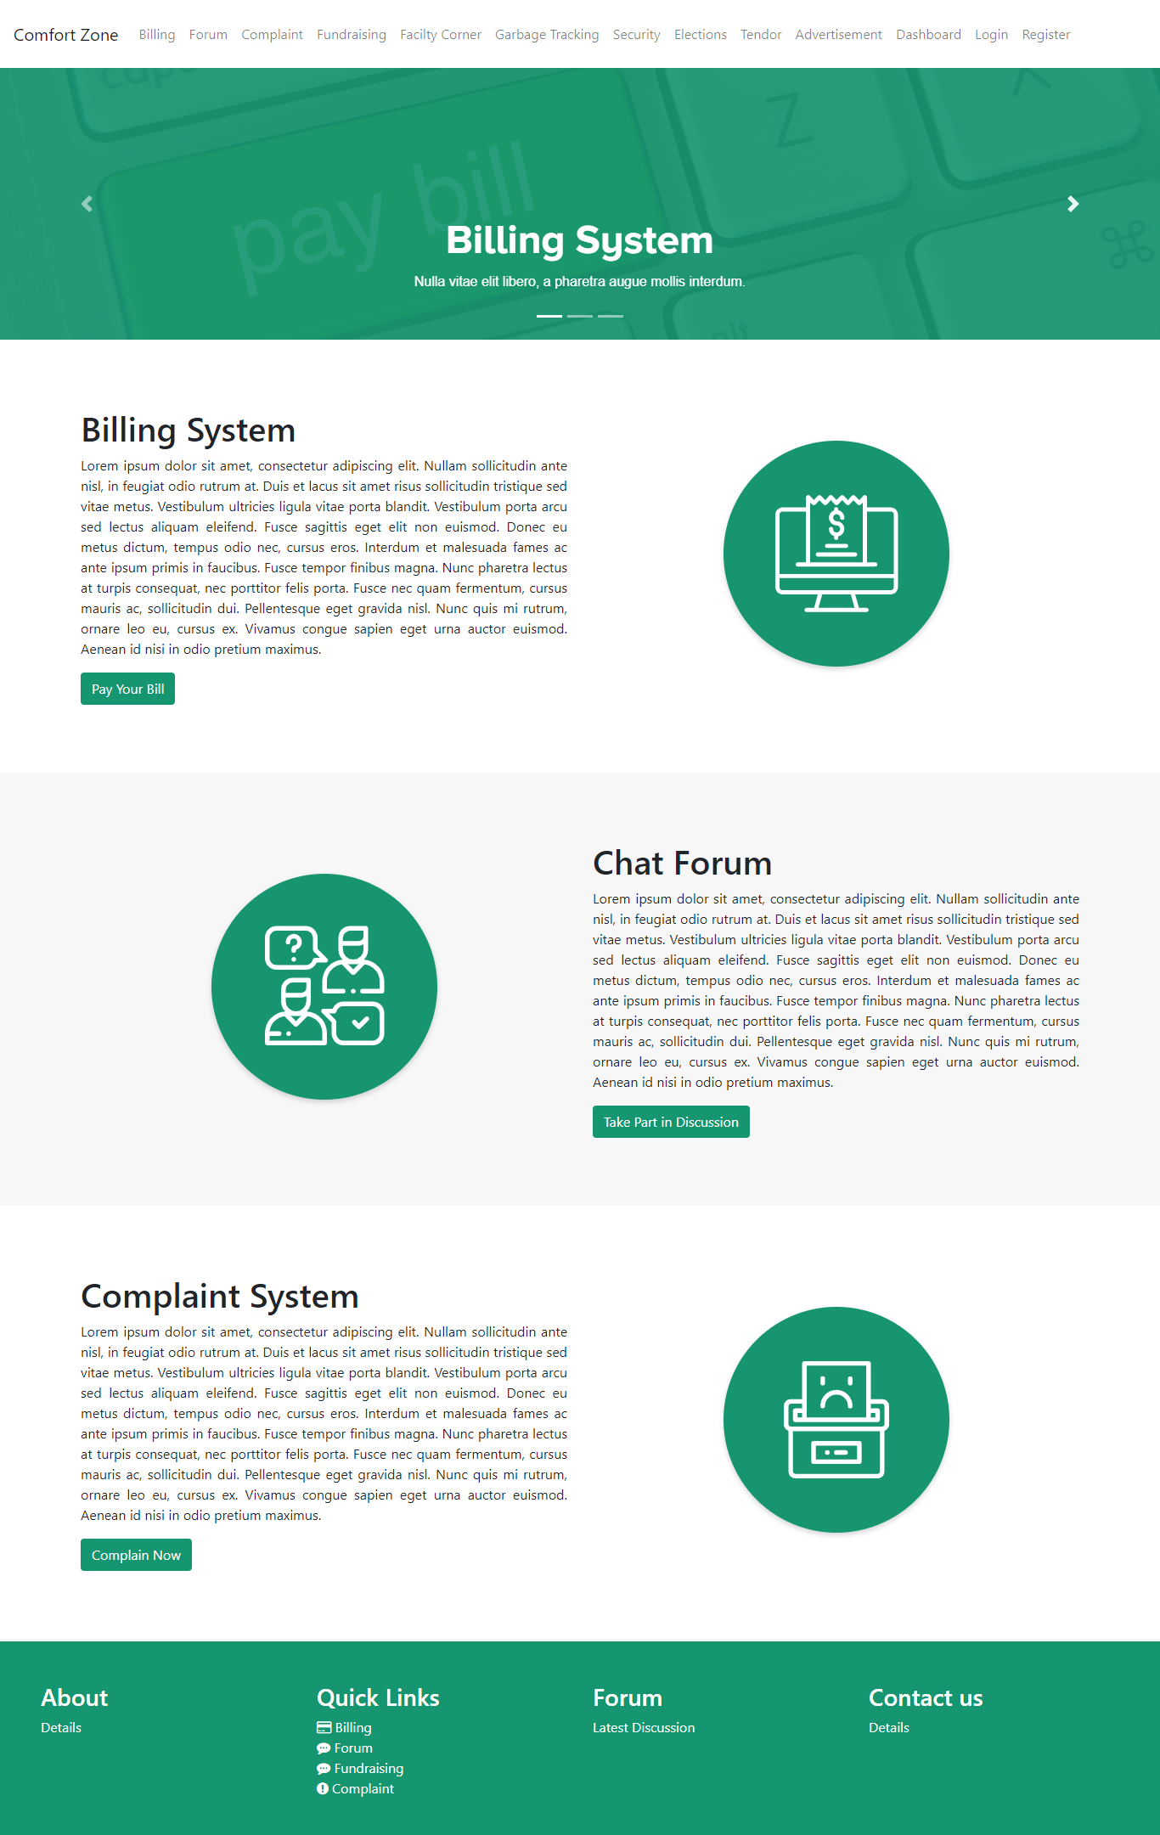

### C:\Users\imuha\AppData\Local\Microsoft\Windows\INetCache\Content.MSO\510EC57.tmpRegistration Page:

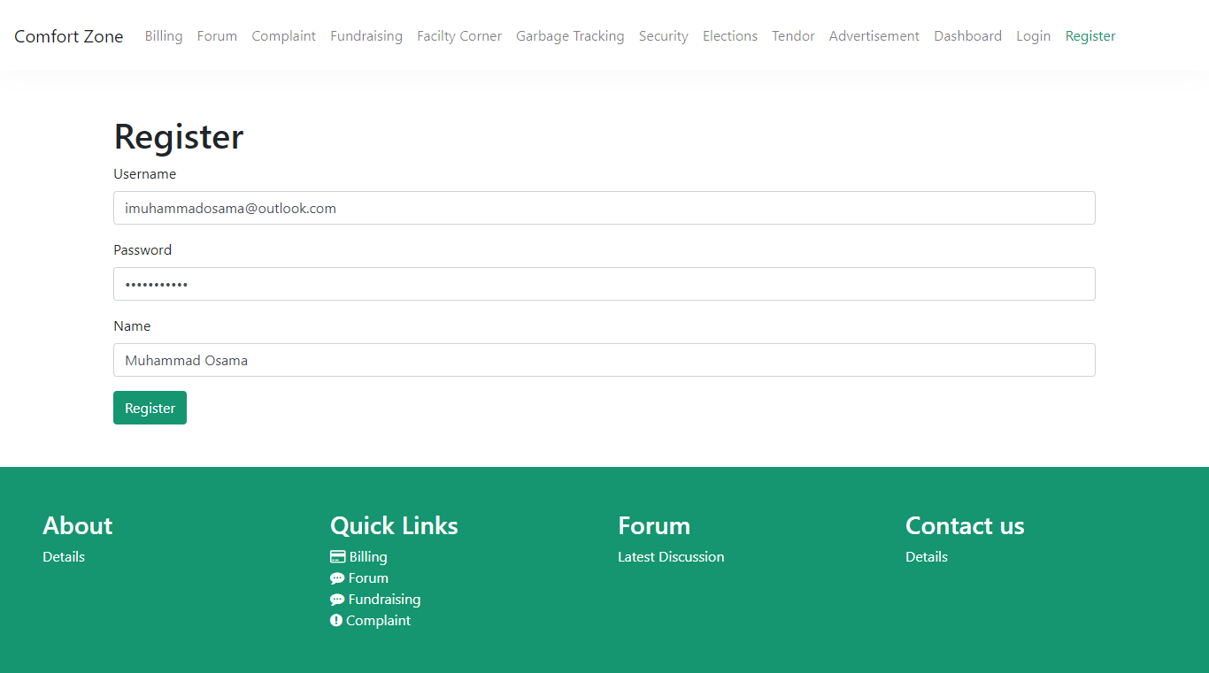

### C:\Users\imuha\AppData\Local\Microsoft\Windows\INetCache\Content.MSO\8368FE19.tmpC:\Users\imuha\AppData\Local\Microsoft\Windows\INetCache\Content.MSO\AE922B93.tmpLogin Page:

### C:\Users\imuha\AppData\Local\Microsoft\Windows\INetCache\Content.MSO\ED2C4875.tmpDashboard:

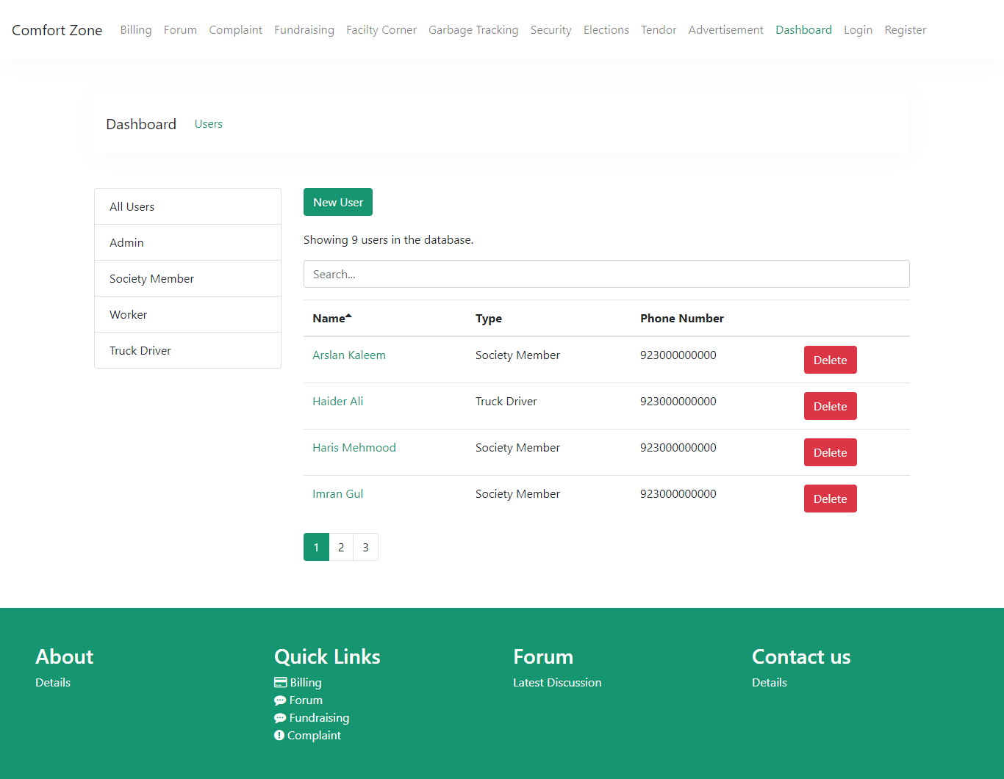

### C:\Users\imuha\AppData\Local\Microsoft\Windows\INetCache\Content.MSO\2171DBC7.tmpAdding New User Page:

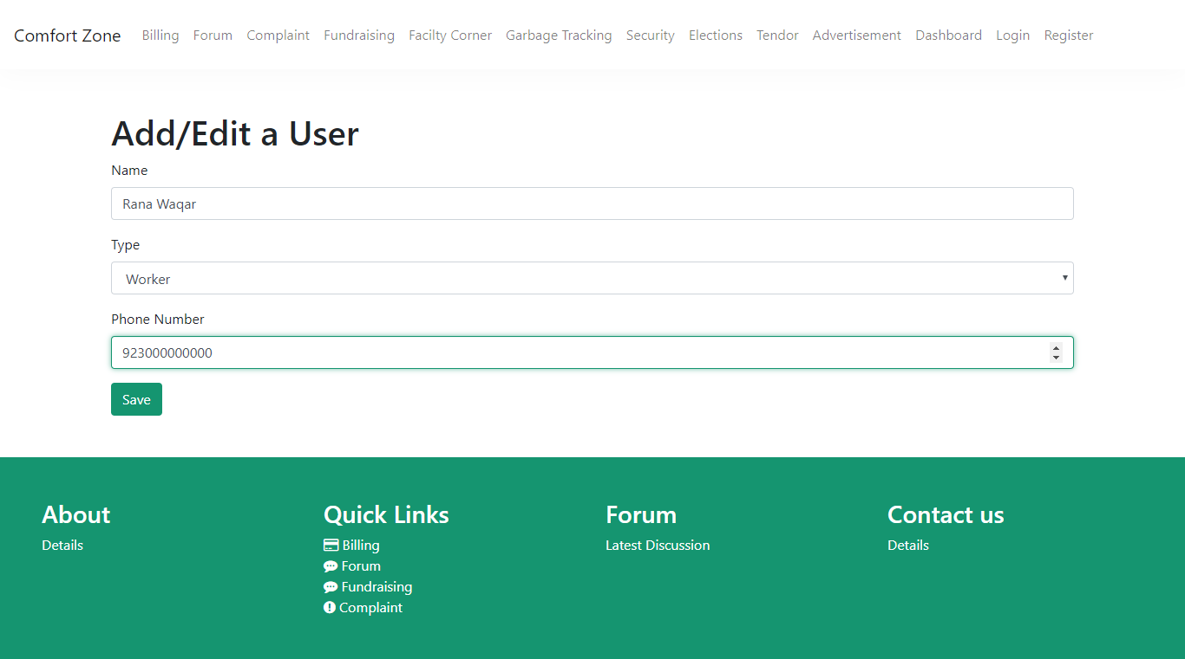

### C:\Users\imuha\AppData\Local\Microsoft\Windows\INetCache\Content.MSO\5577DA03.tmpBilling Page:

#### Billing Payment Page:

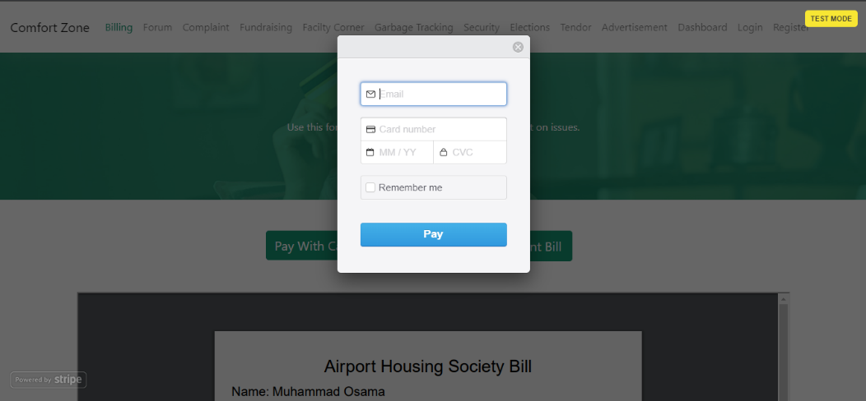

### C:\Users\imuha\AppData\Local\Microsoft\Windows\INetCache\Content.MSO\1682C3BB.tmpChat Forum Page:

#### C:\Users\imuha\AppData\Local\Microsoft\Windows\INetCache\Content.MSO\78ABD081.tmpSingle Discussion Post Page:

## 8.2 Screen objects and actions

A discussion of screen objects and actions associated with those objects

# Appendix I

* How to design using UML (OOP): For guidance please follow the instructions mentioned in the link: http://agilemodeling.com/artifacts/
* How and when to design ER diagrams: For guidance please follow the instructions mentioned in the link:

<http://people.inf.elte.hu/nikovits/DB2/Ullman_The_Complete_Book.pdf>

* Data flow diagrams: For guidance please follow the instructions mentioned in the link and book:
  + http://www.agilemodeling.com/artifacts/dataFlowDiagram.htm
  + Software Engineering –A Practitioner’s approach by Roger Pressman
* Architecture diagram: For guidance please follow the instructions mentioned in the link and book:
  + Ian Sommerville – Software Engineering 9th Edition– Chapter 6