***Basic Mathematics (ABI 105) - Semester I***

***Section A***

**Q.1 What is a set? Explain various methods to represent a set-in set theory.**

**Answer:-** In mathematics, a set is a well-defined collection of distinct objects, considered as an object in its own right. For example, the numbers 2, 4, and 6 are distinct objects when considered separately, but when they are considered collectively they form a single set of size three, written {2,4,6}. Sets are one of the most fundamental concepts in mathematics. Developed at the end of the 19th century, set theory is now a ubiquitous part of mathematics, and can be used as a foundation from which nearly all of mathematics can be derived.

In everyday life, we often speak of collections of objects of a particular kind, such as, a pack of cards, a crowd of people, a cricket team, etc. In mathematics also, we come across collections, for example, of natural numbers, points, prime numbers, etc. More specially, we examine the following collections:

(i) Odd natural numbers less than 10, i.e., 1, 3, 5, 7, 9

(ii) The rivers of India

(iii) The vowels in the English alphabet, namely, a, e, i, o, u

(iv) Various kinds of triangles

(v) Prime factors of 210, namely, 2, 3, 5 and 7

(vi) The solution of the equation: x2 – 5x + 6 = 0, via, 2 and 3.

We note that each of the above examples is a well-defined collection of objects in the sense that we can definitely decide whether a given particular object belongs to a given collection or not. For example, we can say that the river Nile does not belong to the collection of rivers of India. On the other hand, the river Ganga does belong to this collection.

We give below a few more examples of sets used particularly in mathematics, viz.

N: the set of all natural numbers

Z: the set of all integers

Q: the set of all rational numbers

R: the set of real numbers

Z+: the set of positive integers

Q+: the set of positive rational numbers, and

R+: the set of positive real numbers.

The symbols for the special sets given above will be referred to throughout this text.

Again the collection of five most renowned mathematicians of the world is not well-defined, because the criterion for determining a mathematician as most renowned may vary from person to person. Thus, it is not a well-defined collection.

We shall say that a set is a well-defined collection of objects.

The following points may be noted:

(i) Objects, elements and members of a set are synonymous terms.

(ii) Sets are usually denoted by capital letters A, B, C, X, Y, Z, etc.

(iii) The elements of a set are represented by small letters a, b, c, x, y, z, etc.

If a is an element of a set A, we say that “a belongs to A” the Greek symbol ∈(epsilon) is used to denote the phrase ‘belongs to’. Thus, we write a∈A. If ‘b’ is not an element of a set A, we write b ∉A and read “b does not belong to A”.

Thus, in the set V of vowels in the English alphabet, a ∈V but b ∉V. In the set P of prime factors of 30, 3 ∈P but 15 ∉P.

There are two methods of representing a set :-

(i) Roster or tabular form

(ii) Set-builder form.

In roster form, all the elements of a set are listed, the elements are being separated by commas and are enclosed within braces { }. For example, the set of all even positive integers less than 7 is described in roster form as {2, 4, and 6}. Some more examples of representing a set in roster form are given below:-

(a) The set of all natural numbers which divide 42 is {1, 2, 3, 6, 7, 14, 21, and 42}.

Note: In roster form, the order in which the elements are listed is immaterial. Thus, the above set can also be represented as {1, 3, 7, 21, 2, 6, 14, and 42}.

(b) The set of all vowels in the English alphabet is {a, e, i, o, and u}.

(c) The set of odd natural numbers is represented by {1, 3, 5,…}. The dots tell us that the list of odd numbers continue indefinitely.

Note: It may be noted that while writing the set in roster form an element is not generally repeated, i.e., all the elements are taken as distinct. For example, the set of letters forming the word ‘SCHOOL’ is { S, C, H, O, L} or {H, O, L, C, S}. Here, the order of listing elements has no relevance.

In set-builder form, all the elements of a set possess a single common property which is not possessed by any element outside the set. For example, in the set {a, e, i, o, u}, all the elements possess a common property, namely, each of them is a vowel in the English alphabet, and no other letter possess this property. Denoting this set by V, we write

V = {x: x is a vowel in English alphabet}

It may be observed that we describe the element of the set by using a symbol x (any other symbol like the letters y, z, etc. could be used) which is followed by a colon “ : ”. After the sign of colon, we write the characteristic property possessed by the elements of the set and then enclose the whole description within braces. The above description of the set V is read as “the set of all x such that x is a vowel of the English alphabet”. In this description the braces stand for “the set of all”, the colon stands for “such that”. For example, the set

**Q.2 Define the following with the help of suitable examples.**

**(i) Singleton Set:-** A set that has exactly one member in it, is known as a singleton set. In other words, there is only one element (neither less nor more) that belongs to a singleton set. It can be represented in the following way:-  
**S = {a}**  
which means S is a singleton set having an element a. The set S can also be termed as a singleton set of a.  
We may also formulate the notion of singleton set under:-  
**S = {x: x = a}**

The singleton set is also known as a unit set.

Example 1:- **Write** the singleton set for x = {x: x is the smallest number which is divisible by 11 and 3 both}. **Solution:** x = {x: x is the smallest number which is divisible by 11 and 3 both}  
We shall first write the numbers that are divisible by 3 and 11 both.  
Set of numbers divisible by 11 = {11, 22, 33, 44, …..}  
Set of numbers divisible by 3 = {3, 6, 9, 12, 15, 18, 21, 24, 27, 30, 33, 36, ...}  
We can easily observe that the smallest number that is divisible by both 3 and 11 is 33.  
Therefore, x = {x: x is the smallest number which is divisible by 11 and 3 both} = {33}

**(ii) Finite Set**

**Answer:-** In [mathematics](https://en.wikipedia.org/wiki/Mathematics), a finite set is a [set](https://en.wikipedia.org/wiki/Set_(mathematics)) that has a [finite](https://en.wiktionary.org/wiki/finite) number of [elements](https://en.wikipedia.org/wiki/Element_(mathematics)). Informally, a finite set is a set which one could in principle count and finish counting. For example,

{\displaystyle \{2,4,6,8,10\}\,\!}{2, 4, 6, 8, 10}

Is a finite set with five elements? The number of elements of a finite set is a [natural number](https://en.wikipedia.org/wiki/Natural_number) (a [non-negative](https://en.wikipedia.org/wiki/Non-negative) [integer](https://en.wikipedia.org/wiki/Integer)) and is called the [cardinality](https://en.wikipedia.org/wiki/Cardinality) of the set. A set that is not finite is called [infinite](https://en.wikipedia.org/wiki/Infinite_set). For example, the set of all positive integers is infinite:

{1, 2, 3….}{\displaystyle \{1,2,3,\ldots \}.}

Finite sets are particularly important in [combinatorics](https://en.wikipedia.org/wiki/Combinatorics), the mathematical study of [counting](https://en.wikipedia.org/wiki/Counting). Many arguments involving finite sets rely on the [pigeonhole principle](https://en.wikipedia.org/wiki/Pigeonhole_principle), which states that there cannot exist an [injective function](https://en.wikipedia.org/wiki/Injective_function) from a larger finite set to a smaller finite set.

Formally, a set *S* is called **finite** if there exists a [bijection](https://en.wikipedia.org/wiki/Bijection)

{\displaystyle f\colon S\rightarrow \{1,\ldots ,n\}}f:s {1,….,n}

For some natural number *n*. The number *n* is the set's cardinality, denoted as |*S*|. The [empty set](https://en.wikipedia.org/wiki/Empty_set) {} or Ø is considered finite, with cardinality zero.

If a set is finite, its elements may be written — in many ways — in a [sequence](https://en.wikipedia.org/wiki/Sequence):

({\displaystyle x_{1},x_{2},\ldots ,x_{n}\quad (x_{i}\in S,1\leq i\leq n).}

In [combinatory](https://en.wikipedia.org/wiki/Combinatorics), a finite set with *n* elements is sometimes called an *n-set* and a subset with *k* elements is called a *k-subset*. For example, the set {5, 6, and 7} is a 3-set – a finite set with three elements – and {6, 7} is a 2-subset of it.

**(iii) Cardinality of a Set**

The number of distinct elements in a finite set is called its cardinal number. For example, the set {1, 2, and 3} has three distinct elements, so its cardinal number is 3. The set {1, 2, 2, 3} has four elements but only three distinct elements (1, 2, 3) since 2is repeated; so its cardinal number is also 3. All finite sets are countable and have a finite value for cardinality. The set of natural numbers is an infinite set, and its cardinality is called (aleph null or aleph naught). Aleph null is a cardinal number, and the first cardinal infinity — it can be thought of informally as the "number of natural numbers."

**(iv) Subset of a Set**

In mathematics, especially in set theory, a set A is a subset of a set B, or equivalently B is a superset of A, if A is "contained" inside B, that is, all elements of A are also elements of B. A and B may coincide. The relationship of one set being a subset of another is called inclusion or sometimes containment.

If a set contains ‘n’ elements, then the number of subsets of the set is $2^{2}$.

Number of Proper Subsets of the Set:

If a set contains ‘n’ elements, then the number of proper subsets of the set is ${ (2}^{n}$-1).

 If A = {p, q} the proper subsets of A are [{ }, {p}, {q}]

⇒ Number of proper subsets of A are 3 = $2^{2}$ - 1 = 4 - 1

In general, number of proper subsets of a given set = $2^{m}$ - 1, where m is the number of elements.

**For example:**

**1.** If A {1, 3, 5}, then write all the possible subsets of A. Find their numbers.

**Solution:**

The subset of A containing no elements - {  }

The subset of A containing one element each - {1} {3} {5}

The subset of A containing two elements each - {1, 3} {1, 5} {3, 5}

The subset of A containing three elements - {1, 3, 5)

Therefore, all possible subsets of A are { }, {1}, {3}, {5}, {1, 3}, {3, 5}, {1, 3, 5}

Therefore, number of all possible subsets of A is 8 which is equal ${ 2}^{3}$.

Proper subsets are = {  }, {1}, {3}, {5}, {1, 3}, {3, 5}

Number of proper subsets are 7 = 8 - 1 = $2^{m}$- 1

**Q.3. Differentiate between DFA and NFA**

**Answer:-** A DFA is a Deterministic Finite Automaton. Deterministic means that it can only be in, and transition to, one state at a time (i.e. for some given input). The major important difference is that an NFA is usually much more efficient. For Every symbol of the alphabet, there is only one state transition in DFA. A DFA is allowed to be in precisely one state at any given point of time. To preserve this property, each state progresses to precisely one other state given a particular input character. (*)

An NFA can simultaneously be in multiple states (any subset of all of its possible states). Each state may progress to multiple other states on an input character. For example, you might start with the NFA only in state A, read the first input character, and transition to both states B and C. Then, on the second character you read, state B transitions to C and D, and C transitions to D and E. In that case, after reading the second character, you'd be in the states {C,D}∪{D,E}={C,D,E}{C,D}∪{D,E}={C,D,E}.   
A DFA accepts if its state is an accepting state; an NFA accepts if any one of the states it's in is an accepting state.

ϵϵ**-transitions**: the ability to have ϵϵ-transitions is as powerful as allowing a state to progress to multiple other states on an input character. Any NFA containing ϵϵ-transitions can be converted to an ϵϵ-transition-free form, and any NFA having a state that progresses to multiple other states on an input character can be converted to an NFA where each state only progresses to one other state on an input character, but ϵϵ-transitions are present to bifurcate the state from there.

**Relative power of NFAs and DFAs:** NFAs are ultimately not any more powerful than DFAs that have sufficiently many states, since the overall state of any NFA possessing n states can be summarized by stating which of the $2^{n}$  possible subsets of states it's currently in. Any given subset transitions into some other subset on each input character. If you represent each possible subset of NFA states by one state in a DFA, you can build a DFA that recognizes the same language as the NFA. However, the DFA could, and in some cases must, have a number of states exponential in the number of states in the NFA.

|  |  |
| --- | --- |
| **NFA** | **DFA** |
| Deterministic Finite Automaton is a FA in which there is only one path for a specific input from current state to next state. There is a unique transition on each input symbol. | NFA or Non Deterministic Finite Automaton is the one in which there exists many paths for a specific input from current state to next state. |
| DFA cannot use Empty String transition | NFA can use Empty String transition. |
| DFA can be understood as one machine | NFA can be understood as multiple little machines computing at the same time. |
| DFA will reject the string if it end at other than accepting state | If all of the branches of NFA dies or rejects the string, we can say that NFA reject the string. |
| For Every symbol of the alphabet, there is only one state transition in DFA | We do not need to specify how the NFA reacts according to some symbol. |

**Q.4 Define the following concept with an example**

**a) Ambiguity in CFG**

**Answer:-** A grammar is *ambiguous* if there's a word which has two different derivation trees. You'll have to look up *derivation tree* in your textbook since drawing them is awkward, but the idea that it doesn't matter in which order you're doing the derivations as long as it's basically the same derivation.

For example, consider the grammar

SA→AS|a→aS→AS|aA→a

Let's derive aa twice:

S→AS→Aa→aaS→AS→Aa→aa

S→AS→aS→aaS→AS→aS→aa

These derivations share the same derivation tree:

[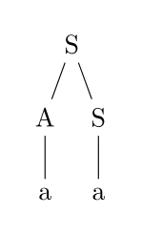](https://i.stack.imgur.com/YTd7u.png)

However, consider now the grammar

S→SS|aS→SS|a

Generating the same language.

There are now two "really" different derivations for aaa:

S→SS→Sa→SSa→Saa→aaaS→SS→Sa→SSa→Saa→aaa

S→SS→aS→aSS→aaS→aaaS→SS→aS→aSS→aaS→aaa

In the first derivation, the first two a's are derived together, whereas in the second derivation, it is the second two a's which are derived together. So it's (aa)a vs. a(aa).

[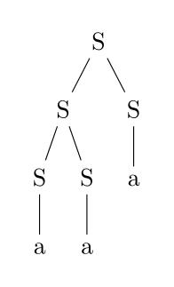](https://i.stack.imgur.com/w2JMp.png)

[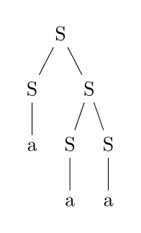](https://i.stack.imgur.com/gaRGb.png)

In this case, the language a+ has an unambiguous grammar, but in other cases, all grammars are ambiguous; such languages are called *inherently ambiguous*.

**b) Turing Machine**

**Answer:-** A Turing machine is an [abstract machine](https://en.wikipedia.org/wiki/Abstract_machine) that manipulates symbols on a strip of tape according to a table of rules; to be more exact, it is a [mathematical model of computation](https://en.wikipedia.org/wiki/Mathematical_model_of_computation) that defines such a device. Despite the model's simplicity, given any [computer algorithm](https://en.wikipedia.org/wiki/Computer_algorithm), a Turing machine can be constructed that is capable of simulating that algorithm's logic.

The machine operates on an infinite memory tape divided into [discrete](https://en.wikipedia.org/wiki/Discrete_mathematics) *cells*. The machine positions its *head* over a cell and "reads" (scans) the symbol there. Then, as per the symbol and its present place in a *finite table*[[7]](https://en.wikipedia.org/wiki/Turing_machine#cite_note-7) of user-specified instructions, the machine (i) writes a symbol (e.g. a digit or a letter from a finite alphabet) in the cell (some models allowing symbol erasure and/or no writing), then (ii) either moves the tape one cell left or right (some models allow no motion, some models move the head), then (iii) (as determined by the observed symbol and the machine's place in the table) either proceeds to a subsequent instruction or halts[[10]](https://en.wikipedia.org/wiki/Turing_machine#cite_note-10) the computation.

The Turing machine was invented in 1936 by [Alan Turing](https://en.wikipedia.org/wiki/Alan_Turing), who called it an *a-machine* (automatic machine). With this model, Turing was able to answer two questions in the negative: (1) Does a machine exists that can determine whether any arbitrary machine on its tape is "circular" (e.g. freezes, or fails to continue its computational task); similarly, (2) does a machine exist that can determine whether any arbitrary machine on its tape ever prints a given symbol. Thus by providing a mathematical description of a very simple device capable of arbitrary computations, he was able to prove properties of computation in general—and in particular, the [incompatibility](https://en.wikipedia.org/wiki/Computability) of the [Entscheidungsproblem](https://en.wikipedia.org/wiki/Entscheidungsproblem" \o "Entscheidungsproblem) ("decision problem").

Thus, Turing machines prove fundamental limitations on the power of mechanical computation. While they can express arbitrary computations, their minimalistic design makes them unsuitable for computation in practice: real-world [computers](https://en.wikipedia.org/wiki/Computer) are based on different designs that, unlike Turing machines, use [random-access memory](https://en.wikipedia.org/wiki/Random-access_memory).

[Turing completeness](https://en.wikipedia.org/wiki/Turing_completeness) is the ability for a system of instructions to simulate a Turing machine. A programming language that is Turing complete is theoretically capable of expressing all tasks accomplishable by computers; nearly all programming languages are Turing complete if the limitations of finite memory are ignored.

**Q.5 Distinguish between Mealy and Moore machine.**

**Answer:-**

**Moore Machines:** Moore machines are finite state machines with output value and its output depends only on present state. It can be defined as (Q, q0, ∑, O, δ, λ) where:

Q is finite set of states.

q0 is the initial state.

∑ is the input alphabet.

O is the output alphabet.

δ is transition function which maps Q×∑ → Q.

λ is the output function which maps Q → O.

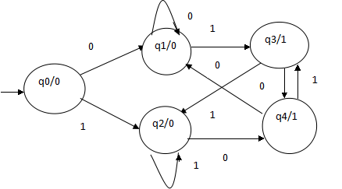

In the moore machine shown in Figure 1, the output is represented with each input state separated by /. The length of output for a moore machine is greater than input by 1.

* **Input:**11
* **Transition:** δ (q0,11)=> δ(q2,1)=>q2
* **Output:**000 (0 for q0, 0 for q2 and again 0 for q2)

**Mealy Machines:** Mealy machines are also finite state machines with output value & its output depends on present state and current input symbol.

It can be defined as (Q, q0, ∑, O, δ, λ’) where:

* Q is finite set of states.
* q0 is the initial state.
* **∑**is the input alphabet.
* O is the output alphabet.
* δ is transition function which maps Q×**∑**→ Q.
* ‘λ’ is the output function which maps Q×**∑**→ O.

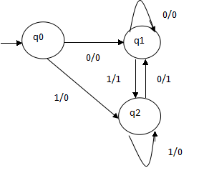

In the mealy machine shown in Figure 1, the output is represented with each input symbol for each state separated by /. The length of output for a mealy machine is equal to the length of input.

* Input:11
* Transition: δ (q0,11)=> δ(q2,1)=>q2
* Output: 00 (q0 to q2 transition has Output 0 and q2 to q2 transition also has Output 0)

***Section B***

QUESTION 1

**a): Describe all the relationships seen in this Venn diagram:**

**Sol 1 a):**

The red portion of this picture shows the relation of A∪B

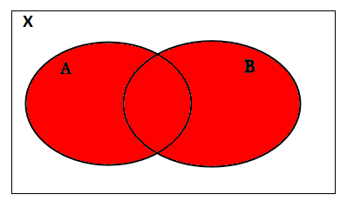

Fig: A∪B

The red portion of the picture bellow indicate the relation of A∩B

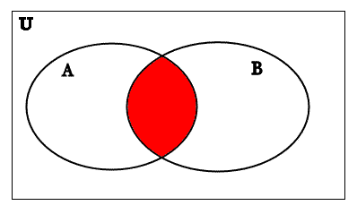

Fig: A∩B

The blue portion of the picture bellow represents the relation of A

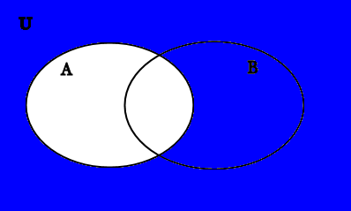

Fig: A′

The red portion of the picture bellow represents B′

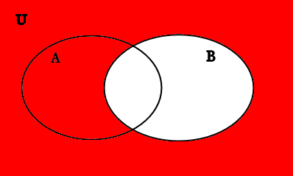

Fig: B′

**Ques 1 b): Draw the Venn diagram for AB= Ø.**

**Sol 1b):**

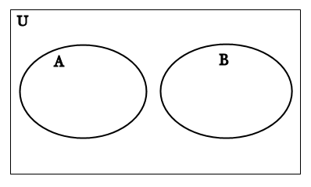

**Que 1 c): Draw a Venn diagram to prove the third subset theorem: If A, B, C are sets with**

** and  then  .**

**Sol 1c:**

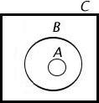

Fig: Proved of subset theorem

QUESTION 2

**Q2 a): Prove that following two statements are contradictions.**

**    **

**Solution 2a):**

Contradiction: A contradictions is a formula which is "always false";

(i): 

|  |  |  |  |  |  |  |
| --- | --- | --- | --- | --- | --- | --- |
| P | Q | ~p | ~q | ~p ^ ~q | p or q |  |
| T | T | F | F | F | T | F |
| T | F | F | T | F | T | F |
| F | T | T | F | F | T | F |
| F | F | T | T | T | F | F |

Since Last Column contains only F’s. So it is contradiction.

**(ii): **

|  |  |  |  |  |  |  |
| --- | --- | --- | --- | --- | --- | --- |
| P | q | ~p | ~q | P ^ ~q | ~p v q |  |
| T | T | F | F | F | T | F |
| T | F | F | T | T | F | F |
| F | T | T | F | F | T | F |
| F | F | T | T | F | T | F |

Since Last Column contains only F’s. So it is contradiction.

**Q2 b): Prove that following are the equivalent statements.**

** p **

**Solution 2b):**

Two statements X and Y are **logically equivalent** if $X \iff Y$ is a tautology.

A **tautology** is a formula which is "always true".

(i): p

|  |  |  |  |  |  |  |  |  |
| --- | --- | --- | --- | --- | --- | --- | --- | --- |
| p | q | r | q v r | p 🡪(qvr) | p 🡪q | p 🡪 r | (p 🡪q)v(p 🡪 r) | p |
| T | T | T | T | T | T | T | T | T |
| T | T | F | T | T | T | F | T | T |
| T | F | T | T | T | F | T | T | T |
| T | F | F | F | F | F | F | F | T |
| F | T | T | T | T | T | T | T | T |
| F | T | F | T | T | T | T | T | T |
| F | F | T | T | T | T | T | T | T |
| F | F | F | F | T | T | T | T | T |

Since Last Column contains only T’s. So it is Tautology.

Hence the statement is equivalent statements.

**(ii): **

|  |  |  |  |  |  |  |  |
| --- | --- | --- | --- | --- | --- | --- | --- |
| p | q | ~p | ~q | p v q | ~(p v q) | (~p ^ ~q) |  |
| T | T | F | F | T | F | F | T |
| T | F | F | T | T | F | F | T |
| F | T | T | F | T | F | F | T |
| F | F | T | T | F | T | T | T |

Since Last Column contains only T’s. So it is Tautology.

Hence the statement is equivalent statements.

**QUESTION 3**

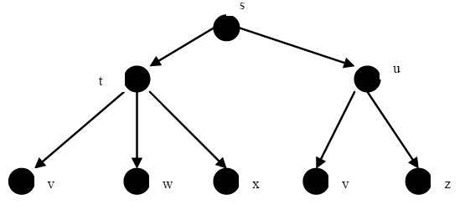

**Solution:-**

**Section C- Multiple Choice Questions**

QUESTION 1

f(x)= (x³/4)+2x² -6x .find f(-2)

1. **18**
2. -18
3. 4
4. -4

QUESTION 2

y=3x^3 +7x^5; then dy/dx at x =7 is

1. 84467
2. **84476**
3. 84477
4. 84478

QUESTION 3

If the order of matrix A is m * p. And the order of B is p*n. Then the order of AB is?

1. **m*n**
2. m*p
3. n*m
4. p*n

QUESTION 4

The number of non-zero rows in an echelon form is called?

1. **reduced echelon form**
2. rank of a matrix
3. conjugate of the matrix
4. cofactor of the matrix

QUESTION 5

Find limx $\int{8 ( 5x + sin x ) /x}$

1. 5
2. **5+sinx**
3. 5/x
4. sinx/x

QUESTION 6

"The smallest set A such that A? {1, 2} = {1, 2, 3, 5, 9} is"

1. "{2,3,5}"
2. **"{3,5,9}"**
3. "{1,2,3,5,9}"
4. None of these

QUESTION 7

A set consisting of a definite number of elements is called a?

1. **Finite set**
2. Infinite set
3. Null Set
4. Singleton set

QUESTION 8

"The number of proper subsets of the set {1, 2, 3} is"

1. 8
2. **9**
3. 6
4. 7

QUESTION 9

Two finite sets have n and m elements. The number of elements in the power set of first set is 48 more than the total number of elements in power set of the second set. Then the values of m and n are

1. **6 and 4**
2. 7 and 4
3. 8 and 6
4. 7and 6

QUESTION 10

Find dy/dx of x^2+e^x+2x when x=3

1. 3+e^3
2. 5+e^3
3. 9+e^3
4. **8+e^3**

QUESTION 11

When we find maxima or minima then derivative of first order is equal to

1. 1
2. -1
3. **0**
4. Cannot say

QUESTION 12

"If n (A) = 115, n (B) = 326, n (A-B) = 47, then n (A U B) is equal to"

1. 370
2. **373**
3. 441
4. none of these

QUESTION 13

Every set is a ___________ of itself

1. Proper subset
2. Compliment
3. Improper set
4. **none of these**

QUESTION 14

integrate x^5 dx=

1. 5x^4 +c
2. **[x^6/6]+c**
3. x^6
4. x^4+c

QUESTION 15

Integrate cotx dx

1. **log|sinx| +c**
2. log|cotx| +c
3. log|cotx| +c
4. tanx

QUESTION 16

Integrate (x+sinx)/(1+cosx)dx =

1. sinx
2. x cot(x/2) +c
3. **x tan(x/2) +c**
4. cosx

QUESTION 17

Integrate tanx dx

1. **{-log|cosx|+c}**
2. log|sinx|+c
3. log|cotx|+c
4. x cot(x/2)+c

QUESTION 18

dy/dx of x(x-10) is

1. 2x+10
2. **2x-10**
3. x-10
4. 2x

QUESTION 19

Matrix multiplication is

1. commutative
2. **associative**
3. both option i&ii
4. none of these

QUESTION 20

Matrix addition is

1. commutative
2. associative
3. **both option I & ii**
4. none of these

QUESTION 21

A matrix whose inverse exists is known as

1. transpose matrix
2. **invertible matrix**
3. both option i&ii
4. none of these

QUESTION 22

If a and b are two given vectors. Then |a+b| is

1. less than or equal to |a|+|b|
2. **more than or equal to |a|+|b|**
3. equal to |a|+|b|
4. none of these

QUESTION 23

If a and b are two given vectors. Then |a-b| is

1. less than or equal to |a|-|b|
2. more than or equal to |a|-|b|
3. **equal to |a|+|b|**
4. none of these

QUESTION 24

Integrate sin^2(x)dx=

1. (x/2)+1/8(sin4x)+c
2. (x/2)+1/8(sin2x)+c
3. **(x/2)-1/4(sin2x)+c**
4. none of these

QUESTION 25

Integrate cos^2(2x)dx=

1. **(x/2)+1/8(sin4x)+c**
2. (x/2)+1/8(sin2x)+c
3. (x/2)-1/4(sin2x)+c
4. none of these

QUESTION 26

Integrate sec x dx =

1. log|sinx|+c
2. **log|secx+tanx|+c**
3. (x/2)-1/4(sin2x)+c
4. none of these

QUESTION 27

Integrate cosec x dx =

1. log|sinx|+c
2. log|secx+tanx|+c
3. **log|cosec x-cotx|+c**
4. none of these

QUESTION 28

A matrix in which number of rows equal to the number of columns is known as

1. Column matrix
2. **Square matrix**
3. Row matrix
4. Scalene matrix

QUESTION 29

"The solution of the equations 3x + y + 2z = 3 , 2x 3y z = 3, x + 2y + z = 4 by Matrix method is"

1. "x = 1, y = 2, z = 1"
2. "x = 1, y = 2, z = 1"
3. **"x = 1, y = 2, z = 1"**
4. "x = 1, y = 2, z = 1"

QUESTION 30

A__________ is a diagonal matrix whose elements in the diagonal are all ones.

1. null matrix
2. unit matrix
3. **diagonal matrix**
4. rectangular matrix

QUESTION 31

The order of the matrix [4 7 3] is__________

1. 3 *3
2. **1*3**
3. 3*1
4. 1*1

QUESTION 32

Find the second derivative of y = x-2 at x = 2

1. 0.375
2. **0.367**
3. 0.96
4. -0.25

QUESTION 33

Find the partial derivatives with respect to x of the function: xy^2 -5y + 6

1. **y2**
2. y2 -5
3. xy-5
4. 2xy

QUESTION 34

f(x)= x+1 and g(x) =2x+3 then fog(x) =

1. 2x+3
2. 2x+5
3. **2x+4**
4. 2x+1

QUESTION 35

f(x)= x+1 and g(x) =2x+3 then gof(x) =

1. **2x+3**
2. 2x+5
3. 2x+4
4. 2x+1

QUESTION 36

Find lim x?8 [ 1 + a/ x ] ^x

1. a^e
2. e^a
3. a^x
4. **x^a**

QUESTION 37

x(dy/dx)+3/(dy/dx)=y^2. Find order and degree

1. **"order=1, degree=2"**
2. "order=2, degree=2"
3. "order=2, degree=1"
4. "order=1, degree=1"

QUESTION 38

Gauss elimination method is used

1. **to solve the system of equations**
2. to make the equations
3. to find determinant value
4. none of these

QUESTION 39

Matrix equations solution is given by

1. **Cramer's rule**
2. Gauss elimination method
3. matrix inverse method
4. all of these

QUESTION 40

What is the first derivative dy/dx of the expression (xy)x = e?

1. y(1+ lnxy)/x
2. **0**
3. y(1 lnxy) / x2
4. y/x