CS 610
Midterm Exam
Due: Monday 11/05/2018, 6:00 P.M.
No delay is accepted whatsoever. After the due date I grade the test for 0
Copy/paste your Java classes to this document and drop it into the folder Midterm Exam on blackboard.
Do not delete anything from this file. Just copy/paste your java classes under the word: Answer in this document.
I cannot answer the questions to help you, but if you like to clarify anything about the questions email me at mbadii@pace.edu. In this case let me know which part of a question is not clear for you.
Each question is for 25 points.

Question 1 (Threads): Complete the following program to:
1. Divide array: arr into the number of threads equal segments.
2. Create a number of threads. The number of threads is a random integer in the range 4 to 12.
3. Each thread finds the biggest number.
4. The method: main takes the biggest number of each thread and displays.
5. The method: main displays the biggest of the biggest number that gets from the threads.

import java.util.Random;

public class Main {
public static void main(String[] args) throws InterruptedException {
Random r = new Random(System.currentTimeMillis());
int n = 400;
int numberOfThreads = Math.abs(r.nextInt())%10 + 4; //Number of threads
while(n%numberOfThreads != 0)
n++; //To make n divisible by numberOfThreads
int[] arr = new int[n];
for(int i = 0; i < n; i++)
arr[i] = r.nextInt();
int segment = arr.length/numberOfThreads;
//The following for-loop is here to search the entire array and finds the
//biggest number. Your answer with using threads should be the same.
int biggest = arr[0];
for(int i = 1; i < n; i++)
if(biggest < arr[i])
biggest = arr[i];
System.out.println("The biggest number of the entire array before creating threads is: " + biggest);
//You must write a for-loop to create threads. Then write a second for-loop to
//start the threads. Complete this part
//………………….

System.out.println("The biggest number of these " + numberOfThreads +
" threads is: " + biggest);
}
}

public class MyThread extends Thread
{
//Complete this class and the method run

public void run()
{
}
}

Example 1:
The biggest number of the entire array before creating threads is: 2123886777
The biggest number of these 8 threads is: 2123886777

Example 2:
The biggest number of the entire array before creating threads is: 2139516065
The biggest number of these 5 threads is: 2139516065

Answer:
import java.util.Random;

public class Main {

public static void main(String[] args) throws InterruptedException {
Random r = new Random(System.currentTimeMillis());
int n = 400;
int numberOfThreads = Math.abs(r.nextInt())%10 + 4; //Number of threads
while(n%numberOfThreads != 0) {
n++;
}
int[] arr = new int[n];

for(int i = 0; i < n; i++) {
arr[i] = r.nextInt();
}

int segment = arr.length/numberOfThreads;
//The following for-loop is here to search the entire array and finds the
//biggest number. Your answer with using threads should be the same.
int biggest = arr[0];
for(int i = 1; i < n; i++) {
if(biggest < arr[i])
biggest = arr[i];
}
System.out.println("The biggest number of the entire array before creating threads is: " + biggest);
//You must write a for-loop to create threads. Then write a second for-loop to
//start the threads. Complete this part
//………………….
// start with partitioning the arr
int c = 0;
int[][] partition = new int[numberOfThreads][segment];

for(int row = 0; row < numberOfThreads; row++) {
for(int col = 0; col < segment; col++) {
partition[row][col] = arr[c];
c++;
}
}

MyThread[] threadArr = new MyThread[numberOfThreads];
for(int i = 0; i < numberOfThreads;i++) {
threadArr[i] = new MyThread(partition[i]);
threadArr[i].start();
}
for (MyThread myThread : threadArr) {
myThread.join();
}
int tBiggest = 0;
for (MyThread myThread : threadArr) {
if(myThread.biggestFromThread > tBiggest) tBiggest = myThread.biggestFromThread;
}

System.out.println("The biggest number of these " + numberOfThreads +
" threads is: " + tBiggest);
}

}

public class MyThread extends Thread{
private int[] segment;
public int biggestFromThread;
public MyThread(int[] segment) {
this.segment = segment;
}
public void run() {
int biggest = 0;
for (int i : segment) {
if( i > biggest) biggest = i;
}
biggestFromThread = biggest;
}
}

Question 2 (Sockets and applets): Complete the following client-server program using sockets to do the following:
a) On the server side:
- The program prompts the user to enter word: blue, green, or any other word.
- Then the program prompts the user to enter a message.
- The server program sends the color and the message to the client.
b) The client program must be an applet. On the client side when the program receives the message from the server:
- If the color is blue the program sets the background color of the applet to blue and writes the message on the applet.
- If the color is green the program sets the background color of the applet to green and writes the message on the applet.
- If the color is neither blue nor green the program does not change the color of the background and writes the message on the applet.

Server Side:

import java.io.*;
import java.net.*;
import java.util.Scanner;

public class MyServer {
public static void main(String[] args){
//Complete this method.
ServerSocket serverSocket = null;
Scanner keyboard = new Scanner(System.in);
try {
serverSocket = new ServerSocket(16790);
Socket clientSocket = null;
clientSocket = serverSocket.accept();
System.out.print("Enter 1, or 2: ");
int n = keyboard.nextInt();
PrintWriter out = new PrintWriter(clientSocket.getOutputStream(), true);
out.println("" + n);
out.close();
clientSocket.close();
serverSocket.close();
} catch (IOException e) {
System.out.println("Error: " + e);
System.exit(0);
}
}
}

Client Side:

import java.applet.Applet;
import java.awt.*;
import java.io.*;
import java.net.*;

public class MyClient extends Applet {
private int s;

public void init(){
//Complete this method.
setSize(400, 400);
try{
InetAddress host = InetAddress.getByName("localhost");
Socket clientSocket = new Socket(host, 16790);

//You may need to call the method: repaint();

}catch(Exception e){
System.out.println("Error: " + e);
System.exit(0);
}
}

public void paint(Graphics page){
//Complete this method.

}
}

Example 1:

Server Console:

Server is ready
Enter blue/ green for a color: blue
Enter a message: Hello World

Client applet:

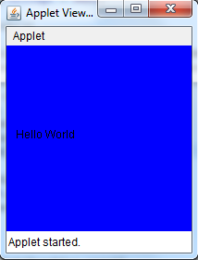

Example 2:

Server Console:

Server is ready
Enter blue/ green for a color: green
Enter a message: Hello World

Client applet:

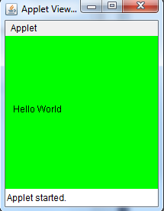

Example 3:

Server Console:

Server is ready
Enter blue/ green for a color: xyzt
Enter a message: Hello World

Client applet:

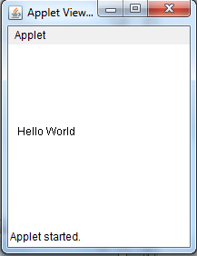

Complete the following programs:

Answer:

Server Side:
import java.io.*;
import java.net.*;
import java.util.Scanner;

public class MyServer {
public static void main(String[] args){

ServerSocket serverSocket = null;
Scanner keyboard = new Scanner(System.in);
try {
serverSocket = new ServerSocket(16790);

Socket clientSocket = null;
System.out.println("Server is ready");
clientSocket = serverSocket.accept();

PrintWriter out = new PrintWriter(clientSocket.getOutputStream(), true);
System.out.print("Enter a color blue or green:");

String a = keyboard.nextLine();
out.println(a);

System.out.print("Enter a message:");
String b = keyboard.nextLine();
out.println(b);

out.close();
clientSocket.close();
serverSocket.close();
} catch (IOException e) {
System.out.println("Error: " + e);
System.exit(0);
}
}
}

Client Side:
import java.applet.Applet;
import java.awt.*;
import java.io.*;
import java.net.*;

public class MyClient extends Applet {

private String color;
private String message;

public void init(){
setSize(400, 400);
try{
InetAddress host = InetAddress.getByName("localhost");
Socket clientSocket = new Socket(host, 16790);

BufferedReader in = new BufferedReader(new InputStreamReader(clientSocket.getInputStream()));
color = in.readLine();

if (color.equalsIgnoreCase("blue")) {
setBackground(Color.BLUE);
}
else if (color.equalsIgnoreCase("green")) {
setBackground(Color.GREEN);
}

message = in.readLine();

}catch(Exception e){
//System.out.println("Error: " + e);
e.printStackTrace();
System.exit(0);
}
}

public void paint(Graphics page){

page.drawString(message, 20, 200);
}
}

Question 3 (RMI): Using RMI, write an application for a prototype opinion poll system. Assume that only one issue is being polled. Respondents may choose yes, or no. Write a client-server application to accept the votes, keep the tally (in memory), and provide the current counts to those who are interested.
Note: Copy/paste the classes: (all java files) under the word: Answer.
Note: This question is a shorten version of exercise: 9 on page 230 of your book.
Note: You do not need to make a number of client programs. Make one server and one client programs. Keep the server running and run the client several times. For example, I run the client three times as follows:
Enter port: What is your vote?[yes|no] : yes
Yes = 1; No = 0
Enter port: What is your vote?[yes|no] : no
Yes = 1; No = 1
Enter port: What is your vote?[yes|no] : no
Yes = 1; No = 2
Server Side:
import java.rmi.Remote;
public interface VoteInterface extends Remote{
//This interface is complete. Do not change it.
public String castVote(char vote )throws java.rmi.RemoteException;
}

import java.rmi.*;
import java.rmi.server.*;

public class VoteServerImpl extends UnicastRemoteObject implements VoteInterface {
//Complete this method.
}

import java.rmi.*;
import java.rmi.server.*;
import java.rmi.registry.Registry;
import java.rmi.registry.LocateRegistry;
import java.net.*;

public class MyServer{
public static void main(String args[]){
//Complete this method.
}
}
Client Side:
import java.rmi.Remote;
public interface VoteInterface extends Remote{
//This interface is complete. Do not change it.
public String castVote(char vote )throws java.rmi.RemoteException;
}

import java.rmi.*;
import java.util.*;

public class MyClient{
public static void main(String args[]){
//Complete this method.
}
}
Answer:
Client Side:
import java.rmi.*;
import java.util.*;
import java.util.Scanner;

public class MyClient {

public static void main(String[] args) {
// TODO Auto-generated method stub
try {
Scanner keyb = new Scanner(System.in);
int port = 1337;
String host = "localhost";
String registryUrl = "rmi://" + host + ":" + port + "/voting";
VoteInterface voteSystem = (VoteInterface)Naming.lookup(registryUrl);
System.out.println("Lookup completed");

System.out.print("Enter port: What is your vote?[Yes][No] : ");
String vote = keyb.nextLine();
if(vote.equalsIgnoreCase("Yes")||vote.equalsIgnoreCase("No"))
System.out.println(voteSystem.castVote(vote.charAt(0)));
else
System.out.print(voteSystem.castVote('x'));
//Close the scanner
keyb.close();
} catch (Exception e) {
// TODO: handle exception
e.printStackTrace();
}

}

}
import java.rmi.Remote;
import java.rmi.RemoteException;
public interface VoteInterface extends Remote{
public String castVote(char vote) throws RemoteException;
}

Server Side:
import java.rmi.*;
import java.rmi.server.*;
import java.rmi.registry.Registry;
import java.rmi.registry.LocateRegistry;
import java.net.*;

public class MyServer {

public static void main(String[] args) {
// TODO Auto-generated method stub
try {
int port = 1337;
String host = "localhost";
VoteServerImpl voteServerImpl = new VoteServerImpl();
LocateRegistry.createRegistry(port);
String registryUrl = "rmi://" + host + ":" + port + "/voting";
Naming.rebind(registryUrl, voteServerImpl);
System.out.println("Server is ready for connection");

} catch (Exception e) {
// TODO: handle exception
e.printStackTrace();
}

}

}
import java.rmi.RemoteException;
import java.rmi.*;
import java.rmi.server.*;

public class VoteServerImpl extends UnicastRemoteObject implements VoteInterface {
public int yesVotes = 0;
public int noVotes = 0;

protected VoteServerImpl() throws RemoteException {
super();
// TODO Auto-generated constructor stub

}
/**
*
*/
private static final long serialVersionUID = 1L;

@Override
public synchronized String castVote(char vote) throws RemoteException{
// TODO Auto-generated method stub
if(vote == 'Y' || vote == 'y') {
yesVotes += 1;
return "Yes = " + yesVotes + "; No = " + noVotes;
}
else if (vote == 'N' || vote == 'n') {
noVotes+=1;
return "Yes = " + yesVotes + "; No = " + noVotes;
}
else return "You have not entered the vote statement correctly. Please use [Yes][No] only";
}

}
import java.rmi.Remote;
public interface VoteInterface extends Remote{
public String castVote(char vote) throws java.rmi.RemoteException;
}

Question 4 (Servlet): Use cookies (and not MySQL) to accomplish the following:
1. Make a folder in drive C named: Temp.
2. Copy the following line to notepad editor (or any other text editor) and save the editor with file name: names.txt in the folder Temp (On each line there are two words separated by a single space):

Jane Doe
John Doe
Adam Smith
Ann Smith
Joe Bean
Mike Smith
Sara Doe
Rose Nigel
William Smith
David Depaoli
Thomas Iacovelli
Dominick Olsen
Danielle Williams
George Perez
Elaine Silva
Angela Dawnell

3. Make a servlet named: AddCookies and copy the following over it.

import java.io.File;
import java.io.IOException;
import java.util.Scanner;

import javax.servlet.ServletException;
import javax.servlet.annotation.WebServlet;
import javax.servlet.http.Cookie;
import javax.servlet.http.HttpServlet;
import javax.servlet.http.HttpServletRequest;
import javax.servlet.http.HttpServletResponse;

@WebServlet("/AddCookies")
public class AddCookies extends HttpServlet {
private static final long serialVersionUID = 1L;
//This servlet is complete. Do not change it.
public AddCookies() {
super();
}

protected void doGet(HttpServletRequest request, HttpServletResponse response)
throws ServletException, IOException {
addCookies(response);
System.out.println("The program terminated with no error.");
}

private void addCookies(HttpServletResponse response){
Scanner inputStream = null;
try{
inputStream = new Scanner(new File("C:\\Temp\\names.txt"));
while(true){
String name = inputStream.next();
String value = inputStream.next();
Cookie c = new Cookie(name, value);
c.setMaxAge(365 * 24*60*60);
response.addCookie(c);
}
}catch(Exception e){
}
inputStream.close();
}
}

4. Load XAMPP and start: Apache.

5. Run the servlet: AddCookies. This servlet reads the file: names.txt one lien at a time to make cookies. The servlet makes a cookie for each line. On each line there are two words. The first word would be the name of the cookie and the second word would be the value of the cookie.

6. Make an html document and copy following over it. Do not change this html document:

<html>
<head>
<meta http-equiv="Content-Type" content="text/html; charset=ISO-8859-1">
<title>Q 4</title>
</head>
<body>
<form action="http://localhost:8080/Project/Main">
<center>
<pre>
User Name:<input name="name" type="text" value=""><br>
Password: <input name="password" type="text" value=""><br><br>
Changing Password<br>
New Password: <input name="newPassword" type="text" value=""><br>
Re enter The New Password:<input name="reEnterPassword" type="text" value=""><br>
<input name="changePassword" type="Submit" value="Change the Password">
</pre>
</center>
</form>
</body>
</html>

7. Make a servlet named: Main and copy the following over it:

/*
1. If we make a cookie with a name and password and make a
second cookie with the same name and different password IE
replaces the first one.
2. For the sake of simplicity assume the user enters strings in all
the input boxes.
*/
import java.io.*;
import javax.servlet.ServletException;
import javax.servlet.annotation.WebServlet;
import javax.servlet.http.HttpServletRequest;
import javax.servlet.http.HttpServletResponse;
import javax.servlet.http.Cookie;
import java.util.Scanner;

@WebServlet("/Main")
public class Main extends javax.servlet.http.HttpServlet implements javax.servlet.Servlet {
private String head, tail;
public Main() {
super();
head = "<html><title>Not In The List</title><body><font color = blue><h1>";
tail = "</h1></font></body></html>";
}

protected void doGet(HttpServletRequest request, HttpServletResponse response)
throws ServletException, IOException {
//This method is complete. Do not change it.
String userName = request.getParameter("name");
String password = request.getParameter("password");
String newPassword = request.getParameter("newPassword");
String reEnteredPassword = request.getParameter("reEnterPassword");
displayCookies(request);
if(isIn(request, userName, password))
if(isTheSame(newPassword, reEnteredPassword))
replace(request, response, userName, password, newPassword);
else
isNotTheSame(response, newPassword, reEnteredPassword);
else
isNotInTheList(response, userName, password);
displayCookies(request);
}

private boolean isIn(HttpServletRequest request, String userName, String password){
//Complete this method.
//Check the cookies. If one of them has the name: userName and the value: password
//return false
return false; //Once this method is complete remove this line.
}

private boolean isTheSame(String newPassword, String reEnteredPassword){
//Complete this method
//Make sure the user entered the same new password twice. If both newPassword and
//reEnteredPassword have the same string return true otherwise return false.
return false; //Once this method is complete remove this line.
}

private void replace(HttpServletRequest request, HttpServletResponse response,
String userName, String password, String newPassword){
//Complete this method
// This is the case that the program is sure there is a cookie with the name:
// username and the value: password. Replace the value of this cookie by the
// value of: newPassword.

}

private void isNotInTheList(HttpServletResponse response, String userName, String password){
//Complete this method.
//Make an html document to display the content of the console.

System.out.println(userName + " with the password: " + password + " is not in the list");
}

private void isNotTheSame(HttpServletResponse response, String newPassword,
String reEnteredPassword){
//Complete this method.
//Make an html document to display the content of the console.

System.out.println(newPassword + " must be the same as " + reEnteredPassword);
}

private void success(HttpServletResponse response){
//Complete this method.
//Make an html document to display the content of the console.

System.out.println("The password is changed successfully.");
}

private void displayCookies(HttpServletRequest request){
//This method is complete. Do not change it.
Cookie[] cookies = request.getCookies();
if (cookies != null && cookies.length > 0)
for(int i=0; i<cookies.length; i++)
System.out.println(cookies[i].getName() + ", " + cookies[i].getValue());
System.out.println("********************************************************");
}
}

Example 1:

User enters a user name and password that has no cookie:

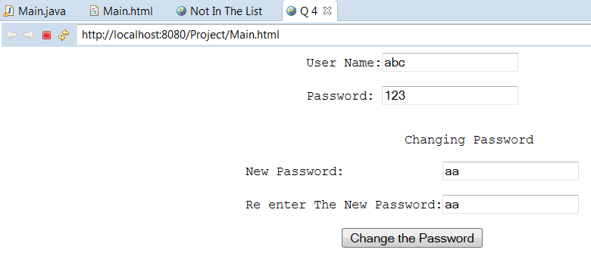

The response would be:

Example 2: The new password and reentered password are not the same:

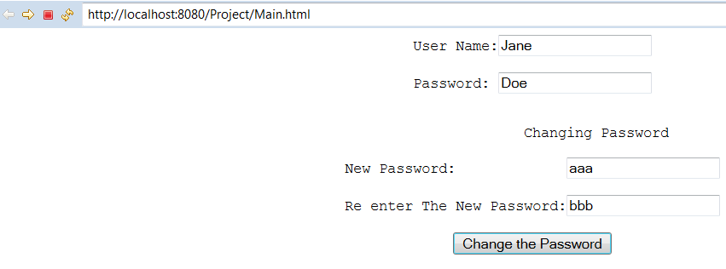
The response would be:

Example 3: The user name and password has a cookie and want to change the password:

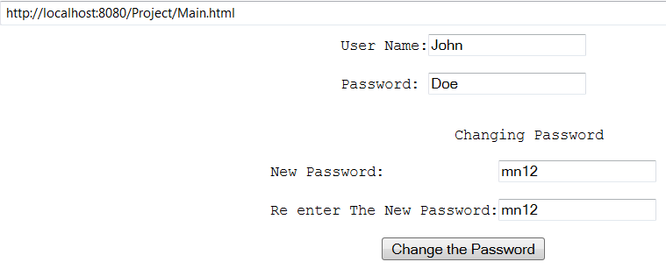

The response would be:

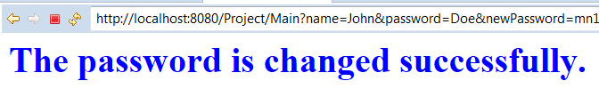

Answer
Only copy the class: Main.java

/*
1. If we make a cookie with a name and password and make a
second cookie with the same name and different password IE
replaces the first one.
2. For the sake of simplicity assume the user enters strings in all
the input boxes.
*/
import java.io.*;
import javax.servlet.ServletException;
import javax.servlet.annotation.WebServlet;
import javax.servlet.http.HttpServletRequest;
import javax.servlet.http.HttpServletResponse;
import javax.servlet.http.Cookie;
import java.util.Scanner;

@WebServlet("/Main")
public class Main extends javax.servlet.http.HttpServlet implements javax.servlet.Servlet {
private String head, tail;
public Main() {
super();
head = "<html><title>Not In The List</title><body><font color = blue><h1>";
tail = "</h1></font></body></html>";
}

protected void doGet(HttpServletRequest request, HttpServletResponse response)
throws ServletException, IOException {
//This method is complete. Do not change it.
String userName = request.getParameter("name");
String password = request.getParameter("password");
String newPassword = request.getParameter("newPassword");
String reEnteredPassword = request.getParameter("reEnterPassword");
displayCookies(request);
if(isIn(request, userName, password))
if(isTheSame(newPassword, reEnteredPassword))
replace(request, response, userName, password, newPassword);
else
isNotTheSame(response, newPassword, reEnteredPassword);
else
isNotInTheList(response, userName, password);
displayCookies(request);
}

private boolean isIn(HttpServletRequest request, String userName, String password){
//Complete this method.
//Check the cookies. If one of them has the name: userName and the value: password
//return false
// I have the PASSWORD comparison CASE sensitive
// the USERNAME is not CASE SENSITIVE
for (Cookie cookie : request.getCookies()) {
String cookieName = cookie.getName();
String cookieValue = cookie.getValue();
if(cookieName.compareToIgnoreCase(userName)==0 && cookieValue.compareTo(password)==0) {
//System.out.println(cookieName + cookieValue);
return true;
}
}

return false; //Once this method is complete remove this line.
}

private boolean isTheSame(String newPassword, String reEnteredPassword){
//Complete this method
//Make sure the user entered the same new password twice. If both newPassword and
//reEnteredPassword have the same string return true otherwise return false.
if(newPassword.compareTo(reEnteredPassword)==0 && newPassword!="" && reEnteredPassword!="") {
return true;
}
return false; //Once this method is complete remove this line.
}

private void replace(HttpServletRequest request, HttpServletResponse response,
String userName, String password, String newPassword) throws IOException{
//Complete this method
// This is the case that the program is sure there is a cookie with the name:
// username and the value: password. Replace the value of this cookie by the
// value of: newPassword.
for (Cookie cookie : request.getCookies()) {
if(cookie.getName().compareToIgnoreCase(userName)==0) {
if(cookie.getValue().compareTo(password)==0) {
cookie.setValue(newPassword);
cookie.setMaxAge(365 * 24*60*60);
response.addCookie(cookie);
success(response);
}
}
}

}

private void isNotInTheList(HttpServletResponse response, String userName, String password) throws IOException{
//Complete this method.
//Make an html document to display the content of the console.
String message =userName + " with the password: " + password + " is not in the list";
PrintWriter out = response.getWriter();
out.println("<html><title>Hello</title><body>\n");
out.println("<font color = blue>");
out.println("<h1>"+message+"</h1>\n");
out.println("</font>");
out.println("</body></html>");
out.close();
System.out.println(userName + " with the password: " + password + " is not in the list");
}

private void isNotTheSame(HttpServletResponse response, String newPassword,
String reEnteredPassword) throws IOException{
//Complete this method.
//Make an html document to display the content of the console.
String message =newPassword + " must be the same as " + reEnteredPassword;
if(newPassword=="" && reEnteredPassword=="")
message = "You can't have an empty password";
PrintWriter out = response.getWriter();
out.println("<html><title>Hello</title><body>\n");
out.println("<font color = blue>");
out.println("<h1>"+message+"</h1>\n");
out.println("</font>");
out.println("</body></html>");
out.close();

System.out.println(newPassword + " must be the same as " + reEnteredPassword);
}

private void success(HttpServletResponse response) throws IOException{
//Complete this method.
//Make an html document to display the content of the console.
String message = "The password is changed successfully.";
PrintWriter out = response.getWriter();
out.println("<html><title>Hello</title><body>\n");
out.println("<font color = blue>");
out.println("<h1>"+message+"</h1>\n");
out.println("</font>");
out.println("</body></html>");
out.close();

System.out.println("The password is changed successfully.");
}

private void displayCookies(HttpServletRequest request){
//This method is complete. Do not change it.
Cookie[] cookies = request.getCookies();
if (cookies != null && cookies.length > 0)
for(int i=0; i<cookies.length; i++)
System.out.println(cookies[i].getName() + ", " + cookies[i].getValue());
System.out.println("********************************************************");
}
}

