**SOP for Deploying Flask Application on Azure Web Apps**

**- Soham Deshmukh**

**Objective:**

This Standard Operating Procedure (SOP) outlines the steps required to deploy a Flask application on Azure Web Apps.

**Flask App Link**: <https://flask-app-triluxo-technologies-private-limited.azurewebsites.net/>

**Github Link** - <https://github.com/som-d/Flask-app>

**Prerequisites:**

1. Azure Account

2. Github Account

3. Git: Install Git on your local machine. You can find installation instructions(<https://git-scm.com/book/en/v2/Getting-Started-Installing-Git>).

**Procedure:**

**1. Application Setup:**

1. **Creating Folder for Flask application code:**

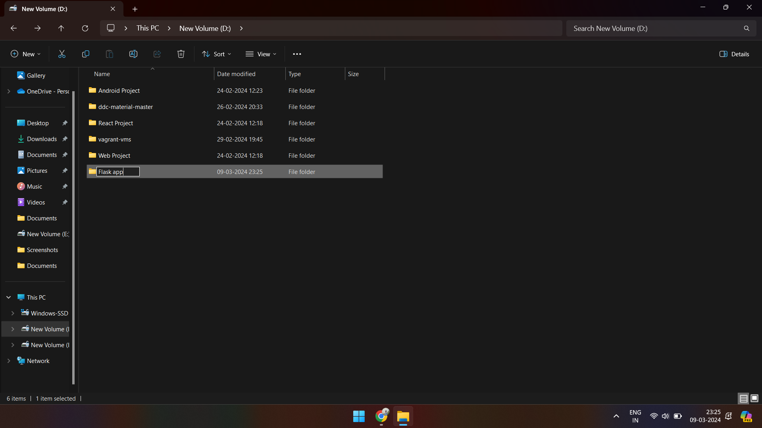

1. **Open the folder and type cmd in search field:**

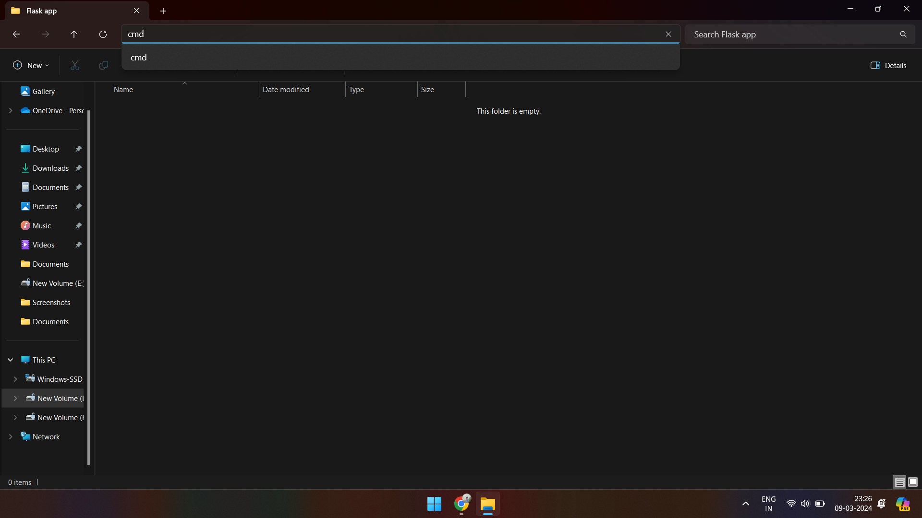

1. **Creating an environment for the Flask app:**

**Command : python -m venv .**

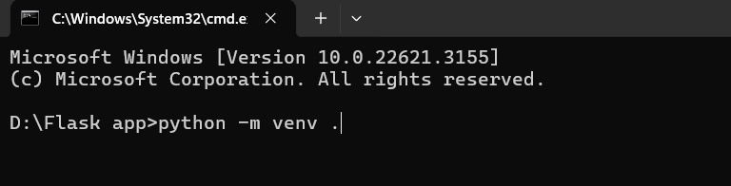

1. **Activating the Virtual Environment:**

**Command : .\scripts\activate**

**Installing Flask : pip install Flask**

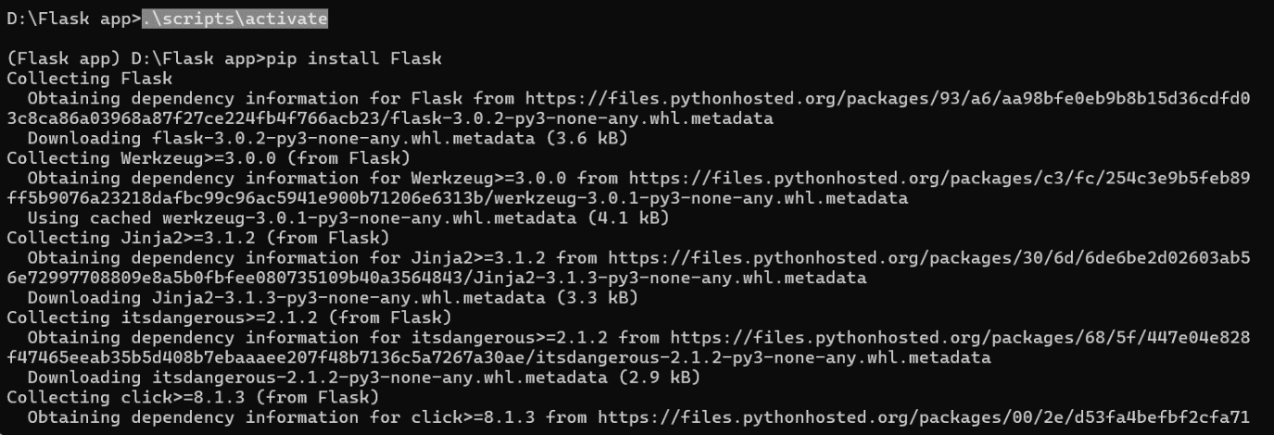

1. **Creating Requirements.txt :**

**Command : pip3 freeze > requirements.txt # Python3**

**pip freeze > requirements.txt # Python2**

Note – in requirement.txt comment/delete: pywin32==306

1. **Creating app.py:**

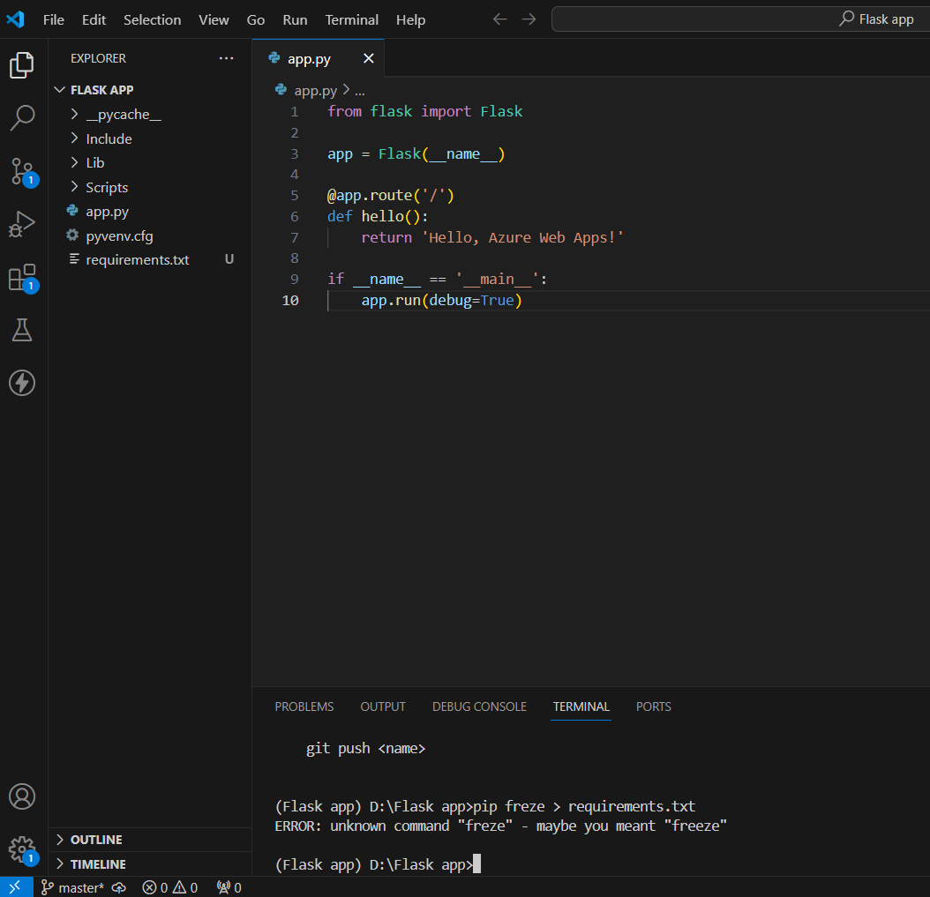

1. **Starting the server:**

**Command : python app.py**

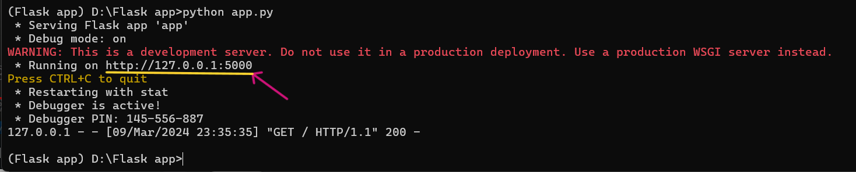

* Copy the URL and past in browser to run Web App.

1. **Flask app loaded on local server:**

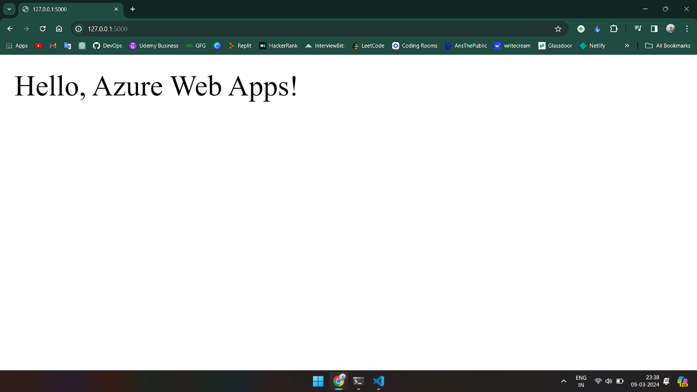

**2. Create Azure Web App:**

Create a new Azure Web App:

1. **Login to Azure and click Create a resource:**

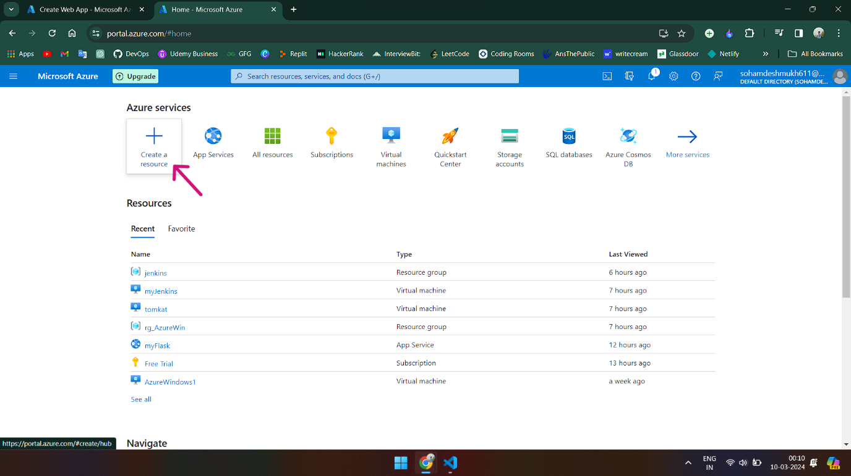

1. **Search for Web App and click Create:**

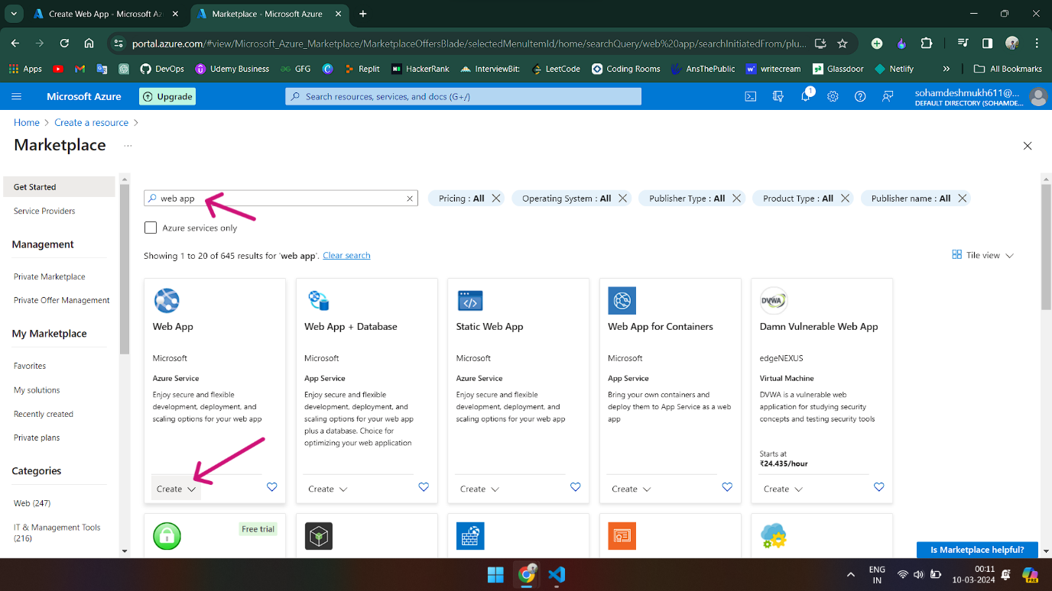

**3. Creating Resource group:**

- Click Create New and name the resource group.

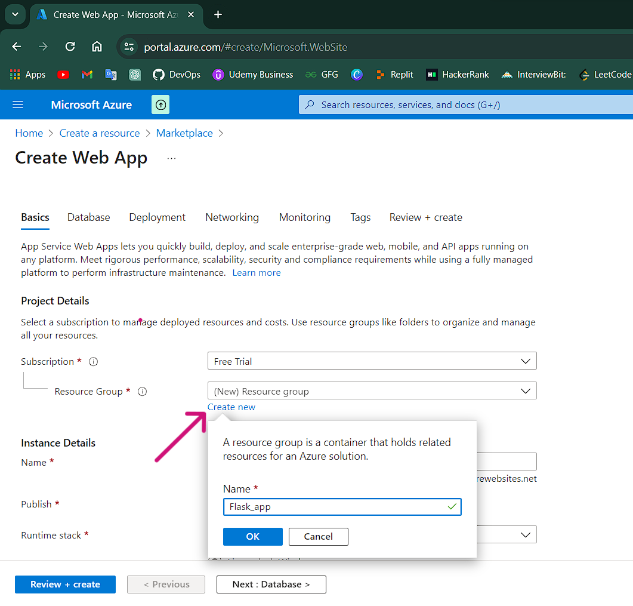

1. **Fill in all required fields and click Create:**

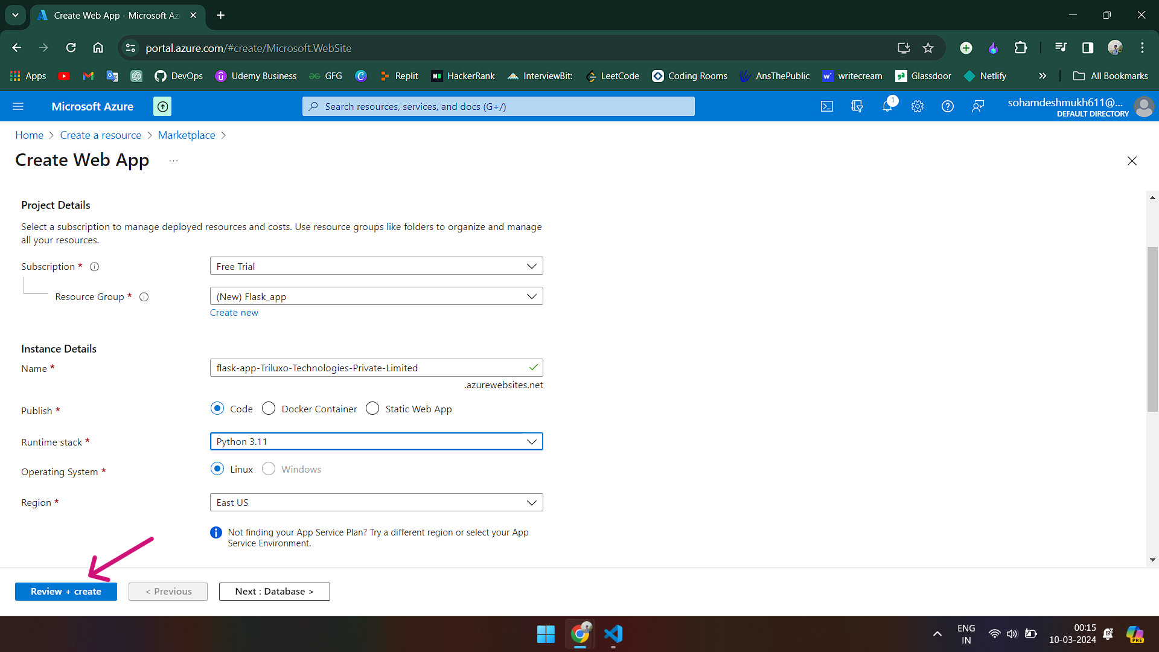

**5. After creating the web app, click Deploy Center:**

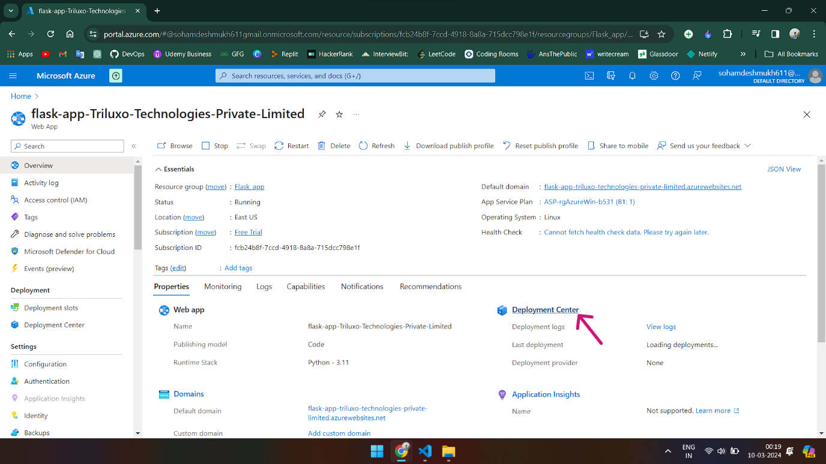

**6. Fill in all required fields and click Save:**

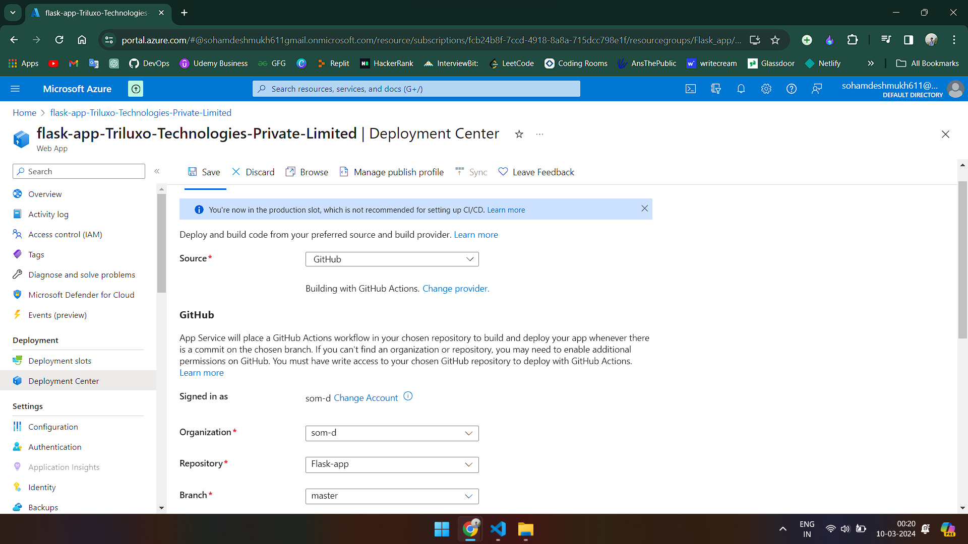

**3.Azure Web App Deployment:**

Deploy the application to the Azure Web App using Git:

1. **Creating an empty Git repository**

Command : git init

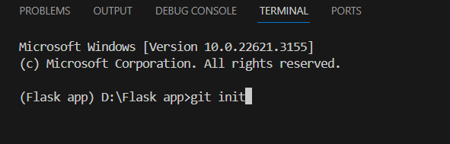

1. **Commit by using GUI:**

Arrow 1: Click on Source Control.

Arrow 2: Add a comment.

Arrow 3: Click Commit.

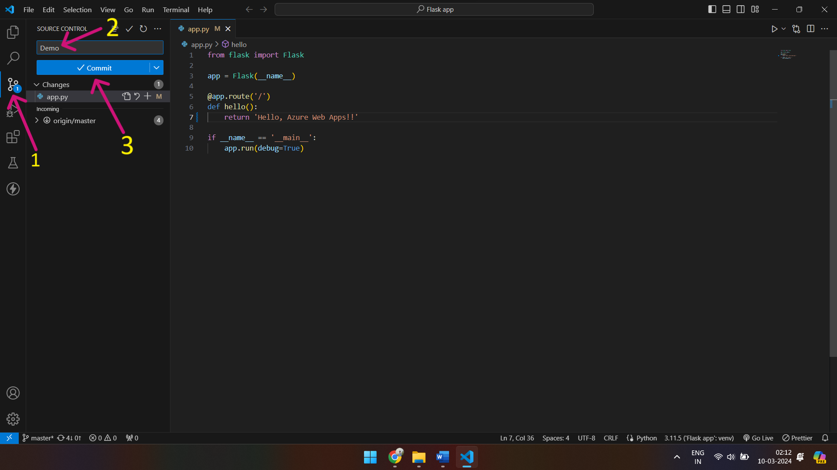

1. **After that click Sync Changes:**

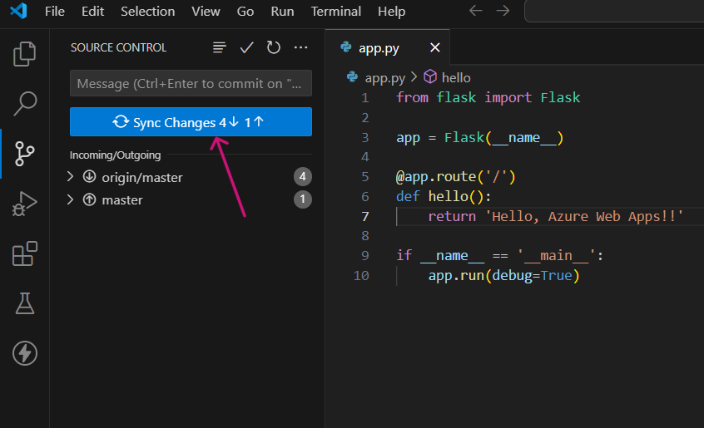

1. **Go to your Git repository and click on Actions to see all your workflows:**

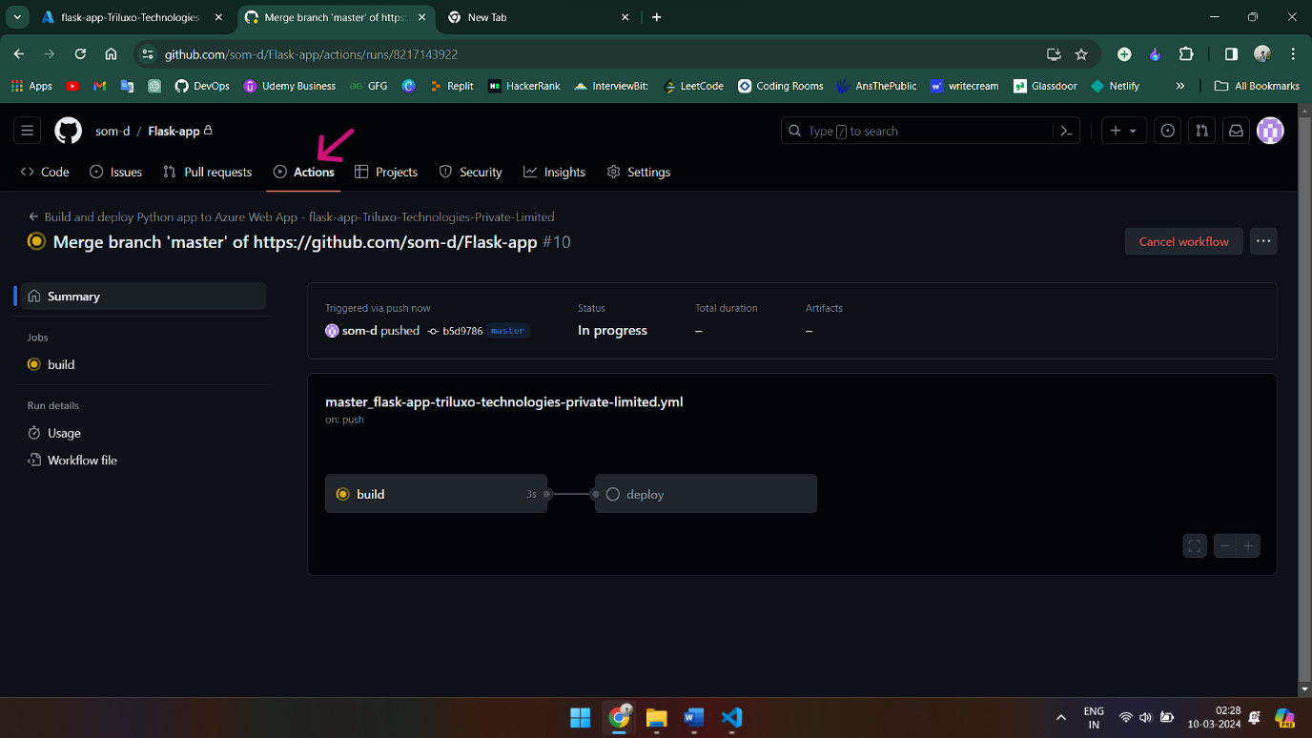

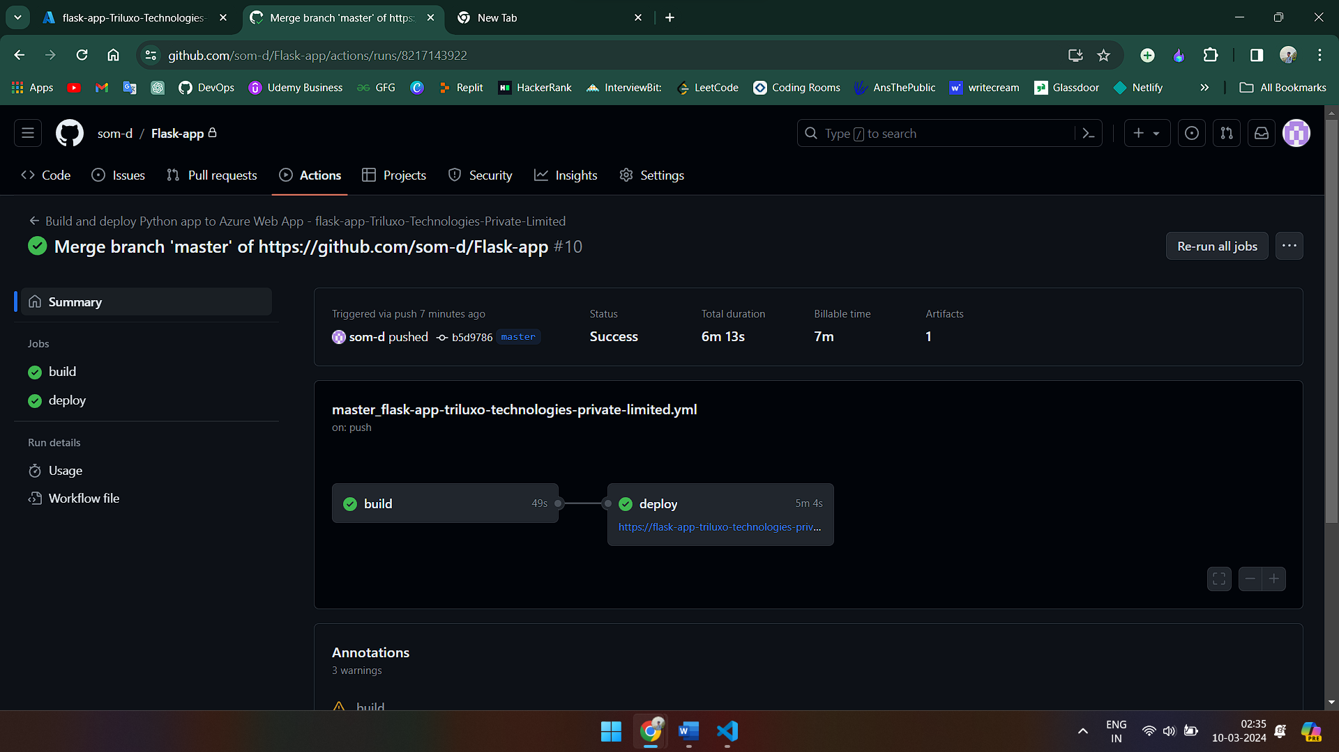

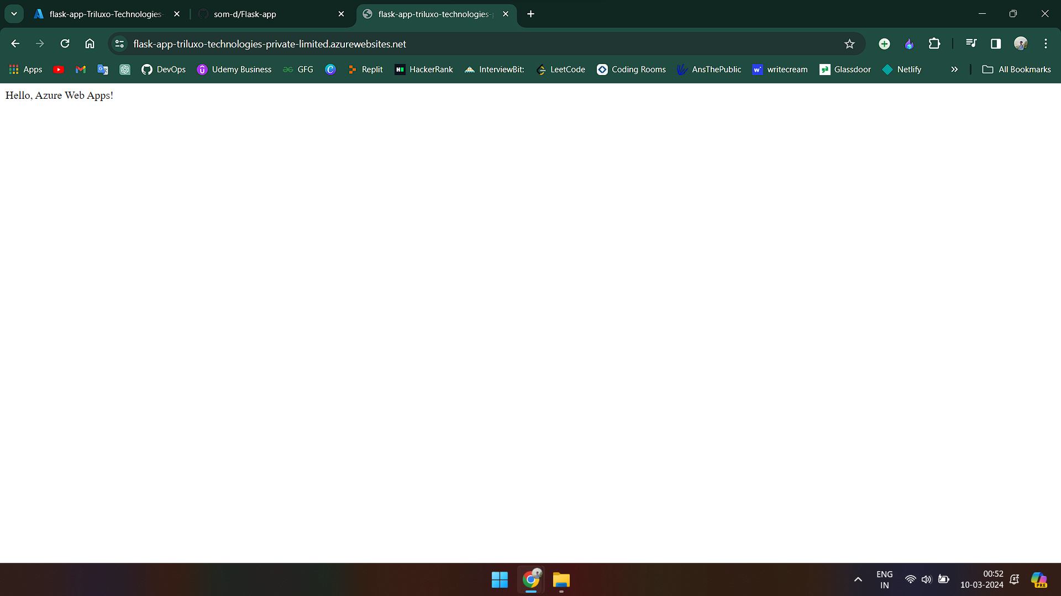

**4. Configuration:**

1. Ensure that any necessary environment variables required by the application are configured in the Azure Web App settings.

**5. Testing:**

1. **Once the deployment is complete, access the deployed application using the URL provided by Azure Web Apps.**

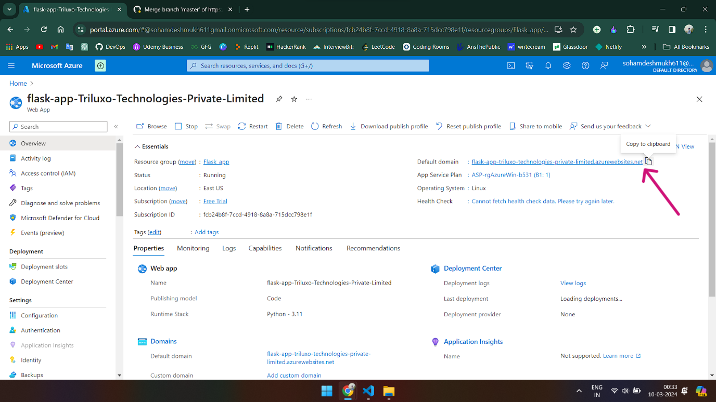

1. **You should receive a response "Hello, Azure Web Apps!" indicating that the application is running successfully.**



**Contributors:**

**Soham Deshmukh** - https://github.com/som-d

**Contact Information:**

For any questions or issues regarding this SOP, please contact: sohamdeshmukh611@gmail.com