PAM > Pluggable Authentication Modules

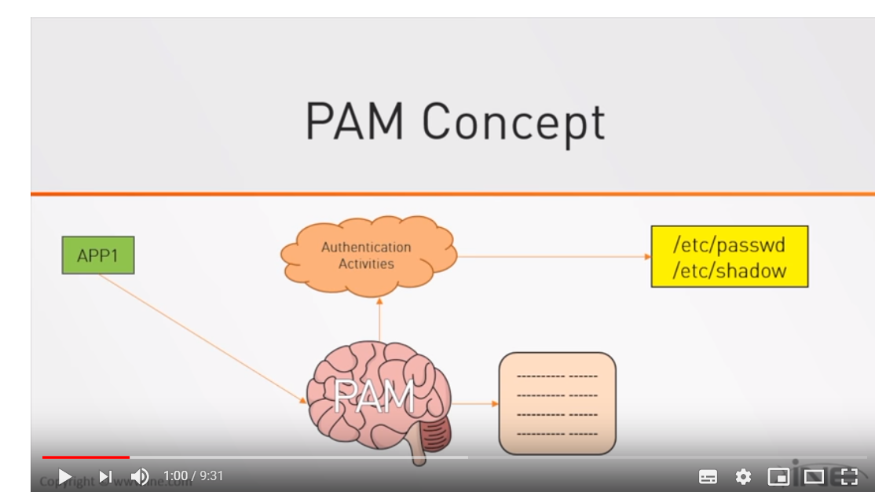

Earlier Linux used normal authentication services to give access to user by checking /etc/passwd & shadow file. Any change in authentication services it had been a trouble.

Now using PAM Pam manages auth. Services and (for each app. It has its own config. File), also changes in any policies is much easier than before. It has Modules which is executed top down and result of success and failure depends on these modules.

The main configuration file for **PAM** is **/etc/pam.conf** and the **/etc/pam.d/** directory contains the PAM configuration files for each PAM-aware application/services