**Q.1. For a group of 7 people, find the probability that all 4 seasons (winter, spring, summer, fall) occur at least once each among their birthdays, assuming that all seasons are equally likely.**

Ans:

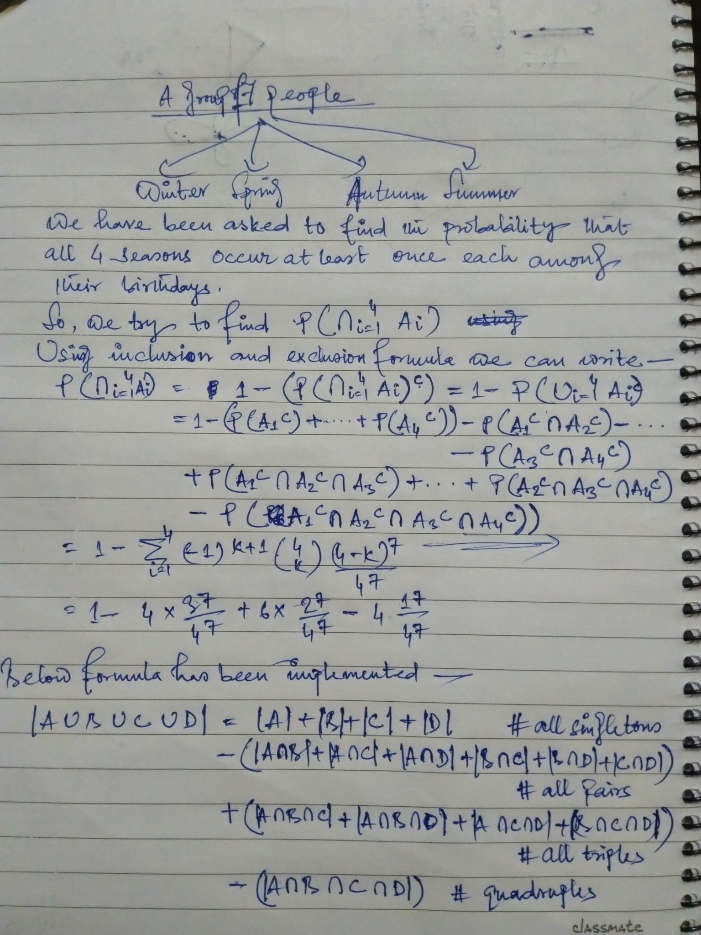

**Q.2. Alice attends a small college in which each class meets only once a week. She is deciding between 30 non-overlapping classes. There are 6 classes to choose from for each day of the week, Monday through Friday. Trusting in the benevolence of randomness, Alice decides to register for 7 randomly selected classes out of the 30, with all choices equally likely. What is the probability that she will have classes every day, Monday through Friday?**

Ans:

