**Q.1 Give an example of 3 events A, B, C which are pairwise independent but not independent.**

**Hint: find an example where whether C occurs is completely determined if we know whether A occurred and whether B occurred, but completely undetermined if we know only one of these things.**

Ans:

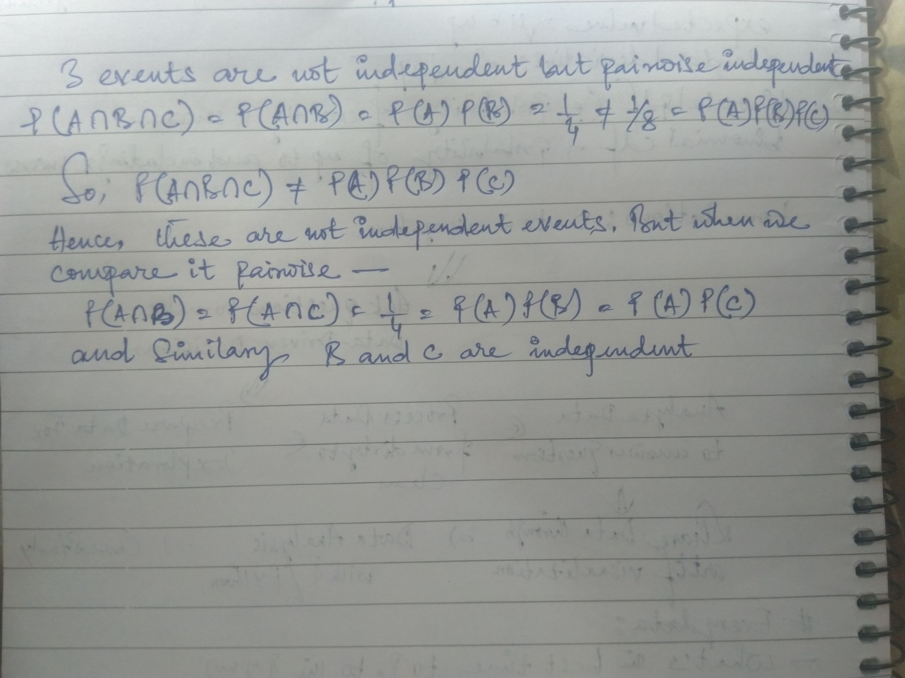

**Q.2 A bag contains one marble which is either green or blue, with equal probabilities. A green marble is put in the bag (so there are 2 marbles now), and then a random marble is taken out. The marble taken out is green. What is the probability that the remaining marble is also green?**

Ans:

