My Account Dashboard Builder
My Account Dashboard Builder allows your WooCommerce store to turn the plain My Account page into a branded customer dashboard.
My Account Dashboard Builder turns the plain WooCommerce My Account page into a branded customer dashboard. Reorder and add menu items, design the page beside a live preview, add banners and personal offers, and give customers self-service tools — without editing theme templates or writing code.
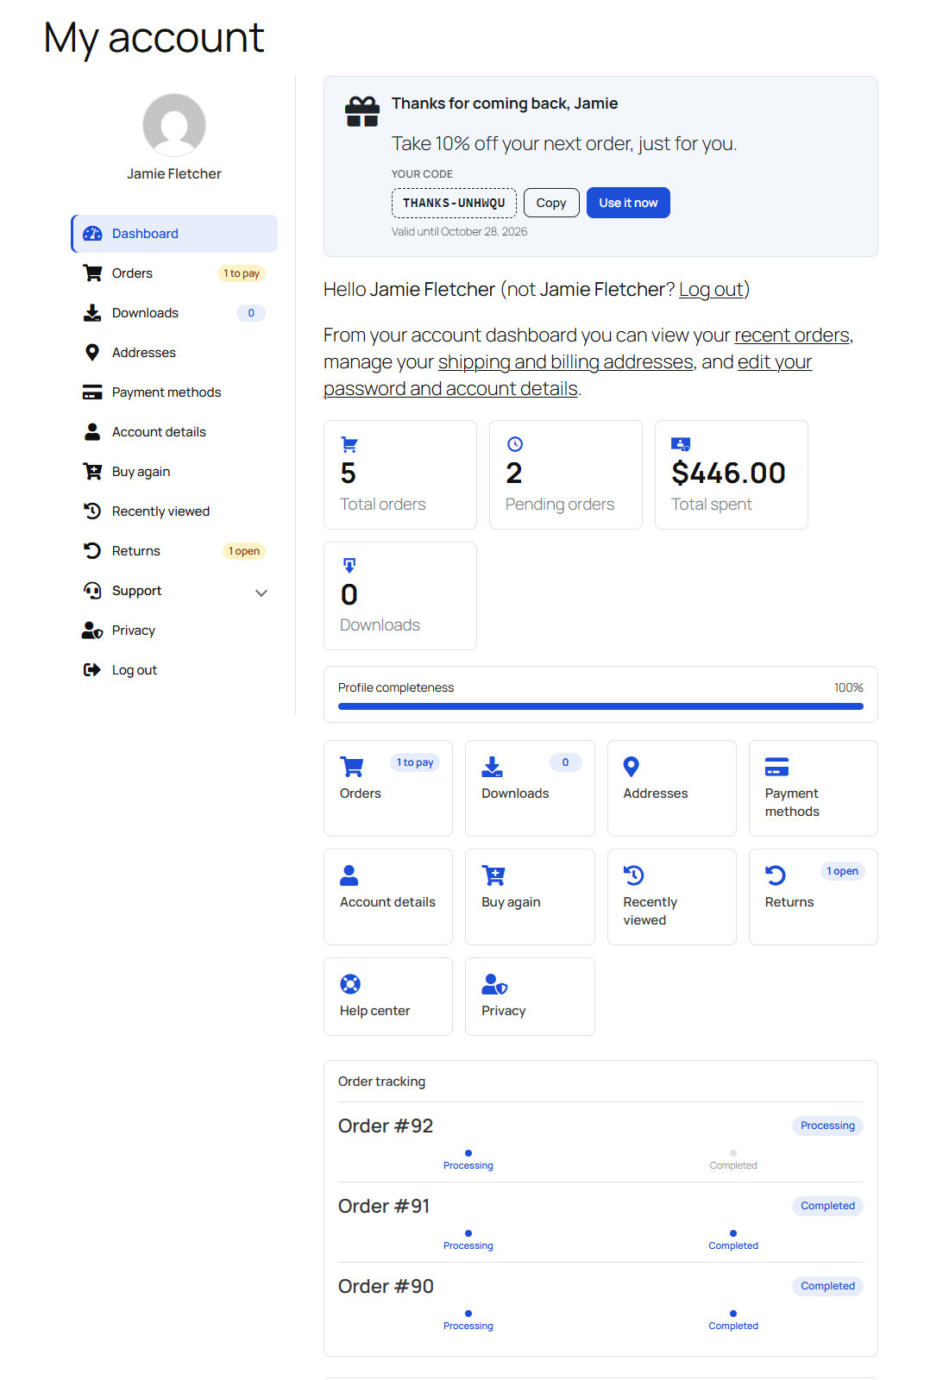
A customer’s My Account dashboard: a personal offer, the icon menu with status badges, account numbers, the profile meter, shortcut tiles and order tracking.
Image: submission/docs-media/01-my-account-dashboard.png

Installation
- In WordPress admin, go to Plugins → Add New → Upload Plugin.
- Upload my-account-dashboard-builder.zip and click Install Now.
- Click Activate. WooCommerce must be installed and active.
- Open WooCommerce → Account Dashboard.
Requires WordPress 6.0+, WooCommerce 6.0+ and PHP 7.4+.
The default WooCommerce pages are already loaded, so My Account keeps working before you change anything.

Setup and Configuration
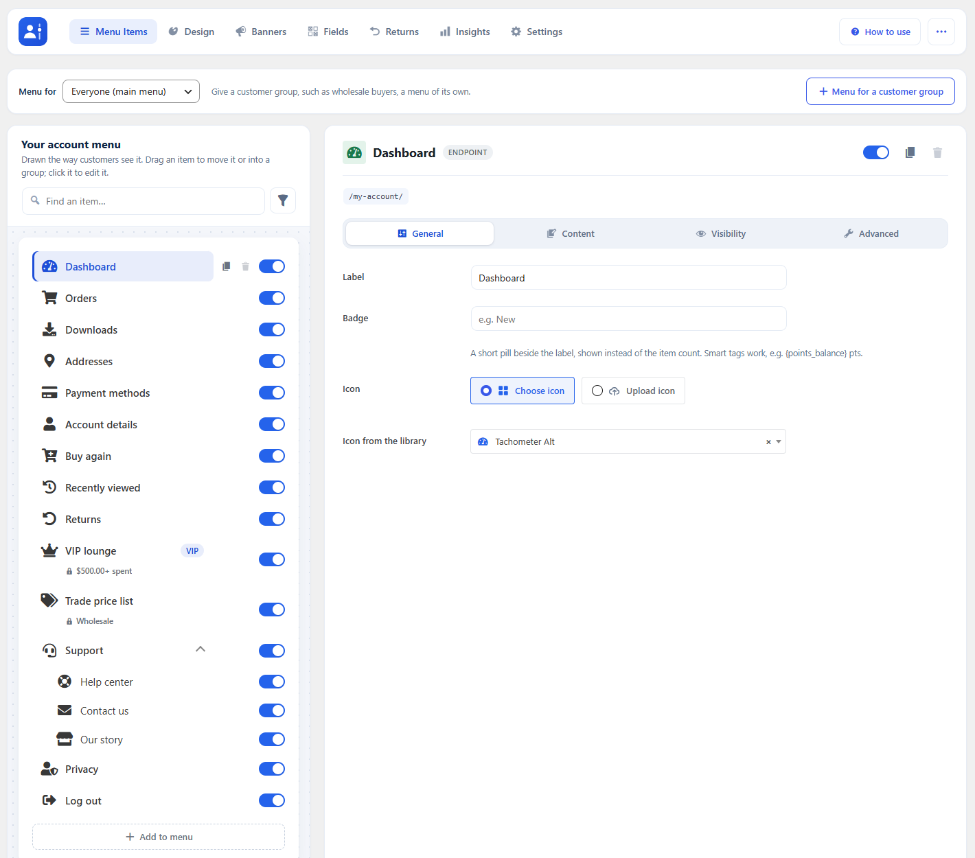
WooCommerce → Account Dashboard, on the Menu Items tab.
Image: submission/docs-media/02-admin-overview.png

Getting started
To set up your store with My Account Dashboard Builder, go to WooCommerce → Account Dashboard. The screen has four parts:
- Top section — the tabs (Menu Items, Design, Banners, Fields, Returns, Insights, Settings), How to use (a searchable guide to every feature) and ⋯ (Preview and View My Account).
- Left panel — the menu canvas: your account menu drawn the way customers see it.
- Main content area — the options of the item you select.
- Bottom section — Save menu. The save bar floats in view while there are unsaved changes, and leaving the page asks first.

Menu Items
There are four item types: Endpoint (a page inside My Account, built-in or your own), Group (a collapsible heading), Link (any URL) and Page (a WordPress page).

Endpoint Controls
- Drag an item to reorder it, or drop it into a group. Alt + arrow keys do the same.
- The switch shows or hides an item without deleting it.
- Hover an item for Duplicate and Delete. Built-in items can be switched off but not deleted.
- A line under an item sums up who sees it, e.g. Customer · 2+ orders.
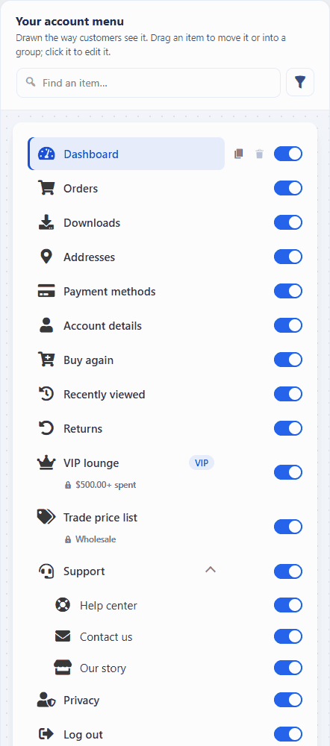
Drag an item to reorder the menu, or drop it into a group.
GIF: submission/docs-media/05-drag-menu-items.gif

Endpoint Options
Click an item to edit it. Its options are grouped in four tabs:
- General — label, address (custom endpoints), badge text and icon (Font Awesome library or your own image).
- Content — Classic or Block editor content shown before, after or instead of the default page; smart tags work here. Attach banners at the top or bottom.
- Visibility — limit the item by user role, dates, products bought, number of orders, amount spent or days since the last order.
- Advanced — an extra CSS class and the item key.
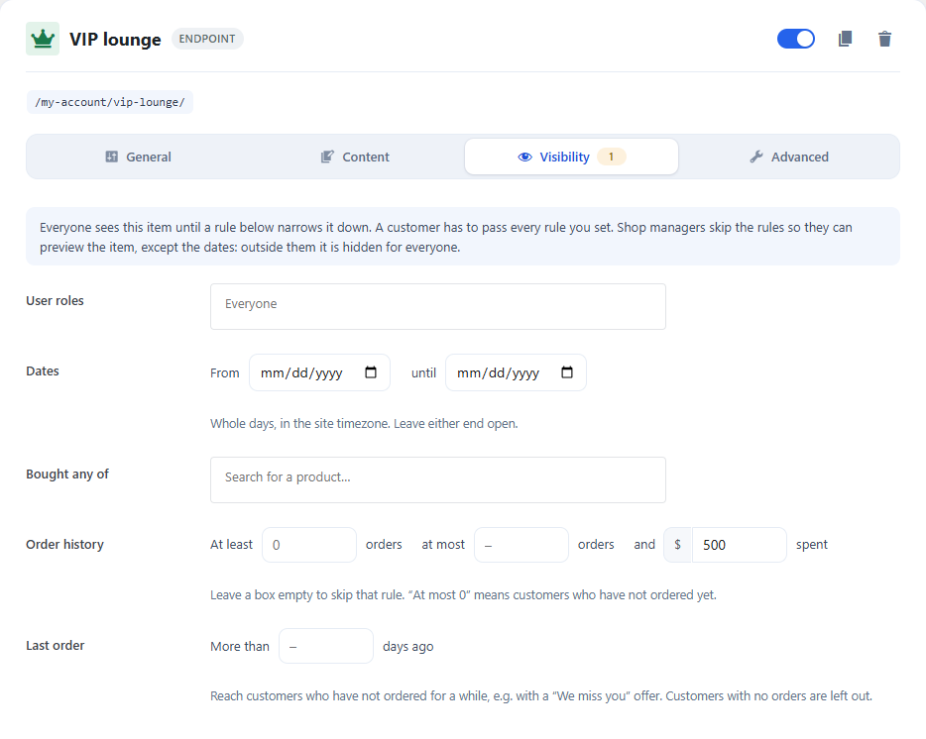
The Visibility tab: the VIP lounge item shows only to customers who have spent $500 or more.
Image: submission/docs-media/08-item-visibility.png

Add an Endpoint, Group, Link or Page
- Click Add to menu under the menu.
- Pick the type, type a label and click Add item. It is added at the end of the menu.
- Set its options (a link's URL, a page's WordPress page) and drag it where it belongs.
- Click Save menu.
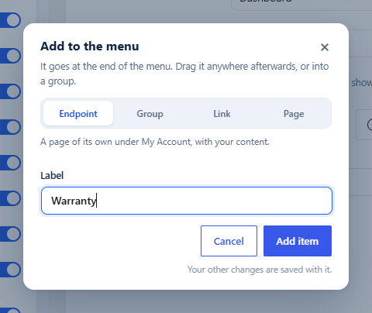
Add to menu: pick the type, type a label, Add item.
Image: submission/docs-media/10-add-to-menu.png

Menus for Customer Groups
Give wholesale buyers or members a menu of their own: click Menu for a customer group, name it and tick the roles. It starts as a copy of the main menu; take items out, add others and reorder it. Item settings stay shared, and everyone else keeps the main menu.
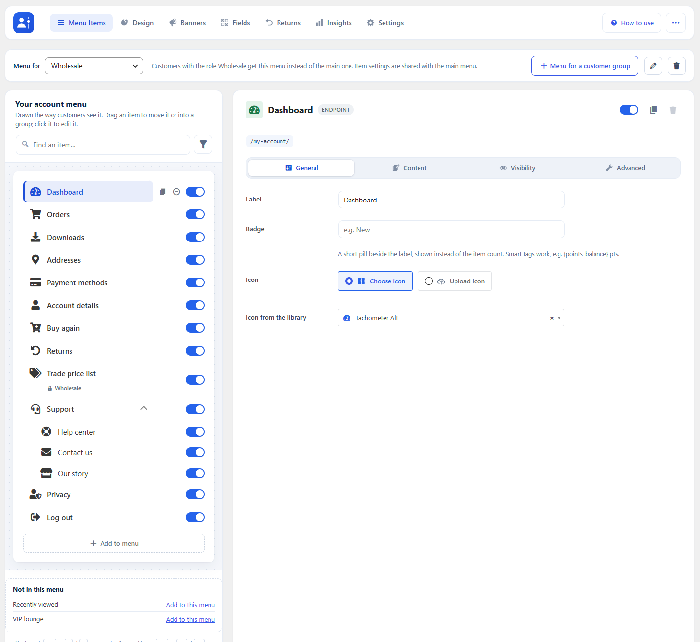
The Wholesale menu: Recently viewed and VIP lounge are taken out.
Image: submission/docs-media/11-customer-group-menu.png

Design Studio
Design holds every look setting, beside a live preview of the real account page at desktop, tablet and phone widths. Nothing changes on your site until you click Save design.
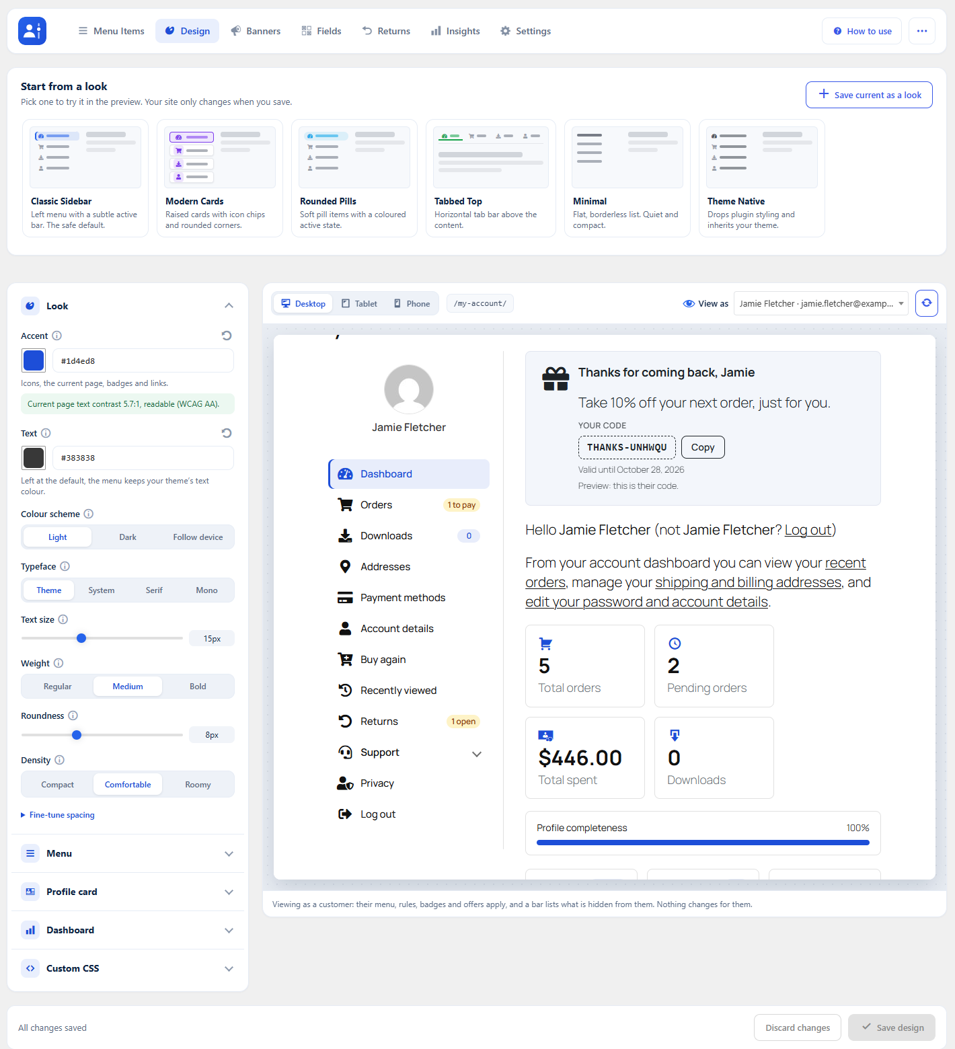
The Design Studio: ready-made looks on top, controls on the left, the live account page on the right.
Image: submission/docs-media/16-design-studio.png

Ready-made Looks
Start from Classic Sidebar, Modern Cards, Rounded Pills, Tabbed Top, Minimal or Theme Native. Click one to try it in the preview. Save current as a look keeps your own design as one more card.
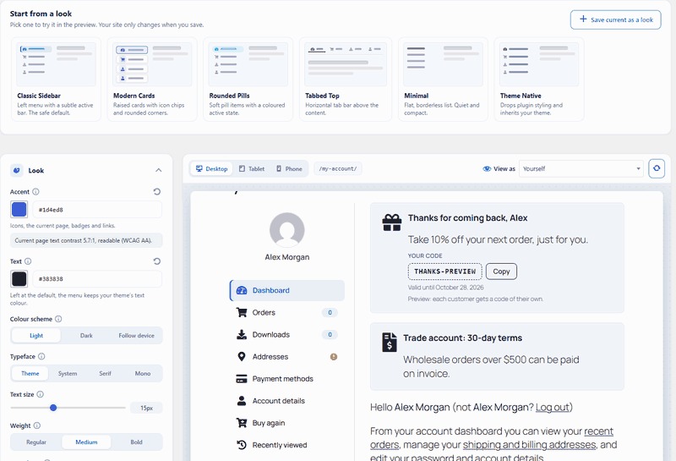
Click a look to try it in the preview.
GIF: submission/docs-media/14-design-looks.gif

Design Controls
- Look — accent and text colours (with a live WCAG contrast check), light or dark scheme, typeface, size, weight, roundness and density.
- Menu — style, placement (left, right or above the content), current-page marker, hover effect, colours, icons, counts, status badges (1 to pay, 1 open), search box, pinned favourites and a collapsible icon rail.
- Profile card — the customer's picture and name above the menu; customers can upload their own picture.
- Dashboard — a heading (smart tags work) and Arrange the dashboard: drag the greeting, account numbers, profile meter, shortcut tiles, order tracking and Buy again into any order, or hide them.
- Custom CSS — your own rules, loaded on account pages.
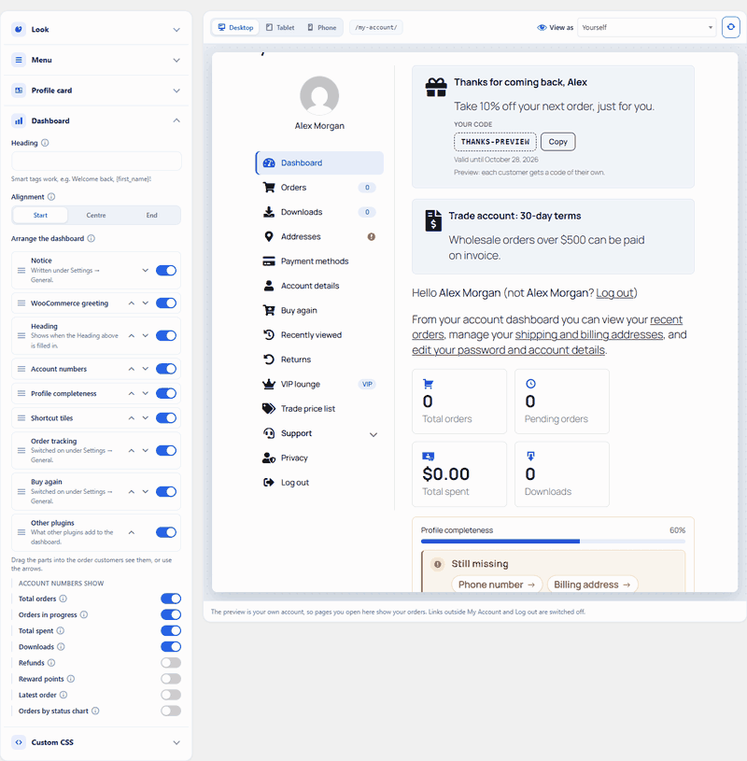
Arrange the dashboard: the preview follows as parts are hidden and moved.
GIF: submission/docs-media/18-arrange-dashboard.gif

View as a Customer
Pick a customer in View as to see My Account exactly as they do: their menu, badges, offers and dashboard. A bar lists what is hidden from them, and why. It is read-only: nothing is changed, sent or counted for the customer.
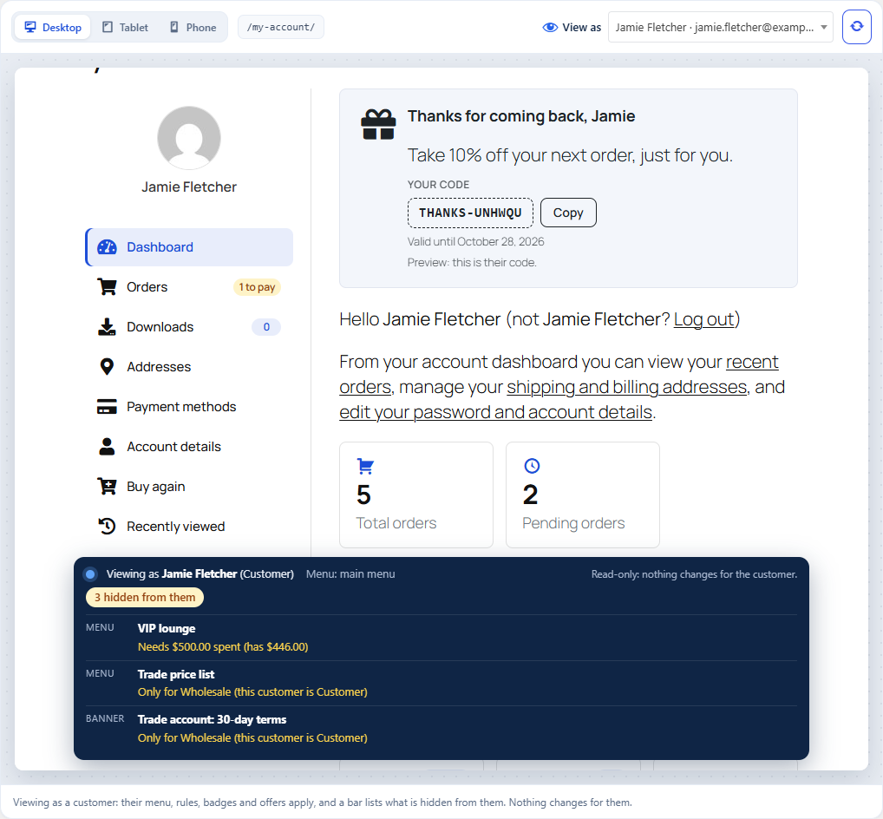
The bar lists what this customer does not see, and why.
Image: submission/docs-media/22-view-as-hidden.png

Banners and Personal Offers
Banners are reusable blocks shown on any endpoint (set under the item's Content tab).
- On Banners, click Add banner.
- Choose Widget (icon, title, text, colours, optional count) or Image.
- Add a Link to an endpoint or any URL, and set Visibility with the same rules as menu items.
- Click Save banner.
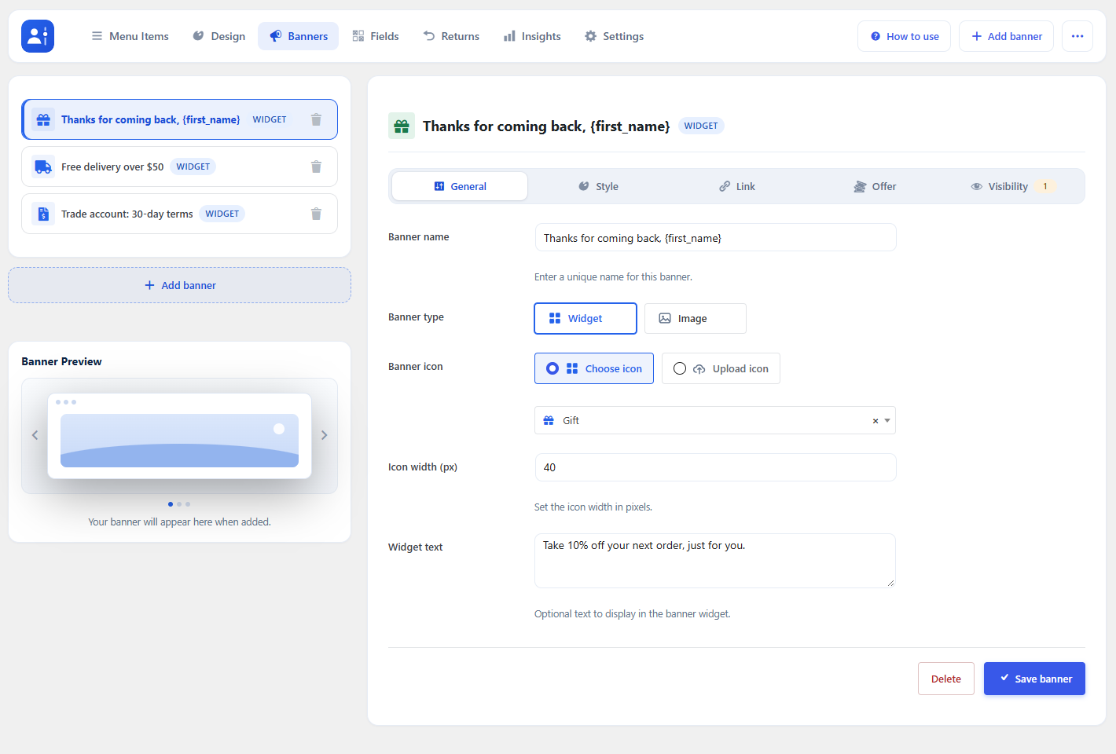
The Banners tab: your banners on the left, the selected banner’s settings on the right.
Image: submission/docs-media/23-banner-general.png
Switch on Personal coupon on the Offer tab and each customer who sees the banner gets a one-use code of their own (percent or amount off, valid for N days, optional minimum spend and free shipping). The banner shows the code with Copy and Use it now. Codes are ordinary WooCommerce coupons.
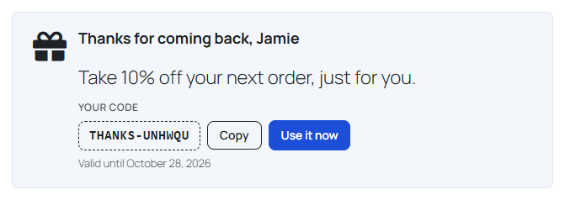
What the customer sees: their own code, Copy and Use it now.
Image: submission/docs-media/26-front-offer-banner.png

Customer Fields
On Fields, add your own questions — VAT number, company, birthday, "How did you hear about us?" — as text, number, date, dropdown, choices or a tick box. Show each one on the Registration form, Account details and the admin order screen. Answers work as smart tags, e.g. {field_vat}.
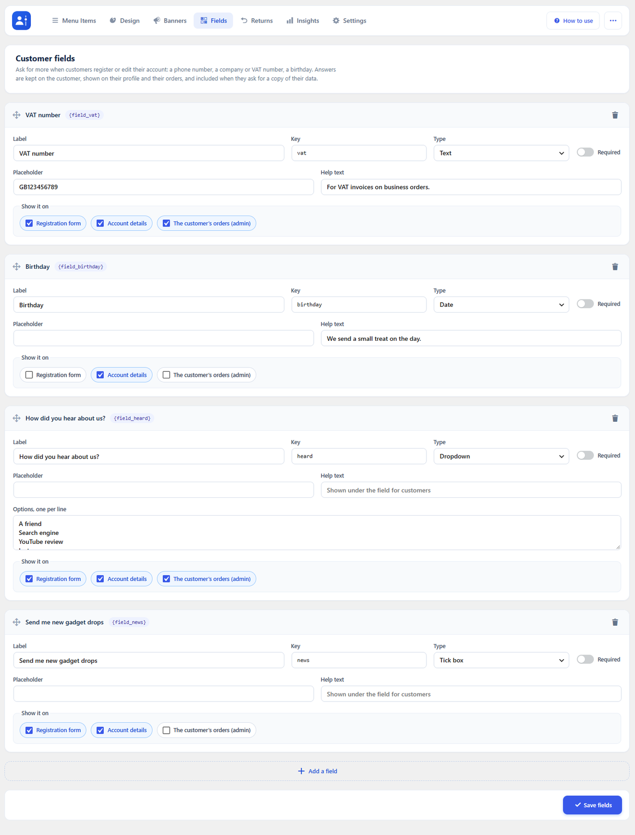
The Fields tab.
Image: submission/docs-media/27-fields-admin.png

Returns and Cancelling Orders
Switch both on under Settings → Orders & privacy.
- Cancel orders — customers cancel an order that has not shipped, for the number of hours you allow. Stock goes back.
- Returns — customers pick items from a completed order, a reason and an optional photo. You answer on the Returns tab; each status change emails the customer.
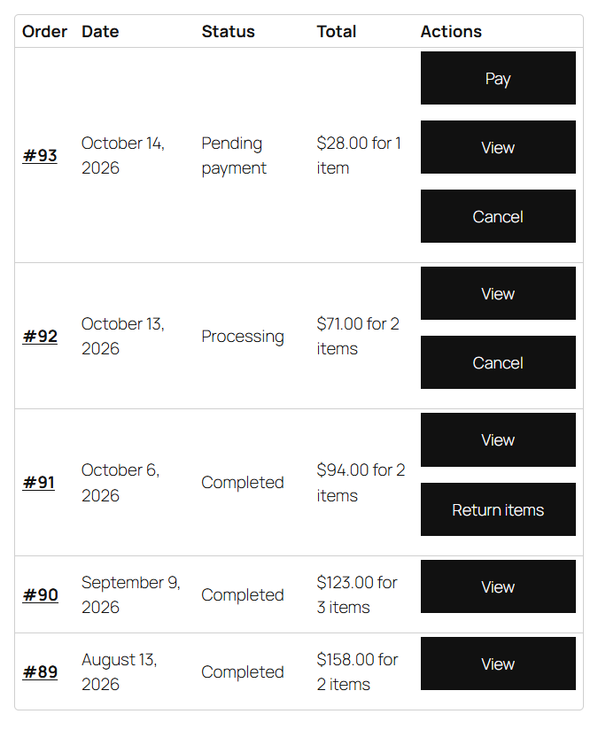
The Orders list: Cancel on orders that have not shipped, Return items on completed ones.
Image: submission/docs-media/29-front-order-actions.png
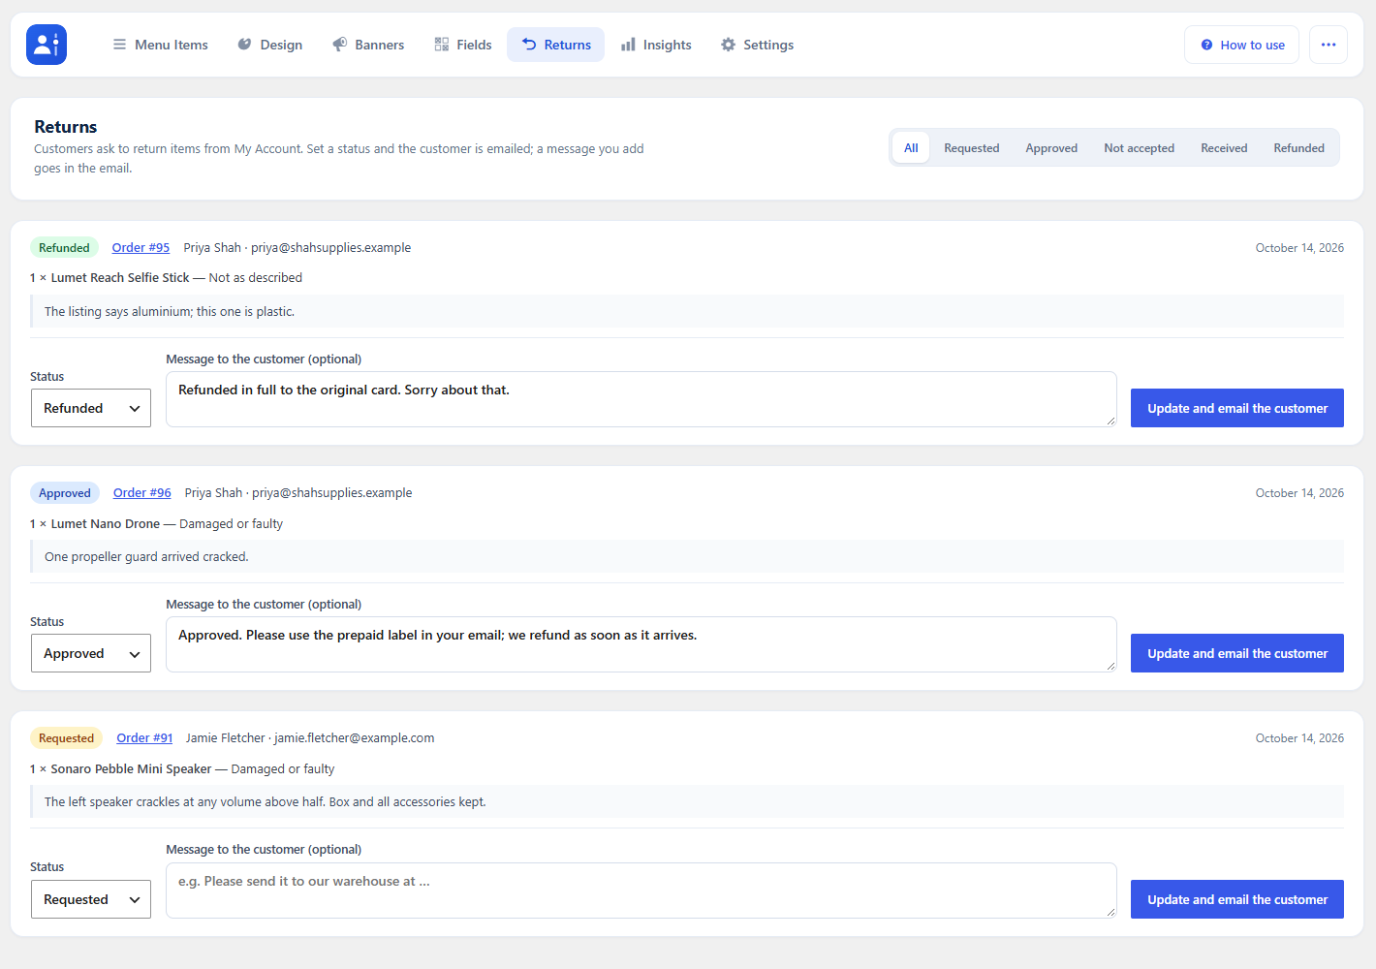
The Returns tab: set a status, add a message, and the customer is emailed.
Image: submission/docs-media/32-returns-admin.png

Insights
Insights shows account page views, banner clicks and click rates, and how personal offers convert, over 7, 30 or 90 days. Switch on Record usage under Settings → General. Only customers are counted, as daily totals.
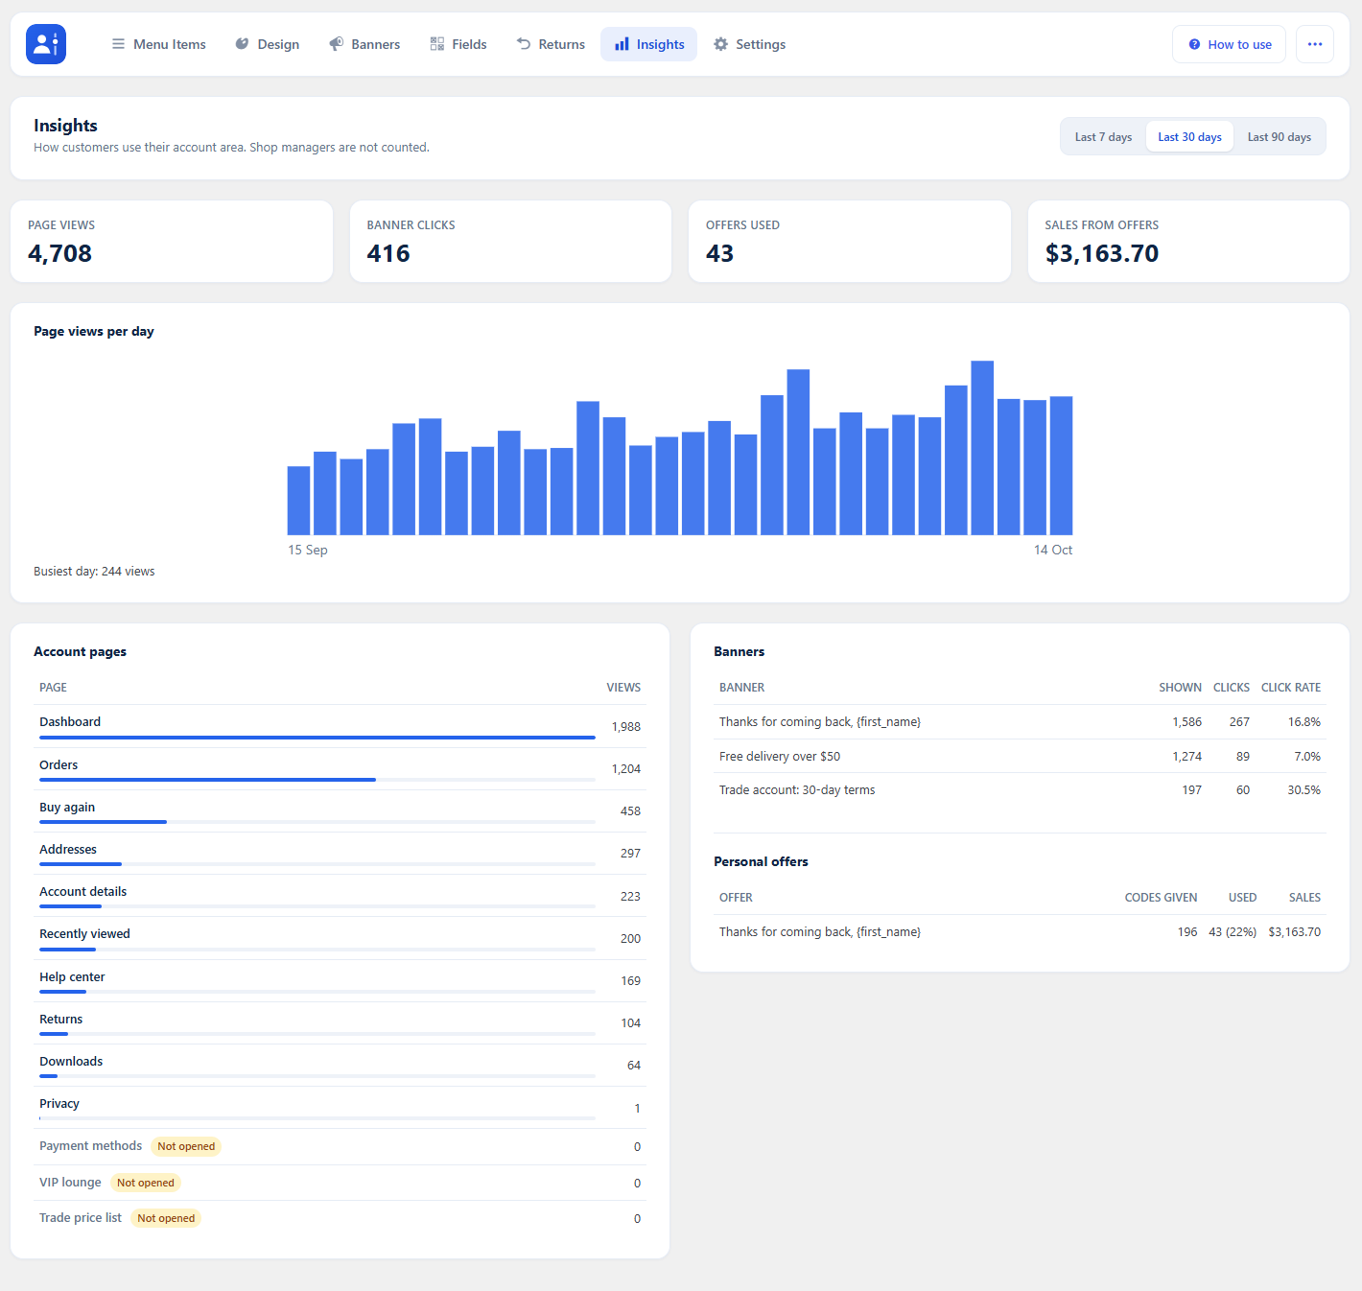
Insights over the last 30 days.
Image: submission/docs-media/33-insights.png

Settings
- General — AJAX navigation, the default endpoint, login and logout redirects, a guest message, a dashboard notice, Record usage, and Buy again / Recently viewed / Order tracking.
- Orders & privacy — cancelling, returns and their reasons, address book, privacy page.
- Presets & Reset — save the design as a named preset, or reset everything to defaults.
- Import / Export — move the whole configuration to another site as a JSON file.
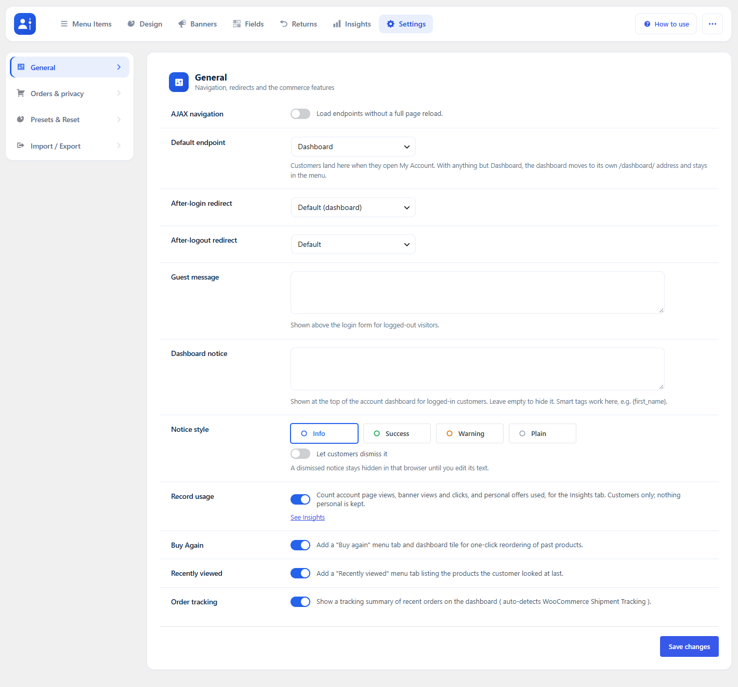
Settings → General.
Image: submission/docs-media/34-settings-general.png

Smart Tags
Use these in content, the dashboard heading, badges and banners: {first_name}, {last_name}, {display_name}, {user_email}, {order_count}, {total_spent}, {download_count}, {member_since}, {last_login}, {cart_count}, {site_title}, {shop_url}, {points_balance}, {membership_plan}, {field_…} and, in a banner, {offer_code}, {offer_amount}, {offer_expiry}. In the Classic editor, use Add smart tags.

Developer Options
- Show the account menu anywhere with the [acfw_account_menu] shortcode, the Account Menu block or widget. Classic themes also get a My Account box under Appearance → Menus.
- Override templates by copying files from templates/ to yourtheme/my-account-dashboard-builder/.
- Filters include acfw_status_badges, acfw_dashboard_blocks, acfw_smart_tag_values, acfw_item_is_visible and acfw_endpoint_content.

Compatibility with Third-Party WooCommerce Plugins
- Account pages added by Subscriptions, Memberships, Bookings, points and wallet plugins appear in the menu with fitting icons; arrange them like any other item.
- YITH and TI WooCommerce Wishlist get a Wishlist page inside My Account.
- Points & Rewards, YITH Points and myCred feed {points_balance} and the Reward points stat; Memberships feeds {membership_plan}.
- HPOS, the Cart and Checkout blocks, WPML and Polylang are supported.

Usage
What customers see on the front end.

Customer Self-Service
Switch these on under Settings; each adds a menu item and a dashboard part.
- Buy again — past purchases with Add to cart, and Reorder my last order.
- Recently viewed — the products the customer looked at last.
- Order tracking — recent orders on the dashboard, with numbers from WooCommerce Shipment Tracking.
- Address book — more saved addresses, used for shipping or billing in a click.
- Privacy page — customers ask for a copy of their data, or for it to be erased.
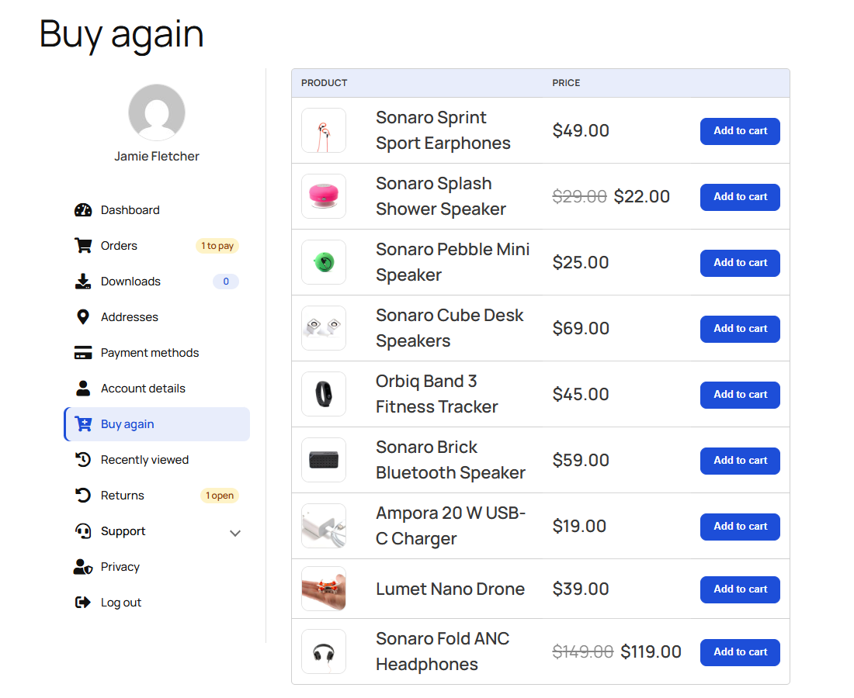
Buy again: one click puts a past purchase back in the cart.
Image: submission/docs-media/38-buy-again.png

Troubleshooting
Known errors or issues and how to solve them.

Personal offer codes do not appear
Coupons must be switched on in WooCommerce → Settings → General. Shop managers see a PREFIX-PREVIEW code instead of a real one; check with View as a Customer.

"Free shipping too" has no effect on an offer
The store needs a free shipping method that accepts a coupon.

The menu looks doubled or items jump around
Use only one My Account menu builder at a time. Two plugins rewriting the same menu will conflict; deactivate the other customizer.

Saved addresses are missing at checkout
The address book picker shows on the classic checkout. The Checkout block does not list the saved addresses.

FAQs

Do I need to edit theme templates?
No. The plugin replaces the WooCommerce account menu and endpoint output through the hooks WooCommerce already provides. Nothing is copied into your theme.

What happens if I deactivate the plugin?
My Account falls back to the standard WooCommerce menu. Your configuration is kept, so reactivating restores everything. Uninstall from the Plugins screen removes only this plugin’s data.

Can different customers get different menus?
Yes. On Menu Items, add a menu for a customer group (for example wholesale or members). It starts as a copy of the main menu; remove or reorder items as needed. Item settings stay shared, and everyone else keeps the main menu.

Are personal offer codes ordinary WooCommerce coupons?
Yes. They appear under Marketing → Coupons, limited to one use and to the customer’s email. Coupons must be enabled in WooCommerce → Settings → General.

Is it compatible with HPOS and the block cart/checkout?
Yes. Compatibility with High-Performance Order Storage and the block-based cart and checkout is declared. Orders are read through the WooCommerce CRUD API only.

Can I move my setup from staging to the live site?
Yes. Use Settings → Import / Export to download a JSON file of the configuration, then Import it on the other site.

Image and GIF Placement
Every screenshot and GIF in this guide, in order, with the section it belongs to. The files are in submission/docs-media/ in the plugin repository; each one is also named under its caption above. GIFs animate in Word and in browsers; a PDF shows their first frame.
# | Where it goes | File | What it shows
1 |  | Image: 01-my-account-dashboard.png | A customer’s My Account dashboard: a personal offer, the icon menu with status badges, account numbers, the profile meter, shortcut tiles and order tracking.
2 | Setup and Configuration | Image: 02-admin-overview.png | WooCommerce → Account Dashboard, on the Menu Items tab.
3 | Setup and Configuration › Menu Items | GIF: 05-drag-menu-items.gif | Drag an item to reorder the menu, or drop it into a group.
4 | Setup and Configuration › Menu Items | Image: 08-item-visibility.png | The Visibility tab: the VIP lounge item shows only to customers who have spent $500 or more.
5 | Setup and Configuration › Menu Items | Image: 10-add-to-menu.png | Add to menu: pick the type, type a label, Add item.
6 | Setup and Configuration › Menu Items | Image: 11-customer-group-menu.png | The Wholesale menu: Recently viewed and VIP lounge are taken out.
7 | Setup and Configuration › Design Studio | Image: 16-design-studio.png | The Design Studio: ready-made looks on top, controls on the left, the live account page on the right.
8 | Setup and Configuration › Design Studio | GIF: 14-design-looks.gif | Click a look to try it in the preview.
9 | Setup and Configuration › Design Studio | GIF: 18-arrange-dashboard.gif | Arrange the dashboard: the preview follows as parts are hidden and moved.
10 | Setup and Configuration › Design Studio | Image: 22-view-as-hidden.png | The bar lists what this customer does not see, and why.
11 | Setup and Configuration › Banners and Personal Offers | Image: 23-banner-general.png | The Banners tab: your banners on the left, the selected banner’s settings on the right.
12 | Setup and Configuration › Banners and Personal Offers | Image: 26-front-offer-banner.png | What the customer sees: their own code, Copy and Use it now.
13 | Setup and Configuration › Customer Fields | Image: 27-fields-admin.png | The Fields tab.
14 | Setup and Configuration › Returns and Cancelling Orders | Image: 29-front-order-actions.png | The Orders list: Cancel on orders that have not shipped, Return items on completed ones.
15 | Setup and Configuration › Returns and Cancelling Orders | Image: 32-returns-admin.png | The Returns tab: set a status, add a message, and the customer is emailed.
16 | Setup and Configuration › Insights | Image: 33-insights.png | Insights over the last 30 days.
17 | Setup and Configuration › Settings | Image: 34-settings-general.png | Settings → General.
18 | Usage › Customer Self-Service | Image: 38-buy-again.png | Buy again: one click puts a past purchase back in the cart.
GIF rows are shaded.

