My Account Dashboard Builder
Branded My Account dashboard: drag-and-drop menu, Design Studio, Buy again, returns, personal offers and self-service tools.
Highlights
- A drag-and-drop account menu with your own pages, groups and links
- A Design Studio with a live preview and ready-made looks
- Personal coupon offers and banners for the right customers
- Self-service returns, cancellations and an address book
- View My Account exactly as any customer sees it

Make My Account Work as Hard as Your Shop Pages
Every logged-in customer lands on My Account, yet in most stores it is a plain list of links. It is where customers check an order, change an address and decide whether to buy again, and where they get stuck and email you instead.
My Account Dashboard Builder turns it into a dashboard that matches your brand: a menu customers find their way around, account numbers and order tracking at a glance, offers that bring them back, and tools that answer their own questions. No theme templates to edit and no code to write.
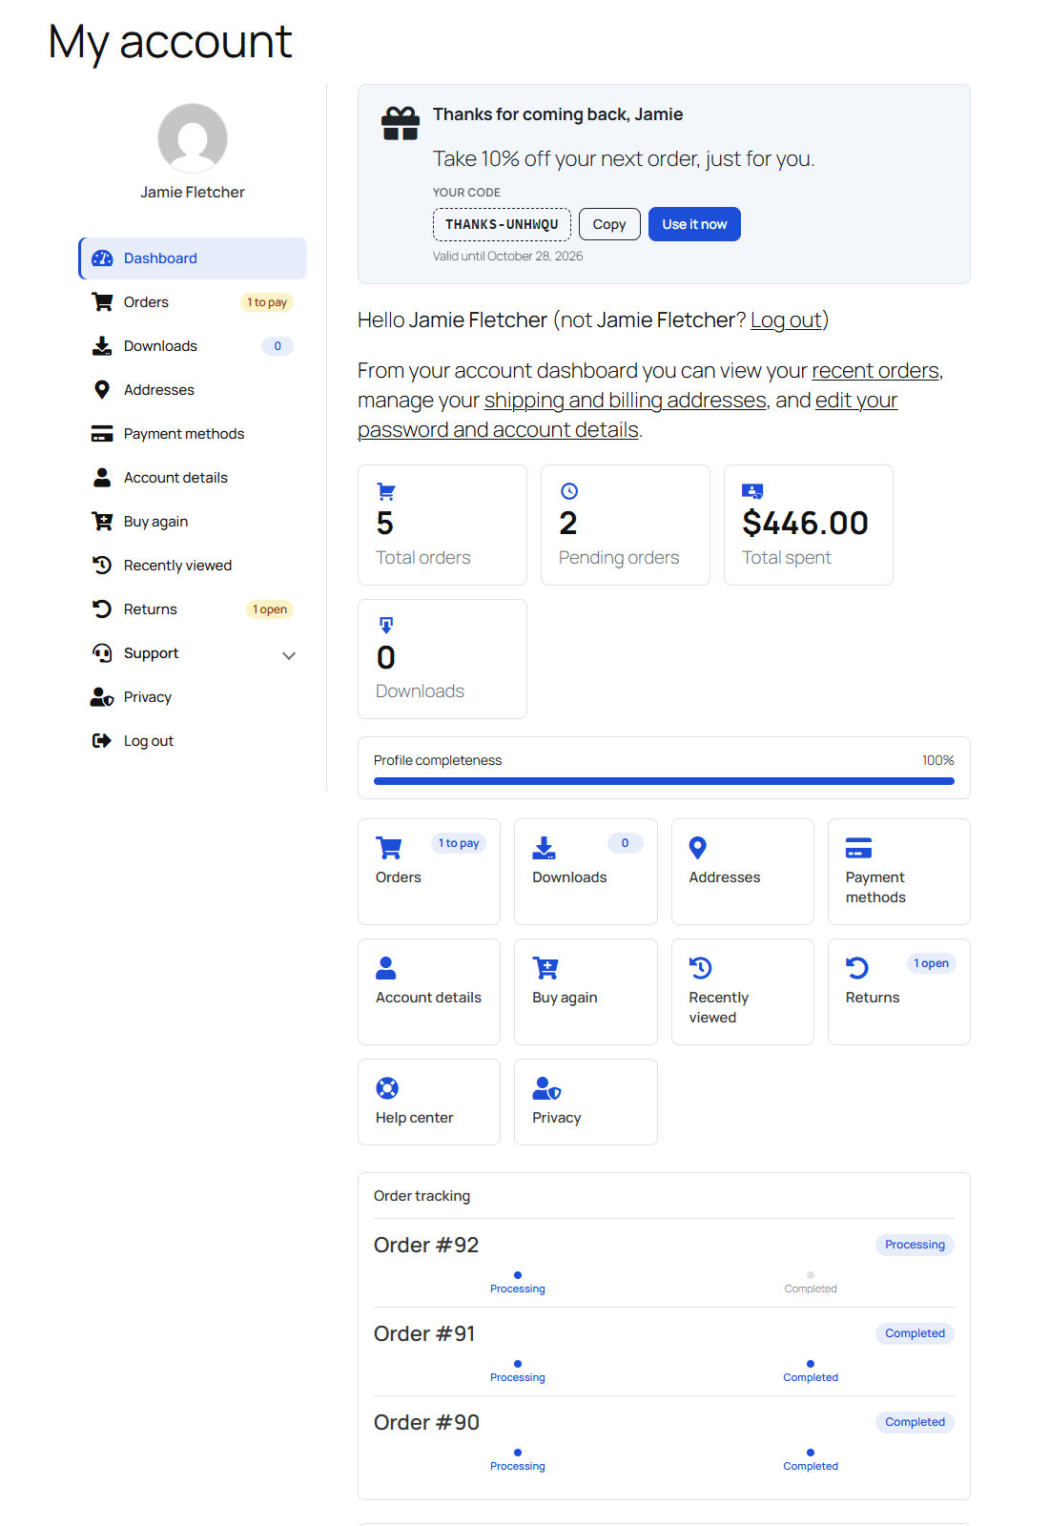
Image: 01-my-account-dashboard.png
 | Drag-and-Drop Menu  Reorder, rename, hide and nest account pages on a canvas drawn the way customers see it.  Image: icons/icon-menu.png
 | Your Own Account Pages  Add endpoints, links, WordPress pages and collapsible groups, with Classic or Block editor content.  Image: icons/icon-endpoints.png
 | The Right Items for the Right People  Show an item by role, dates, products bought, orders placed, amount spent or time since the last order.  Image: icons/icon-rules.png
 | Menus for Customer Groups  Give wholesale buyers or members a menu of their own, while item settings stay shared.  Image: icons/icon-groups.png
 | Design Studio  Change colours, layout, density and type beside a live preview at desktop, tablet and phone widths.  Image: icons/icon-design.png
 | Arrange the Dashboard  Put account numbers, the profile meter, shortcut tiles, order tracking and Buy again in the order you want.  Image: icons/icon-arrange.png
 | View as a Customer  See any customer’s menu, badges and offers, plus what is hidden from them and why. Nothing changes for them.  Image: icons/icon-viewas.png
 | Personal Offers  Banners that hand each customer a one-use coupon of their own, with Copy and Use it now.  Image: icons/icon-offers.png
 | Returns and Cancellations  Customers cancel unshipped orders and request returns with a photo; you answer from one screen.  Image: icons/icon-returns.png
 | Buy Again  Past purchases one click from the cart, plus recently viewed products and order tracking.  Image: icons/icon-buyagain.png
 | Customer Fields  Ask for a VAT number, a birthday or “How did you hear about us?” at registration and in account details.  Image: icons/icon-fields.png
 | Insights  See which account pages customers open, which banners they click and the sales personal offers bring.  Image: icons/icon-insights.png

Features:
- Drag-and-drop menu canvas, with keyboard moves
- Custom endpoints, links, WordPress pages and groups
- Font Awesome icons or your own images
- Badges and live status badges (“1 to pay”, “1 open”)
- Visibility rules by role, date, purchases and order history
- Separate menus for customer groups
- Design Studio with six ready-made looks, plus your own
- Account numbers, profile meter and shortcut tiles on the dashboard
- Banners with personal coupon offers
- Returns, order cancelling, address book and privacy page
- Buy again, recently viewed and order tracking
- Custom registration and account fields
- Smart tags such as {first_name} and {total_spent}
- Insights, import / export, WPML and Polylang ready

Build the Menu on a Canvas
The Menu Items screen draws your account menu exactly as customers see it. Drag an item to move it or drop it into a group, flip its switch to hide it, and click it to edit its label, icon and badge. The canvas follows as you type.
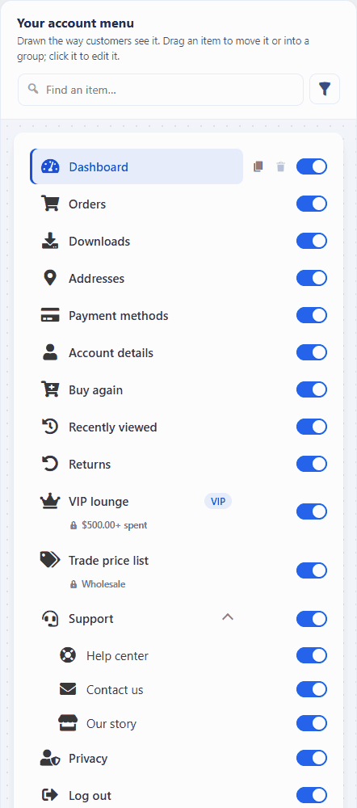
GIF: 05-drag-menu-items.gif

Add Your Own Account Pages
Click Add to menu, pick a type and type a label. Fill a page with the Classic or Block editor, shown before, after or instead of WooCommerce’s own content. Smart tags greet each customer by name.
- Endpoint — a page of its own under My Account, e.g. /my-account/help-center/
- Group — a collapsible heading that holds other items
- Link — any URL, in the same or a new tab
- Page — one of your WordPress pages

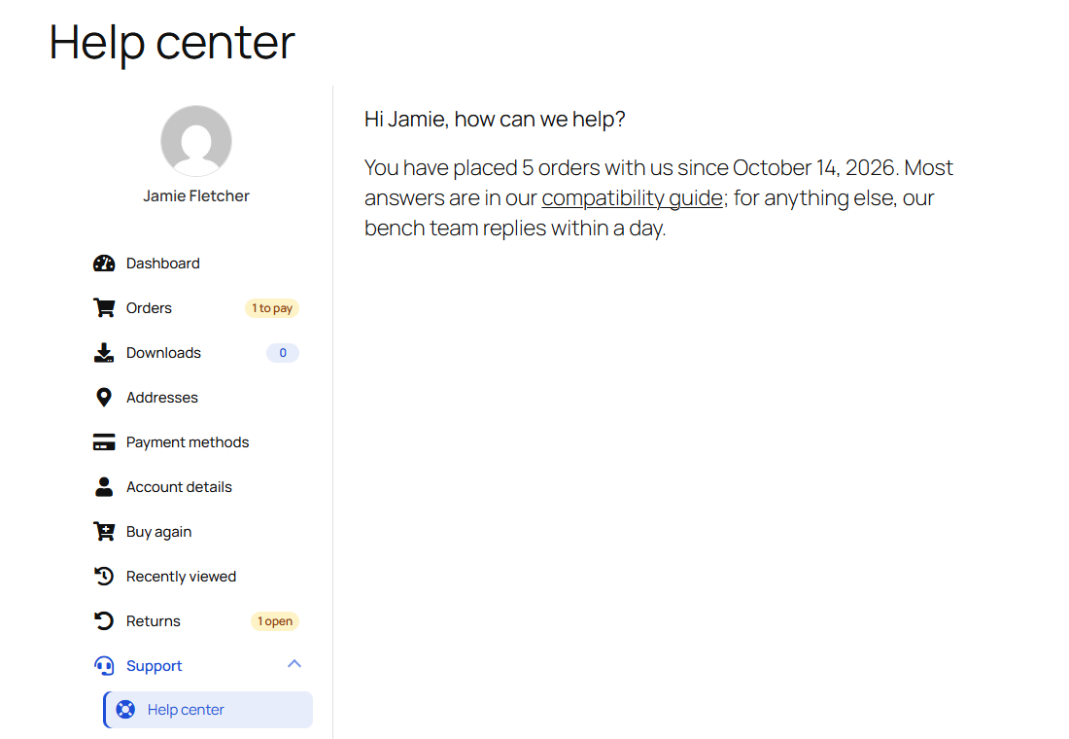
Image: 12-front-group-and-endpoint.png

Show Each Item to the Right Customers
Every item and banner has the same visibility rules: user roles, a date range, products bought, at least or at most a number of orders, an amount spent, or a last order more than N days ago. A VIP page for big spenders or a “we miss you” offer takes a minute to set up.
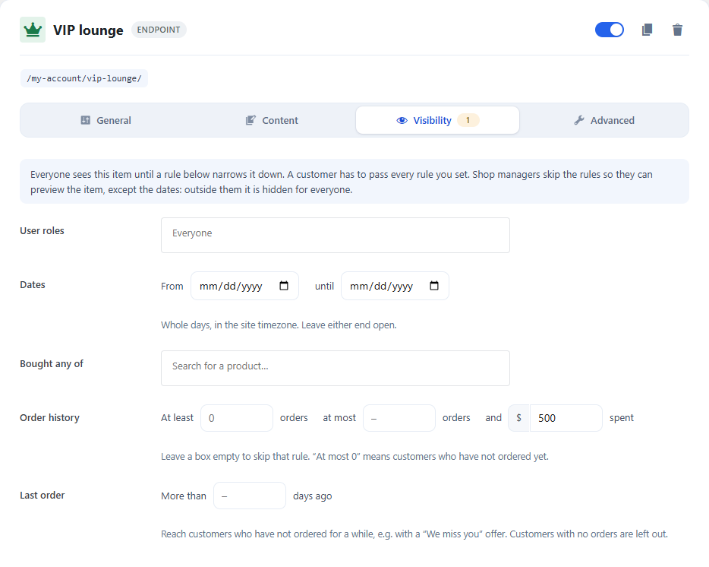
Image: 08-item-visibility.png

A Menu for Every Customer Group
Wholesale buyers or members can get a menu of their own. It starts as a copy of the main menu; take items out, add others and reorder it. Everyone else keeps the main menu.
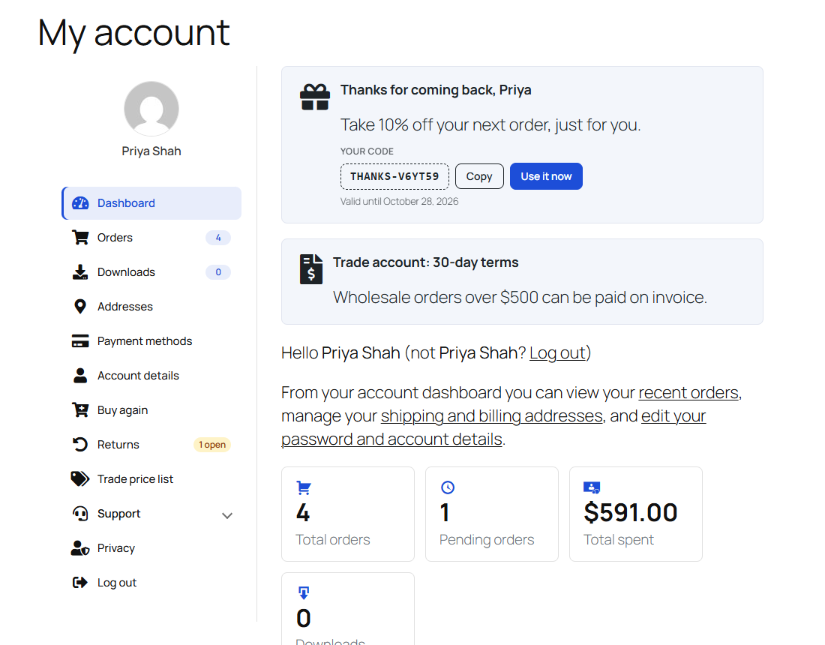
Image: 44-wholesale-customer.png

Design It Beside a Live Preview
The Design Studio shows the real account page at desktop, tablet and phone widths while you change colours, typeface, density, the menu style and the profile card. Start from a look:
- Classic Sidebar — a left menu with a subtle active bar
- Modern Cards — raised cards with icon chips
- Rounded Pills — soft pill items with a coloured active state
- Tabbed Top — a tab bar above the content
- Minimal — flat and borderless
- Theme Native — your theme’s own styling

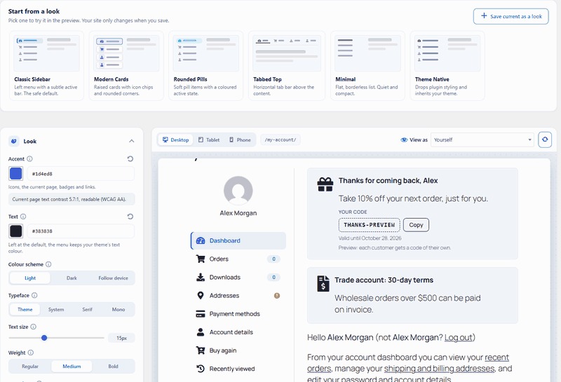
GIF: 14-design-looks.gif

Arrange the Dashboard
Drag the greeting, account numbers, profile meter, shortcut tiles, order tracking and Buy again into any order, or hide them. The preview follows at once, and nothing goes live until you save.
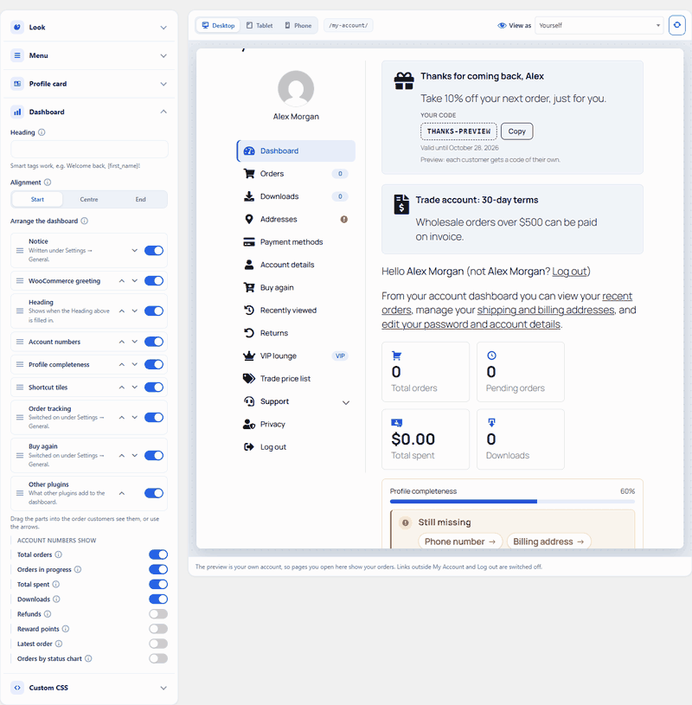
GIF: 18-arrange-dashboard.gif

See My Account as Any Customer
Pick a customer in View as and the preview shows their menu, badges, offers and dashboard. A bar lists everything hidden from them, and why. It only looks: nothing is changed, sent or counted for them.
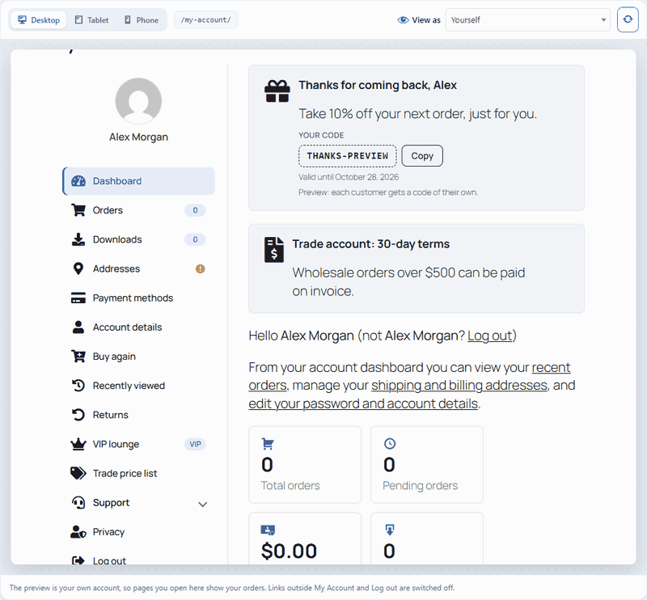
GIF: 21-view-as-customer.gif

Banners and Personal Offers
Put banners at the top or bottom of any account page, with an icon, text, a link and an order or cart count. Switch on a personal offer and each customer who sees the banner gets a one-use coupon for their own email, valid for the days you choose.
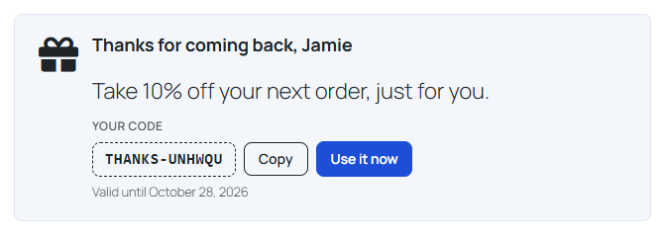
Image: 26-front-offer-banner.png

Self-Service Returns and Cancellations
Customers cancel an order that has not shipped, within the hours you allow, and request a return on a completed order with a reason and a photo. You answer each request on the Returns tab, and the customer is emailed.
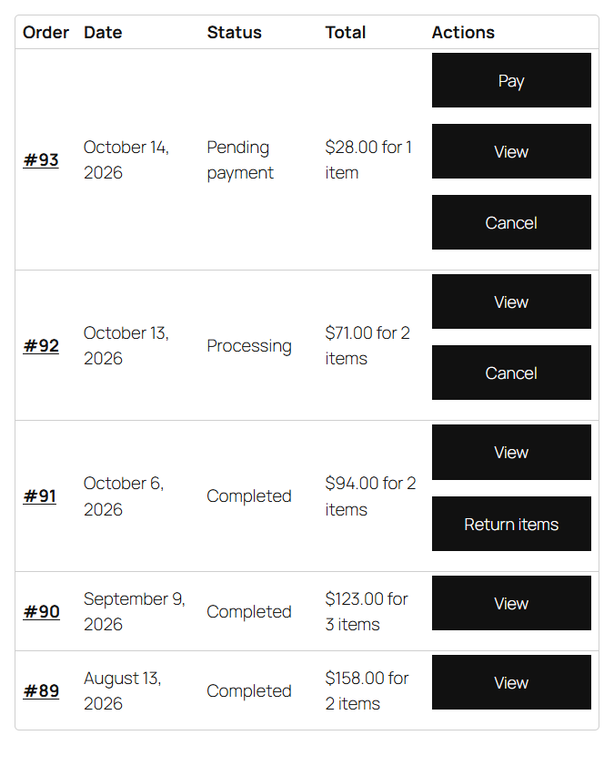
Image: 29-front-order-actions.png

Buy Again, Recently Viewed and Order Tracking
Past purchases sit one click from the cart, recently viewed products wait on their own page, and recent orders show their progress on the dashboard.
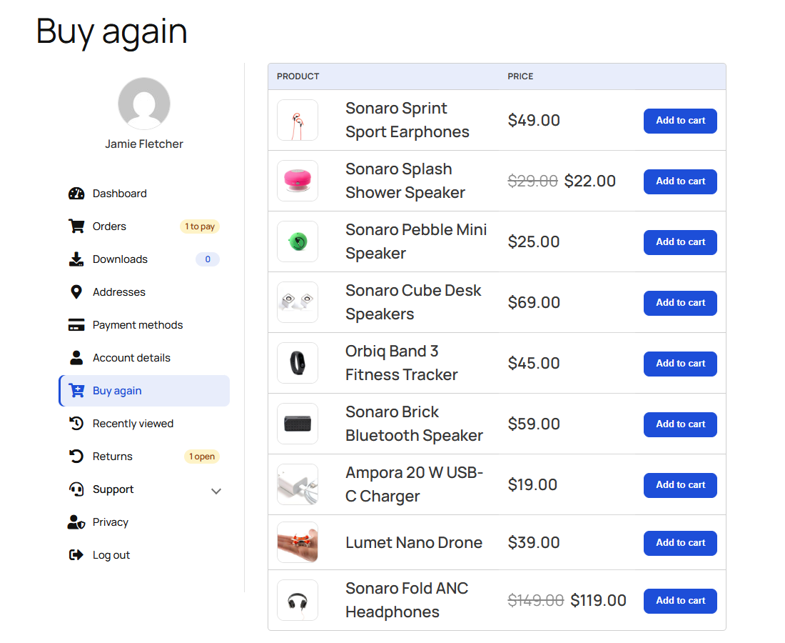
Image: 38-buy-again.png

Ask Customers the Questions You Need
Add a VAT number, a company, a birthday or a dropdown to the registration form and account details. Answers show on the admin order screen and work as smart tags.
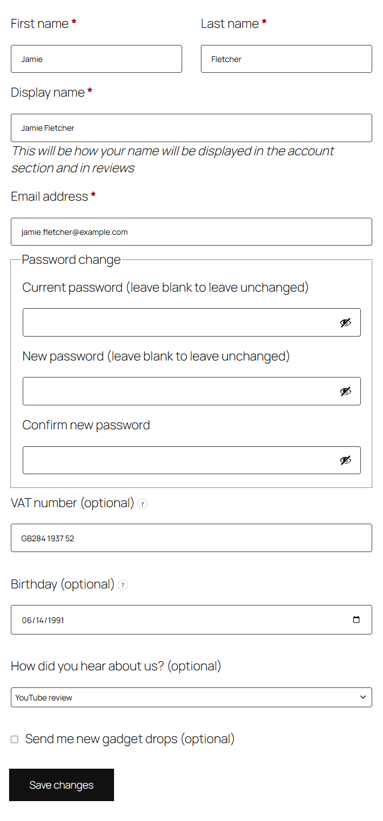
Image: 28-front-account-fields.png

Know What Gets Used
Insights counts account page views, banner clicks and the sales personal offers bring, over 7, 30 or 90 days. Only daily totals are kept.
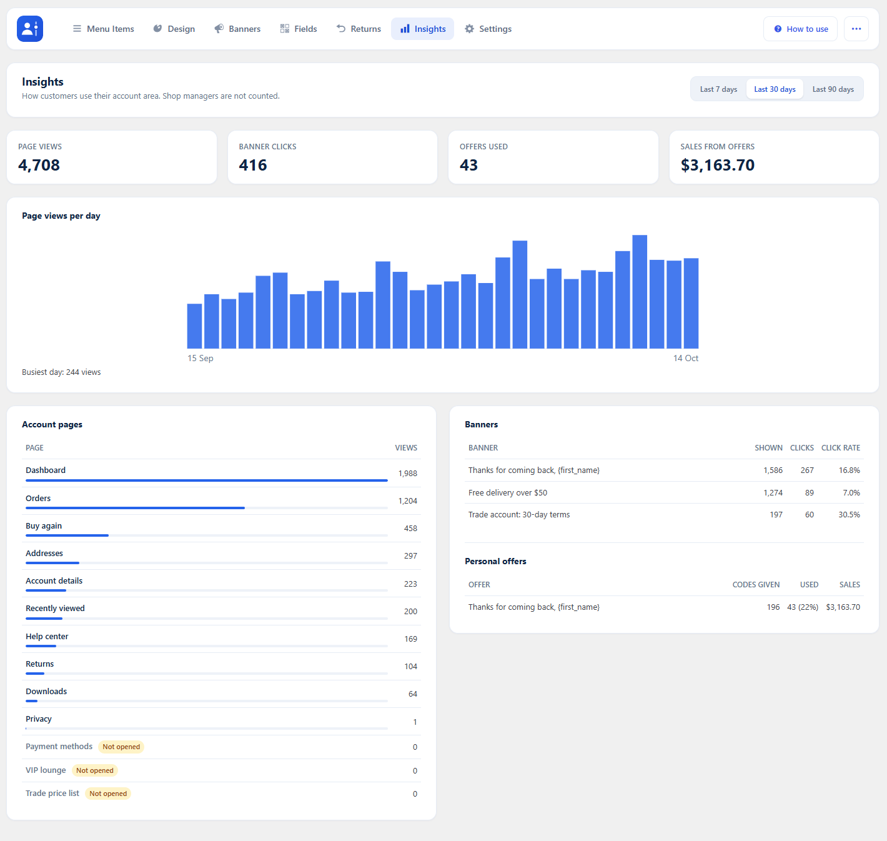
Image: 33-insights.png

Works on Phones
On small screens the menu folds into an Account menu button.
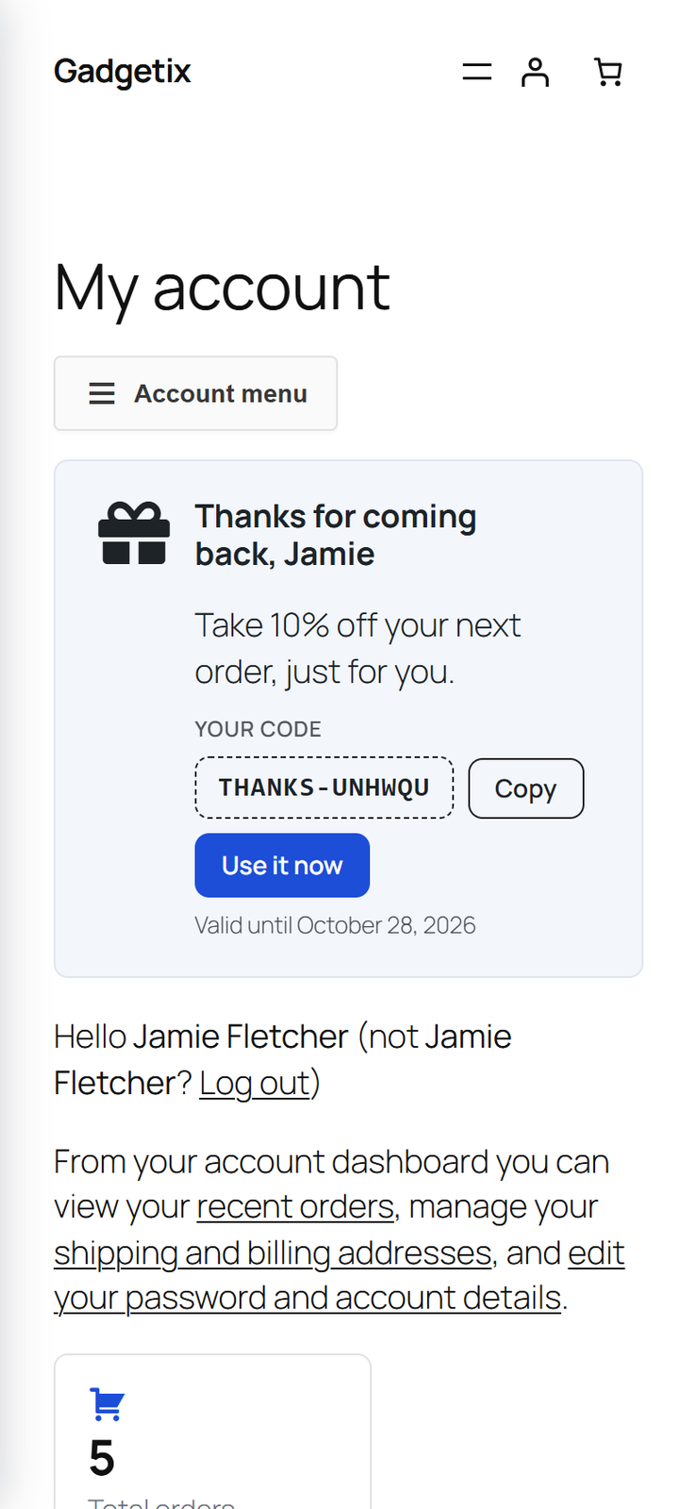 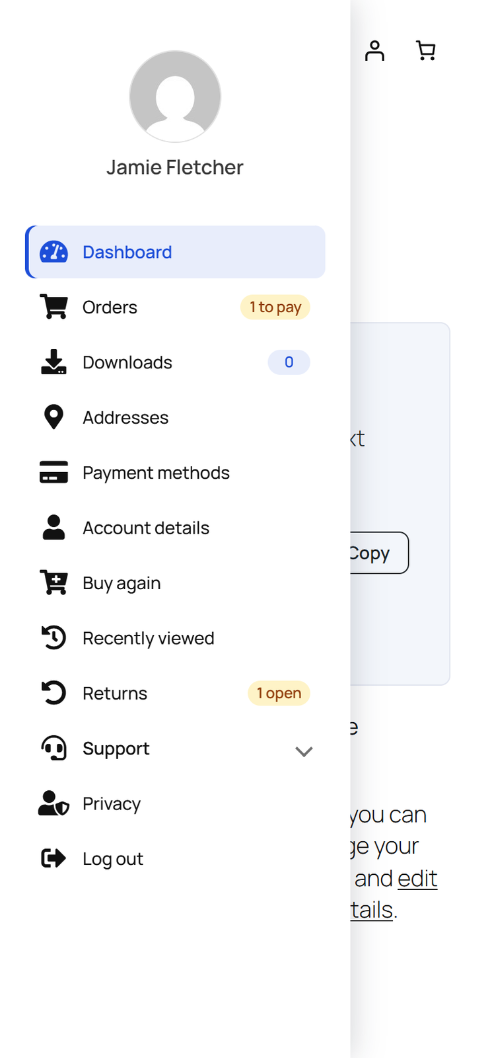
Image: 43-front-phone.png · Image: 43b-front-phone-menu.png

Requirements
WordPress 6.0+, WooCommerce 6.0+ and PHP 7.4+.
Compatible with HPOS and the Cart and Checkout blocks. Translation ready, with WPML and Polylang support.

Media to Upload
Files are in submission/docs-media/ ( icons in its icons/ folder ). The product icon and gallery images are listed in submission/media/README.md.
Where | File
Under the pitch | 01-my-account-dashboard.png
Card: Drag-and-Drop Menu | icons/icon-menu.png
Card: Your Own Account Pages | icons/icon-endpoints.png
Card: The Right Items for the Right People | icons/icon-rules.png
Card: Menus for Customer Groups | icons/icon-groups.png
Card: Design Studio | icons/icon-design.png
Card: Arrange the Dashboard | icons/icon-arrange.png
Card: View as a Customer | icons/icon-viewas.png
Card: Personal Offers | icons/icon-offers.png
Card: Returns and Cancellations | icons/icon-returns.png
Card: Buy Again | icons/icon-buyagain.png
Card: Customer Fields | icons/icon-fields.png
Card: Insights | icons/icon-insights.png
Build the Menu on a Canvas | 05-drag-menu-items.gif
Add Your Own Account Pages | 12-front-group-and-endpoint.png
Show Each Item to the Right Customers | 08-item-visibility.png
A Menu for Every Customer Group | 44-wholesale-customer.png
Design It Beside a Live Preview | 14-design-looks.gif
Arrange the Dashboard | 18-arrange-dashboard.gif
See My Account as Any Customer | 21-view-as-customer.gif
Banners and Personal Offers | 26-front-offer-banner.png
Self-Service Returns and Cancellations | 29-front-order-actions.png
Buy Again, Recently Viewed and Order Tracking | 38-buy-again.png
Ask Customers the Questions You Need | 28-front-account-fields.png
Know What Gets Used | 33-insights.png
Works on Phones | 43-front-phone.png, 43b-front-phone-menu.png

