FATIGUE-ADAPTIVE CLASSIFICATION
USING OPEN SURFACE EMG DATASETS
A Reproducible Subject-Independent Benchmark of Classical and Deep Learning, with Supervised Calibration and Ablation Analysis

COMPREHENSIVE SCIENTIFIC PROJECT REPORT
Prepared from the executed project notebook and exported experiment results

Abstract
Surface electromyography (sEMG) offers a non-invasive representation of muscle activation, but classifying fatigue from dynamic movements is challenging because spectral and amplitude signatures depend on the individual, muscle, movement, electrode arrangement, and recording conditions. This project systematically evaluates whether three-level self-perceived fatigue labels can be inferred from multichannel upper-limb sEMG in a participant-independent setting, and whether supervised personalization with a small labeled support subset offers additional benefit. A public dataset of 13 adults, 12 movement trials per participant, and synchronized fatigue ratings was processed using integrity and timestamp checks, muscle-signal filtering, one-second overlapping windows, and deterministic sampling. The exported run contains 156 matched trial pairs, 50 trial exclusions for timing integrity violations, and 11,692 labeled windows. Eight classification methods were compared: a majority baseline, logistic regression, radial-basis support vector machine, random forest, histogram gradient boosting, multilayer perceptron, one-dimensional convolutional neural network, and convolutional gated recurrent unit network. Participant-held-out evaluation was used for all methods; classical candidates were tuned using an inner validation scheme, and deep networks used training-side validation with early stopping. Histogram gradient boosting achieved the largest mean held-out participant macro-F1 (0.4354), narrowly ahead of the MLP (0.4344); the one-dimensional CNN and CNN-GRU achieved 0.3693 and 0.3569. The separate supervised adaptation experiment produced macro-F1 values of 0.3121 for source-only and 0.3104 following calibration, providing no evidence of a general macro-F1 improvement under the tested protocol. Feature ablations further suggested that time-domain descriptors retained most of the information captured by the complete feature set. These results emphasize the difficulty of generalizing subjective fatigue classification across individuals and support careful dataset auditing, subject-disjoint evaluation, and honest characterization of personalization outcomes. No clinical diagnostic claim is made.
Keywords: surface electromyography; perceived muscular fatigue; subject-independent evaluation; leave-one-subject-out; handcrafted features; convolutional networks; supervised calibration; reproducible research.

Executive findings
Indicator | Observed result
Participants / matched pairs | 13 / 156
Excluded recordings | 50 (42 EMG timestamp; 8 fatigue timestamp)
Analysis windows | 11,692; labels 0, 1, and 2
Best held-out mean macro-F1 | 0.4354 — histogram gradient boosting
CNN / CNN-GRU mean macro-F1 | 0.3693 / 0.3569
Adaptation macro-F1 (source / calibrated) | 0.3121 / 0.3104

Contents and navigation
1. Introduction and motivation
2. Research questions, objectives and scope
3. Literature review and scientific context
4. Dataset provenance and cohort
5. Data quality assurance and selection
6. EMG signal preprocessing and temporal annotation
7. Feature engineering and representation design
8. Model architectures and learning strategies
9. Experimental design and reproducibility
10. Evaluation methodology and uncertainty
11. Primary results
12. Personalization and adaptation analysis
13. Feature ablation and error diagnosis
14. Discussion and synthesis
15. Threats to validity, ethics and limitations
16. Conclusions and future work
References
Appendix A. Reproduction record
Appendix B. Additional evaluation tables

1. Introduction and motivation

1.1. Why muscle fatigue is a challenging classification target
Muscular fatigue is not simply a discrete event in the electrophysiological signal. It involves task-dependent changes in contractile capability, neural recruitment, motor-unit firing patterns, force control and the individual experience of effort. Surface electromyography captures the combined electrical activity observable at the skin, but its measured amplitude and frequency composition are also influenced by movement geometry, electrode placement, skin impedance, subcutaneous tissue, and crosstalk. As a consequence, the relationship between a recorded window and a self-perceived fatigue category is conditional on multiple factors that a fixed classifier cannot necessarily identify.
The current study treats fatigue as an ordinal self-reported target with three observed levels rather than as a clinical diagnosis. This choice is essential to interpreting the outcome: predicting a perceptual rating is not equivalent to quantifying neuromuscular failure or diagnosing fatigue-related pathology. The target may contain label delays, individual response thresholds, and substantial variation between movements. A scientifically sound evaluation must therefore separate genuine participant transfer from memorization of participant-specific signal baselines.

1.2. Applications and practical relevance
Reliable monitoring of changes in muscle status could eventually support ergonomic assessment, training-load awareness, fatigue-sensitive human–robot interaction, and assistive systems. Such applications require not merely high pooled accuracy but robust performance on previously unseen people, transparent error profiles across categories, realistic runtime constraints, and a defensible strategy for collecting any personalization data. The study deliberately emphasizes those questions rather than claiming immediate deployment readiness.

1.3. Contributions of this project
The work delivers a reproducible analysis of a public upper-limb sEMG dataset, a verified mapping between individual movement trials and fatigue annotations, an exclusion log and label-window inventory, a participant-independent benchmark spanning traditional and deep architectures, a separately interpreted supervised support-calibration experiment, feature-domain ablations, class-level error diagnostics, and exported artifacts sufficient to audit the reported numerical results. The most relevant contribution is methodological: it documents what survives a subject-disjoint test, including negative results.

2. Research questions, objectives and scope

2.1. Main research question
To what extent can three-level perceived muscular fatigue be classified from short multichannel surface-EMG windows in previously unseen participants, and does limited supervised subject-specific calibration improve performance under an explicitly defined temporal support/query protocol?

2.2. Specific hypotheses and assessment

RQ1 — Classical versus deep models
Compare feature-based discriminative models with networks trained on standardized raw windows. Performance is judged by participant-level mean macro-F1, with balanced accuracy, per-class metrics and runtime as supporting endpoints.

RQ2 — Generalization across people
Quantify spread between the 13 held-out participants and bootstrap subject-level uncertainty. A per-window random split would not be an equivalent test because neighboring windows and participant signatures could leak across partitions.

RQ3 — Value of calibration
Test whether a labeled early support segment improves prediction on temporally later query data, with a guard gap. The calibration question is separate from the unseen-subject zero-shot benchmark and cannot be conflated with it.

RQ4 — Representation dependence
Compare time-domain, frequency-domain and combined handcrafted features. A reduction in performance after removing a domain indicates contribution under this model and split design, not causal proof that one physiological process is unimportant.

2.3. Study boundaries
The study uses one public cohort, one data collection protocol, three perceptual categories, and predominantly offline signal processing. It does not estimate external-site deployment performance, prove causal biomarkers of fatigue, test medical sensitivity/specificity, or establish prospective streaming readiness. Interpretations are restricted to the evaluated dataset and the executed notebook settings.

3. Literature review and scientific context

3.1. Physiological foundations of myoelectric fatigue manifestations
The landmark review by De Luca [2] describes fatigue-associated changes in myoelectric activity, especially shifts in spectral content during sustained contractions, while emphasizing physiological complexity. Such observations motivate descriptors including median frequency and mean frequency, but their behavior in dynamic upper-limb tasks can be confounded by force, speed, muscle length, and electrode orientation. The present project consequently avoids treating a single frequency metric as a definitive fatigue detector and instead evaluates multiple complementary families of features.
The broader sEMG exercise-fatigue review [3] discusses the complete sensing and analysis chain—acquisition, preprocessing, representative features, classification and multimodal opportunities. That context explains why signal-derived features should be judged alongside sampling, task design and labels, rather than detached from how fatigue was measured. In this study the reference labels are self-perceived, so discrepancies between electrophysiological descriptors and perception are expected rather than automatically reducible to modeling error.

3.2. Feature-based recognition and the redundancy problem
Phinyomark, Phukpattaranont and Limsakul [4] examined feature reduction and selection for EMG recognition and reported that many handcrafted time-domain descriptors share information. This work supports the use of feature ablations and regularized classifiers, but it also cautions against interpreting many extracted features as many independent physiological measurements. The executed benchmark used a 44-dimensional descriptor representation and explicitly tested time-only and frequency-only variants. This approach makes the claimed utility of spectral descriptors empirically falsifiable.

3.3. Subject variability, evaluation leakage and domain shift
Cross-person EMG transfer is difficult because the observation model differs across individuals. If randomly selected windows from the same trial appear in both train and test, a model can exploit correlated temporal segments, recording baselines, participant-specific amplitude scaling and movement signatures. Such a split answers a within-recording interpolation question, not deployment to a novel subject. Leave-One-Subject-Out (LOSO) evaluation instead trains on 12 people and tests on the thirteenth, repeating the process for each participant. This is a stronger internal validity design for the chosen deployment question, although it still uses participants from one collection site.
Model selection introduces a second leakage risk. Choosing hyperparameters based on the same held-out participant used to report accuracy would optimistically bias the benchmark. Accordingly, the project specifies inner selection on training-side data for classical models and training-side validation for the deep systems. Feature standardization and other learnable transforms must remain within the training pipeline in every fold.

3.4. Classical learning algorithms in EMG
Linear classifiers provide simple, interpretable capacity controls; nonlinear support vector machines accommodate curved decision surfaces in a standardized feature space; random forests can represent nonlinear interactions; histogram gradient boosting adds sequentially refined trees; and multilayer perceptrons represent smooth nonlinear feature combinations. Because time-frequency features compress potentially relevant information while reducing sequence dimensionality, these classifiers can be competitive on datasets with modest numbers of independent human participants. Their advantage should not be assumed in advance and is tested here.

3.5. Deep temporal architectures and their trade-offs
One-dimensional convolutional networks learn localized temporal filters directly from multichannel sequences, potentially capturing waveform envelopes and short-term morphology without manual descriptors. A CNN-GRU hybrid combines convolutional encoding with gated recurrence so that the temporal arrangement of encoded features may matter. These extra degrees of freedom require careful regularization and validation: the apparent availability of thousands of overlapping windows does not increase the number of independently sampled participants beyond 13. Deep model capacity can therefore exceed the diversity of the training cohort.

3.6. Personalization and adaptation in fatigue monitoring
A personalization protocol can compensate for participant-specific amplitude and label thresholds, but the definition of adaptation matters. Supervised support calibration is a practical strategy only where a new subject can provide labeled examples; it is not zero-shot transfer. Temporal ordering further matters because future labels should not inform earlier predictions. The experiment here reserves a labeled early support fraction and evaluates later observations following a gap, so any observed improvement is attributable to this defined assisted scenario rather than to unsupervised deployment.

3.7. Positioning against the available literature
Prior EMG feature research motivates engineered representations [4], the fatigue physiology literature motivates spectral interpretation [2], and the open dataset record defines the available cohort and label semantics [1]. The research gap addressed here is an integrated, participant-independent comparison with transparent exclusions and an adaptation experiment that allows a negative outcome to remain visible. This is a within-dataset benchmark rather than a claim of state-of-the-art superiority across heterogeneous studies; numerical scores from other datasets would not be directly comparable without harmonizing labels, tasks and evaluation splits.

3.8. Literature review synthesis
Theme | Established rationale | Implementation / limitation in this study
Spectral shifts | Fatigue can change myoelectric frequency distribution [2] | Frequency features included; no single-feature diagnosis
Feature redundancy | Many features carry overlapping information [4] | Ablations test time and spectral subsets
Collection protocol | Perceived-fatigue dataset has task-specific labels [1] | Labels treated as subjective ordinal ratings
Transfer evaluation | Shared subject identity may inflate random-split estimates | Participant-disjoint LOSO outer folds
Model complexity | Sequence models may learn temporal dependencies | CNN and CNN-GRU compared with feature-based models
Calibration | Labeled support can help adapt to new subjects | Separate temporal supervised-support experiment

4. Dataset provenance and cohort

4.1. Public source, access and ethics context
The analysis uses “A Dataset of sEMG and Self-Perceived Fatigue Levels for Muscle Fatigue Analysis,” released by Cerqueira and collaborators through the University of Minho and archived on Zenodo as record 14182446 [1]. The record describes 13 healthy adults completing 12 upper-body dynamic movement trials per individual, involving eight instrumented muscles across the two arms (typically four channels active within a particular recording). The dataset includes time-stamped subjective fatigue levels coded 0, 1 and 2, protocol information and participant metadata. The reported study uses only the research archive; it does not acquire new human data.

4.2. Nested archive structure and exact pairing
The root sEMG and fatigue archives contain subject-level ZIP files. Within each subject archive, trial_N.csv contains raw EMG measurements and Trial_N.csv contains corresponding fatigue timestamps and labels. The executed manifest identifies 156 one-to-one trial pairs, exactly 13 participants multiplied by 12 trials. File identity was determined by participant and trial number; alignment of the paired files was then checked using their numeric time columns. MVC recordings exist in the source archive but are not described as inputs to the executed classification feature pipeline.

4.3. Sampling rates, channels and labels
The archive states an EMG acquisition rate of approximately 1259 Hz and fatigue ratings sampled at 50 Hz [1]. The preview and schema audit show EMG timestamps in seconds, repeated alongside channel voltage columns; each file supplies four observed muscle channels, and channel names vary with the measured side. The fatigue stream contains “time” and “label” columns. Labels represent subjective fatigue levels, not independently confirmed metabolic or force-decline states. The model is therefore assessed as a three-class perceived-fatigue classifier.

4.4. Final modeling inventory
Quantity | Value
Participants | 13
Trial pairs indexed | 156
Trials excluded after timing checks | 50
Trials remaining after exclusions | 106
Labeled sampled windows | 11692
Label 0 windows | 4,198
Label 1 windows | 3,617
Label 2 windows | 3,877
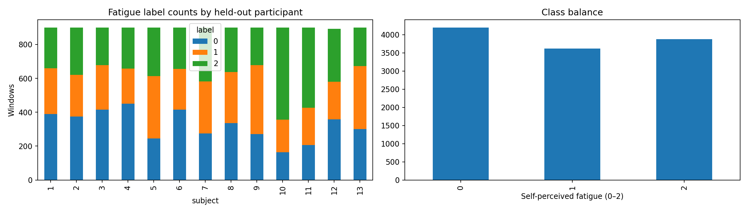
Figure 1. Label distribution and exploratory dataset balance from the executed run.
The distribution is not perfectly uniform (approximately 35.9%, 30.9% and 33.2% for labels 0, 1 and 2, respectively). Nevertheless, overall window balance alone is insufficient: subjects and movement trials can exhibit different local label prevalences, and the held-out test participant may have a different mix from training subjects. Macro-averaged metrics are used for this reason.

5. Data quality assurance and selection

5.1. Why explicit audit is indispensable
Invalid timestamps can distort filter frequency assumptions, create nonphysical temporal mappings, or cause windows to receive labels from the wrong instant. A classification pipeline can produce plausible-looking metrics despite such contamination. The notebook therefore inspects the structure of every paired trial and records failures rather than silently repairing them. The archived schema audit enumerates 156 trial-level inspections and the excluded-trials file records each exclusion and reason.

5.2. Observed exclusions and integrity outcomes
Exclusion reason | Trials | Interpretation
Non-monotonic EMG time | 42 | Consecutive EMG time entries did not strictly increase
Invalid fatigue time | 8 | Label-timestamp stream did not pass validity checks
Total exclusions | 50 | Recorded pairs not converted into the analysis window set
Fifty exclusions represent approximately 32.1% of the 156 matched pairs. This is a substantial data-quality limitation and not a trivial preprocessing footnote. Strict rejection protects temporal validity but changes the analyzed population of trials. The study does not establish whether excluded recordings are missing at random with respect to fatigue level, movement or participant; therefore complete-case selection bias cannot be ruled out. Any generalization claim must be bounded to the retained recordings.

5.3. Reporting the data-quality trade-off
The protocol could alternatively attempt timestamp reset segmentation or informed repairs. However, such approaches require understanding the original acquisition format and validation against the source protocol. The executed project chose conservative exclusion. That choice prevents unsupported correction of potentially corrupted sequence order but reduces data coverage. A future robustness experiment should document acquisition discontinuities and compare safe segmentation with strict complete-trial exclusion under the same subject-disjoint evaluation.

5.4. Integrity checks across the computational chain
The procedure checks archive file presence, subject/trial pairing, column readability, numeric EMG channel selection, finite values, time ordering, sampling plausibility and fatigue time integrity before constructing feature windows. The downstream outputs—schema_audit.csv, excluded_trials.csv, verified_trial_manifest.csv and window_metadata.csv—allow reviewers to trace the principal sample counts. Numeric agreement between all intermediate stages should be treated as a necessary reproducibility requirement, not as proof of physiological validity.

6. EMG signal preprocessing and temporal annotation

6.1. Signal filtering assumptions
EMG channels were processed on a trial-wise basis using a fourth-order Butterworth band-pass filter over 20–450 Hz and an optional mains-frequency notch stage as specified in the executed notebook. The lower cutoff attenuates movement artifact and slow baseline variation; the upper cutoff limits high-frequency contributions and noise. Trial-wise preprocessing avoids filtering across abrupt recording boundaries. The notebook uses offline zero-phase filtering, which is suitable for retrospective signal analysis but requires future samples and therefore cannot directly be described as a causal streaming implementation.

6.2. Window construction
The study segments recordings into 1.0-second windows with a 0.5-second hop, yielding 50% temporal overlap. For a nominal sampling frequency of 1259 Hz, a one-second window contains roughly 1259 EMG samples per channel. Overlap increases the number of feature examples while preserving continuity, but adjacent windows share raw observations and must never be interpreted as statistically independent participants or trials. All such windows remain together within each participant’s outer fold.

6.3. Aligning asynchronous fatigue annotations
The EMG and perceived-fatigue streams operate at different rates. Their common time basis is used to attach fatigue information to EMG windows, subject to a maximum tolerated age of 0.2 seconds. A label-purity requirement of 0.8 excludes windows near transitions for which one label does not dominate sufficiently. The resulting labels represent window-level approximations to time-varying subjective annotations, rather than direct continuous measurements of fatigue physiology.

6.4. Deterministic window caps
The executed configuration constrains samples to no more than 900 windows per participant and 150 windows per trial, using a fixed random seed of 42. These limits bound computation and reduce domination by very long recordings. They also mean the experiment is not a full exhaustive-window evaluation: selection can alter which durations, tasks and fatigue transitions are represented. We therefore report the exact number of sampled windows and flag the need for a full-window sensitivity analysis in future work.

6.5. Mathematical formulation
Let x_c[n] denote the voltage sequence of EMG channel c; filtered output is x̃_c[n] = F(x_c[n]), where F represents the offline filtering operator. For each start index s, a window W_s contains x̃_c[s:s+L] for c = 1,…,4, with L ≈ f_s seconds × 1.0 and hop H ≈ f_s × 0.5. The class y_s ∈ {0,1,2} is assigned from temporally valid fatigue annotations, subject to purity and freshness conditions. This mapping defines the unit of prediction used in every model score.

7. Feature engineering and representation design

7.1. Feature families
For the classical benchmark, the executed workflow produces 44 signal features—11 descriptors per channel across four measured channels. The representation combines amplitude/energy statistics, temporal complexity indices and frequency-domain measures. Such a fixed-size representation permits classical algorithms to operate on windows of equal length without learning convolutional filters from raw voltages. As the data are multichannel, the overall vector describes several muscles but does not directly model all cross-channel temporal interactions.

7.2. Amplitude and time-domain quantities
Root mean square (RMS) summarizes signal power and is computed as sqrt((1/N) Σ_n x[n]²). Mean absolute value (MAV) is (1/N) Σ_n |x[n]|. Waveform length (WL) is Σ_(n=2)^N |x[n] − x[n−1]| and tracks overall signal activity and complexity. Related descriptors such as signal variance, integrated amplitude, sign-change and thresholded-activity counts can complement these statistics but are sensitive to scale and thresholds. They should be interpreted as descriptors of recorded voltage patterns, not direct measurements of muscle force.

7.3. Spectral measures
A power spectral density estimate P(f) supports mean frequency MNF = Σ_f fP(f)/Σ_f P(f) and median frequency MDF defined so that half of total spectral power lies on each side of MDF. Other normalized spectral summaries can reflect distribution shape and band-energy composition. A downward frequency shift may be associated with fatigue in particular contraction protocols [2], yet movement-related changes can produce similar shifts. Spectral statistics therefore enter a multivariate classifier rather than serving as standalone fatigue truth.

7.4. Scaling and avoiding leakage
Models sensitive to feature magnitude should fit their standardization parameters using only the training subjects within each fold. Transforming held-out participants with training-derived scaling is permitted; recomputing mean or variance from the held-out participant without declaring an adaptation procedure would leak test-domain information. For neural sequence models, per-channel normalization is similarly derived on training windows. Within-fold preprocessing is a key distinction between a reproducible benchmark and an optimistic proof-of-concept.

7.5. Feature selection implications
An expanded feature vector can introduce correlated or noisy quantities and raise tuning variance. The ablation analysis addresses one aspect of this problem by comparing time-only, frequency-only and combined representations. It does not replace formal sequential feature selection or causal attribution, but it identifies whether broad feature families contribute incremental predictive utility on held-out people.

8. Model architectures and learning strategies

8.1. Majority baseline
The majority classifier predicts the most prevalent class observed in each training fold, providing a sanity-check lower-capacity reference. Its subject-mean macro-F1 of 0.1737 is substantially below the feature-based methods. Its balanced accuracy is 0.3333, as expected for a single fixed prediction across a three-class test in which all categories are represented. It is not a realistic deployed model, but it quantifies the cost of ignoring EMG entirely.

8.2. Logistic regression
Multinomial logistic regression maps standardized descriptors to class probabilities using a linear score function followed by softmax. Regularization limits coefficient growth and offers a stable baseline with modest training complexity. It is particularly useful for distinguishing gains from nonlinearity: if sophisticated models barely outperform it, the data may not support additional representational complexity reliably.

8.3. RBF support vector machine
The SVM with radial-basis-function kernel defines a nonlinear decision boundary in the feature space. It can fit interactions not linearly separable, while kernel width and regularization determine effective flexibility. This can be advantageous with moderate feature dimensionality but carries comparatively high inference cost when many support vectors remain. Training and scaling must be fitted on training subjects only.

8.4. Random forest
A random forest aggregates decorrelated decision trees to represent nonlinear feature interactions without requiring the same scale assumptions as distance-based models. Tree ensembles may tolerate heterogeneous descriptors and can expose coarse feature importance, although impurity-based importance can be biased by feature distribution and correlation. The benchmark primarily judges it on held-out participant performance rather than interpreting a tree as a physiology model.

8.5. Histogram gradient boosting
Histogram gradient boosting sequentially improves tree-based partitions using discretized feature values. Its inductive bias is well suited to nonlinear thresholds and structured tabular descriptors. In the executed comparison, this model achieved the highest mean subject macro-F1, but the margin over the MLP was approximately 0.001. Without stronger paired evidence this narrow difference should not be overstated as a statistically established superiority.

8.6. Multilayer perceptron
The MLP learns nonlinear combinations of standardized handcrafted features through stacked dense transformations and activation functions. Unlike a raw waveform network, it cannot recover details discarded during feature computation. However, the reduced input dimensionality and constrained parameterization can be an advantage with few independent subjects. Its near-leading macro-F1 suggests that a nonlinear learned decision surface over engineered features is competitive in this particular setup.

8.7. One-dimensional convolutional network
The 1D-CNN receives normalized multichannel temporal windows and learns localized time filters using convolution, nonlinear activation and aggregation before classification. It is designed to capture within-window morphology without explicit hand-engineered summary features. Its lower average performance than the feature-based leaders suggests that raw-sequence capacity alone did not overcome subject variation and label uncertainty under the executed training regime.

8.8. Convolutional gated recurrent network
The CNN-GRU variant adds a recurrent stage to convolutional embeddings, enabling order-dependent temporal context inside the window to affect class decisions. Although attractive for sequential muscle activation, recurrent capacity introduces extra optimization and validation demands. Its observed mean macro-F1 was below that of the CNN alone. This finding constrains claims about benefits of hybrid recurrence for short windows in a modest-sized cohort.

8.9. Training controls
The deep training configuration reports 18 maximum epochs, patience 5, and batch size 128, with CPU execution in the exported environment. Early stopping monitors training-side validation, and per-subject results plus learning curves are saved. These controls bound computational resources and help mitigate overfitting; nevertheless, modest epoch budgets and small cohorts may affect the comparative optimum. Deep and classical models thus share outer subjects but not necessarily identical training budgets or tuning search breadth.

9. Experimental design and reproducibility

9.1. Subject-independent outer folds
The primary evaluation uses 13 LOSO outer folds. For each fold, all examples from one held-out participant form the test set, while remaining participants are available for training and training-side model selection. Since no participant appears in both sides of a fold, estimates are not inflated by memorizing repeated windows from the same person. Results are recorded separately for every fold so that group-level variation is visible.

9.2. Nested hyperparameter selection
Classical model hyperparameters are selected within training subjects, with a log of per-fold chosen parameter settings. This reduces the risk of tuning directly to the held-out participant. The all_model_fold_scores.csv inventory contains 104 rows (13 subjects × 8 models), with model-specific validation fields where applicable. A fair reading recognizes that validation design, search size, and optimization method may differ among model families; macro-F1 remains an evaluation endpoint rather than evidence of perfectly matched compute budgets.

9.3. Deep validation and checkpoints
Both deep architectures are evaluated across the same 13 held-out participants. Training uses an additional training-side validation participant and early stopping, with best-epoch and curve information serialized per test subject. The deep_fold_errors.csv artifact is empty in the exported archive, which supports that no deep-fold error was logged, but it is not independent proof of correctness beyond the saved results.

9.4. Hardware, software and reproducibility
Execution metadata records Python 3.13.16, NumPy 2.1.3, pandas 2.3.3, SciPy 1.18.1, scikit-learn 1.9.1, and Matplotlib 3.10.0. The deterministic seed is 42; the reported deep compute device is cpu. The entire pipeline is contained in a single executed notebook, and the output package captures source configuration, fold scores, predictions, learning curves and integrity logs. Reproducibility still depends on the continued availability of the public data archive, library version compatibility and the computational randomness of libraries.

9.5. Comparison fairness and scope
Classical feature methods and raw-input neural models use the same outer subject identities, but they do not necessarily operate on identical intermediate representations or identical hyperparameter budgets. Their common macro-F1 metric allows benchmark comparison under the selected protocol; it does not isolate architecture as the sole explanatory variable. Similarly, the adaptation study has a distinct support/query design and is analyzed as a separate experiment rather than ranked directly against the zero-shot table.

10. Evaluation methodology and uncertainty

10.1. Confusion matrix and classification measures
A confusion matrix C_ij counts examples whose true class is i and predicted class is j. Per-class precision is TP/(TP+FP), recall is TP/(TP+FN), and F1 is 2PR/(P+R) where defined. Macro-F1 is the unweighted mean of the three class F1 values, giving low-prevalence states equal conceptual importance. Balanced accuracy averages per-class recall and reduces the influence of the global class mixture. Both measures are more informative than accuracy alone for heterogeneous test participants.

10.2. Participant-weighted summary rather than pooled-window dominance
The main model ranking is the mean of subject-level macro-F1 scores, not a single score computed after concatenating all windows. This prevents one participant with more retained windows from dominating the headline estimate. Pooled confusion matrices are still valuable as diagnostics because they show absolute error counts; however, their aggregated metrics need not numerically equal the participant-mean summary. The report explicitly distinguishes those estimands.

10.3. Uncertainty and paired testing
The exported 95% intervals are calculated by resampling held-out participants rather than individual overlapping windows. This better reflects the limited number of independent persons, although only 13 sampling units remain and bootstrap intervals can be unstable. Paired subject-wise comparisons are preferable to independent-window significance tests because models are evaluated on the same subject identities. Numerical proximity should not be represented as a statistically significant difference unless a suitable paired estimate supports that interpretation.

10.4. Runtime metrics
Milliseconds per window were recorded as an auxiliary inference-efficiency proxy. These measurements depend on implementation, batch size and CPU environment; they are not guaranteed edge-device latency and should not be used to imply real-time deployability. Offline filtering and feature extraction are also not necessarily included within the reported classifier inference timings.

11. Primary results

11.1. Full benchmark ranking
Model | Mean macro-F1 | SD across subjects | Balanced acc. | ms/window
Hist Gradient Boosting | 0.4354 | 0.0368 | 0.4627 | 0.0265
Mlp | 0.4344 | 0.0422 | 0.4610 | 0.0036
Svm Rbf | 0.4301 | 0.0524 | 0.4544 | 0.9274
Random Forest | 0.4226 | 0.0633 | 0.4555 | 0.0650
Logistic | 0.4173 | 0.0531 | 0.4515 | 0.0036
Cnn 1D | 0.3693 | 0.0754 | 0.4110 | 0.1204
Cnn Gru | 0.3569 | 0.0654 | 0.3926 | 0.4489
Majority | 0.1737 | 0.0363 | 0.3333 | 0.0002
Table 1. Subject-level benchmark means for all eight executed models; inference timings reflect the recorded runtime setup.
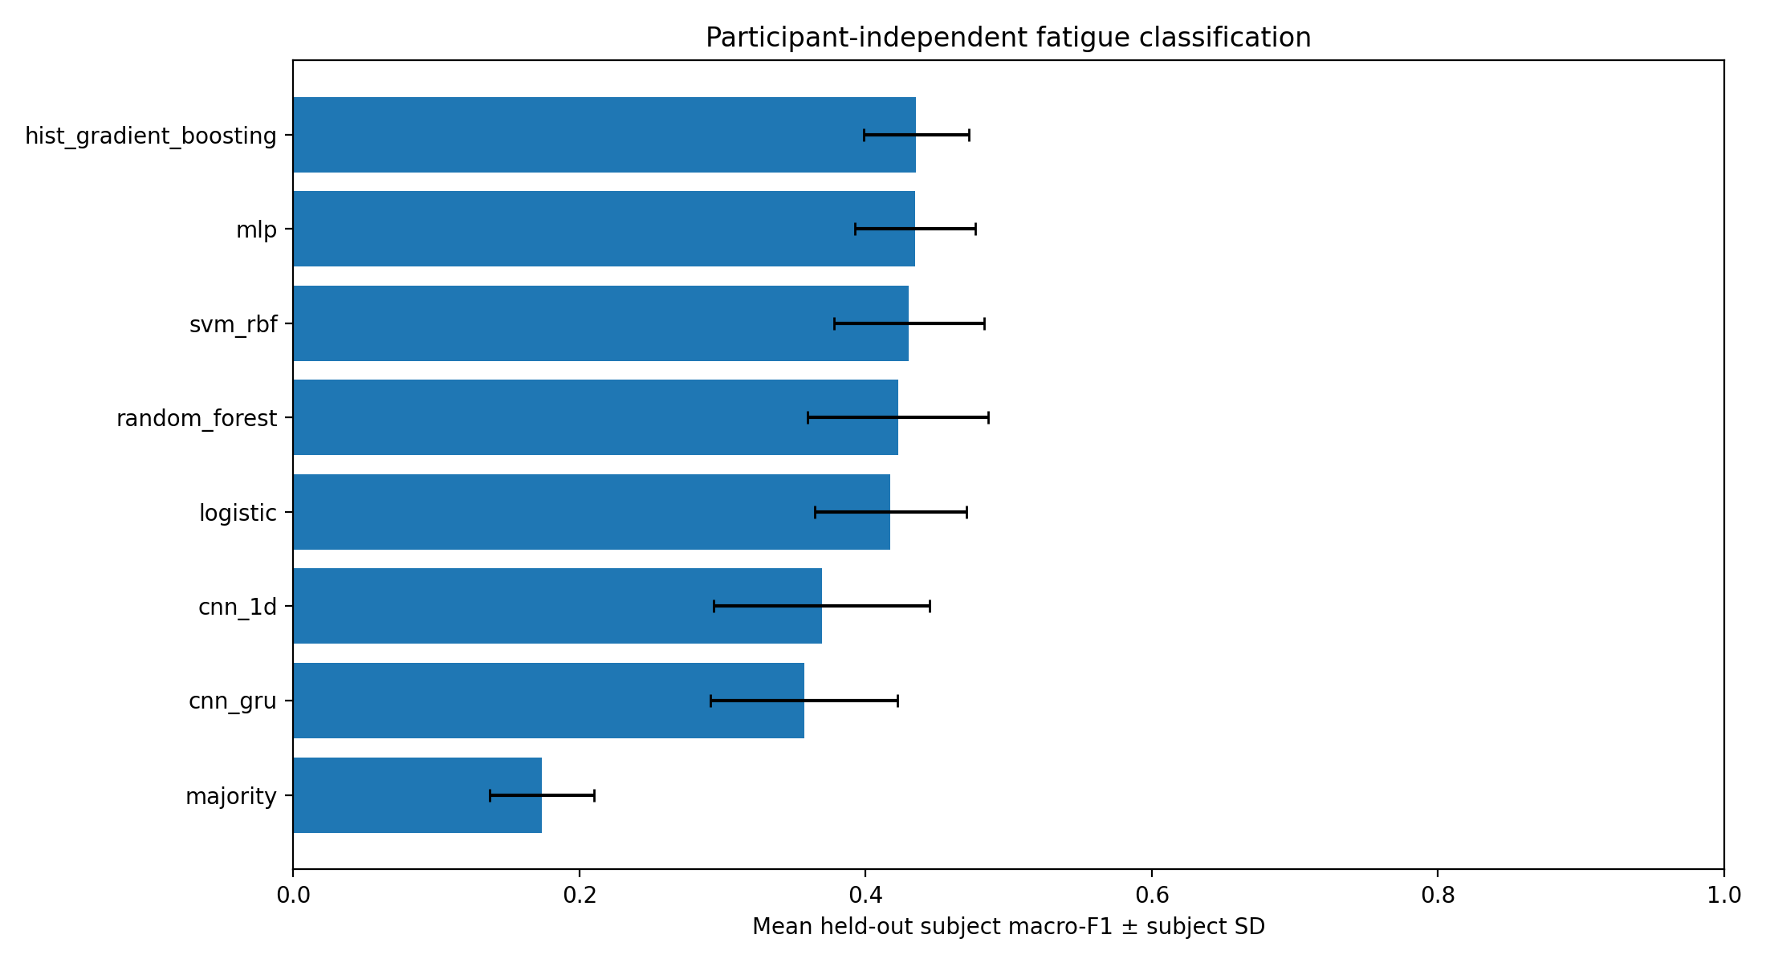
Figure 2. Comparison of all model families across the held-out participant benchmark.

11.2. Interpretation of the leading methods
Histogram gradient boosting achieved 0.4354 mean subject macro-F1, narrowly exceeding the MLP by 0.0010 and RBF SVM by approximately 0.0052. The differences between the leading feature-based models are small relative to the between-subject standard deviations, which range from approximately 0.037 to 0.052. Therefore the most defensible conclusion is that several feature-based classifiers perform similarly and outperform the two evaluated sequence networks under the executed settings, rather than that any one leading algorithm is decisively superior.
Compared with the majority baseline of 0.1737 macro-F1, the strongest model improves by roughly 0.2616 absolute points. The gap establishes useful information beyond the global class prior, but a mean macro-F1 below 0.5 also indicates substantial class overlap and/or domain shift. Performance cannot be described as clinically reliable; the results instead establish a quantitative starting point for subsequent methodological work.

11.3. Deep learning results
The 1D-CNN achieved 0.3693 mean subject macro-F1 (SD 0.0754), and the CNN-GRU achieved 0.3569 (SD 0.0654). Their variance across subjects is higher than the strongest classical results, and both trail the leading feature-based systems. The outcome is consistent with a setting where engineered descriptors summarize relevant information efficiently and raw-input networks may be more sensitive to limited participant diversity, short temporal context, or training schedule. This is interpretation, not an experimentally isolated causal explanation.

11.4. Cross-subject heterogeneity
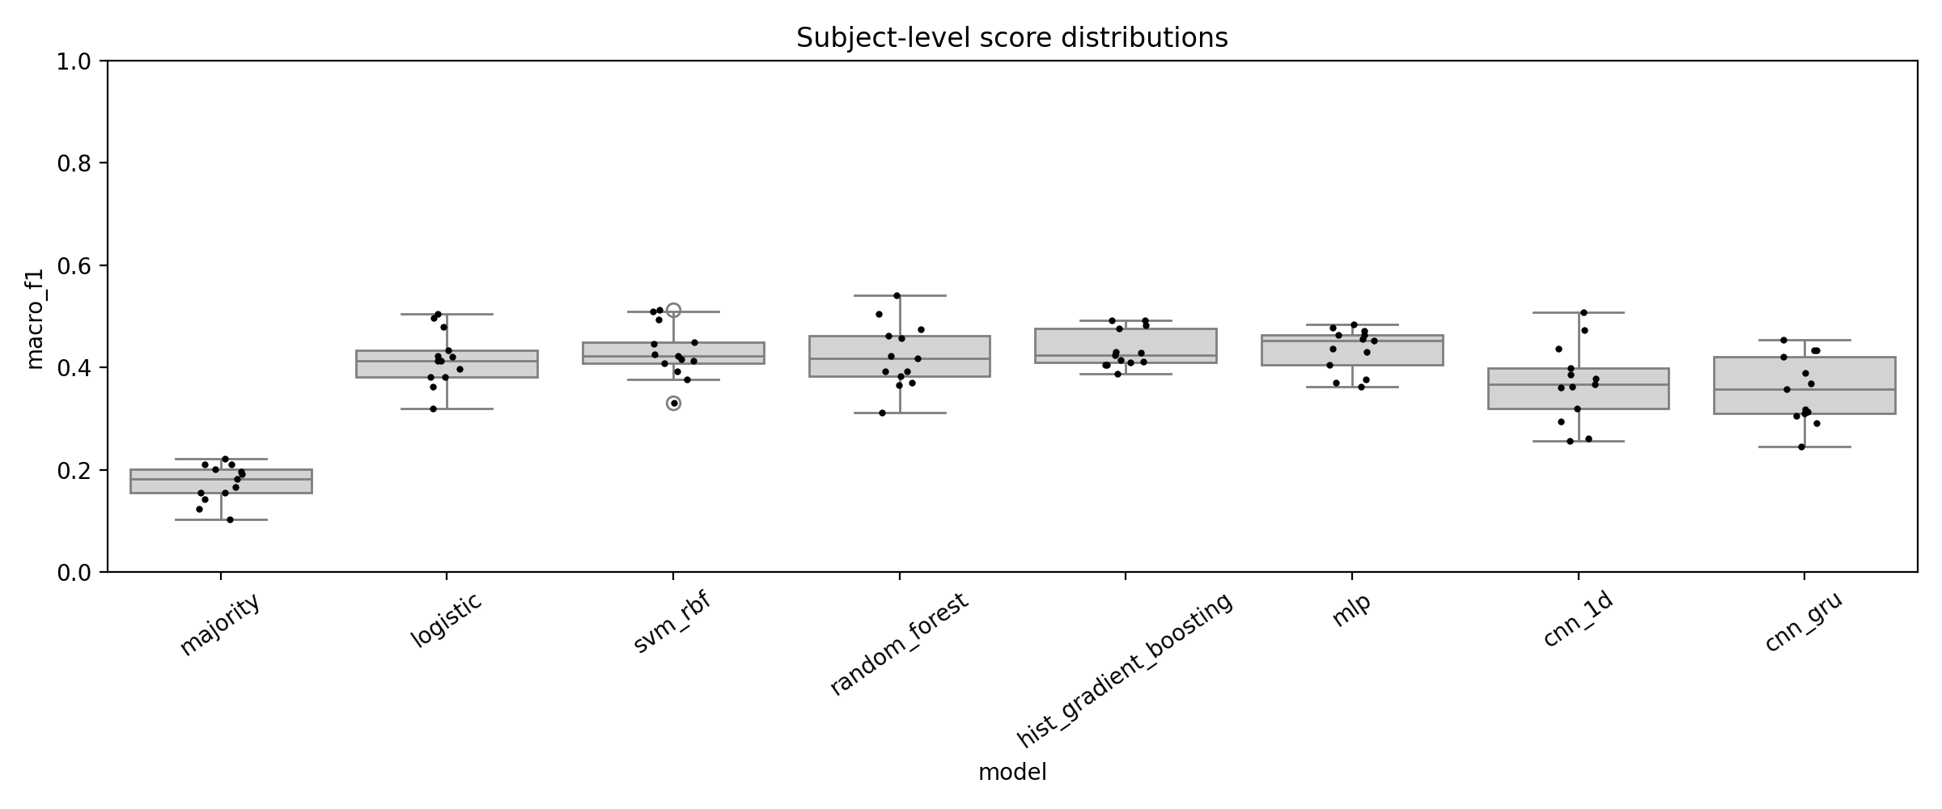
Figure 3. Per-participant score distributions across classification systems.
Held-out subject scores vary materially, illustrating that aggregate metrics conceal individual differences. A model that performs adequately for one person may struggle for another with different recorded muscle magnitudes, movements or label thresholds. Such variability directly motivates the adaptation question but also signals that dependable deployment would require broader demographic, physiological and protocol variation than this cohort contains.

11.5. Uncertainty intervals
Model | 95% lower | 95% upper
cnn 1d | 0.3312 | 0.4106
cnn gru | 0.3219 | 0.3907
hist gradient boosting | 0.4173 | 0.4559
logistic | 0.3891 | 0.4466
majority | 0.1537 | 0.1920
mlp | 0.4100 | 0.4552
random forest | 0.3898 | 0.4577
svm rbf | 0.4017 | 0.4578
These subject-resampling intervals should be understood as uncertainty summaries for this cohort and protocol, not as externally validated performance guarantees. Overlap between intervals is not itself a formal paired hypothesis test; the full fold-score and subject-paired artifacts remain available for formal comparison.

11.6. Error structure and confusion matrices
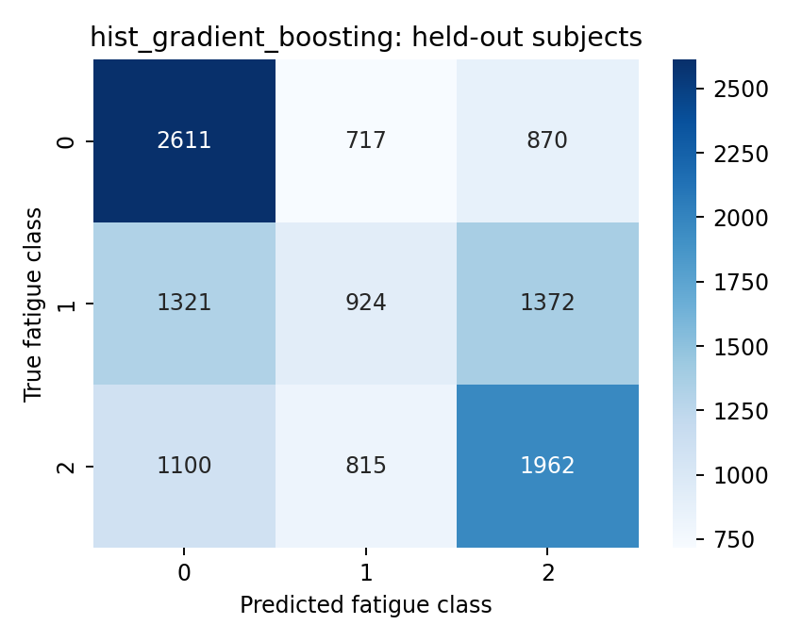
Figure 4. Pooled class-level confusion matrix for histogram gradient boosting.
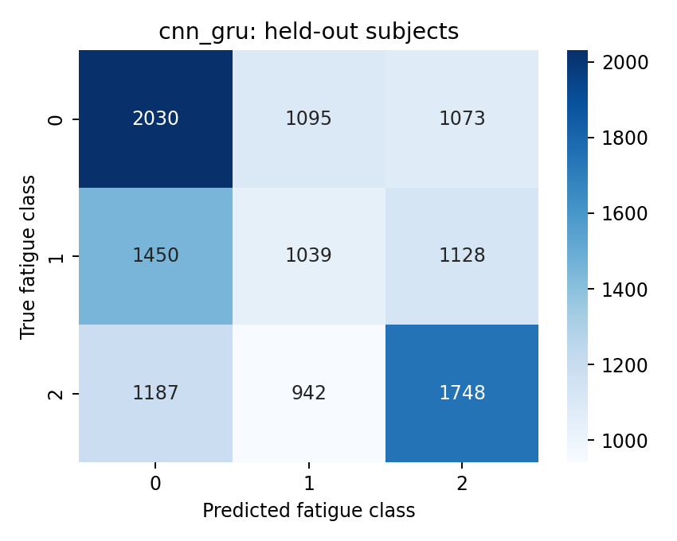
Figure 5. Pooled class-level confusion matrix for the CNN-GRU system.
The confusion matrices reveal which transitions between label levels are most commonly mistaken. Because labels 0, 1 and 2 are ordered, errors between adjacent fatigue levels are qualitatively different from confusing the two extremes; however, ordinary macro-F1 assigns no additional penalty to a two-level jump. The report therefore treats these matrices as necessary complements to the scalar ranking. An ordinal-aware loss or ordinal distance error would be worthwhile in future work.

11.7. Class-specific performance

Hist Gradient Boosting
Class | Precision | Recall | F1 | Support
0 | 0.519 | 0.622 | 0.566 | 4198
1 | 0.376 | 0.255 | 0.304 | 3617
2 | 0.467 | 0.506 | 0.486 | 3877
This class-wise breakdown should be read together with the total number of windows per label: a similar overall macro-F1 can arise from very different precision–recall trade-offs for low, moderate and high perceived fatigue.

Mlp
Class | Precision | Recall | F1 | Support
0 | 0.523 | 0.587 | 0.553 | 4198
1 | 0.369 | 0.287 | 0.323 | 3617
2 | 0.452 | 0.486 | 0.469 | 3877
This class-wise breakdown should be read together with the total number of windows per label: a similar overall macro-F1 can arise from very different precision–recall trade-offs for low, moderate and high perceived fatigue.

Cnn 1D
Class | Precision | Recall | F1 | Support
0 | 0.446 | 0.450 | 0.448 | 4198
1 | 0.346 | 0.301 | 0.322 | 3617
2 | 0.436 | 0.484 | 0.459 | 3877
This class-wise breakdown should be read together with the total number of windows per label: a similar overall macro-F1 can arise from very different precision–recall trade-offs for low, moderate and high perceived fatigue.

Cnn Gru
Class | Precision | Recall | F1 | Support
0 | 0.435 | 0.484 | 0.458 | 4198
1 | 0.338 | 0.287 | 0.310 | 3617
2 | 0.443 | 0.451 | 0.447 | 3877
This class-wise breakdown should be read together with the total number of windows per label: a similar overall macro-F1 can arise from very different precision–recall trade-offs for low, moderate and high perceived fatigue.

12. Personalization and adaptation analysis

12.1. Question and design
The calibration experiment asks a different question from the zero-shot benchmark: after receiving a limited labeled portion of a new participant’s early observations, does adaptation improve later predictions? The executed configuration specifies a 20% labeled support fraction and a 2-second temporal exclusion gap before the query period. These constraints aim to reduce overlap-based temporal leakage and ensure that model assistance is explicitly described as supervised rather than unsupervised.

12.2. Aggregate outcome
Protocol | Macro-F1 | Balanced accuracy
source_only | 0.312133 | 0.404950
supervised_support | 0.310364 | 0.405213
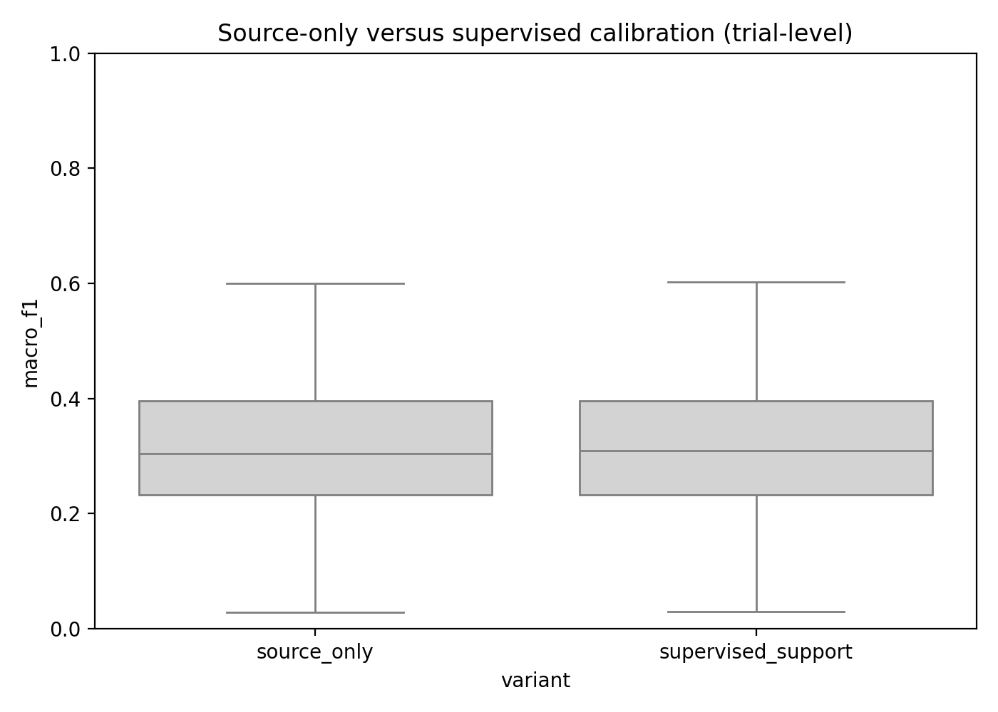
Figure 6. Source-only versus supervised-support adaptation under the executed query protocol.
Macro-F1 decreased from 0.312133 to 0.310364, an absolute change of −0.001769. Balanced accuracy increased slightly from 0.404950 to 0.405213, a change of +0.000263. The two metrics therefore provide different directional signals, neither of which supports a robust improvement claim. The calibrated protocol should be reported as neutral to slightly adverse for macro-F1 at the observed operating point.

12.3. Why calibration may not help
A brief support segment may inadequately represent the fatigue levels that occur later, especially if fatigue evolves systematically with time or task. Participant-specific recalibration can also overfit transient recording characteristics, shift decision thresholds in an unfavorable direction, or face labels with high within-person ambiguity. The support/query subset itself is not identical to the main zero-shot evaluation set, so the adaptation macro-F1 values should not be compared as if they were fold-level substitutes for the all-model summary. These are plausible explanations, not experimentally verified mechanisms.

12.4. Subject and trial variability
The exported adaptation_trial_paired_deltas.csv contains 105 paired trial comparisons, and adaptation_subject_mean_delta.csv summarizes participant-wise changes. This granularity enables inspection of whether a small subset benefited even though the aggregate macro-F1 did not. Such analysis must avoid cherry-picking: exploratory subgroup gains are hypothesis-generating and should be tested on new participants with a prespecified calibration rule.

12.5. Implications for future personalization
Personalization should be revisited only with a richer design: multiple support budgets, careful support-class coverage, class-conditional calibration, temporally separated validation, calibrated confidence estimates, and a control for mere exposure to the target subject. A method that uses labeled examples at deployment also has a human interaction cost; any accuracy gain should be balanced against the burden of collecting labels.

13. Feature ablation and error diagnosis

13.1. Feature-family ablation
Feature variant | Mean macro-F1 | SD
all_features | 0.4186 | 0.0512
time_only | 0.4154 | 0.0571
frequency_only | 0.3509 | 0.0905
The complete handcrafted feature set achieved 0.4186 average macro-F1 in the fixed logistic-regression ablation, and the time-domain subset achieved 0.4154. The frequency-only subset achieved 0.3509. The small combined-versus-time-only gap (about 0.0033) suggests limited incremental benefit from the selected spectral features under this specific model and protocol. Crucially, the ablation uses a fixed logistic baseline; its all-features value should not be numerically equated to the nested logistic score in the primary benchmark because the experimental setups may differ.

13.2. Interpretation of time-frequency differences
Time-domain measures may be more stable summaries of overall activation under variable dynamic movement than spectral fatigue shifts, which can respond to contraction speed and biomechanical conditions. Conversely, low frequency-only performance could reflect representation choices, estimation variability over one-second windows or the nature of subjective labels. The study cannot conclude that spectral fatigue physiology is absent; it can only say that the tested frequency-only feature pipeline was less predictive on held-out participants.

13.3. Error diagnosis at the data-model boundary
Several data characteristics can jointly generate hard classification cases: nonstationary movement artifacts, variable muscle recruitment, overlapping adjacent windows, subjective timing delays, class transitions within a window, participant-specific perception thresholds, and a finite number of clean trials. Distinguishing among these would require additional controlled ablations beyond those executed. Therefore the report documents plausible mechanisms while avoiding unsupported claims that one source of error has been proven dominant.

13.4. Inference efficiency trade-offs
The saved timings suggest that lightweight feature-space models can make rapid predictions once features are available. The SVM is substantially slower than the MLP in the recorded per-window classifier timing, whereas sequence models require their own normalization and waveform processing. Fair engineering comparison should include preprocessing, batching, resource utilization and memory footprint. The current timings are informative for relative implementation cost only and not definitive end-to-end latency measurements.

14. Discussion and synthesis

14.1. Answers to the research questions
RQ1: All tested feature-based nonlinear classifiers surpassed the two raw-waveform deep networks on the primary held-out participant metric; gradient boosting led with mean macro-F1 0.4354, closely followed by MLP and SVM. RQ2: performance variation across the 13 participants was substantial, demonstrating unresolved cross-person transfer difficulty. RQ3: the supervised-support adaptation design did not improve aggregate macro-F1, though balanced accuracy changed marginally in the positive direction. RQ4: time-domain features nearly matched the complete descriptor set, while the frequency-only representation was weaker under the fixed logistic ablation.

14.2. Why sophisticated models did not automatically dominate
The classical versus deep outcome is compatible with the statistical structure of the dataset. Short overlapping windows create many training examples but only 13 distinct persons. Handcrafted descriptors impose useful priors, smoothing waveform details that may be subject-specific; deeper models instead must learn both filtering and decision rules from a constrained cohort. The 18-epoch training budget and CPU execution also limit hyperparameter exploration. None of these potential explanations was isolated experimentally, so they should guide follow-up studies rather than be reported as established causes.

14.3. What “fatigue-adaptive” means for this study
The project includes a precisely specified supervised personalization test, which justifies describing adaptation as an examined research component. It does not justify claiming successful improvement. There is an important distinction between implementing and evaluating an adaptation technique and demonstrating that the technique outperforms source-only transfer. In the current experimental evidence, the latter was not shown. A scientifically rigorous report retains this result in the abstract and conclusions rather than hiding it in supplementary tables.

14.4. Scientific strengths
The strongest elements of this work are the explicit public dataset provenance, nested subject ZIP handling, verified trial pairing, visible timing-based exclusions, window-level annotation criteria, subject-disjoint outer testing for all eight models, clear classical/deep separation, class-wise and subject-wise reports, labeled support/query differentiation, feature-domain ablations, and a complete export package of numerical artifacts. Together these features permit the central claims to be traced to the executed run rather than relying solely on screenshots of successful cells.

14.5. Practical interpretation
The results support continued research into fatigue-state prediction from EMG, particularly with robust compact feature representations, but do not support operational deployment without further data and testing. For a practical system, required progress would include an independent dataset, live causal processing, subject and task adaptation validated prospectively, uncertainty-aware abstention, and a clear operational definition of what a predicted self-perceived fatigue level should trigger.

15. Threats to validity, ethics and limitations

15.1. Internal validity and integrity
The most immediate constraint is the removal of 50 of 156 paired trials following timing checks. The report cannot establish that these failures are unrelated to participant, movement, fatigue or recording duration. As a consequence, it cannot assert that reported accuracy represents the complete source protocol. Any future repair strategy must preserve the integrity of the time axis and be compared under identical held-out splits.

15.2. Construct validity of self-reported fatigue
Perceptual ratings are meaningful observations but should not be conflated with physiological fatigue as measured by force decline, electrical conduction velocity or biochemical fatigue markers. The 0–2 categories are ordinal but conventional multiclass models optimize nominal losses and metrics. Mixed subjective thresholds can lower attainable agreement even when EMG faithfully reflects activation. External physiological validation would be necessary for clinical or industrial risk inference.

15.3. Statistical dependence and sample size
There are only 13 independent participants. The 11,692 windows contain substantial temporal overlap and clustering within trials. Subject-resampled intervals mitigate, but cannot eliminate, the small-sample uncertainty of cross-person inference. Reporting a high-precision decimal score does not imply equally precise biological generalization. Larger heterogeneous cohorts should be collected before making claims about expected deployment performance.

15.4. External validity and domain shift
Results derive from one upper-limb movement protocol and one acquisition ecosystem. Unseen work environments may involve different movement distributions, electrode designs, skin conditions, clothing, ambient electrical noise, or demographic variation. Independent protocol transfer and prospective site validation are necessary to establish external validity.

15.5. Sampling, filtering and model-budget constraints
The experiment caps the number of sampled windows per trial and participant; it also uses offline zero-phase filtering. Its runtime and quality may differ from fully streaming inference. Deep networks were optimized within finite epochs and validation patience, and comparative hyperparameter-search budgets were not shown to be equalized by computation. These factors limit strong architecture-superiority conclusions even though the subject-level benchmarking is informative.

15.6. Ethical implications and responsible use
Even non-invasive fatigue estimation could be misused for automated performance management or workplace surveillance. The study contains no individual identification or identity inference and reports group-averaged classification, but any deployment would require informed consent, data minimization, secure storage, human review of adverse decisions and validation against unfair differences across user groups. Fatigue-related alerts should complement professional judgment rather than penalize a person based on uncertain algorithmic inference.

16. Conclusions and future work

16.1. Conclusions
This research established a reproducible, participant-held-out three-class classification benchmark using an openly archived surface-EMG dataset with time-stamped perceived-fatigue ratings. After auditing 156 paired movement trials and excluding 50 trials with timing anomalies, the pipeline produced 11,692 labeled windows for evaluation. Feature-based histogram gradient boosting achieved the highest observed mean participant macro-F1 of 0.4354, closely followed by the MLP (0.4344) and RBF SVM (0.4301), while the 1D-CNN (0.3693) and CNN-GRU (0.3569) achieved lower means. Supervised target-person calibration did not improve overall macro-F1 under the chosen support/query protocol. The findings show that carefully engineered representations are competitive in this small, heterogeneous cohort, but reveal substantial challenges in transferring perceived-fatigue classifiers across people.

16.2. Recommended follow-up studies

Data-integrity sensitivity
Reconstruct or segment recordings with timestamp resets only after validating source acquisition semantics; quantify whether exclusions introduce class or participant selection bias.

External test cohort
Evaluate a new subject cohort and a genuinely different sensor/session protocol without tuning on the external test set.

Ordinal learning
Compare ordinal regression and label-distance-aware loss functions to standard nominal three-class cross-entropy.

Improved temporal modeling
Test longer, multi-scale windows, causal filters and carefully budget-matched CNN/GRU/Transformer alternatives with the same participant splits.

Adaptation design
Sweep labeled support size and per-class availability; prespecify target-free and supervised calibration separately; report adaptation costs.

Robustness and deployment
Measure full preprocessing-plus-model latency, memory demand, calibration drift, uncertainty and selective prediction on resource-limited devices.

16.3. Closing statement
The central result is not a claim that one classifier has solved fatigue estimation. Rather, it is an auditable demonstration of the performance limits, data-quality constraints and calibration uncertainties encountered when applying modern machine learning to subjective fatigue labels across previously unseen people. The next research step is improved validity, not merely additional model capacity.

References
[1] S. Cerqueira, R. Vilas-Boas, J. Figueiredo, and C. Santos, “A Dataset of sEMG and Self-Perceived Fatigue Levels for Muscle Fatigue Analysis,” Zenodo, Version 2, Nov. 2024. doi: 10.5281/zenodo.14182446. https://zenodo.org/records/14182446
[2] C. J. De Luca, “Myoelectrical manifestations of localized muscular fatigue in humans,” Critical Reviews in Biomedical Engineering, vol. 11, no. 4, pp. 251–279, 1984. PMID: 6391814.
[3] “Application of Surface Electromyography in Exercise Fatigue: A Review,” 2022. Accessible via PubMed Central, PMID: 36032326. https://pmc.ncbi.nlm.nih.gov/articles/pmid/36032326/
[4] A. Phinyomark, P. Phukpattaranont, and C. Limsakul, “Feature reduction and selection for EMG signal classification,” Expert Systems with Applications, vol. 39, no. 8, pp. 7420–7431, 2012. doi: 10.1016/j.eswa.2012.01.102.
[5] L. Breiman, “Random Forests,” Machine Learning, vol. 45, pp. 5–32, 2001. doi: 10.1023/A:1010933404324.
[6] C. Cortes and V. Vapnik, “Support-vector networks,” Machine Learning, vol. 20, pp. 273–297, 1995. doi: 10.1007/BF00994018.
[7] J. H. Friedman, “Greedy function approximation: A gradient boosting machine,” The Annals of Statistics, vol. 29, no. 5, pp. 1189–1232, 2001. doi: 10.1214/aos/1013203451.
[8] S. Hochreiter and J. Schmidhuber, “Long short-term memory,” Neural Computation, vol. 9, no. 8, pp. 1735–1780, 1997. doi: 10.1162/neco.1997.9.8.1735.
[9] K. Cho et al., “Learning phrase representations using RNN encoder–decoder for statistical machine translation,” in Proc. EMNLP, 2014, pp. 1724–1734. doi: 10.3115/v1/D14-1179.
[10] D. P. Kingma and J. Ba, “Adam: A method for stochastic optimization,” International Conference on Learning Representations, 2015. arXiv:1412.6980.
[11] F. Pedregosa et al., “Scikit-learn: Machine learning in Python,” Journal of Machine Learning Research, vol. 12, pp. 2825–2830, 2011.
[12] A. Paszke et al., “PyTorch: An imperative style, high-performance deep learning library,” in Advances in Neural Information Processing Systems 32, 2019, pp. 8024–8035.

Appendix A. Reproduction record

A.1. Archived configuration
dataset_url: https://zenodo.org/records/14182446
seed: 42
n_subjects: 13
n_paired_trials: 156
n_windows: 11692
window_seconds: 1.0
hop_seconds: 0.5
purity_threshold: 0.8
max_label_age_s: 0.2
max_windows_subject: 900
max_windows_trial: 150
CNN_EPOCHS: 18
CNN_PATIENCE: 5
CNN_BATCH_SIZE: 128
compute_device: cpu
support_fraction: 0.2
gap_seconds: 2.0
execution_utc: 2026-10-16T00:51:24.127897+00:00

A.2. Primary exported artifacts
all_model_summary.csv; all_model_fold_scores.csv; all_model_predictions.csv; nested_fold_scores.csv; nested_hyperparameters.csv; deep_fold_scores.csv; deep_predictions.csv; confusion matrices; per_class_metrics.csv; subject_bootstrap_ci.csv; adaptation_summary.csv; adaptation_trial_scores.csv; adaptation_trial_paired_deltas.csv; ablation_scores.csv; experiment_configuration.json; environment.json; verified_trial_manifest.csv; schema_audit.csv; excluded_trials.csv; window_metadata.csv. These files together support reconstruction of the principal tables and plots.

A.3. Interpretation safeguards
Independent units are participants, not windows. Main benchmark scores are subject means. The adaptation aggregate is a separate labeled-support query protocol. The recorded model inference times do not necessarily include full preprocessing. No independent test cohort, physiological gold-standard fatigue endpoint or prospective streaming evaluation was used.

Appendix B. Additional evaluation tables

B.1. Full subject-by-model macro-F1 matrix
Subject | cnn 1d | cnn gru | hist gradient | logistic | majority | mlp | random forest | svm rbf
1 | 0.363 | 0.433 | 0.483 | 0.496 | 0.201 | 0.483 | 0.541 | 0.512
2 | 0.294 | 0.291 | 0.411 | 0.320 | 0.196 | 0.370 | 0.312 | 0.330
3 | 0.367 | 0.314 | 0.410 | 0.362 | 0.210 | 0.377 | 0.365 | 0.393
4 | 0.508 | 0.433 | 0.492 | 0.505 | 0.222 | 0.477 | 0.505 | 0.509
5 | 0.398 | 0.311 | 0.405 | 0.434 | 0.143 | 0.453 | 0.417 | 0.422
6 | 0.436 | 0.390 | 0.491 | 0.480 | 0.210 | 0.463 | 0.462 | 0.493
7 | 0.257 | 0.245 | 0.405 | 0.413 | 0.156 | 0.463 | 0.393 | 0.445
8 | 0.387 | 0.421 | 0.387 | 0.421 | 0.181 | 0.406 | 0.423 | 0.412
9 | 0.262 | 0.357 | 0.415 | 0.381 | 0.154 | 0.430 | 0.382 | 0.449
10 | 0.473 | 0.454 | 0.424 | 0.423 | 0.103 | 0.363 | 0.457 | 0.376
11 | 0.378 | 0.368 | 0.429 | 0.412 | 0.124 | 0.455 | 0.393 | 0.408
12 | 0.320 | 0.305 | 0.476 | 0.381 | 0.191 | 0.471 | 0.475 | 0.425
13 | 0.360 | 0.318 | 0.431 | 0.397 | 0.167 | 0.437 | 0.369 | 0.416

B.2. Trial exclusions by participant
Subject | Invalid fatigue time | Non-monotonic EMG time
1 | 1 | 4
2 | 2 | 3
3 | 1 | 2
4 | 2 | 1
5 | 2 | 2
6 | 0 | 2
7 | 0 | 5
8 | 0 | 3
9 | 0 | 4
10 | 0 | 3
11 | 0 | 5
12 | 0 | 6
13 | 0 | 2

B.3. Cohort-window counts
Subject | Windows | Retained trials | Min recorded t (s) | Max recorded t (s)
1 | 900 | 7 | 0.0 | 811.5
2 | 900 | 7 | 0.5 | 624.9
3 | 900 | 9 | 0.5 | 1350.3
4 | 900 | 9 | 0.5 | 420.7
5 | 900 | 8 | 0.5 | 616.9
6 | 900 | 10 | 0.5 | 642.9
7 | 900 | 7 | 0.5 | 400.2
8 | 900 | 9 | 0.5 | 1110.7
9 | 900 | 8 | 0.5 | 1344.8
10 | 900 | 9 | 0.5 | 435.3
11 | 900 | 7 | 1.0 | 489.8
12 | 892 | 6 | 0.5 | 446.3
13 | 900 | 10 | 0.5 | 1486.9

B.4. Supplemental confusion figures
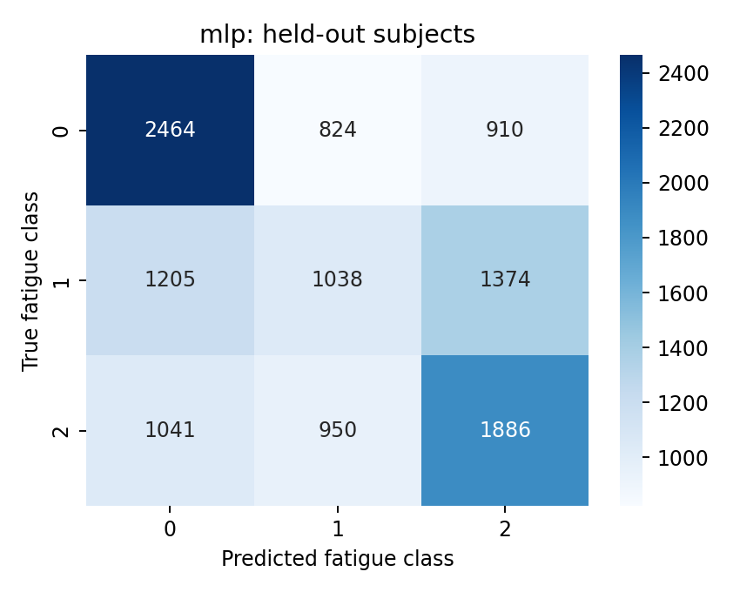
Figure B1. Multilayer perceptron pooled classification errors.
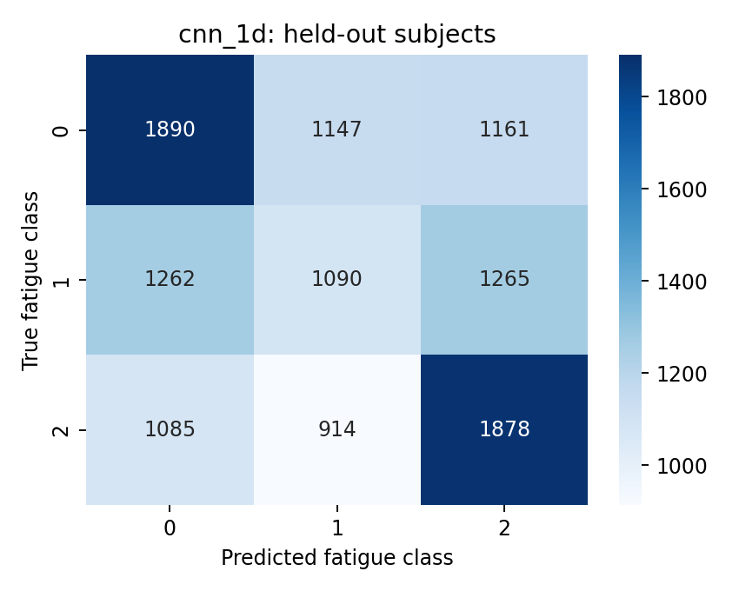
Figure B2. Convolutional network pooled classification errors.
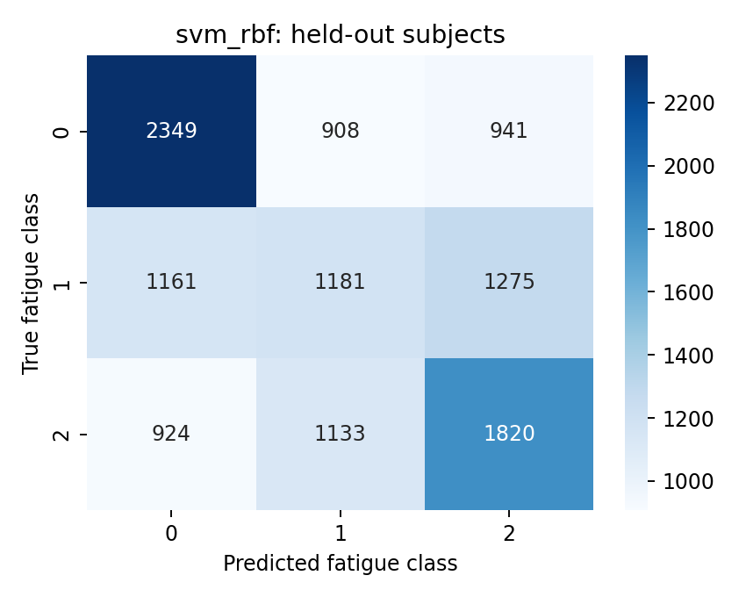
Figure B3. RBF SVM pooled classification errors.

