INTRODUCTION:-

Pradita Technosoft Pvt. Ltd. would be pleased to work towards Development of MIS package for monitoring of financial &amp; physical progress along with
outcomes towards implementation of sericulture components under SCSP & TSP [Scheduled Caste Sub
Plan (SCSP) & Tribal Sub Plan (TSP)] , Within :-“SILK
SAMAGRA” scheme using latest version of the technology stack,
developing the application using best practices and industry standard, compatibility
with any third party integrations and would be compatible with latest browser which includes, IE. Firefox, Chrome, and Safari.

GOALS:-
The goals of the Software required:
• Provide professional cloud based software solution by develping the Application within MVC Framework - Codelgniter to provide a robust, reliable and stable system.

• Design, test & deploy a reliable Database system by deploying the System in MYSQL

• Implement Web Server based MIS (in short) on Cloud Server targetted to be hosted on LAMP server.

PROJECT PLAN & LAYOUT:-

Dashboard should display summary information on screen for quick understanding of current position in
graphical manner as required by the user.

User Login along with Captcha Support for Added security :-

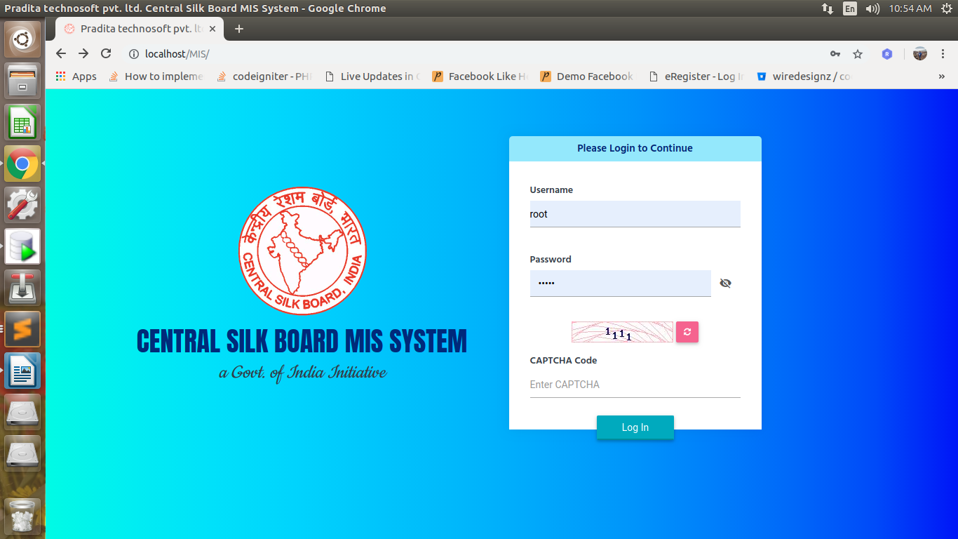

Admin features:-
1. Dashboard – Dashboard will be fully responsive and will be a single point of information gathering with appropriate Graphs Charts (wherever applicable)

2. Users – User (CRUD – Create, Update and Delete )

3. User Roles – Role Setting and Definition of Users from within the Software

4. Granular permissions and access control- Permissions and Access Control based on Access Rights and permission to particular informations on the software based on Users and User roles as predefined.

5. Admin reports – Admin Reports with full option to “View”, “Save as” and “Print” options. And “State / Component / Year Filters ”

4. Fund Budget as per set guidelines as per fund budget logic provided

5. Fund allocation as per get guidelines as per fund allocation logic

6. Beneficiary management

7. Asset management

8. Direct benefit transfer data integration

9. State, component and department management

10. Mobile friendly interface for uploading data

11. Feedback system

MIS Reports :
All the reports should have “View”, “Save as” and “Print” options.

All the reports should have option to select “State / Component / Year etc.,” to obtain relevant report.

List of reports and report format is enclosed as per the Format provided .

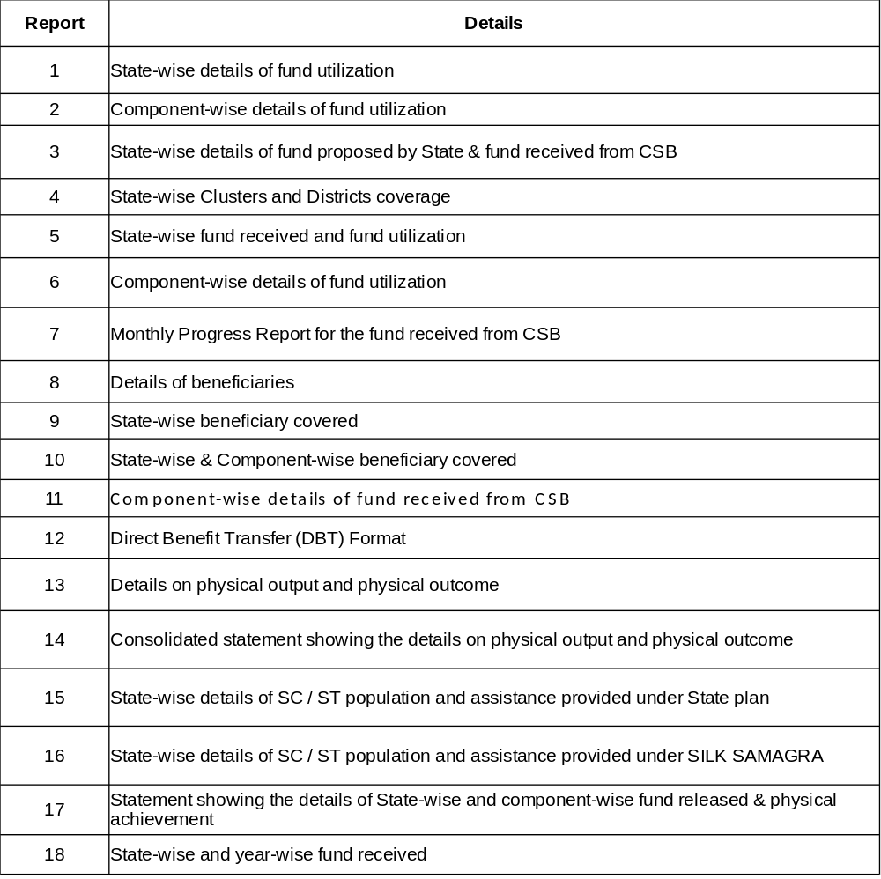

Total Project Phase would iterate through the Folowing Phases :-

1)Requirement Gathering and Specifications

2)Design

3)Iterations – will follow Spiral Software Developmnent Approach

4)UAT – User acceptance Testing

5)Final Delivery within the stipulated 90 days time frame.

