BUGFLOW
INTELLIGENT SOFTWARE DEFECT TRACKING SYSTEM
WITH RESOLUTION ASSISTANCE
MODULE 1 PROJECT REPORT

Student Name | Soma Sekhar Pallapothula
Mentor Name | Sumathy S
Batch Number | Batch 3
Project Title | Intelligent Software Defect Tracking System with Resolution Assistance
Technologies Used | Python, FastAPI, SQLAlchemy, PostgreSQL, pgAdmin 4, HTML, CSS, JavaScript

Module 1 focuses on the foundation and base modules of BugFlow: project setup, database connectivity, authentication, structured defect creation, role/person assignment, protected Admin access, and the basic defect management workflow.
The project was developed as a practical training deliverable and validated locally using FastAPI and Uvicorn with PostgreSQL as the persistent data store. The project communication also identifies Batch 3.

1. Executive Summary and Project Context
From a practical software-engineering perspective, the first module establishes the minimum reliable loop needed for later expansion: identity is verified, issue data is structured, the database becomes the source of truth, and administrators can act on the same record. This gives the project a clear foundation instead of building interface screens independently.
The module also demonstrates why a shared backend is important. A User does not need direct access to administrative data, while the Admin does not need to recreate a defect manually. Both interfaces communicate through FastAPI and the same PostgreSQL records, reducing duplication and keeping the workflow consistent.
BugFlow is a web-based software defect tracking and resolution platform designed to bring defect reporting, ownership, review, and status management into one structured workflow. Instead of depending on scattered notes or messages, the application provides a consistent form for capturing defect information and a connected Admin workspace for review.
The core Module 1 idea is simple: a defect is created by an authenticated user, stored in PostgreSQL, and then exposed through protected Admin APIs. This makes the record persistent and shared between the two interfaces. Assignment information can identify the responsible project person, while the Admin can later accept or reject a pending defect.
The foundation also establishes a clear separation of responsibilities. Login determines whether the person enters the Admin or User experience. Assignment values are project responsibility choices, not alternate login accounts. This distinction prevents confusion between authentication and defect ownership.

Problem Statement
Software defects become difficult to manage when issue details are incomplete, ownership is unclear, or status changes are communicated manually. A useful defect record should capture what failed, how it was reproduced, what was expected, what actually happened, the environment, and the priority. The system should also make the record visible to the people responsible for reviewing and resolving it.

Module 1 Coverage
- Project setup and local execution through a Python virtual environment.
- FastAPI routes for authentication and defect management.
- PostgreSQL database storage with SQLAlchemy ORM access.
- User defect reporting with structured fields.
- Assignment to a responsible project role/person.
- Protected Admin dashboard and defect review workflow.
- Separate defect listing with status actions and audit information.

2. Objectives, Scope and Expected Outcomes
Another important scope decision is to keep authentication and assignment conceptually separate. Authentication controls access to the application, while assignment communicates responsibility for a particular defect. This distinction supports a cleaner workflow in which the reporting User remains the owner of the submitted issue and the selected project person is responsible for review or resolution.
Module 1 also provides a base for future modules. Once defect records contain consistent fields and status values, later reporting, analytics, notifications and automation can be developed on top of the same data without redesigning the complete application.
The first module establishes the working base of the project before advanced reporting and visualization features are considered. The objective is to make the defect life cycle reliable from the moment a user enters an issue to the moment an administrator reviews its state.

Objectives
- Centralize defect creation and storage in a single PostgreSQL-backed application.
- Provide authenticated entry points for Admin and User experiences.
- Capture complete issue information using structured input fields.
- Allow the reporting user to identify a responsible project person.
- Expose current defect status to both User and Admin views.
- Provide Admin actions for resolving or rejecting pending defects.
- Maintain a simple audit trail for administrative status changes.

Functional Scope
Module 1 covers the foundation modules visible in the implemented interface: authentication, User Dashboard, Report Defect, My Defects, Admin Dashboard, and defect management. The system supports search/filter interaction on the defect register and a View action for inspecting individual records.
The database-centered workflow means that the browser is not the source of truth. The application sends validated requests to FastAPI; SQLAlchemy performs ORM operations; PostgreSQL stores the durable record. This design makes changes consistent across browser sessions and between User and Admin screens.

Expected Outcomes
Outcome | Expected result
Defect capture | A structured defect record is created with title, category, priority and supporting details.
Ownership | The record can carry a responsible assignment such as System Administrator or a development/testing role.
Visibility | Admin can retrieve the same defect through the protected Admin defect endpoint.
Decision | Admin can accept/resolve or reject a pending defect.
Traceability | An AdminAction record can represent the administrative status transition.
Usability | User and Admin pages remain separate while sharing the same project data.

3. Technology Stack and Project Setup
The stack was selected to keep the project lightweight and easy to run locally while still following a clear backend, data and interface separation. FastAPI provides a concise API layer, SQLAlchemy keeps database operations in Python objects and sessions, and PostgreSQL gives the application durable storage. HTML, CSS and JavaScript handle the browser presentation without requiring a separate frontend build system for the module.
The development commands are part of the implementation record because they show how the project was checked and launched. The syntax-check step is especially useful after editing a large Python file: it identifies invalid syntax before Uvicorn is started, making troubleshooting faster.
Technology | Role in BugFlow
Python 3.x | Backend programming and project scripts
FastAPI | HTTP routes, validation and dependency injection
Uvicorn | Local ASGI server for running the application
SQLAlchemy | ORM models, sessions and database queries
PostgreSQL | Persistent database for users, defects and actions
pgAdmin 4 | Graphical PostgreSQL administration and verification
HTML / CSS / JavaScript | User and Admin interfaces
Visual Studio Code | Development and terminal environment

Development and Verification Commands
tree /F
Get-Content .\app\main.py
python -m py_compile app/main.py
python -m uvicorn app.main:app --host 127.0.0.1 --port 8080
The project is run locally using Uvicorn. The syntax-check command is useful before starting the server because it catches Python syntax errors early. After the server starts, the primary application entry is the login page at http://127.0.0.1:8080/login-ui.

Project Structure
- app/main.py - FastAPI application, authentication, API routes and page routes.
- app/database.py - database connection and session handling.
- app/models.py - SQLAlchemy models for application entities.
- app/Frontend/ - HTML pages for login, User, Admin, All Defects and Analytics.
- create_database.py / check_database.py - project database setup and verification utilities.
- requirements.txt - Python package requirements.
Keeping the frontend and backend in a single project structure simplifies local development and makes the complete Module 1 workflow reproducible on the development machine.

4. System Architecture and End-to-End Workflow
The workflow can be understood as a controlled sequence of state changes rather than a collection of independent pages. Each stage depends on the result of the previous stage: authentication creates an authenticated context, reporting creates a defect record, assignment adds responsibility, and Admin action changes the defect state. This sequence makes the behaviour easier to test and explain.
The design also supports maintainability. The presentation layer can be redesigned without moving database logic into HTML, while the API layer can evolve without changing the meaning of the stored entities. The use of a dedicated database administration tool further separates operational verification from the application interface.
BugFlow follows a layered application flow. The browser contains the User and Admin interfaces. FastAPI acts as the application and authorization layer. SQLAlchemy provides the ORM session and query layer, while PostgreSQL stores the persistent application records. pgAdmin 4 is used alongside the application for database administration and verification.
Layer | Main components | Responsibility
Presentation | index.html, user.html, admin.html, all-defects.html, analytics.html | Collect input and display the current system state
Application | FastAPI, Uvicorn, authentication dependencies and API routes | Validate requests, authorize users and update defects
Data | SQLAlchemy + PostgreSQL | Persist users, defects and administrative actions
Administration | pgAdmin 4 | Inspect database objects, tables, rows and connection state

Primary Workflow
- 1. The user opens the BugFlow login interface and authenticates with email and password.
- 2. The authenticated User enters the defect reporting form and supplies structured issue details.
- 3. The user may select a responsible project role/person such as John Doe or Alex Rivera.
- 4. FastAPI validates the request and SQLAlchemy writes the defect to PostgreSQL.
- 5. The Admin opens the protected Admin interface and reads the same defect collection.
- 6. The Admin reviews the defect and can accept it (Resolved) or reject it (Rejected).
- 7. The resulting state is stored in PostgreSQL and the action can be recorded for audit purposes.
The architecture deliberately separates presentation from persistence. This means that a visual change to a dashboard does not change the underlying defect record, while a status change made through the Admin workflow can be reflected wherever that same database record is displayed.

5. Database Design, PostgreSQL and pgAdmin 4
PostgreSQL is the durable data store for BugFlow. SQLAlchemy opens database sessions and maps application objects to database records. pgAdmin 4 provides a graphical environment for connecting to PostgreSQL, opening the project database, inspecting tables and verifying that the application's changes are being persisted.

Core Database Entities
Entity | Purpose | Typical information
User | Authentication and ownership | Name, email, password hash, role
Defect | Main issue record | Title, description, category, priority, status, assignment, timestamps
AdminAction | Administrative history | Admin, defect, action and timestamp
During development, the database can be checked in pgAdmin 4 after creating a defect or changing its status. The verification workflow is: connect to PostgreSQL, open the BugFlow database, inspect the schema/tables, perform an action in the application, refresh the table view, and confirm the row or status reflects the application change.

Issue Table Evidence
The defect register shown below demonstrates how stored issue records can be displayed with identification, category, priority, status, User ID, creation time and action controls.
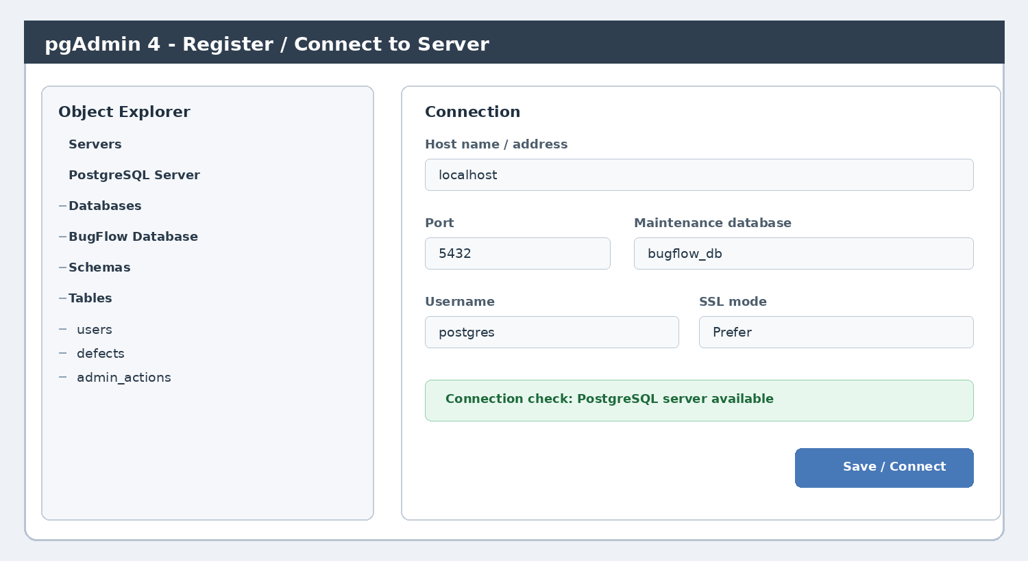 | 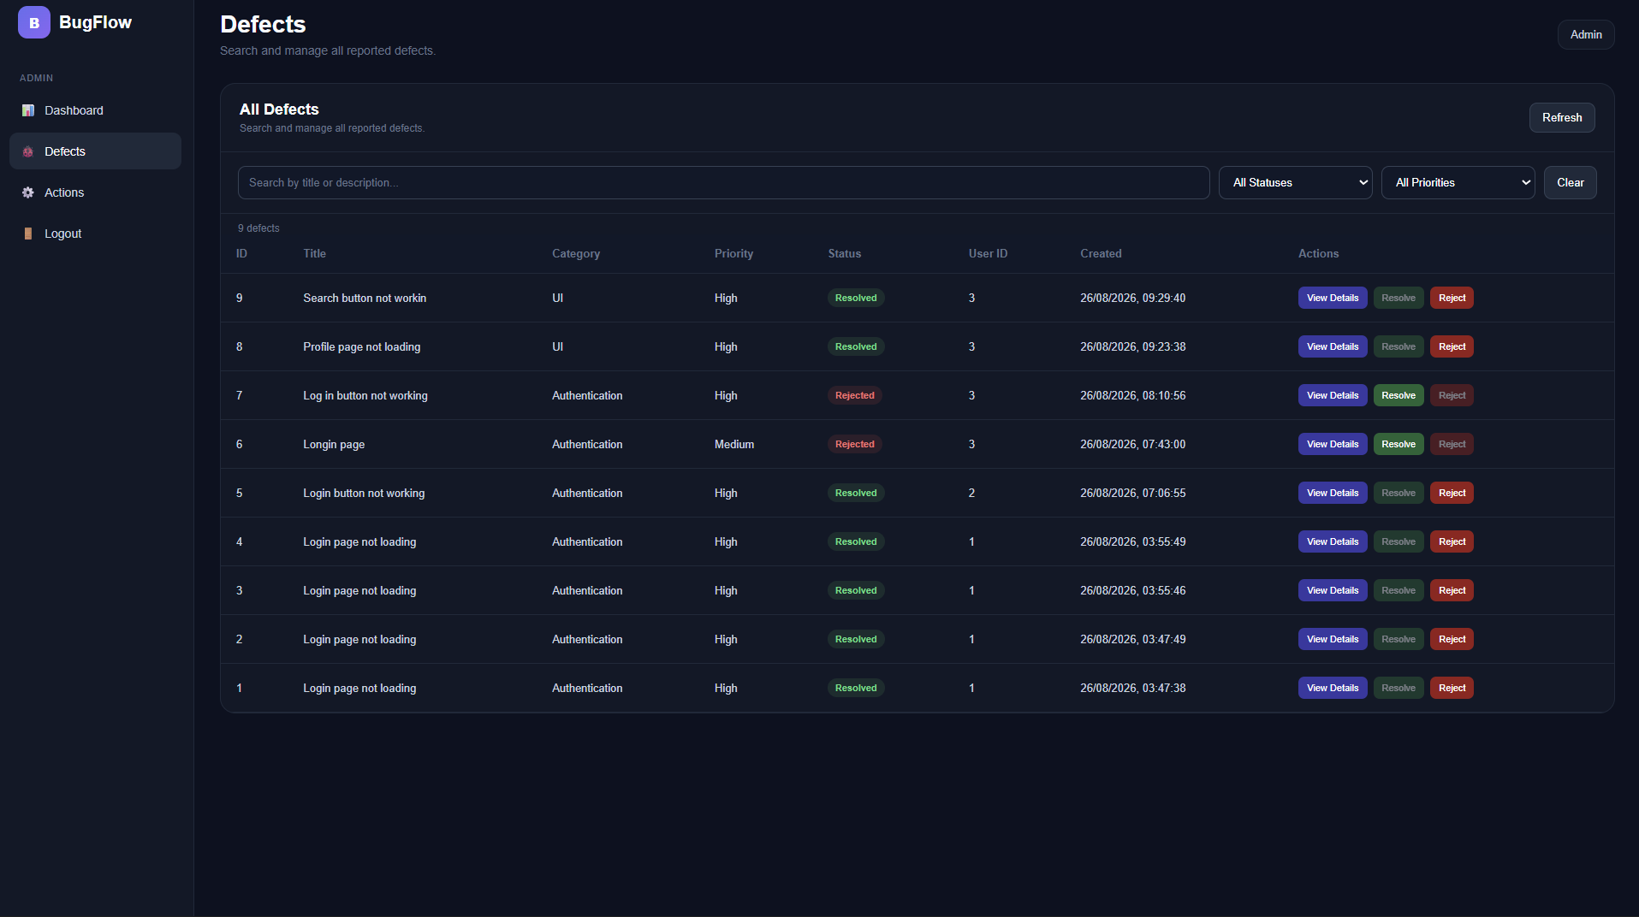
Figure 5.1: pgAdmin 4 PostgreSQL connection view (illustrative). | Figure 5.2: Issue table/register used during the project workflow.
Useful PostgreSQL verification commands in pgAdmin 4:
SELECT current_database(); SELECT * FROM users;
SELECT * FROM defects ORDER BY id; SELECT * FROM admin_actions ORDER BY id;

6. Authentication and Role-Based Entry
Authentication is the entry point for the complete workflow. The login page presents separate Admin and User choices while keeping the actual credentials as the email and password supplied to the server. The selected area determines which application experience opens after successful authentication.
The backend validates the submitted credentials against the stored user record and returns an access token. Protected endpoints use the Bearer token to identify the authenticated user. This prevents direct access to Admin data without an authenticated session.
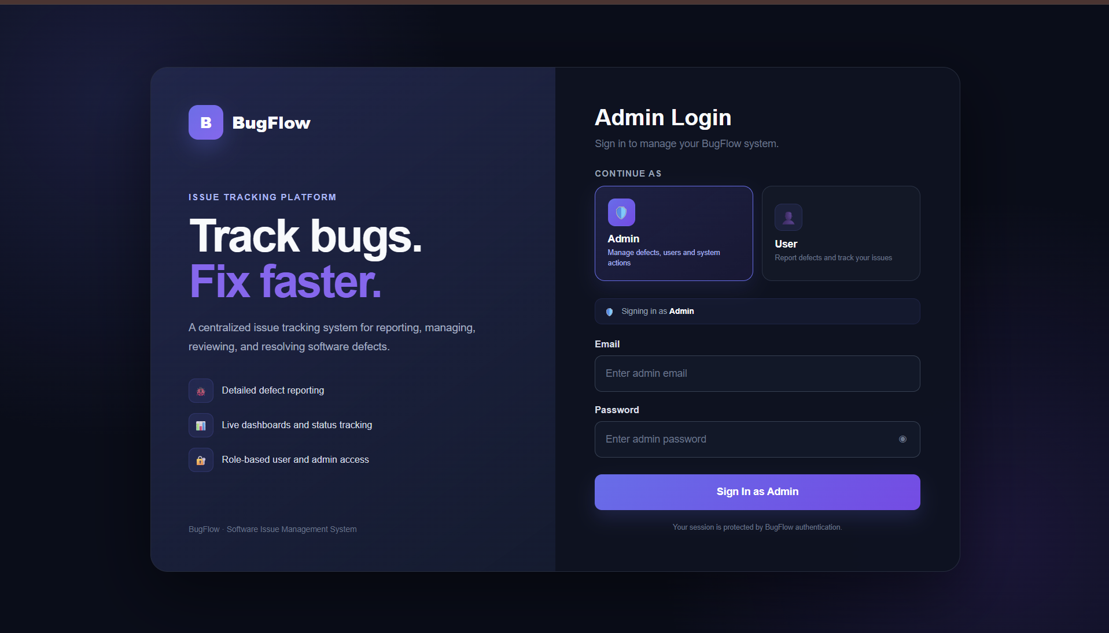
Figure 6.1: BugFlow Admin/User login interface used for authentication.

Authentication Features
- Email and password based login.
- Admin and User experiences remain visually separated.
- Admin APIs require authenticated access.
- Logout removes the active application session.
- The assignment choices used for defects are separate from login identity.
The screenshot also demonstrates the final visual separation between the Admin and User entry choices. This is important for the project because the person who reports a defect is not necessarily the person responsible for fixing it.

7. User Dashboard and Defect Reporting
The User side is designed around a simple reporting workflow. The user can open Report Defect, enter the defect title, choose a category and priority, provide the environment, describe the problem, and give reproduction steps. Expected and actual results add clarity for the person who reviews the issue.
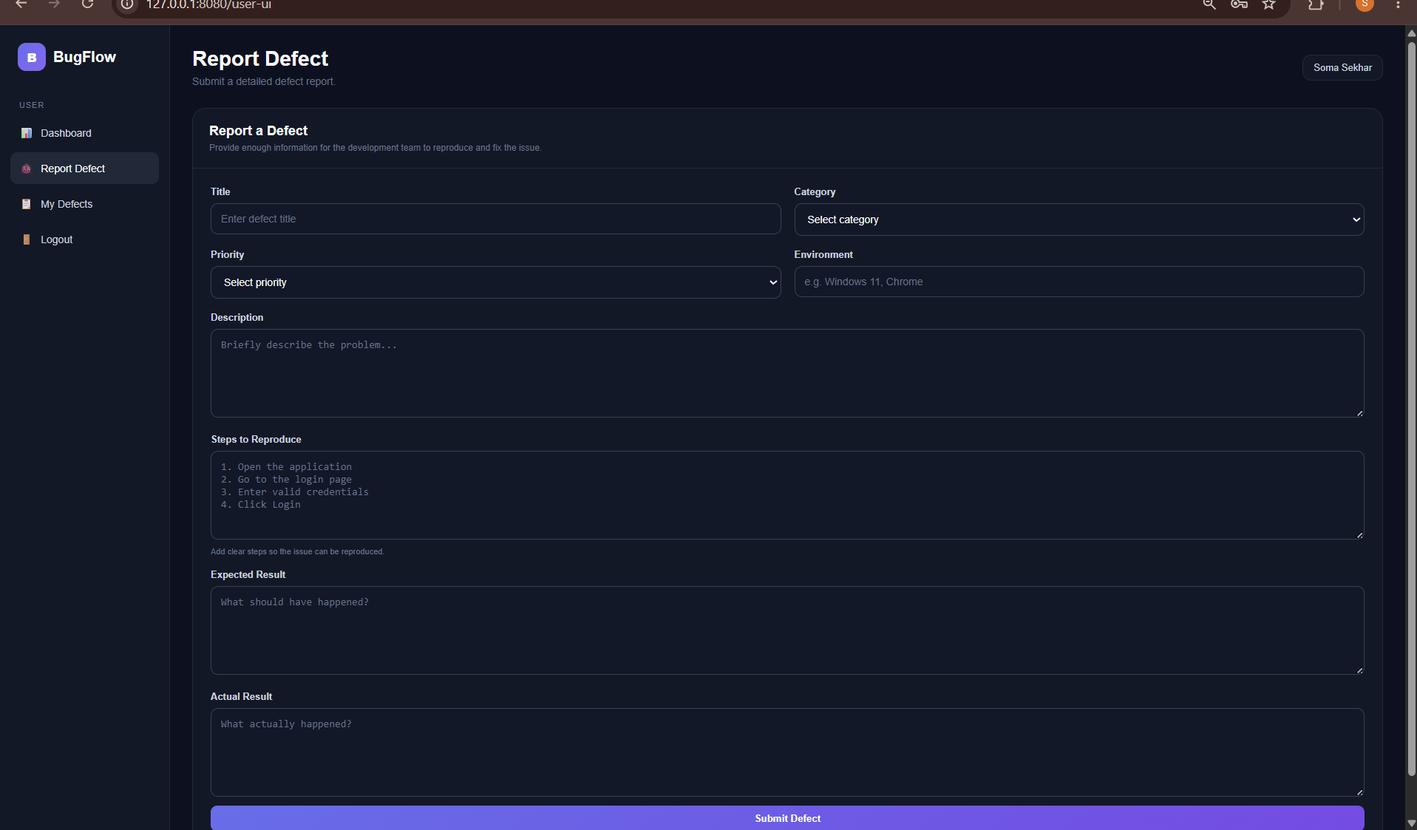
Figure 7.1: User Report Defect screen with structured issue fields and assignment area.

Assignment Workflow
The assignment area allows the reporting user to select a responsible project person. The implemented choices are intended as project responsibilities, for example System Administrator (Admin), John Doe (Senior Developer), Alex Rivera (Developer) and Bruce Wayne (Tester). User accounts are not presented as defect assignment roles.
When a defect is submitted, the selected assignment should travel with the defect record into the database. The Admin side can then display the same responsibility next to the defect, creating a clear connection between reporting and resolution.

User-Side Benefits
- Structured reporting reduces missing information.
- Assignment makes responsibility visible before review.
- Users can later inspect defects that they have reported.
- Status changes made by Admin can be reflected back to the User view.

8. Admin Dashboard and Operational Workspace
The dashboard is intentionally a summary surface rather than a second copy of the All Defects table. Its purpose is to answer high-level questions quickly: How many defects exist? How many are pending? How many are resolved or rejected? What recent activity occurred? Which operational shortcuts are immediately available?
The workspace sections also make the page useful when the defect count is small. Recent Activity provides context, Quick Actions reduce navigation effort, System Health communicates the state of core components, and the lower information panels provide space for operational notices and help content.
The Admin Dashboard is the operational landing page of the system. It is deliberately separated from the full defect register so the dashboard is not a duplicate table. Instead, it provides summary indicators and workspace sections that help the administrator understand the current state before opening All Defects.
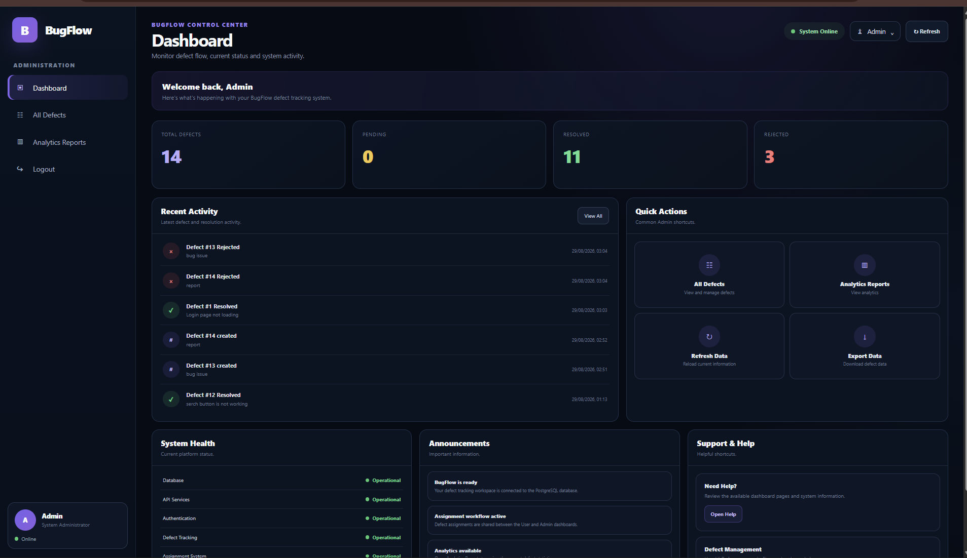
Figure 8.1: Final BugFlow Admin Dashboard design used for Module 1 validation.

Dashboard Components
- Total Defects, Pending, Resolved and Rejected summary cards.
- Recent Activity showing recent defect creation and status events.
- Quick Actions linking to All Defects and Analytics Reports.
- System Health section for checking major application components.
- Announcements and Support & Help areas for operational information.
The dashboard therefore acts as the starting point for the administrator, while the separate All Defects page provides the detailed operational table. This separation improves navigation, reduces repetition and gives each page a clear responsibility.

9. All Defects Register and Administrative Actions
All Defects is a dedicated page containing the complete defect register. It uses the protected Admin defect endpoint to retrieve the same records stored in PostgreSQL. Search and filtering can narrow the displayed collection without modifying the underlying records.
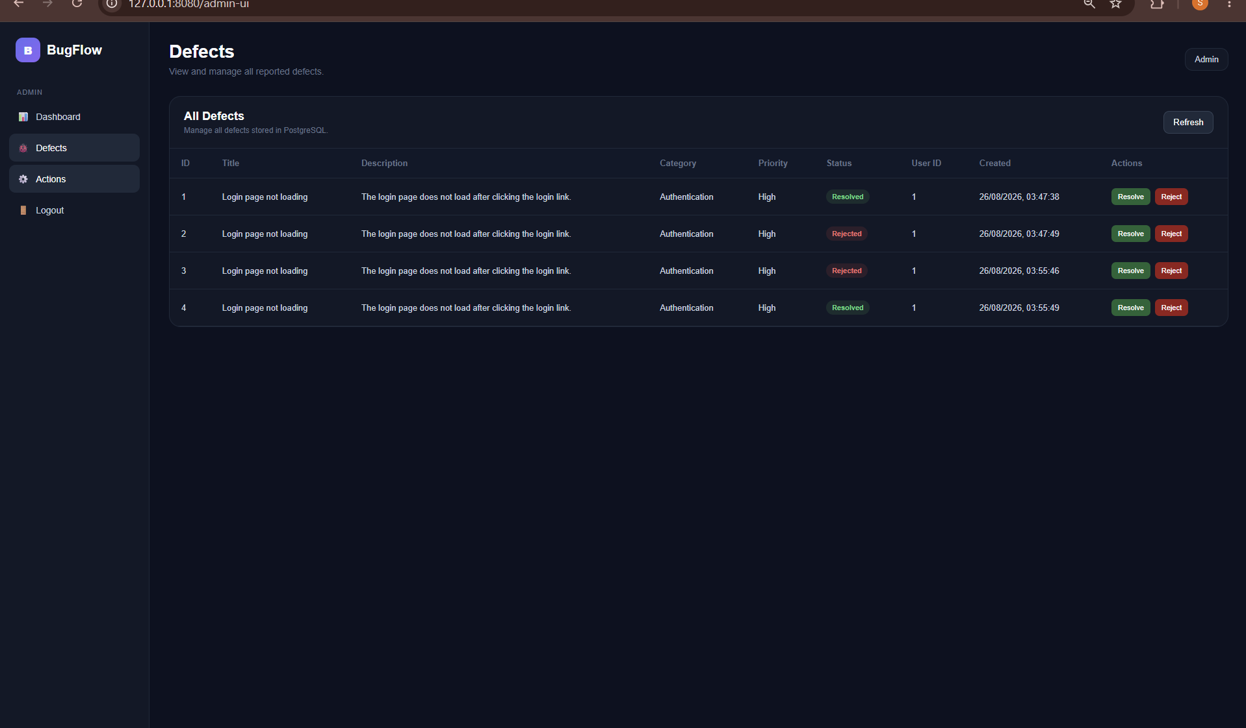
Figure 9.1: All Defects register with issue records and administrative action controls.

Accept and Reject Workflow
For a pending defect, the Admin can use Accept or Reject. Accept changes the defect state to Resolved. Reject changes it to Rejected. After the action is completed, the row displays the resulting state instead of continuing to present the same pending decision buttons.
This workflow gives the project a concrete review step. The User creates the issue, the Admin reviews it, the decision is persisted, and the same defect state can then be displayed in both experiences. An AdminAction record can additionally capture the administrative decision for traceability.

Operational Search
The register supports searching by defect information and filtering by status or priority. This becomes increasingly useful as the number of stored records grows.

10. Testing, Validation and Development Issues
Testing was not limited to checking whether a page opened. The workflow was validated by following the real sequence from login to defect creation, assignment, Admin review and final status. This type of end-to-end verification is important because a page can look correct while its API request, authentication header or database update is incorrect.
During debugging, the project also demonstrated the difference between a browser page request and an authenticated API request. Directly opening a protected API endpoint without credentials is expected to fail, whereas the application page can succeed because its JavaScript attaches the Bearer token to the API request.
Testing for Module 1 was carried out through local server execution, browser interaction and repeated verification of the shared workflow. The goal was to check both individual screens and the connection between the User and Admin experiences.
Test case | Expected result | Observed/validated
Admin login | Admin Dashboard opens | Validated
User login | User Dashboard opens | Validated
Create defect | Defect appears in stored collection | Validated
Select assignment | Responsibility is stored/displayed | Validated
Accept pending defect | Status becomes Resolved | Validated
Reject pending defect | Status becomes Rejected | Validated
All Defects page | Dedicated defect register opens | Validated
Refresh | Latest database state is shown | Validated

Development Issue and Resolution
During development, opening a protected API URL such as /admin/defects directly in a browser returned an authentication-required response. The endpoint itself was working as designed because it required a Bearer token. The correct workflow is to open the Admin UI after login and let the page JavaScript send the token with its API request.

Final Run Commands
python -m py_compile app/main.py
python -m uvicorn app.main:app --host 127.0.0.1 --port 8080
This validation approach helped separate frontend navigation problems from backend authentication problems and ensured that the final workflow was tested through the same authenticated path a normal user follows.

11. Module 1 Conclusion and Future Enhancements
The completed module provides a strong base for the remaining project work because the main data objects and workflow states are already defined. Future improvements can therefore focus on scale, security, automation and richer reporting instead of rebuilding the basic defect life cycle.
The project also gives a useful demonstration of full-stack integration: a browser form becomes a validated HTTP request, the request becomes an ORM operation, the ORM operation becomes a PostgreSQL row, and an administrative decision becomes a persisted status transition visible in the application.
Module 1 establishes the foundation of BugFlow as a functioning software defect tracking platform. The project connects a structured User reporting workflow to a protected Admin workspace through FastAPI, SQLAlchemy and PostgreSQL. The use of pgAdmin 4 supports database administration and verification during development.
The most important result is the connected defect life cycle: a User can report an issue, identify a responsible project person, and persist the record. The Admin can then view the same record, review it and change its status. The separate Dashboard and All Defects pages make the Admin workflow clearer and avoid using one screen for every responsibility.

Future Enhancements
- Replace temporary in-memory sessions with a durable secure session/token mechanism.
- Add automated unit and API tests for login, creation, assignment and status transitions.
- Add server-side pagination for larger defect collections.
- Support screenshot/file attachments on defect reports.
- Add email notifications for assignment and status changes.
- Expand analytics with reliable date-range reporting after the core workflow is stable.
- Deploy behind HTTPS and move database secrets to environment variables.

Quick Reference
Item | Reference
Login | http://127.0.0.1:8080/login-ui
Admin Dashboard | http://127.0.0.1:8080/admin-ui
User Dashboard | http://127.0.0.1:8080/user-ui
All Defects | http://127.0.0.1:8080/all-defects-ui
Analytics Reports | http://127.0.0.1:8080/analytics-ui
Server command | python -m uvicorn app.main:app --host 127.0.0.1 --port 8080

