ANCIENT INDIAN CHEMISTRY & ALCHEMY
The Eternal Science of Mercury, Metals & Transformation

━━━━━━━━━━━━━━━━━━━━━━━━━━━━━━━━━━━━━━━━

A Comprehensive Guide to the Lost Science of Rasavidya
Covering: History · Philosophy · The 18 Mercurial Operations · Alchemy · Medicine

[ NotebookLM Source Document — YouTube Deep Dive Series ]

📌 How to Use This Document
This document is structured as a detailed knowledge source designed for use with AI-powered tools like NotebookLM to generate YouTube video scripts, podcast episodes, and educational content. Each section covers one major concept from the ancient Indian scientific tradition, explained in depth with context, evidence, and implications.

💡 FOR NOTEBOOKLM USERS: Upload this document and prompt: "Create a 10-minute YouTube script on [Topic Name] with a hook, key points, visual cues, and a strong conclusion."

Document Structure
- Section 1 — The Eternal Universe: Cosmology and Time
- Section 2 — The Puranas as History: Cross-Cultural Evidence
- Section 3 — Rasavidya: The Ancient Super-Science of Chemistry
- Section 4 — The Four Systems of Ancient Indian Medicine
- Section 5 — Mercury (Parada): The Central Element
- Section 6 — The 18 Mercurial Operations — Complete Breakdown
- Section 7 — Alchemy: Philosopher's Stone and Metal Transformation
- Section 8 — The Dark Age: How Knowledge Was Lost
- Section 9 — The Revival Call: Cultural Independence over Political

Section 1: The Eternal Universe — Cycles of Creation & Destruction

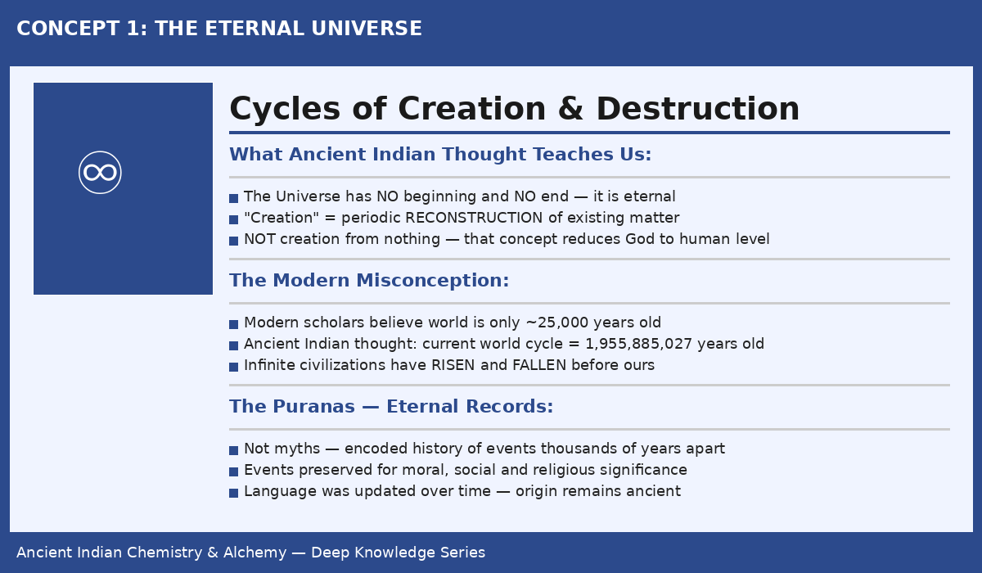
Figure 1: The ancient Indian cosmological model — an eternal universe of infinite civilisation cycles

1.1 The Core Philosophical Premise
One of the most profound and misunderstood ideas from ancient Indian thought is the concept of an eternal universe. Unlike the modern Western assumption that the cosmos was created at a specific point in time — an idea rooted in Abrahamic religious tradition — the ancient Indian intellectual tradition maintained that the universe has no beginning and no end.
The word "creation" in this framework does not mean creation out of nothing (ex nihilo). Instead, it refers to periodic reconstruction — the remoulding and recombination of pre-existing matter. This process, it was argued, happens to some extent at every moment, on the cosmic scale it manifests as vast cycles of construction followed by dissolution, followed again by reconstruction.

"The idea of the absolute creation of the Universe out of nothing, at a particular point of time, is more than an ordinary human being can conceive — it attributes to God the characteristics of desire, want, and striving, reducing the divine to the level of an imperfect, human being."

1.2 Why the Modern View Falls Short
The modern educated world in the early twentieth century generally accepted that civilization was, at most, 25,000 years old. Ancient Indian cosmological thought considers this assumption absurd for the following reasons:
- If the world is eternal, then an infinite number of civilisations must have risen, flourished, and fallen before the present one.
- History as we know it covers only a tiny fraction of time — a few thousand years at best.
- Even modern historians will eventually be forced to abandon the idea of a comprehensive chronological record, as the sheer volume of events across millennia makes complete documentation physically impossible.
- What humans have called "history" is really a selective record — the most morally and spiritually significant events — which is exactly the method followed in the Indian Puranas.

1.3 The Age of the Current Kalpa
According to the Indian cosmological tradition, a Kalpa is a single cycle of the universe — one complete epoch from reconstruction to dissolution. The age of the current Kalpa (the present world cycle, from its last reconstruction to the early 20th century) was calculated in the tradition as:

1,955,885,027 Years
The calculated age of the current world cycle

This figure was not arbitrary — it was derived from an unbroken chain of scientific, philosophical, and scriptural transmission going back through generations of scholars. The precision of the number itself is a testament to the sophistication of ancient Indian mathematical and astronomical traditions.

1.4 The Puranas — Ancient Encyclopedias of History
The Puranas (meaning "ancient records") are not mythological fantasy as modern critics have often assumed. They represent a deliberate, sophisticated method of preserving the most important facts across enormous spans of time. Consider this parallel:
- Modern historians compile detailed records for a few centuries — eventually, they too would need to abbreviate.
- After 30,000 years of record-keeping, even the most diligent historian would need to select only the most historically significant events.
- The authors of the Puranas were doing exactly this — encoding the most morally, socially, and cosmically significant events from civilisations stretching back millions of years.

💡 VIDEO HOOK IDEA: "What if the world is not 25,000 years old — but nearly 2 BILLION years old? And what if an advanced civilisation knew chemistry and alchemy more than 900,000 years ago? The ancient Indians left us the proof."

KEY TERM | MEANING
Kalpa | A complete cosmic cycle — from reconstruction to dissolution and back. The current Kalpa is ~1.95 billion years old.
Puranas | Ancient Indian records containing encoded history, philosophy, science, and cosmology of past civilisations.
Rasavidya | The ancient Indian science of chemistry and alchemy, literally meaning "knowledge of mercury/essence".
Siddha | A perfected chemist or alchemist in the ancient Indian tradition.
Arya | Term used for the ancient Indian civilisation — meaning "noble" or "civilised".

Section 2: The Puranas as Real History — Cross-Cultural Evidence

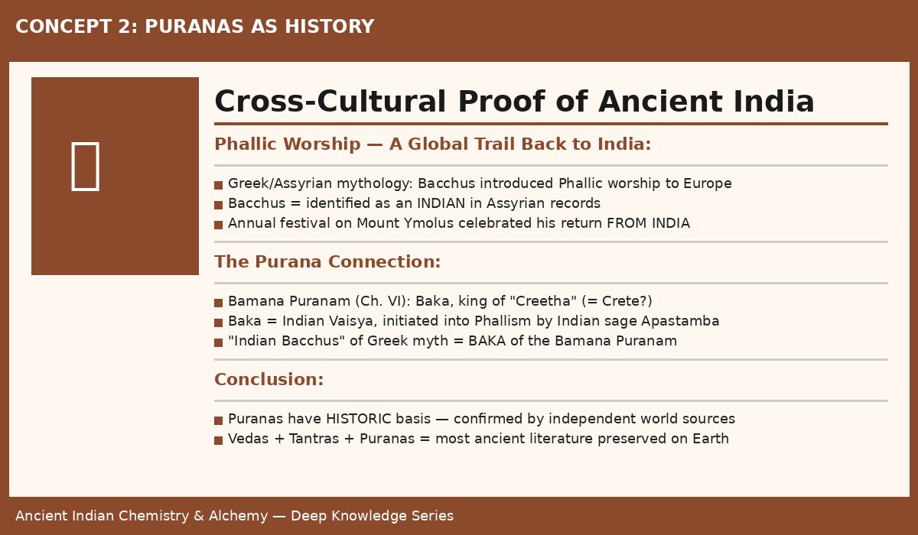
Figure 2: The Phallic Worship trail — Greek mythology traces back directly to ancient India via the Puranas

2.1 Independent Corroboration from World History
The claim that the Puranas are based on real events — not mythology — gains significant support from cross-cultural historical analysis. One of the most striking examples involves the phenomenon of Phallic Worship, which spread across ancient civilisations worldwide.

The Greek/Assyrian-Indian Connection
According to European tradition and mythology, Phallic worship was introduced to Europe by Bacchus (Greek) or Bacche (Assyrian). However, the key fact that is often overlooked is this: Bacchus, according to Assyrian mythology, was identified as an INDIAN.
- The Encyclopedia of Ethics and Religion (under "Phallism") confirms: Bacchus was Indian.
- An annual festival was held on Mount Ymolus in Lydia celebrating his return from India.
- This means the flow of this cultural and religious tradition was FROM India TO Europe — not the other way around.

The Purana Confirmation
Now examining the Bamana Puranam (Chapter VI), we find a remarkable parallel:
- Baka, king of "Creetha" (likely Crete) — is described as an Indian Vaisya by caste.
- Baka was initiated into Phallic Worship by his Indian preceptor, the sage Apastamba.
- The identification of the Greek/Assyrian "Indian Bacchus" with Baka of the Bamana Puranam is strongly supported by both sources.

The significance cannot be overstated: a detail recorded in an Indian Purana perfectly matches an event from Greek and Assyrian mythology — INDEPENDENTLY. This is not coincidence. The Puranas are recording real history.

2.2 The Survival of Ancient Knowledge Against All Odds
The very existence of these ancient texts is remarkable. The Vedas, Tantras, and Puranas represent the most ancient literature known to human civilisation. That they survived at all is due to an extraordinary resilience of oral transmission and manuscript copying, despite:
- Countless destructions of libraries and books by invaders across millennia
- Burning of centres of learning during periods of conquest
- Deliberate suppression of indigenous knowledge systems
- Gradual linguistic evolution requiring periodic textual revision

The fact that the language of the Puranas and Tantras appears "modern" compared to the Vedas does NOT mean these texts are of modern origin. The content was periodically revised and updated in language — the underlying knowledge is far more ancient.

TIMEFRAME | EVENT / DEVELOPMENT
~1.95 Billion yrs | Beginning of current Kalpa — Rasavidya begins to be cultivated by ancient Aryas
~900,000 yrs ago | King Rama Chandra learns chemistry from sage Kalanatha; compiles Rama Rajiya & Rasendra Chintamani
~800,000 yrs ago | King Ravana of Lanka authors "Arka Prakasha" — comprehensive tincture medicine including mineral acids
Ancient Times | Herodotus records Yogis in India living unusually long lives through mercurial preparations
Pre-Mahomedan Era | Indian chemistry at its peak — chemist-physicians, alchemists, Yogis maintain the tradition
Medieval Period | Mahomedan conquests create chaos — trade disrupted, rare metals unavailable, knowledge fades
Last few centuries | Village physicians revert to herb-only medicine; 18 mercurial operations forgotten by most
Early 20th Century | Dr. P. C. Roy publishes History of Indian Chemistry — educated India becomes aware of its own science

Section 3: Rasavidya — The Ancient Super-Science

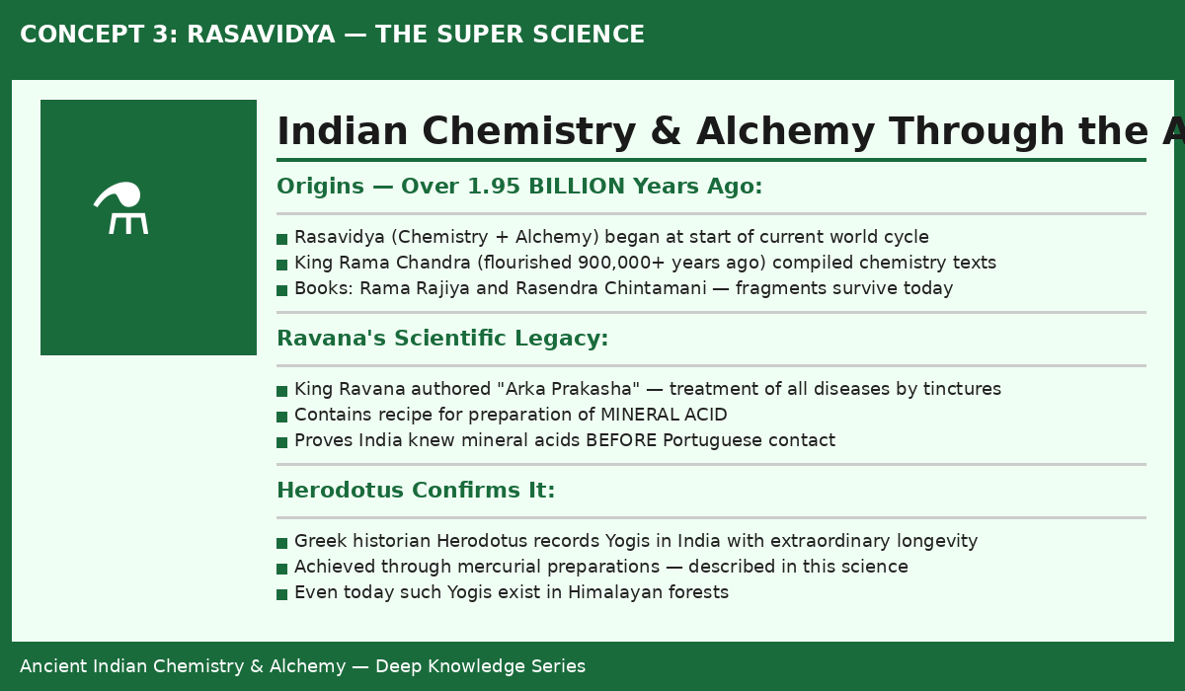
Figure 3: Rasavidya — ancient Indian chemistry encompassing medicine, alchemy, and spiritual science

3.1 What is Rasavidya?
Rasavidya (literally: "knowledge of rasa/essence/mercury") is the ancient Indian science encompassing:
- Medical Chemistry — preparation of powerful medicines from mercury, metals, minerals and herbs
- Alchemy — transformation of base metals into gold and silver
- Longevity Science — preparation of elixirs for extraordinarily extended life spans
- Spiritual Chemistry — the transmutation of matter as a reflection of spiritual transformation

It is described in the tradition not merely as a science but as a "super-science" — meaning it transcends the ordinary boundaries of observation, experiment, and inductive reasoning. Its principles were transmitted through inspiration and revelation, from teacher to student in an unbroken lineage.

3.2 The Antiquity of Rasavidya — Two Key Figures

King Rama Chandra — The Royal Chemist (900,000+ years ago)
According to the Indian tradition, King Rama Chandra — the hero of the epic Ramayanam — was not only a warrior king but a serious student of chemistry. During his 14 years of forest exile in the Dandaka forest (hence also called Dandaka Nath), he studied the science of chemistry under the sage Kalanatha.
He compiled two works that survive in fragmentary form:
- Rama Rajiya — on the kingdom of chemical knowledge
- Rasendra Chintamani — the philosopher's gem of chemical science (distinct from the later Rasa Chintamani by Ananta Deva Suri)

The existence of these fragments demonstrates that medical chemistry had reached "a very high state of perfection" at least 900,000 years ago — an astonishing claim that modern science has not yet found reason to definitively disprove.

King Ravana — The Scientist King of Lanka
King Ravana, the great ruler of Lanka (Sri Lanka) and the antagonist of the Ramayanam, was simultaneously a great scholar and scientist. He authored the "Arka Prakasha" — a comprehensive medical treatise dealing with the treatment of all diseases using tinctures alone.
Most significantly, Arka Prakasha contains at least one recipe for the preparation of a MINERAL ACID. This directly contradicts the commonly repeated colonial-era claim (made by Dr. Sir P.C. Roy) that India learned mineral acid preparation from the Portuguese. The textual evidence clearly predates any Portuguese contact by hundreds of thousands of years.

3.3 Herodotus and the Longevity Yogis
The ancient Greek historian Herodotus — one of the earliest Western scholars to record observations from India — noted the existence of Yogis who lived extraordinarily long lives. He attributed this longevity to the use of mercurial preparations. This independent observation from a Western classical source corroborates what the Indian chemical tradition itself claimed.

Importantly, the tradition maintains that such Yogis are not entirely a thing of the past. The forests of the Himalayas and the region of Amarakantaka reportedly still shelter practitioners of this science who maintain extraordinary longevity through mercurial preparations. The formulas for such preparations are documented in the broader corpus of Rasavidya texts.

3.4 Rasavidya as Super-Science — Beyond Ordinary Knowledge
The key philosophical claim about Rasavidya is that it is not a science in the conventional sense:
- It is NOT a collection of empirical truths derived from repeated experiments.
- It is NOT built primarily on inductive generalization from observations.
- It IS based on something the tradition calls higher than ordinary experience — inspiration, revelation, or what might today be called "direct cognition."

This does not mean it is irrational or unverifiable — quite the opposite. The procedures described in Rasavidya texts work reliably when followed correctly. The point is that the ORIGIN of these procedures came not from trial-and-error but from a higher mode of knowing, transmitted intact through the teacher-student lineage.

Section 4: The Four Systems of Ancient Indian Medicine

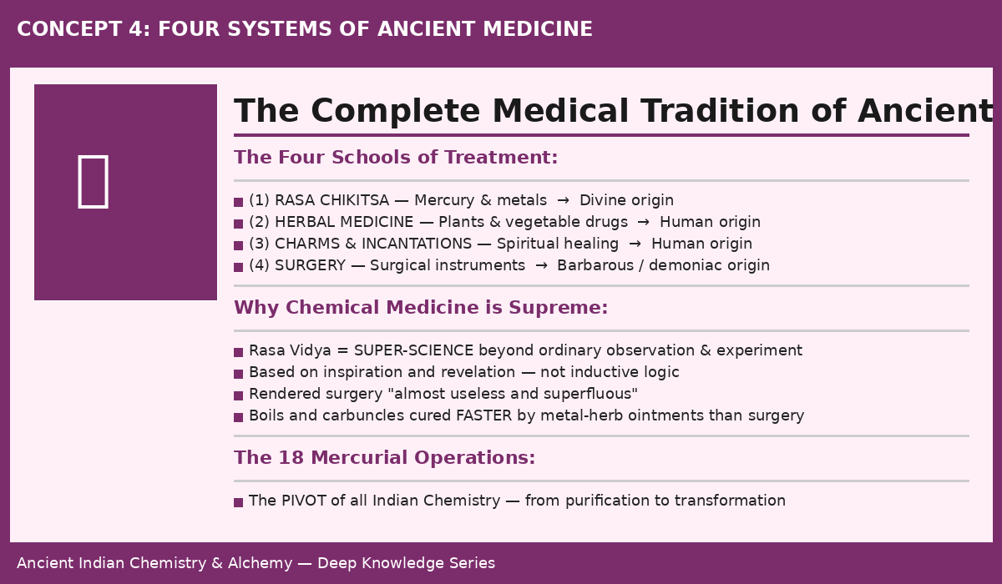
Figure 4: The four complete medical traditions of ancient India — from divine chemical medicine to surgical arts

4.1 Overview of the Four Systems
Ancient India developed four completely distinct and parallel medical traditions, each with its own theoretical basis, practitioners, and social context. They co-existed and were cultivated simultaneously from time immemorial:

# | SYSTEM | DESCRIPTION | ORIGIN | STATUS
1 | Rasa Chikitsa | Treatment by mercury, metals & minerals — the foundation of Indian chemistry of medicine | Divine | HIGHEST
2 | Herbal Medicine | Treatment by plants, vegetable drugs, roots and extracts — the most widely practised system | Human | WIDESPREAD
3 | Charms & Mantras | Treatment by charms, incantations, yantras and spiritual interventions | Human | SPECIALIST
4 | Surgery | Treatment by surgical instruments — wound management, operations | Demoniac / Barbarous | LIMITED

4.2 Why Chemical Medicine Was Ranked Highest
The supremacy of Rasa Chikitsa (chemical medicine) over the other three systems was not a matter of opinion — it was demonstrated practically. Chemical medicines made from processed mercury and metals, combined with carefully selected herbs, were found to:
- Work far more rapidly and effectively than herbal preparations for most serious diseases
- Cure conditions like boils, carbuncles, abscesses, and deep infections without surgery
- Provide longevity benefits that no herb-based system could match
- Treat the root cause of disease rather than merely suppressing symptoms

4.3 Surgery — The Lowest Ranked System
The assignment of "demoniac or barbarous origin" to surgery is remarkable and requires interpretation. It does not mean surgery was evil or wrong — it means that surgery was considered a brute-force intervention: cutting, removing, and repairing by physical means. In a system where chemical medicines could dissolve tumours, heal deep wounds, and cure internal diseases without a single incision, surgery was rendered largely unnecessary.

Even in the modern era, practitioners report that boils and carbuncles treated with metal-herb ointments based on ancient Rasavidya formulas heal more completely and with less scarring than surgical excision. The ancient claim holds up to direct practical observation.

Section 5: The 18 Mercurial Operations — Complete Breakdown

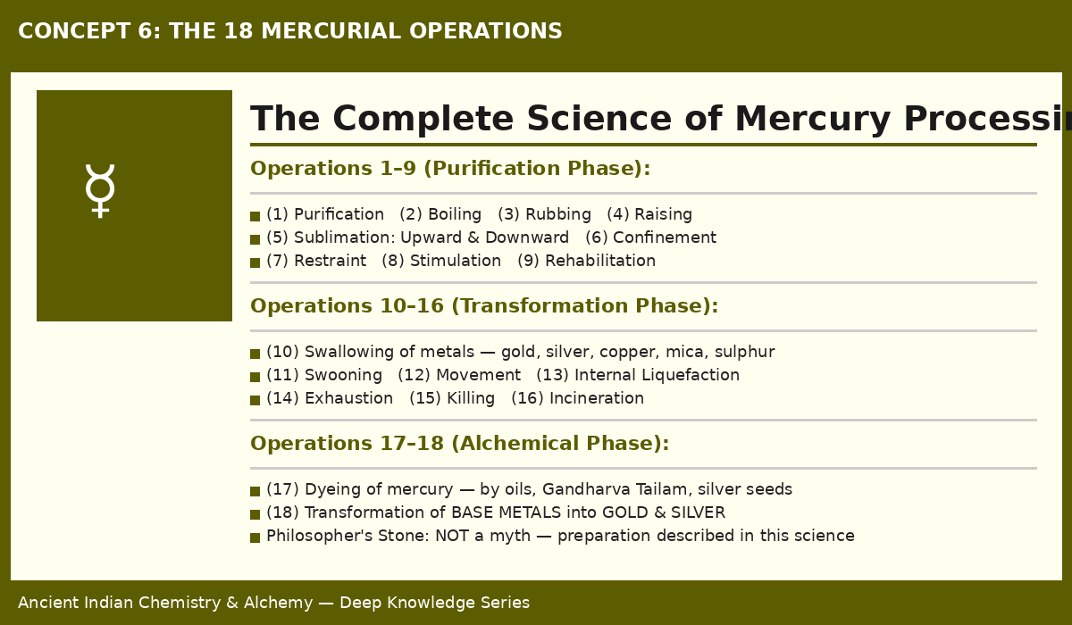
Figure 5: The 18 Mercurial Operations — the pivot of all Indian chemistry from purification to alchemical transformation

5.1 Mercury (Parada) — The Central Element of Rasavidya
Mercury holds a position of supreme importance in ancient Indian chemistry that has no parallel in any other ancient chemical tradition. Called Parada in Sanskrit, mercury was considered not merely a metal but a living, transformable substance — one that could absorb, process, and transmit the properties of other metals and minerals.
The entire science of Rasavidya rotates around mercury. The 18 specific operations performed on mercury constitute the complete curriculum of Indian medical chemistry. A physician who truly understood and could perform all 18 operations was considered a master chemist capable of treating any disease.

5.2 Phase 1: Purification Operations (1–9)
The first nine operations prepare mercury for its role as a medicinal and alchemical agent. Raw mercury as found in nature contains impurities and volatile components that must be systematically removed before it can be safely used.

Op. | Name | What It Achieves
(1) | Purification (Shodhana) | Removes gross and subtle impurities from raw mercury — the essential first step before any other operation
(2) | Boiling (Mardana) | Trituration with herbal substances — activates mercury's absorptive capacity
(3) | Rubbing (Murchhana) | Systematic rubbing with specific liquids causing mercury to lose its usual mobility
(4) | Raising (Utthapana) | Restoration of mercury's mobility after rubbing — heightened purity
(5) | Sublimation (Patana) | Upward and downward sublimation — separates and reconcentrates volatile components
(6) | Confinement (Rodhan) | Mercury is "confined" — made to not run and not evaporate under normal conditions
(7) | Restraint (Niyamana) | Further restriction of mercury's natural volatility for medicinal stability
(8) | Stimulation (Deepana) | Reactivation of mercury's digestive/absorptive fire after confinement
(9) | Rehabilitation (Grasan) | Absolute purification — mercury ready for swallowing metals

5.3 Phase 2: Transformation Operations (10–16)
Once mercury has been purified and prepared through the first nine operations, it becomes capable of absorbing — or "swallowing" — other metals and minerals. This absorption changes both the mercury and the absorbed substance, creating entirely new medicinal compounds.

- Operation (10) — Swallowing (Jarana): Mercury absorbs gold, silver, copper, iron, lead, tin, and mica. It also absorbs sulphur and the essence of mica. Each metal absorbed gives mercury new medicinal properties. The order of swallowing is specific and follows a precise protocol.
- Operation (11) — Swooning (Murcchana): Mercury enters a suspended, inert state — used as a basis for specific medicinal preparations.
- Operation (12) — Movement (Chalanam): Mercury regains specific directional movement properties — used in preparations requiring penetrative action.
- Operation (13) — Internal Liquefaction (Druti): Mercury dissolves internally, creating a fluid state different from ordinary liquid mercury.
- Operation (14) — Exhaustion (Khecharatva): Mercury is brought to a state of complete stability and exhaustion of volatile properties.
- Operation (15) — Killing (Marana): Mercury is "killed" — made non-volatile, non-toxic, and permanently stable. This is the most critical transformation.
- Operation (16) — Incineration (Bhasmikarana): Killed mercury is incinerated into a fine ash (bhasma) — the most potent medicinal form.

Incinerated mercury (Parada Bhasma) is the cornerstone of Indian chemical medicine. It is so fine and bioavailable that it acts on the body at a cellular level. Specific preparations include Bajra Panjara Rasa, Panchamrita, and dozens of others — each targeting specific diseases.

5.4 Phase 3: Alchemical Operations (17–18)
- Operation (17) — Dyeing (Ranjana): Mercury is dyed with specific substances — oils, Gandharva Tailam, seeds of silver — giving it the capacity to transmit colour and metallic properties to other substances.
- Operation (18) — Transformation (Vedha): The final operation — the ultimate alchemical act. Mercury, after all 17 prior operations, gains the power to transform base metals into gold and silver. This is the practical basis of Indian alchemy.

Section 6: Alchemy — Philosopher's Stone & Metal Transformation

6.1 The Philosopher's Stone — Not a Myth
The concept of the Philosopher's Stone — a substance capable of transforming base metals into gold — is often dismissed in Western culture as pure fantasy. In the Indian chemical tradition, it is treated as a documented historical reality. The method of its preparation is described across several Rasavidya texts.
The tradition holds that in ancient times, the knowledge of preparing the Philosopher's Stone was common among master chemists. It fell into obscurity not because it was impossible but because the socio-political conditions required for its practice (stable trade, access to rare metals, uninterrupted teacher-student lineages) were destroyed during centuries of invasions and turmoil.

6.2 Different Types of Metal Transformation
The texts describe multiple distinct categories of metal transformation, each requiring different preparations and levels of mastery:
- Direct Transmutation — base metal converted to gold by contact with a prepared mercury compound
- Seed of Silver — a preparation that multiplies silver when introduced into base metals
- The Dyeing Process — metals take on gold or silver properties through the Ranjana operation
- The Sarana Process — a specific protocol for transmutation described in detail in the texts

6.3 Scientific Plausibility — The Modern Perspective
From a modern chemistry perspective, the idea that mercury — which dissolves most metals into amalgams — could, under specific conditions of temperature, pressure, and chemical environment, facilitate the rearrangement of atomic structures is not as far-fetched as it once seemed. Modern nuclear physics has demonstrated that elemental transformation IS possible (through nuclear reactions). The ancient claim is that chemical processes (not nuclear ones) could achieve similar results under specific conditions. This remains an open question.

💡 VIDEO HOOK IDEA: "Modern science says you cannot turn lead into gold with chemistry. But an ancient Indian text — written when chemistry was considered a divine science — describes exactly how to do it. Is this pure fantasy? Or has modern science not yet caught up to what the ancients knew?"

Section 7: The Dark Age — How Ancient Chemistry Was Lost

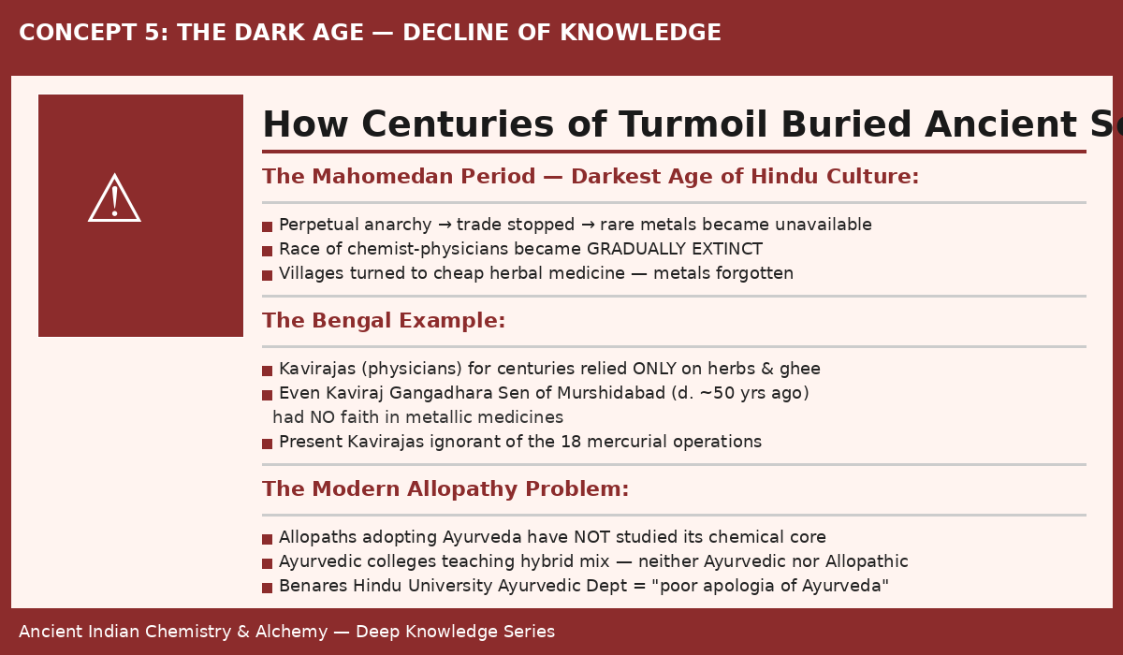
Figure 6: The systematic decline of Indian chemical knowledge through centuries of conquest and neglect

7.1 The Mahomedan Period — Root Cause of the Decline
The most significant factor in the decline of Indian chemistry of medicine was the political and social chaos of the medieval period in India. The consequences were cascading and irreversible on a generational scale:

- Trade collapsed → rare metals like gold, silver, and specific minerals became unavailable.
- With metals unavailable, chemist-physicians could not practice → the profession died out.
- Villages turned to herbal medicine (cheap, locally available) → chemical knowledge abandoned.
- The few remaining practitioners (Yogis in forests) had no patronage or institutional support.
- Without patron-states, the science could not be systematically taught → lineages broke.
- Books and libraries were destroyed repeatedly → texts became fragmentary.
- The language of existing texts became archaic → fewer scholars could read them.
- Result: By the modern era, even the 18 mercurial operations were unknown to most physicians.

7.2 The Bengal Case Study
The state of Bengal provides a clear illustration of how thoroughly chemical knowledge had been forgotten. The Kavirajas (Ayurvedic physicians) of Bengal, for several centuries, relied almost exclusively on medicines prepared from herbs, vegetable products, and clarified butter (ghee).
Even the most celebrated physician of his era — Kaviraj Gangadhara Sen of Murshidabad — had no faith in metallic medicines and made no effort to learn chemistry of medicine. If the greatest physician of the era was ignorant of the core of Indian chemistry, the situation among ordinary practitioners can be imagined.

7.3 The Allopathy-Ayurveda Confusion
When some modern allopathic doctors took up the practice of Ayurveda, hoping to revive the ancient tradition, they compounded the problem by focusing on the wrong branches:
- They emphasised Surgery (Susruta's tradition) — the branch ranked LOWEST in the ancient hierarchy.
- They emphasised Herbal Medicine (Charaka's tradition) — valuable, but not the core of Ayurveda's greatness.
- They IGNORED Medical Chemistry — the branch that made Ayurveda uniquely powerful.

The result was a hybrid medical system — neither properly Ayurvedic nor properly modern — that satisfied neither tradition and served patients less well than either pure system would have.

Specific institutions criticised: The Ayurvedic Department of Benares Hindu University and the Astanga Ayurveda Vidyalaya of Calcutta are identified as teaching "a poor apologia of Ayurveda" — focussed on herbs and surgery while neglecting the chemical heart of the system.

Section 8: The Revival Call — Cultural Independence Over Political

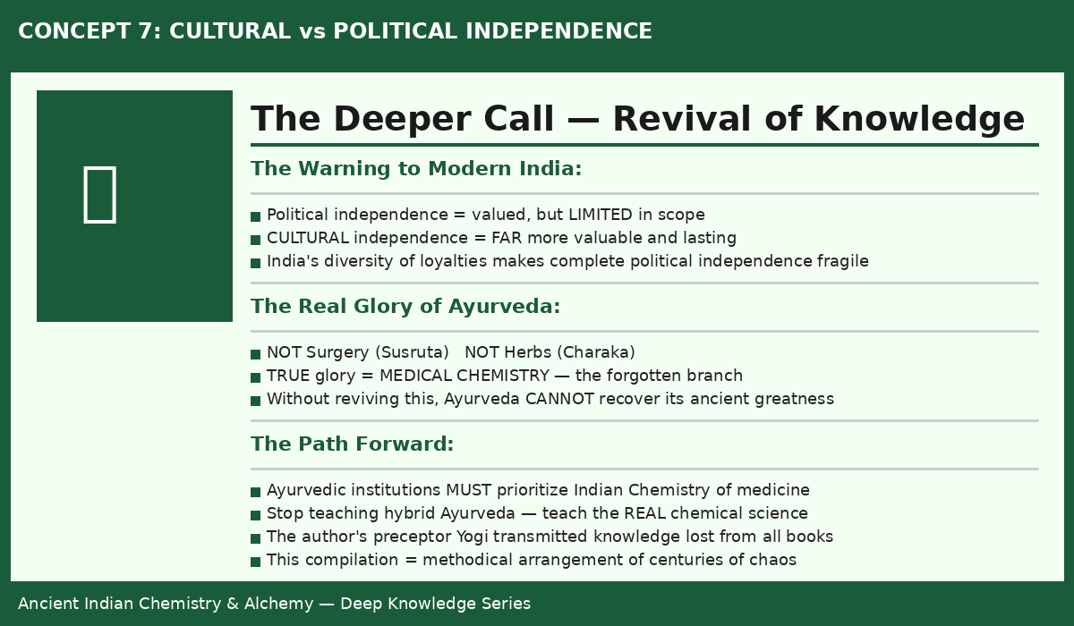
Figure 7: The call for cultural independence — reviving ancient Indian chemistry as the foundation of true national renewal

8.1 The Central Argument
One of the most powerful arguments in the preamble to this body of ancient knowledge is the distinction between political independence and cultural independence. Writing in the early twentieth century, when India's independence movement was at its height, the framing is deliberately provocative:

"Political independence for India is much less valuable than cultural independence. The present day people of India are blind to the fact that cultural independence for India is much more valuable than political independence."

The argument is not that political independence is unimportant — it is that political independence without cultural independence is hollow and unstable. A nation that has forgotten its own greatest intellectual achievement (in this case, Rasavidya and the broader tradition of ancient Indian science) is culturally colonised regardless of who holds political power.

8.2 The Role of This Knowledge Compilation
The motivation for compiling and translating this body of ancient knowledge into English was explicitly to:
- Make ancient Indian chemical knowledge accessible to educated Indians who could not read Sanskrit.
- Provide a systematic, methodical arrangement of material that existed in chaotic, fragmentary form across hundreds of texts.
- Fill in gaps using direct oral transmission from a Yogi preceptor — knowledge not found in any surviving written source.
- Challenge the colonial-era dismissal of Indian science as primitive or unscientific.
- Provide a complete foundation for the revival of genuine Ayurvedic medical education.

8.3 The Preceptor Yogi — Source of Lost Knowledge
A crucial element of the transmission of this knowledge is the role of an unnamed Yogi preceptor. The compiler of this knowledge relates that he had followed the conventional path of Ayurvedic education and would have remained ignorant of the chemical tradition had it not been for an accidental encounter with this Yogi.
The Yogi transmitted knowledge that was:
- Not found in any surviving book on Indian chemistry
- Sufficient to fill the gaps and correct the errors in all existing fragmentary texts
- Essential for transforming a "chaotic state" of disconnected procedures into a coherent, teachable system

This oral transmission lineage — teacher to student, generation after generation — is the mechanism by which the deepest knowledge of Rasavidya survived despite the destruction of libraries and the decline of formal institutions.

Section 9: NotebookLM YouTube Video Prompts

Use the following prompts with NotebookLM after uploading this document to generate YouTube video scripts, episode outlines, and social media content:

Suggested Video Titles & Prompts

Video 1: The 2-Billion Year Universe: What Ancient India Knew That Modern Science Is Only Beginning to Understand
📝 NotebookLM Prompt: Create a 10-minute YouTube script based on Section 1. Start with a shocking hook about the age of the universe. Include 3 visual description cues for animations. End with a cliffhanger about ancient civilisations.

Video 2: The Greek God Was Indian: How the Puranas Predicted World Mythology
📝 NotebookLM Prompt: Based on Section 2, create an 8-minute script exploring how Bacchus in Greek/Assyrian mythology traces back to ancient India. Include visual cues for a map animation showing the cultural spread from India westward.

Video 3: The Science That Made Surgery Obsolete: Ancient Indian Chemical Medicine
📝 NotebookLM Prompt: From Sections 3 & 4, create a 12-minute video explaining the 4 systems of medicine and why chemical medicine (Rasa Chikitsa) was ranked supreme. Include a segment on mercury-based cures that outperform surgery.

Video 4: 18 Steps to Transform Mercury Into Medicine — The Lost Alchemy of India
📝 NotebookLM Prompt: Using Section 5, create a detailed 15-minute explainer video covering all 18 mercurial operations. Structure it as 3 phases with visual diagrams described in the script. Add a "what this means for modern medicine" segment.

Video 5: The Philosopher's Stone Was Real — And India Had It 900,000 Years Ago
📝 NotebookLM Prompt: From Section 6, create a provocative 10-minute video on Indian alchemy. Challenge the Western dismissal of alchemy as fantasy. End with the open scientific question about elemental transformation.

Video 6: How India Forgot Its Greatest Science — The Dark Age That Erased 2 Billion Years of Knowledge
📝 NotebookLM Prompt: Using Section 7, create an emotional 12-minute video documenting the decline. Use the Bengal case study. Include a timeline animation prompt. Make it feel like a detective story uncovering what was lost.

Video 7: Cultural Independence Is More Powerful Than Political Freedom — The Lesson Ancient Chemistry Teaches
📝 NotebookLM Prompt: From Section 8, create a philosophical 8-minute video on cultural identity and the revival of ancient knowledge systems. Connect to modern debates about indigenous science.

Ancient Indian Chemistry & Alchemy — Deep Knowledge Series
NotebookLM Source Document | YouTube Content Pipeline

