INCOME TAX CALCULATION SYSTEM FOR A SALARIED PERSON

**END TERM REPORT**

***By***

**Seelam Raja Shekar Reddy, Soma Diwakar,**

**Popuri Ajay Kumar**

Section: K19PT

Group No: 9

Roll Numbers: 26, 25, 18



**Department of Intelligent Systems,**

**School of Computer Science Engineering,**

**Lovely Professional University, Jalandhar**

November, 2020

**TABLE OF CONTENTS**

|  |  |
| --- | --- |
| * Student Declaration * Bonafide Certificate * Acknowledgement * Introduction * GitHub repository of the project * Description of the project and supporting images |  |

**Student Declaration**

This is to declare that this report has been written by me/us. No part of the report is copied from other sources. All information included from other sources have been duly acknowledged. I/We aver that if any part of the report is found to be copied, I/we are shall take full responsibility for it.

Signature:

Name: Seelam Raja Shekar Reddy

Soma Diwakar

Popuri Ajay Kumar

Roll Number: 26

25

18

Place: Phagwara

Date: 30/10/2020

**BONAFIDE CERTIFICATE**

Certified that this project report “INCOME TAX CALCULATION SYSTEM FOR A SALARIED PERSON” is the bonafide work of “Seelam Raja Shekar Reddy,

Soma Diwakar,

Popuri Ajay Kumar.

” who carried out the project work under my supervision.

### <<Signature of the Supervisor>>(Due to Covid 19, signature is exempted )

<<Name of supervisor>>

<<Academic Designation>>

<<ID of Supervisor>>

<<Department of Supervisor>>

Acknowledgement

I would like to express my special thanks of gratitude to my teacher ***Dr. Dhanpratap Singh*** who gave us the golden opportunity to do this wonderful **project** on the topic **INCOME TAX CALCULATION FOR A SALARIED PERSON**, which also helped us in doing a lot of Research and learn python programming language i came to know about so many ideas to make it happen. And we thank our self **(Seelam Raja Shekar Reddy, Soma Diwakar, and Popuri Ajay Kumar)** with all good team work. we made on time and learned a lot .

Introduction

Income tax is a type of tax that governments impose on income generated by businesses and individuals within their jurisdiction.

There are so many corporate companies paying lot of income tax to government.

Instead of paying full salary to corporate employees.

Corporate company decided to deduct Income tax within the Salary and pay to Government

Not only corporate company but also government employees need to pay the tax to make easy and time efficient we decided to build a software that can give you accurate amount that how much you need to pay and deducts the amount

GitHub repository of the project

<https://github.com/somadiwakar/income-tax-calculation>

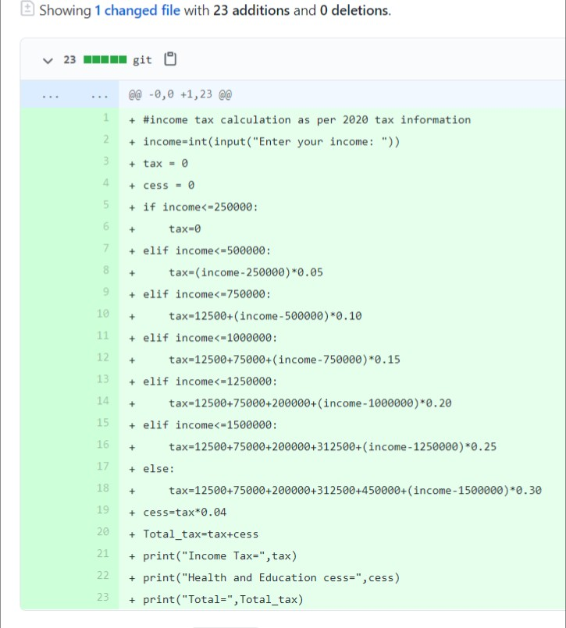

Description of the project

And supporting images

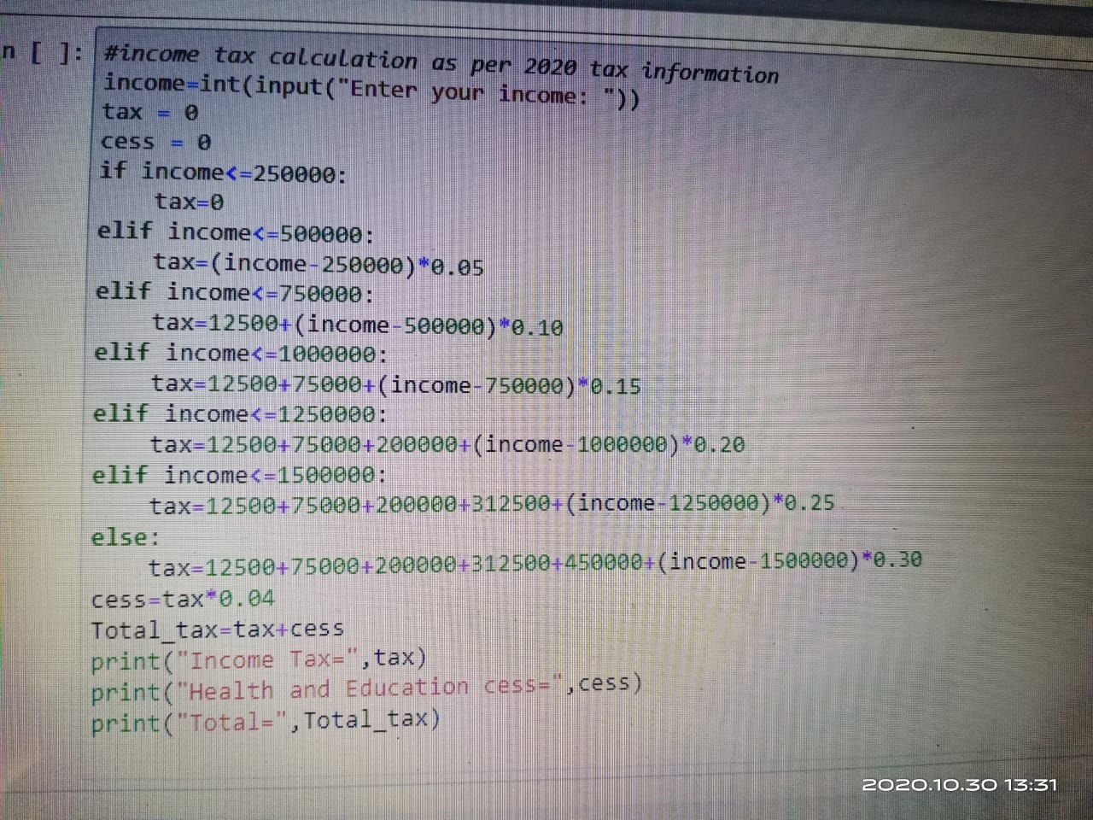

This is the code to calculate the income tax for a salaried person

And run this code

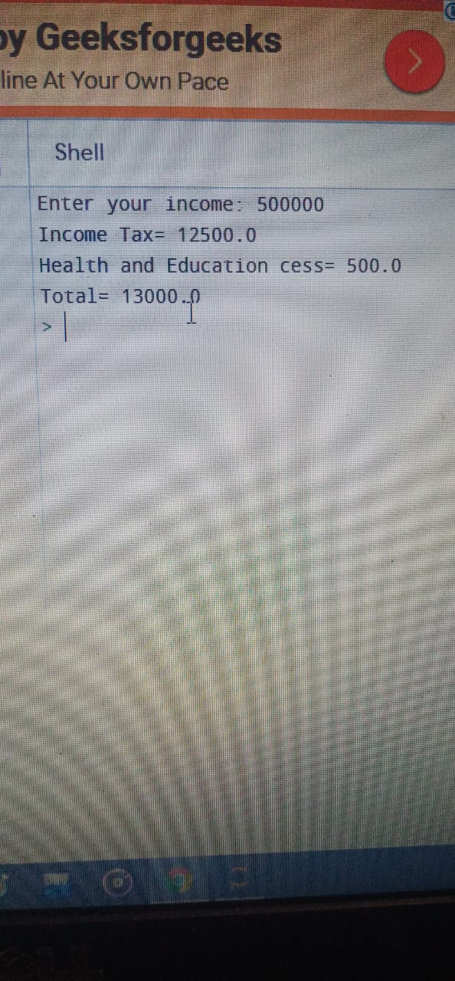

This is the output of the code

Which the salary has

5 lakhs

And income tax calculated as 12500/- at rate of 2.5 percent

And also health and education cess

This code will help people to calculate the tax very easily