Software Requirements Specification
for
Student Advisory System
Version 0.5
Prepared by Chetan Raghav and Sai Somanath Komanduri
SCIS, University of Hyderabad
15th April 2019
Table of Contents
Table of Contents
1. Introduction 1
1.1. Purpose 1
1.2. Scope 1
1.3. Definitions, acronyms, and abbreviations 1
1.4. References 2
1.5. Overview 2
2. Overall Description 3
2.1. Product Perspective 3
2.2. Product Functions 3
2.3. User Characteristics 3
2.4. Constraints 4
2.5. Assumptions and Dependencies 4
2.6. Apportioning of requirements 4
3. Specific Requirements 5
3.1. External interface Requirements 5
3.1.1 User Interfaces 5
3.1.2 Hardware Requirements 11
3.1.3 Software Interfaces 11
3.2. Functional Requirements 11
3.2.1 Register Academic Details 11
3.2.2 Float Course 11
3.2.3 Recommend a Course 11
3.3. Use case Model 12
4. Other Non-functional Requirements 13
4.1. Performance Requirements 13
4.2. Safety Requirements 13
4.3. Security Requirements 13
4.4. Software Quality Attributes 13
4.5. Business Rules 13
APPENDIX A………………………...…………………………………………………………14

Revision History
Name | Date | Reason For Changes | Version
Sai Somanath | 15/04/19 | Initial draft | 1.0

Introduction
This section gives a scope description and overview of everything included in this SRS document. Also, the purpose for this document is described and a list of abbreviations and definitions is provided.

Purpose
The purpose of this document is to give a detailed description of the requirements for the “Student Advisory System” (SAS) software. It will illustrate the purpose and complete declaration for the development of system. It will also explain system constraints, interface and interactions with other external applications. This document is primarily intended to be proposed to Prof. Salman Abdul Moiz for its approval and a reference the product and as an aid to developing and extending the first version of the system for the development team.

This document primarily describes the release of the Student Advisory System version 0.5.

Scope

The “Student Advisory System” is a Web-based application which helps students to find the best course to take up in a particular semester based on previous academic details and interests. The application can be used from a standard web browser either on a computer or on a mobile device.
The faculty of the institute are required to provide the details about the course in the application with the prerequisites of the course so that the system can use that information to crunch up recommendations. This information will act as the basis for the recommendation system that students will make use of. The software needs an active Internet connection to fetch and display results. All system information is maintained in a database, which is located on a web-server. The software also keeps a record of students’ academic performance. The software currently offers recommendations to students allowing them to pick up courses based on their interests and, prerequisites specified by the faculty. Also, the Software is currently only restricted to recommend courses offered by the School of Computing and Information Sciences, University of Hyderabad.

Definitions, acronyms, and abbreviations
Term | Definition
User | Someone who interacts with the system
Student | A registered person of the university who is will to study courses in a semester
Faculty | A registered person of the university who is will to offer courses in a semester
SAS | Student Advisory System
Recommender | The part of the SAS that is responsible for providing the student with recommendations
Stakeholder | Any person who has interaction with the system who is not a developer.

References
[1] IEEE Software Engineering Standards Committee, “IEEE Std 830-1998, IEEE Recommended Practice for Software Requirements Specifications”, October 20, 1998.

[2] Angular documentation (https://angular.io/)

[3] Angular Material User Interface Guide (https://material.angular.io/guides)

[4] Express documentation (https://expressjs.com/)

[5] Mongoose Node.js driver for MongoDB documentation (https://mongoosejs.com/)

Overview
The remainder of this document includes three chapters. The second one provides an overview of the system functionality and system interaction with other systems. This chapter also introduces different types of stakeholders and their interaction with the system. Further, the chapter also mentions the system constraints and assumptions about the product.

The third chapter provides the requirements specification in detailed terms and a description of the different system interfaces. Different specification techniques are used in order to specify the requirements more precisely for different audiences.

The fourth chapter deals with the prioritization of the requirements. It includes a motivation for the chosen prioritization methods and discusses why other alternatives were not chosen.

Overall Description
This section will give an overview of the whole system. The system will be explained in its context to show how the system interacts and introduce the basic functionality of it. It will also describe what type of stakeholders that will use the system and what functionality is available for each type. At last, the constraints and assumptions for the system will be presented.

Product Perspective

This system is a self contained one that only offers a web view through which the stakeholders can interact with the system. The software application is will support the stakeholders completely in the course recommendation cycle. For a better understanding of the system a diagram is provided below that illustrates that modules into which the system is majorly divided.

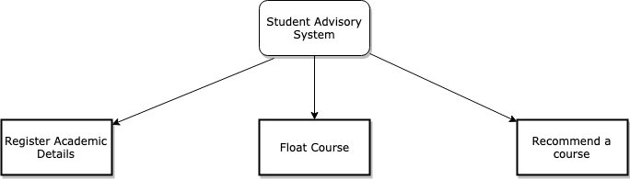

Figure 1: Modules of the Student recommendation System

Product Functions
With the web application, the users will be able to search to do tasks that will help the student get recommendations of the courses. The behavior of the system is based on weather a student is a faculty or a student. The function offered by the system are as follows:

- Register Academic details: This feature allows student to register themselves with the system. A student will need to provide his contact details, university registration details and will also need to fill detailed academic survey form that questions a student about his previous academics.
- Float Course: This feature is intended for use by a faculty. The faculty will float a course which a system will make note of. Additionally, the faculty is able to set prerequisites that need to be met before a student can pick the course.
- Recommend a Course: This feature is intended to be used by the student to help make a decision about the courses that he wants to pick up that semester.

User Characteristics
There are two types of users that interact with the system: Students and faculties. Each of these users have different use of the system.

The faculty can use the application only to float a course with the necessary details so that the application will use to provide recommendations to the students.
The Students will also interact with the system but instead will use it to to provide their details and view recommendations.

Both the user will use the system through the same web interface, the only difference will be in the way in which the dashboard for a particular user, offers different functionalities.

Constraints
The Internet connection is also a constraint for the application. Since the application fetches data from the database over the Internet, it is crucial that there is an Internet connection for the application to function.

The application will also be constrained by the capacity of the database.

The entire application is developed using JavaScript and TypeScript. A non-relational database is used.

Assumptions and Dependencies
In developing the SAS, version: 0.5, the following assumption were made:

- The faculty credentials are already present in the database. These are used so that a faculty can log into the system.
- The Student belongs to a graduate course and has completed all his education until his undergraduate level.

MEAN stack is used for developing this project. Below are the versions of each one of them.
- Mongo DB: 4.0.6
- NPM: 6.9.0
- Angular CLI: 7.3.0
- Node: 10.15.1
The application was built on Visual Studio Code platform on Linux x64 operating system. It uses a modular design where every feature is wrapped into a separate module and the modules depend on each other through well-written APIs.

Apportioning of requirements
In the case that the project is delayed, there are some requirements that could be transferred to the next version of the application. These are listed below:

- The algorithm used to recommend student the subjects that they pick in the semester
- The administrator functionalities.

Specific Requirements
This section contains all of the functional and quality requirements of the system. It gives a detailed description of the system and all its features.

External interface Requirements
This section provides a detailed description of all inputs into and outputs from the system. It also gives a description of the hardware, software and communication interfaces and provides basic prototypes of the user interface.

3.1.1 User Interfaces
The user interface are listed below:

Login page: Users will need to enter the login credentials
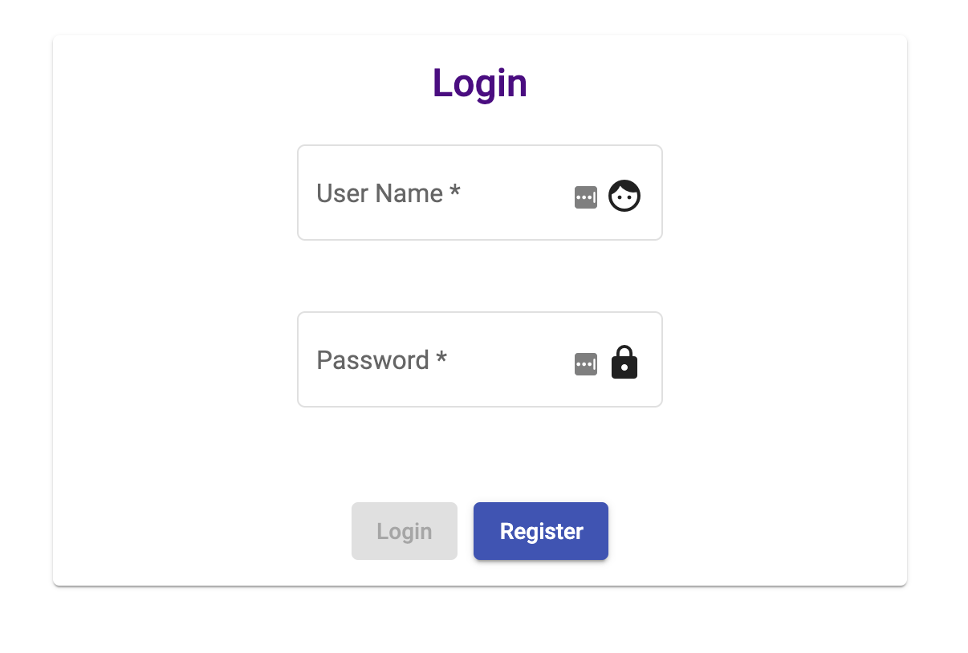

Registration page for students: New student can register here.
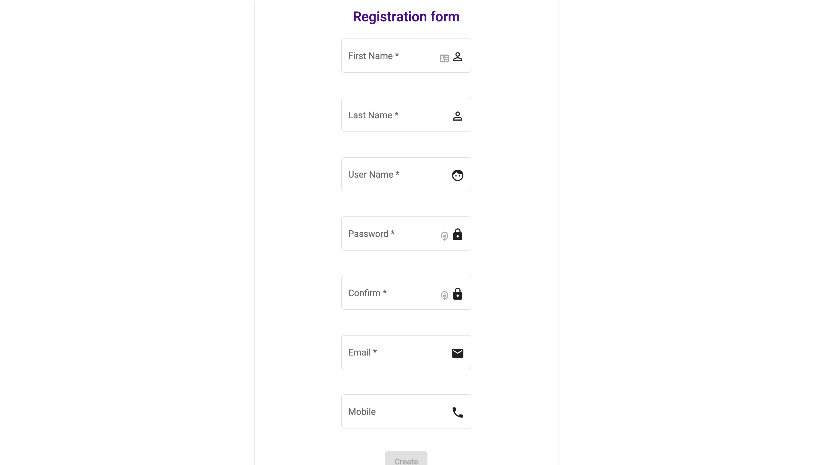

Academic details form: This form has multiple sections as below below in the pictures
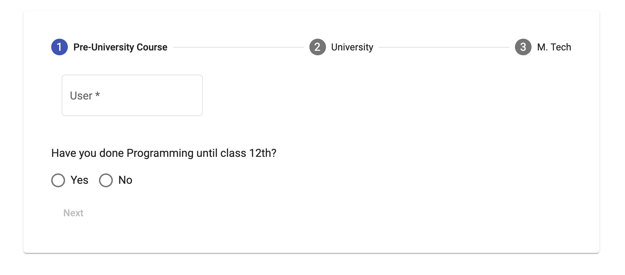
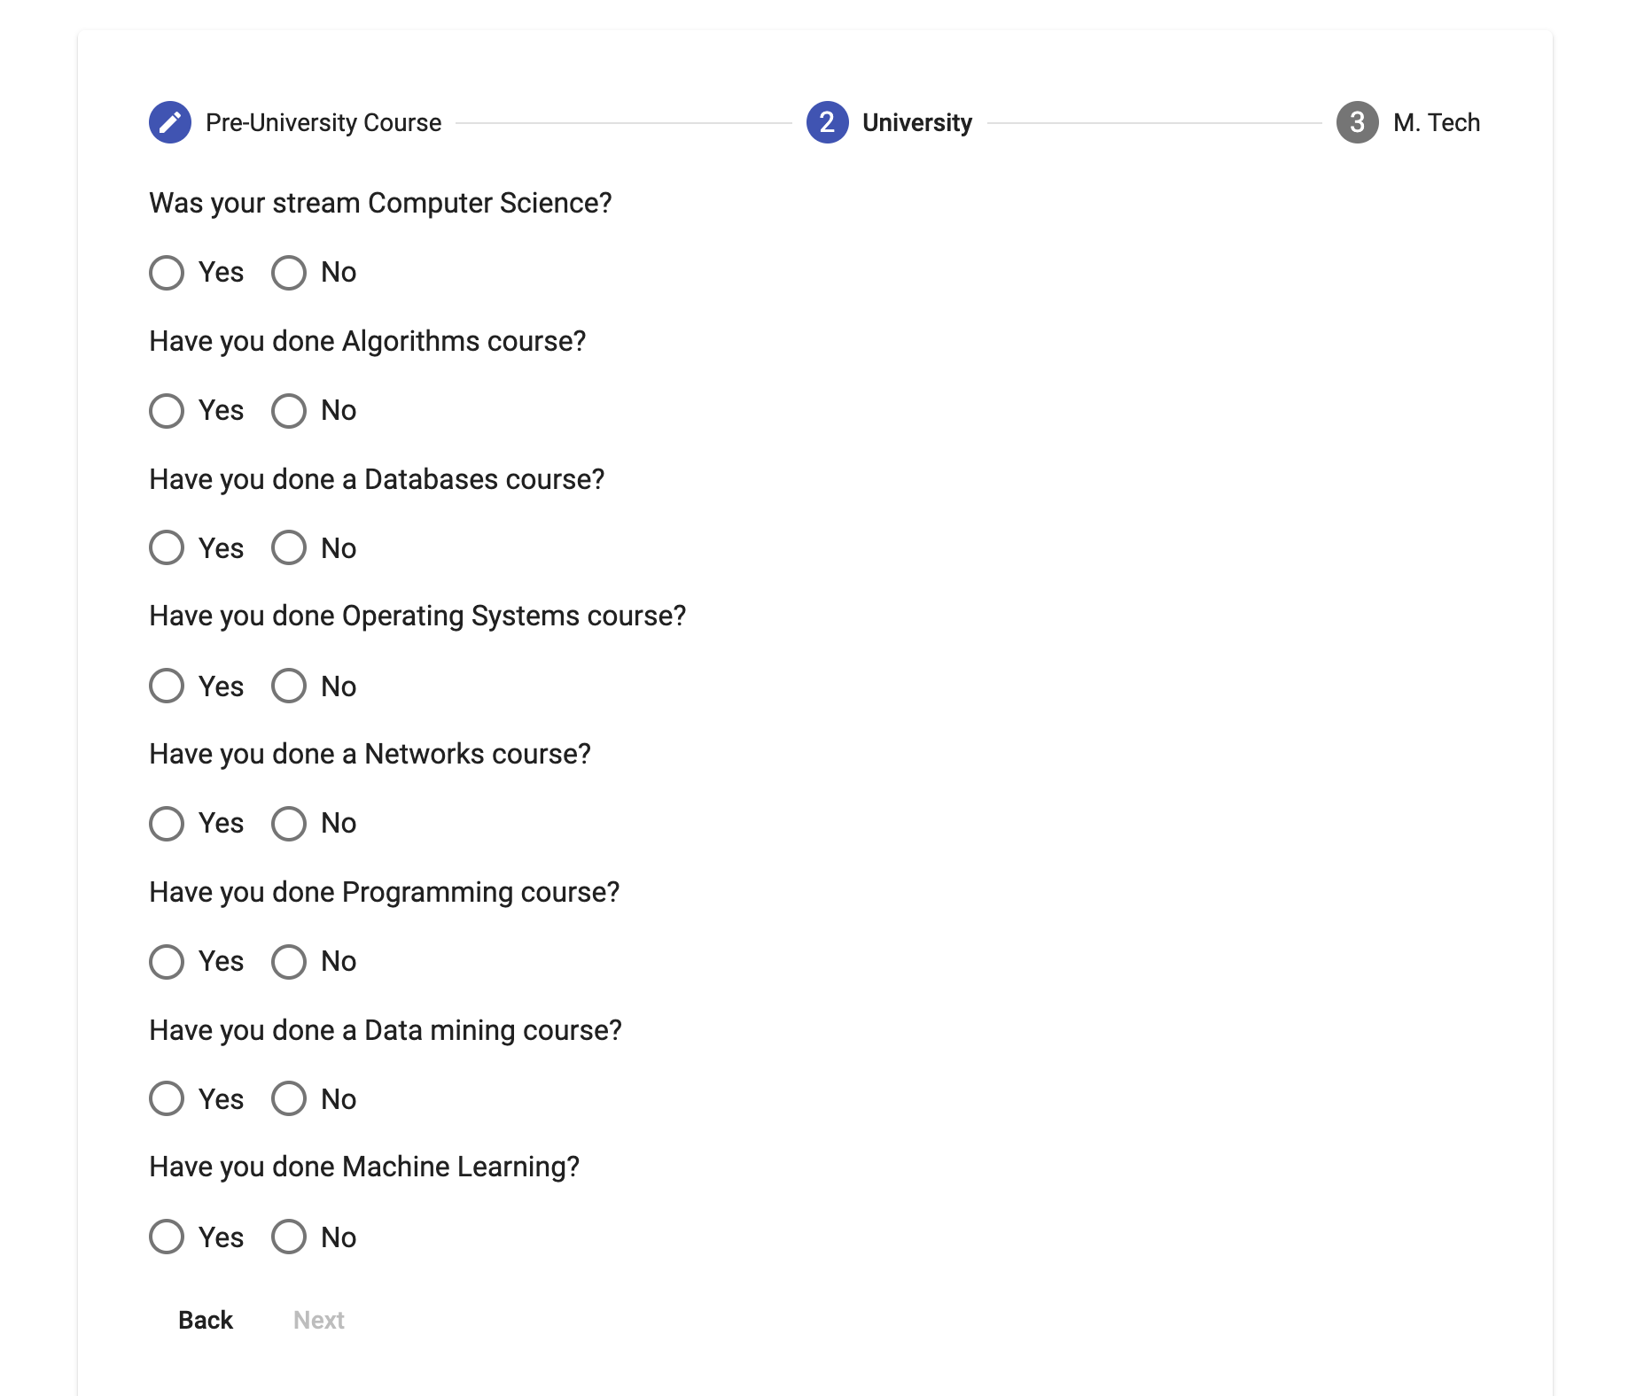

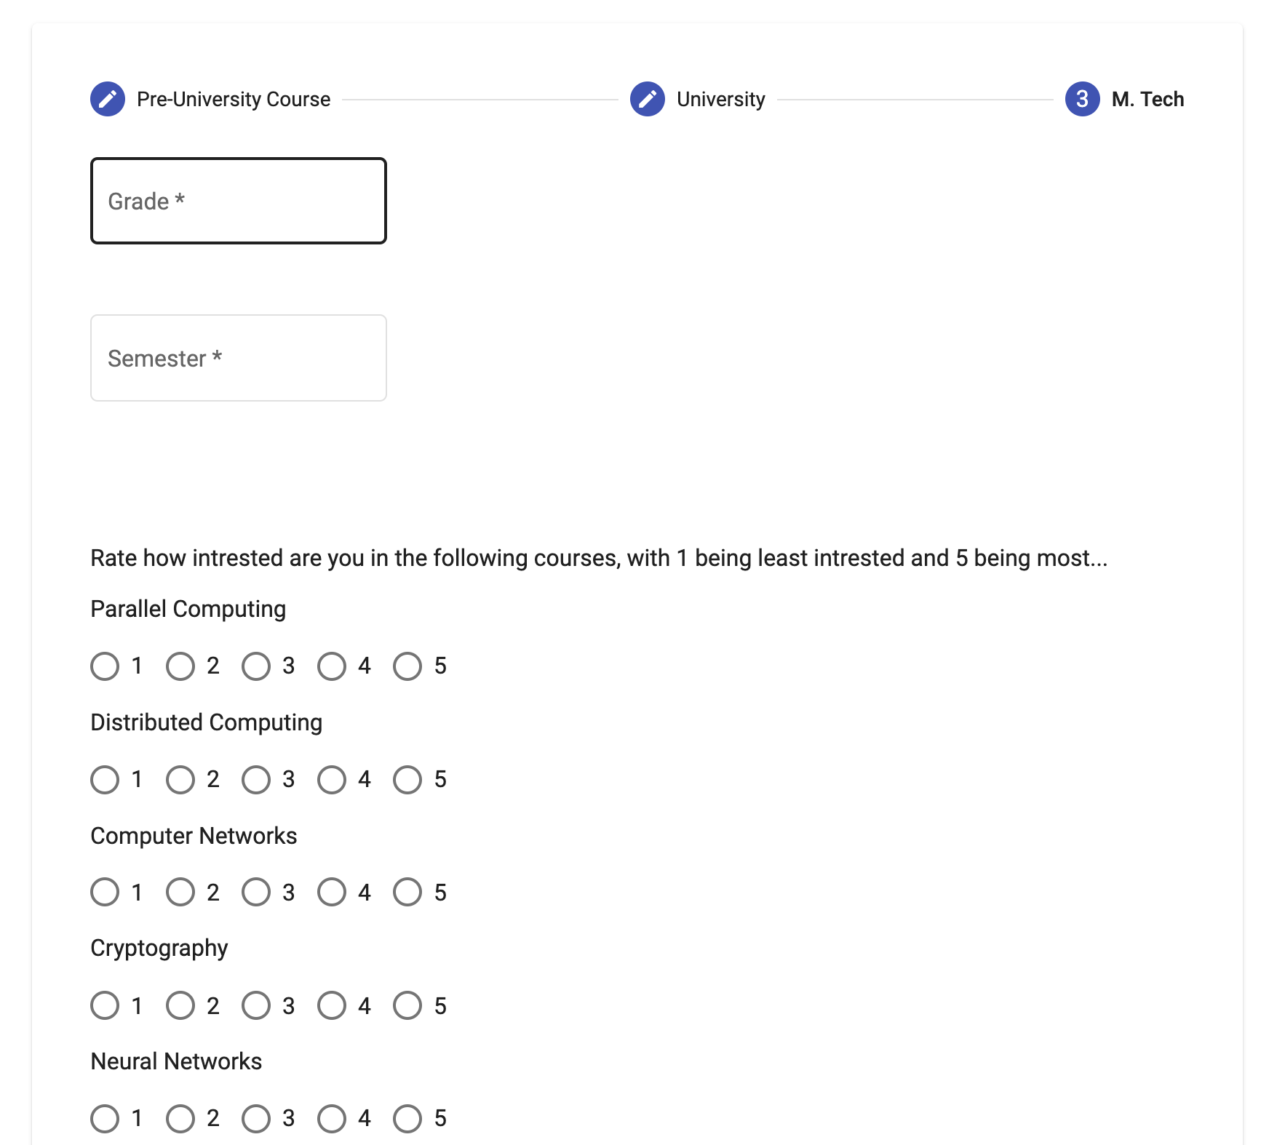

Float Course form: The form that is used by a faculty to float a new course
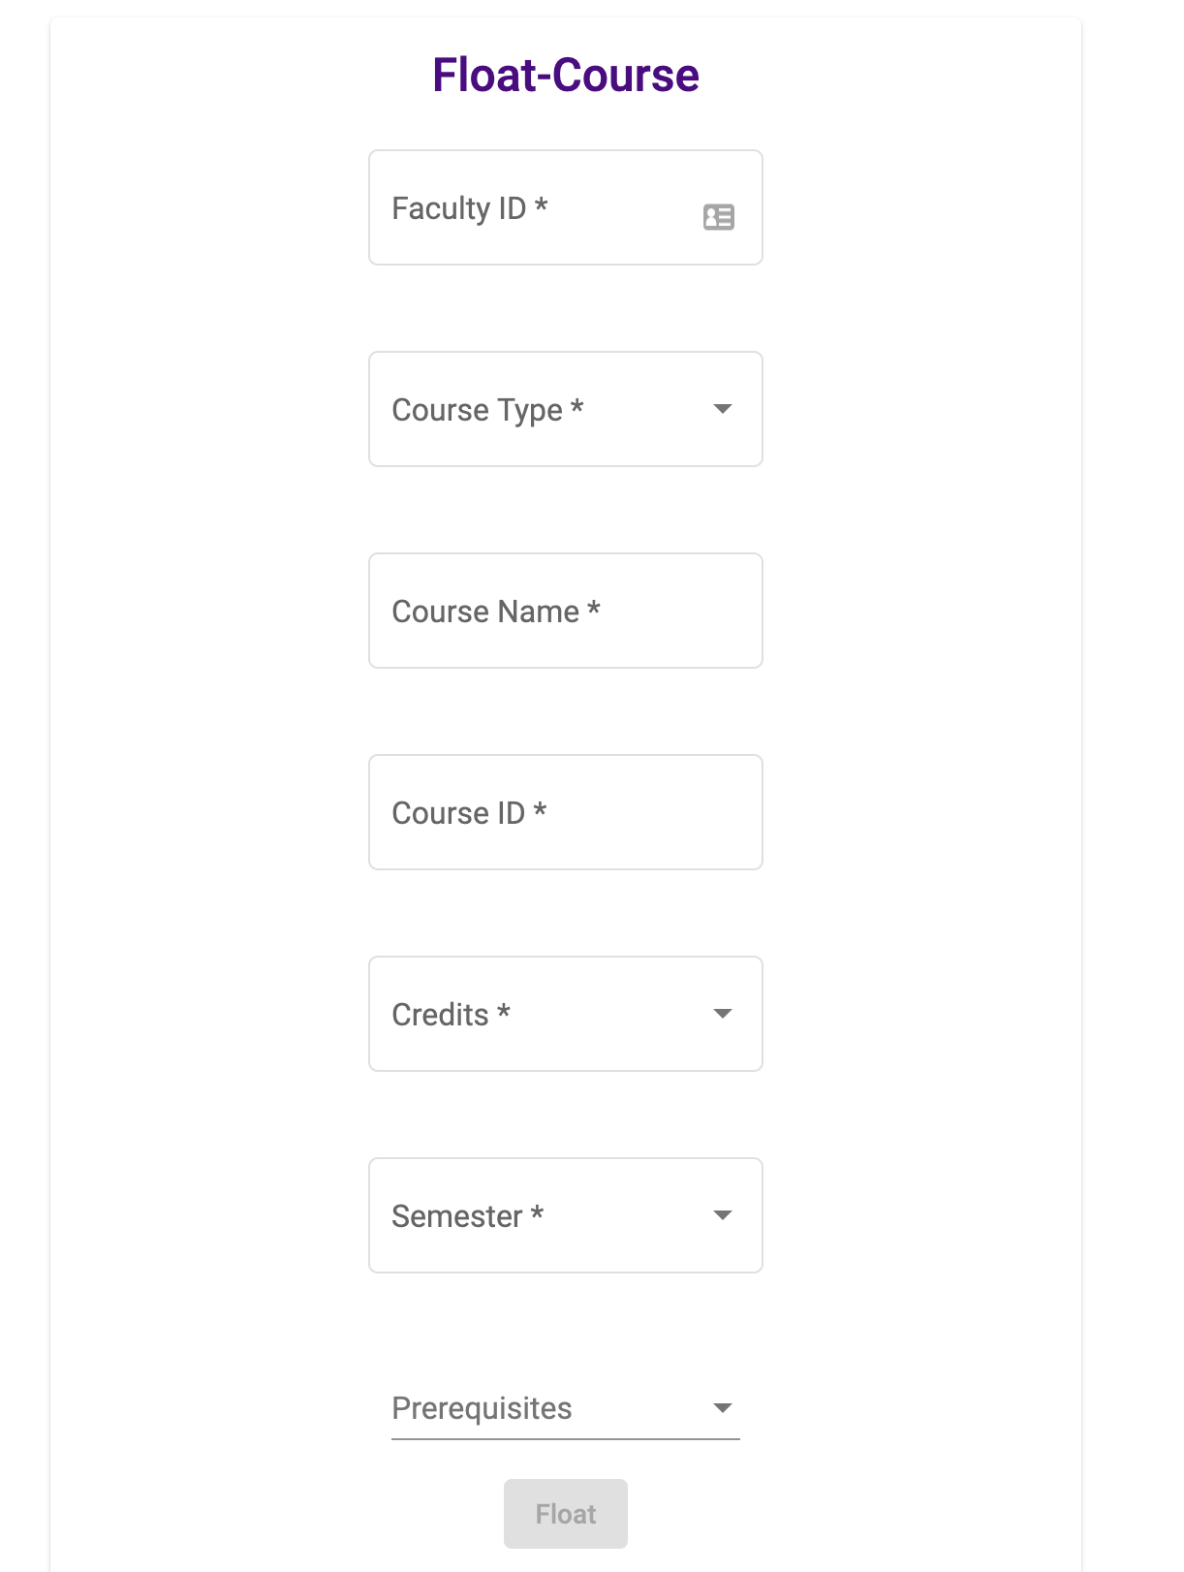

Student dashboard page: The student dashboard page where the student can view his details and the recommendation of the courses.

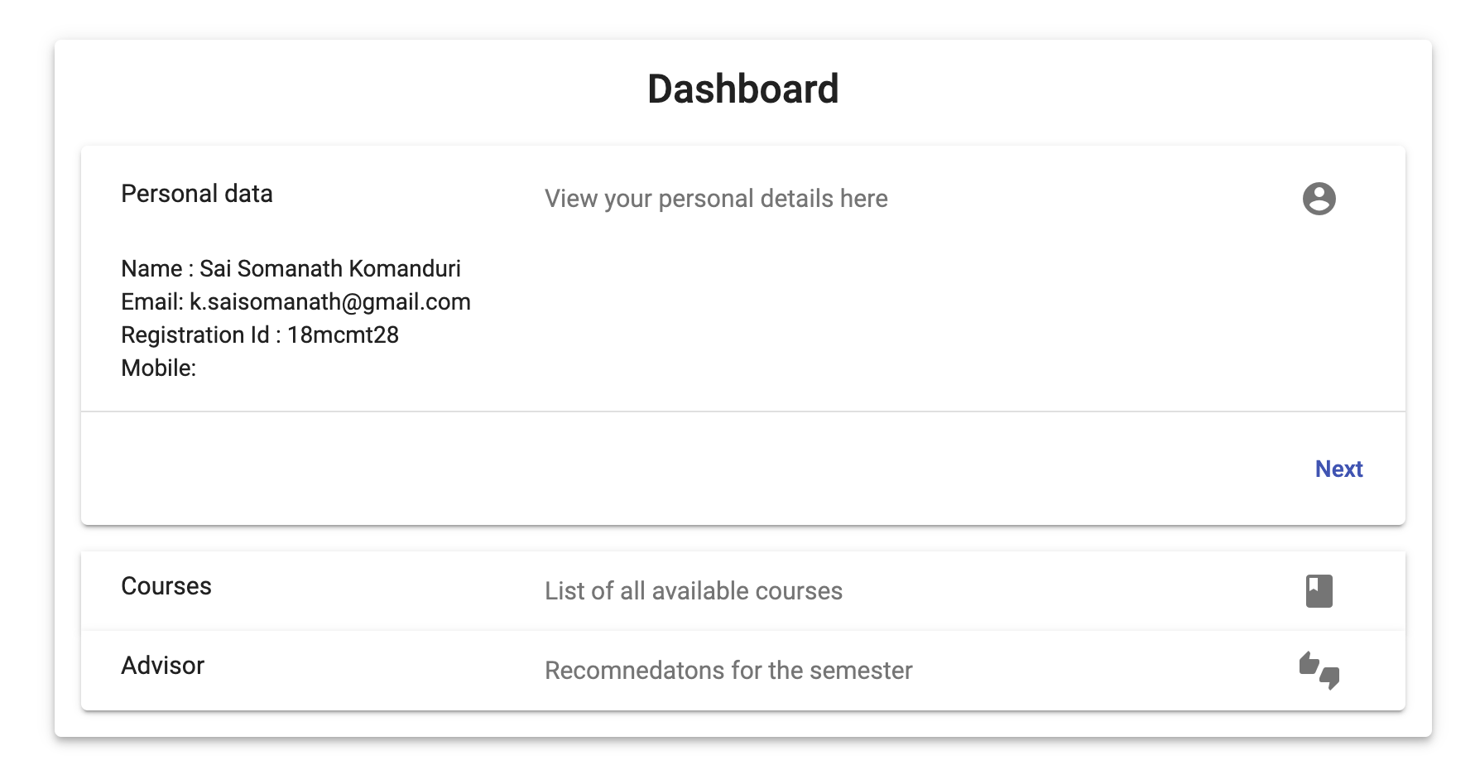
Faculty dashboard page: The faculty dashboard page where the faculty can view his details of the student registered in the course and to float a courses.

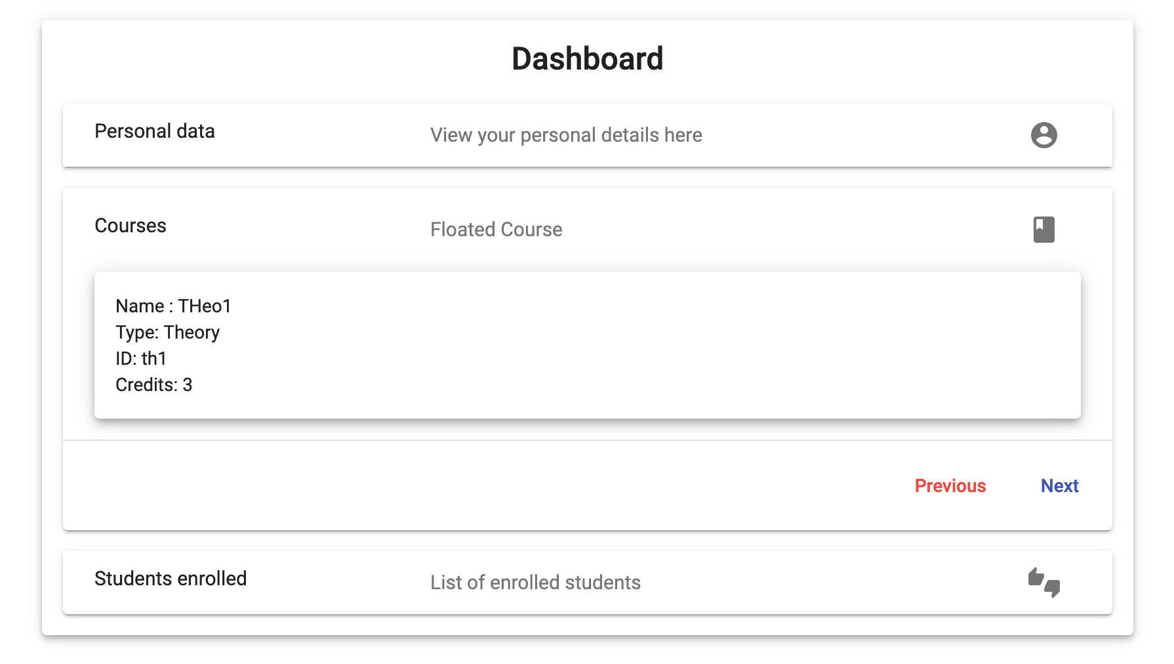

3.1.2 Hardware Requirements
The hardware requirements for the system are as follows:

1. CPU: Intel i3 or higher
2. RAM: 4GB or higher

3.1.3 Software Interfaces
Proper environment setup has to be done in order to develop this application using MEAN Stack. Additional information can be found on section 2.3 of this document.

Functional Requirements

3.2.1 Register Academic Details
This use case concerns with a student who has to register for a semester. A student will need to provide the basic details, that are the name, email, mobile number, and password on the first page. On successful completion of the above actions, an account will be created in the database and the user will receive an email with a verification link. When the user clicks the verification link, the user will be redirected to a login page, where the user must login, before he can continue and complete the form by filling all the previous academic details.

3.2.2 Float Course
This use case concerns with a student who has to float a new course for the semester. The use case starts when faculty logs in. The page now has the details of a course to float a course. The faculty must enter the course type, course name and credits of a course. Optionally, he can also specify the prerequisites.

3.2.3 Recommend a Course
This use case concerns with a student who has to choose the subjects in the new semester. The use case starts when the student has logged into the system and is trying to register for new courses that were previously floated by the faculty of the School.

Use case Model
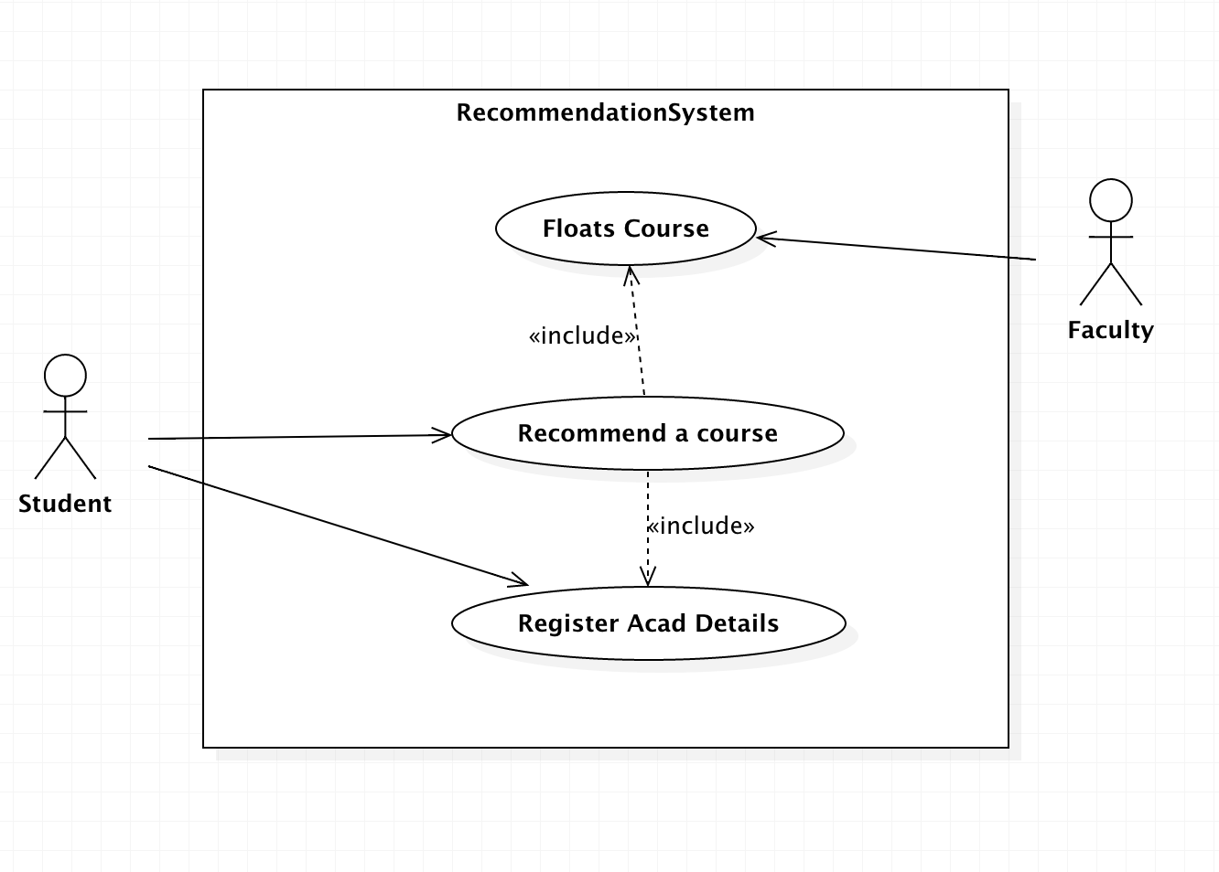

See Appendix A for Use case specifications.

Other Non-functional Requirements

Performance Requirements
The most costly computation if the system is the recommendation process. This recommendation process currently in this release uses simple mathematical calculation to provide a student with his recommendations. There isn’t much of an overhead in the current release.

The Application will be later on extended to have more complex recommendation process. In that case the student must not weight for his recommendations. The recommendation must be visible as soon as a student logs into his dashboard. For this, the results of the recommender must be stored in the database for each student so that it boils down to a single api call.

The second component of the application is the Website itself. The website currently uses the Single Page application standards for superior load times. This rendering speed must be maintained. The Sever side render process may also be considered for even more faster load speeds.

Safety Requirements
The current release of SAS, version: 0.5, has no safety measures in place. If there is extensive damage to a wide portion of the database due to catastrophic failure, such as a disk crash, the database should get all its data from the backup cloud. The backup cloud is asynchronously updated with the primary database.

Security Requirements
The current release of SAS, version: 0.5, has no security measures in place apart from the regular credentials that are required to log into the webpage. The user session must be stored in the browser cache and must be logged out after a specific period of inactivity by the user is noted by the system.

Software Quality Attributes
Other important software attributes include:

- Correctness: The recommendation that are provided by the recommender must be accurate.
- Maintainability: The system must be constructed such that the application is maintainable.
- Usability: The application must be simple to use and clearly communicate its intentions to the user.
- Testability: This quality is also very important as every time the recommendation software is update it must be easy to test it.

Appendix A: Use case specifications

