**MySQL KPI’s**

**1.Total Revenue**

select floor(sum(total_price)) as sum_price from pizza_sales;

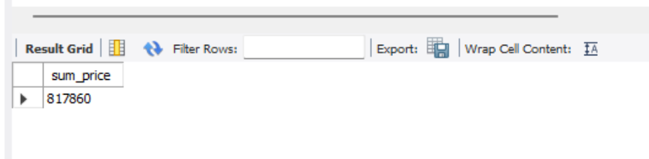

**2.Average Order Value**

select sum(total_price)/count(distinct(order_id)) as average_price from pizza_sales;

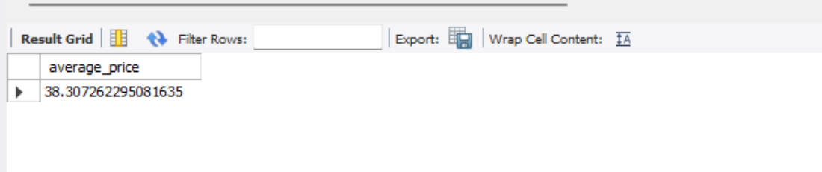

**3.Total Pizzas Sold**

select sum(quantity) as total_quantity_sold from pizza_sales;

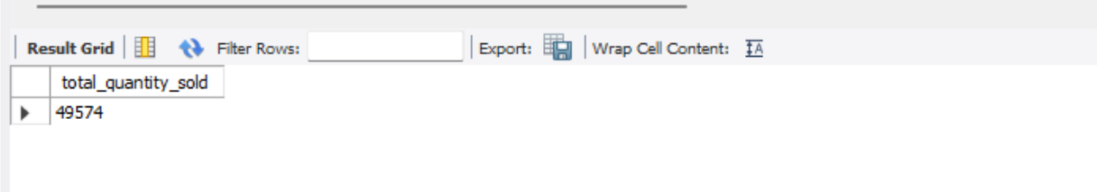

**4.Total Orders**

select count(distinct(order_id)) as count_of_orders from pizza_sales;

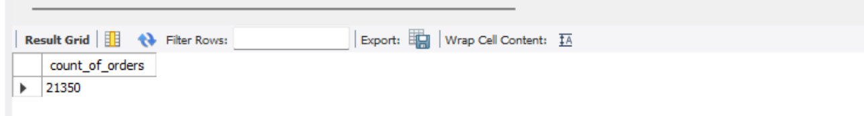

**5.Average Pizza’s Per Order**

select floor(sum(quantity)/count(distinct(order_id))) from pizza_sales as average_pizzas_perorder;

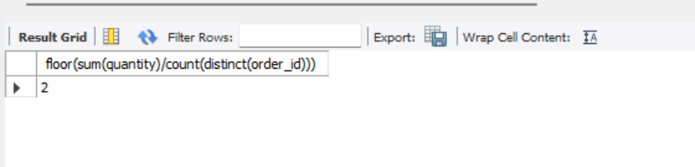

**Chart Requirements**

**1.Daily Trends for Total Orders**

select dayname(str_to_date(order_date,'%Y-%m-%d')) as day_name,count(distinct(order_id)) as total_orders from pizza_sales

group by day_name;

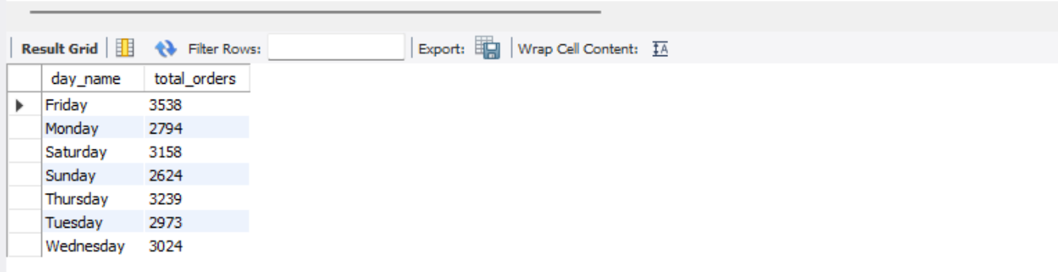

**2.Monthly Trends for Total Orders**

select monthname(str_to_date(order_date,'%Y-%m-%d')) as month_name, count(distinct(order_id)) as total_orders from pizza_sales

group by month_name

order by total_orders desc;

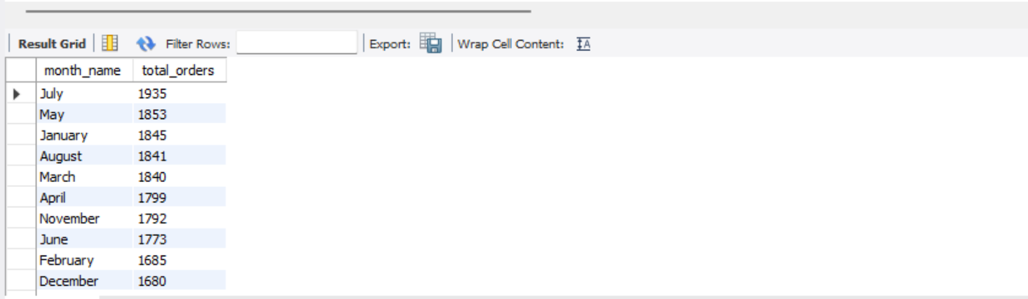

**3.Percentage of sales by pizza category.**

select pizza_category, sum(total_price)/(select sum(total_price) from pizza_sales)*100 as percentage_of_sales from pizza_sales

group by pizza_category;

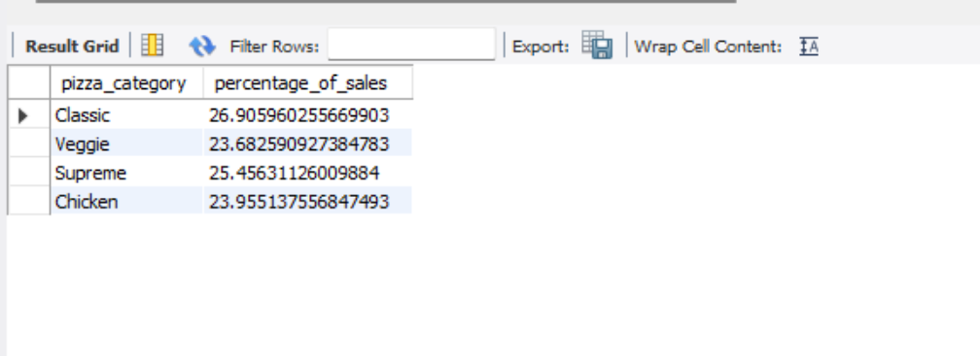

**4.Percentage of sales by pizza size**

select pizza_size,round(sum(total_price)/(select sum(total_price) from pizza_sales)*100,2) as percentage_of_sales from pizza_sales

group by pizza_size

order by percentage_of_sales desc;

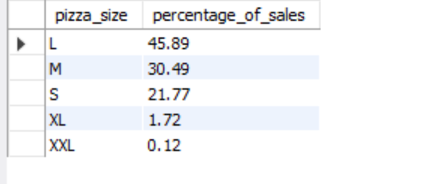

**5. Total pizzas sold by pizza category**

select pizza_category,count(quantity) as total_sold

from pizza_sales

group by pizza_category;

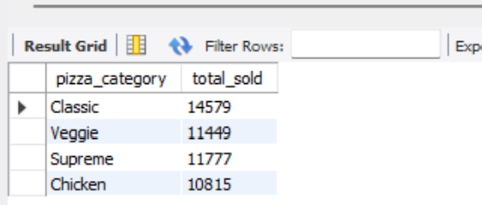

**6. Top 5 best sellers by revenue, total quantity, and total orders**

select pizza_name,sum(total_price) as revenue, sum(quantity) as total_quantity, count(order_id)as total_orders from pizza_sales

group by pizza_name

order by revenue desc,

total_quantity asc,

total_orders asc

limit 5;

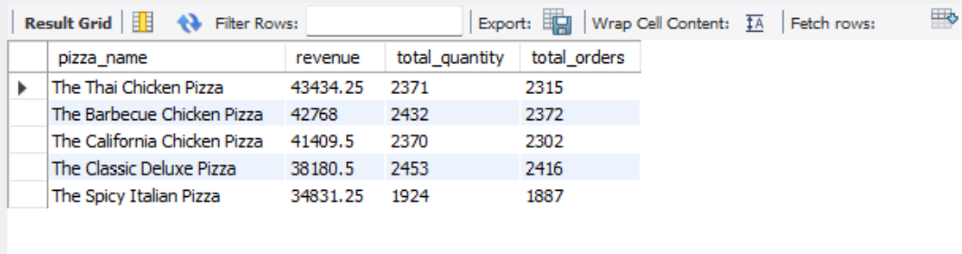

**7. Bottom 5 best sellers by revenue, total quantity, and total orders.**

select pizza_name, sum(total_price) as revenue, sum(quantity) as total_quantity, count(order_id) as total_orders from pizza_sales

group by pizza_name

order by revenue asc,

total_quantity asc,

total_orders asc

limit 5;

