<https://www.youtube.com/watch?v=CGLdH5ORX-Y&ab_channel=OctAcademy>

OctAcademy-angular 8hrs

<https://www.youtube.com/watch?v=NWZniJF9zX4> angular app -octacademy

<https://www.youtube.com/watch?v=aCARwi7e130> figma design - octacademy

Angular framework setup GFG <https://www.geeksforgeeks.org/angular-cli-angular-project-setup/>

1. Step-1: Install angular cli npm install - g @angular/cli.
2. Step-2: Create new project by this command. Choose yes for routing option and, CSS or SCSS. ...
3. Step-3: Go to your project directory cd myNewApp.
4. Step-4: Run server and see your application in action ng serve -o --poll=2000.

<https://youtube.com/playlist?list=PL1BztTYDF-QNlGo5-g65Xj1mINHYk_FM9&si=qwS0iqSOvNc8P58X>

**Proacademy – Angular 60 videos**

Steep 1 -Install nodejs lates version

Step 2 – Install angular CLI

npm install -global @anular/cli@latest

ng version

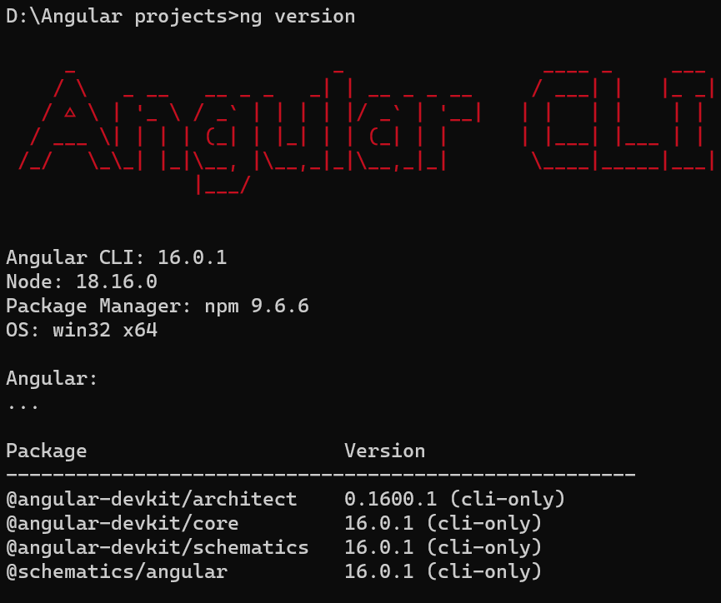

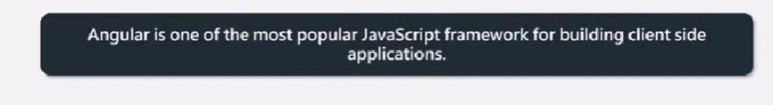

Create angular project

1 create folder>open cmd

>ng new ecomang

Complie and run

>ng serve

Data binding -binding property to html

<https://www.youtube.com/watch?v=p4FKy9Kj9dY&list=PL1BztTYDF-QNlGo5-g65Xj1mINHYk_FM9&index=4&ab_channel=procademy>

#04 Angular files and folder structure| Getting Started with Angular

**Node modules folder**-All required dependent packages and 3rd party libraries .Dont upload on server , don’t push on git hub.If pull from github then just run commant”npm install” then node modules folder will generate .

How to know which packages being installed.Then package.json file comes into picture.

**This file** if imp for every node project.It is project config file.

**Que**.Difference between Dependencies and devdependencies.

**Editorconfig**-define coding standards.Manager or TL can defile this configurations.

**Gitignore**-Mention which files exclude from gitrepo.

Eg. /node_modules

npm-debug.log, /.angular/cache etc.

**Angular.json** file-It contains all configurations in project.

**Package-lock.json**-It records exact version every installed dependencies including subdependency and their versions.Purpose of this file is it insures same versions should be installed in different environment.

**Ts-config.json**-buch of settings for TS compiler.

**src folder—developer put** all application source code.component,service class,module and many more.

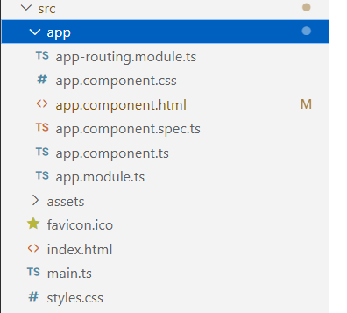

App-whenever we create component,module ,service inside app folder.(in andular a project may contains multiple applications and each app must have 1 component and 1 module file.

Assets folder-All static content, such as icons,images,videos put inside it.It will be accessible publicly.

Index.html-main html file.

Main.ts-Entry point of application.

Style.css-we add all global stylesheet of anguar app.

<https://www.youtube.com/watch?v=zVX1vgsXelo&list=PL1BztTYDF-QNlGo5-g65Xj1mINHYk_FM9&index=5&ab_channel=procademy>

# 05 Bootstrapping Angular Application | Getting Started with Angular



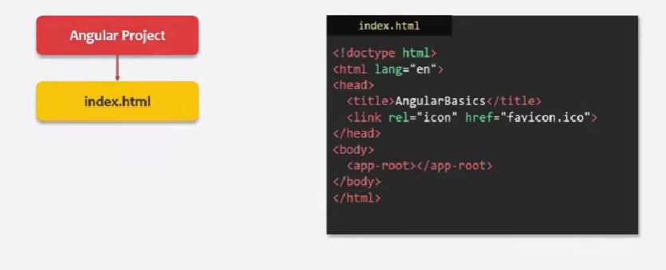

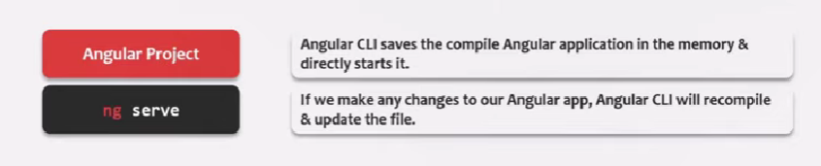

Build application

ng builg

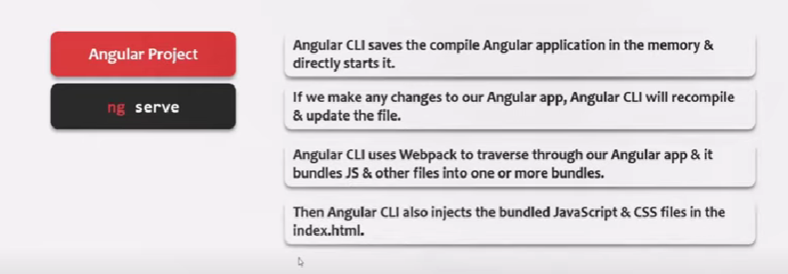

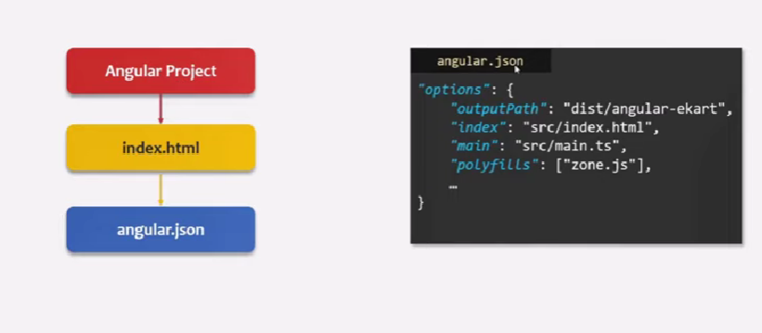

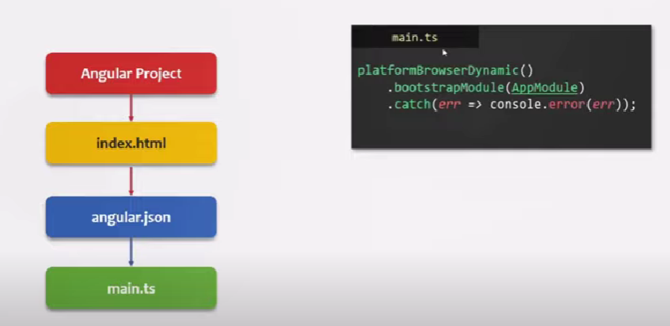

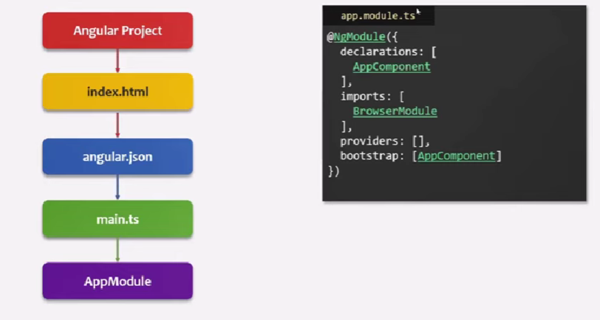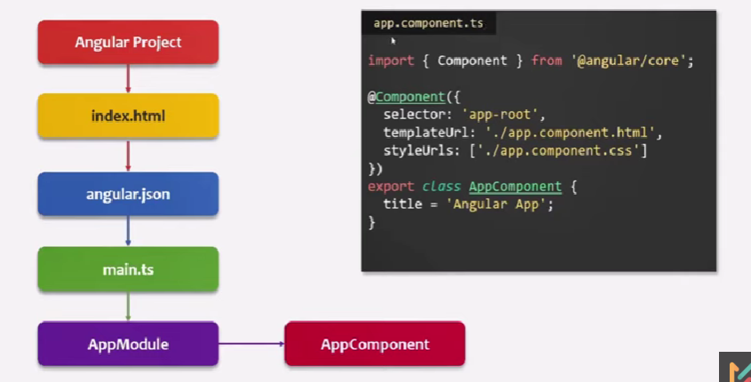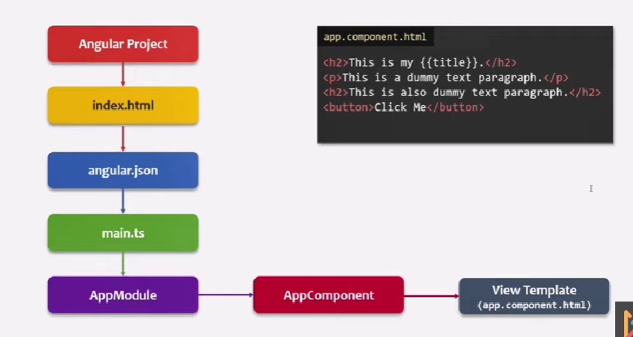

<https://www.youtube.com/watch?v=YZvfAU3WTNg&list=PL1BztTYDF-QNlGo5-g65Xj1mINHYk_FM9&index=6&ab_channel=procademy>

# 06 What is TypeScript | Getting Started with Angular

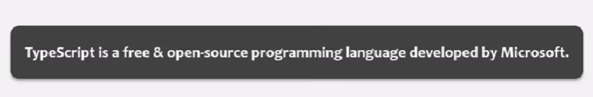

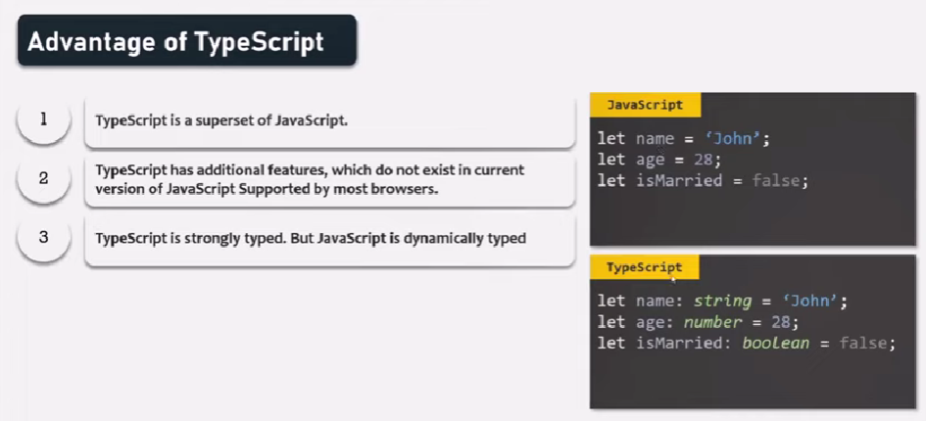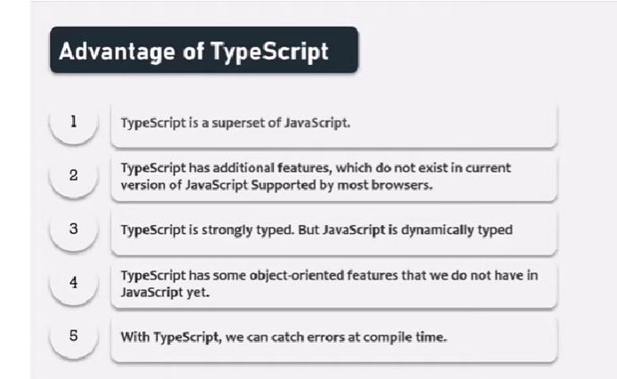

<https://www.youtube.com/watch?v=uTsYQ7UYx5k>

# 07 Understanding Component | Angular Components & Directives

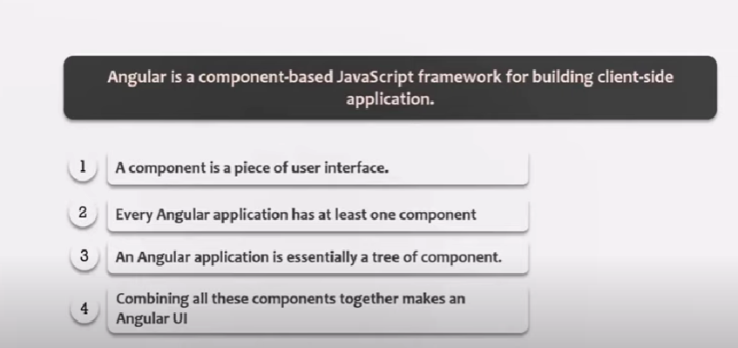

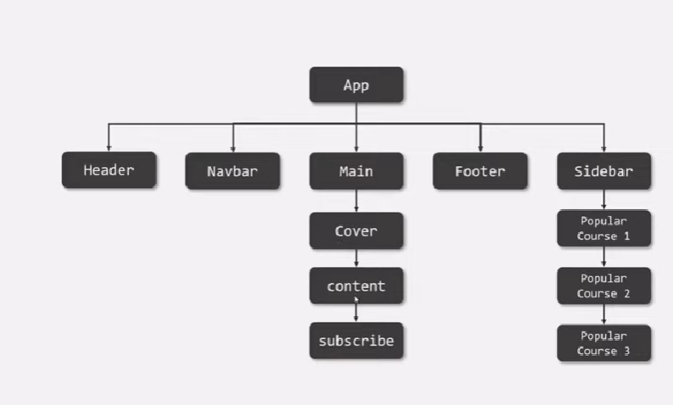

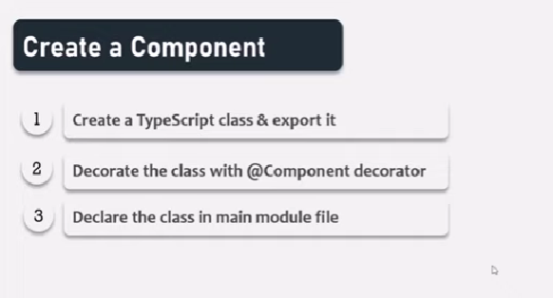

**Create component manually-**

**Step** 1-Create component.name.ts file and export it

Step2-Decorate with @component decorator

Step3-Declare in app.module.ts file

Create html and css in and use in that component such as templateUrls and styleUrls array.

<https://www.youtube.com/watch?v=2zz8jhRWXAc&list=PL1BztTYDF-QNlGo5-g65Xj1mINHYk_FM9&index=8&ab_channel=procademy>

# 08 View Template of Component | Angular Components & Directives

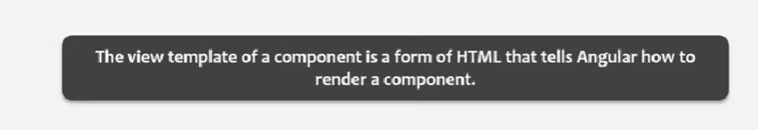

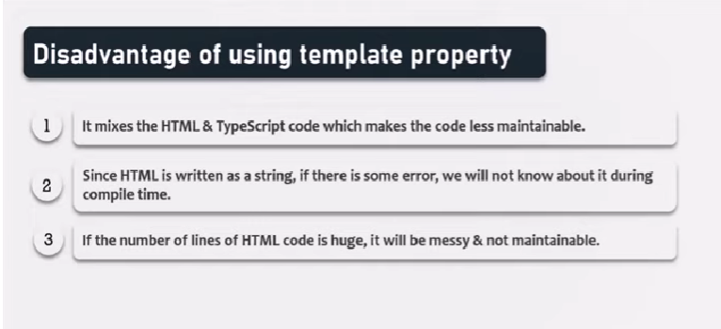

It means separate html code from ts code…

So write separate file eg header.component.html file

# 09 Styling View Template | Angular Components & Directives

<https://www.youtube.com/watch?v=oCErWaNOu3w&ab_channel=procademy>

# 10 Adding CSS Styles Globally | Angular Components & Directives

<https://www.youtube.com/watch?v=ckbsKtnnHFo&list=PL1BztTYDF-QNlGo5-g65Xj1mINHYk_FM9&index=10&ab_channel=procademy>

in src folder **style.css file this,**css I applicable globally

# 11 Using Bootstrap for Styling | Angular Components & Directives

<https://www.youtube.com/watch?v=9pE5t0CcoOM&list=PL1BztTYDF-QNlGo5-g65Xj1mINHYk_FM9&index=11&ab_channel=procademy>

**Bootsrap**-Bootstrap is a free and open-source CSS framework directed at responsive, mobile-first front-end web development. It contains HTML, CSS and JavaScript-based design templates for typography, forms, buttons, navigation, and other interface components.

Ways to use-

1.Use cdn link to index.html

2.installing bootstrap package using terminal command.

npm i –save bootstrap for latest version

npm install –save [bootstrap@3.1](mailto:bootstrap@3.1)

ng version //to check version of application

# 12 Create Component using Angular CLI | Angular Components & Directives

<https://www.youtube.com/watch?v=--Du9-iT78E&list=PL1BztTYDF-QNlGo5-g65Xj1mINHYk_FM9&index=12&ab_channel=procademyhttps://www.youtube.com/watch?v=--Du9-iT78E&list=PL1BztTYDF-QNlGo5-g65Xj1mINHYk_FM9&index=12&ab_channel=procademy>

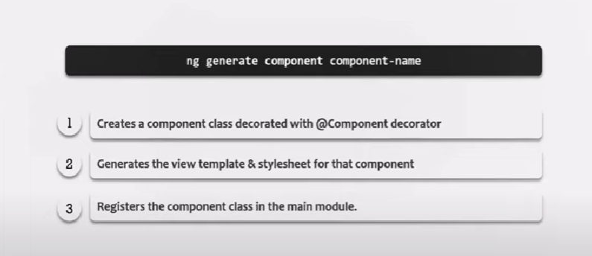

ng generate component topheader OR

ng g c topheader

aAnd use into app component.html file as html tag <topheader/>

iIn component files component.name.spec.ts file.This is for unit testing purpose.

Now, create child component>go to parent component folder..

cd src/app/parentfolder

and werit ng g c childcompo.name

# 13 Types of Component Selector | Angular Components & Directives

<https://www.youtube.com/watch?v=j4KD6xuplsk&list=PL1BztTYDF-QNlGo5-g65Xj1mINHYk_FM9&index=13&ab_channel=procademy>

types

1.html tag

2.html attribute: Note-use in case of angular directives

3.css class

4.id as attribute value

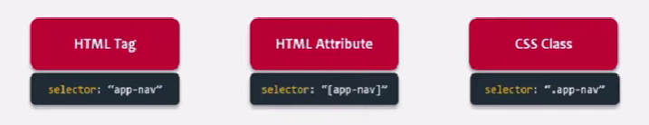

# 14 What is Data Binding | Angular Components & Directives

<https://www.youtube.com/watch?v=hgMo6ZDcNqE&list=PL1BztTYDF-QNlGo5-g65Xj1mINHYk_FM9&index=14&ab_channel=procademy>

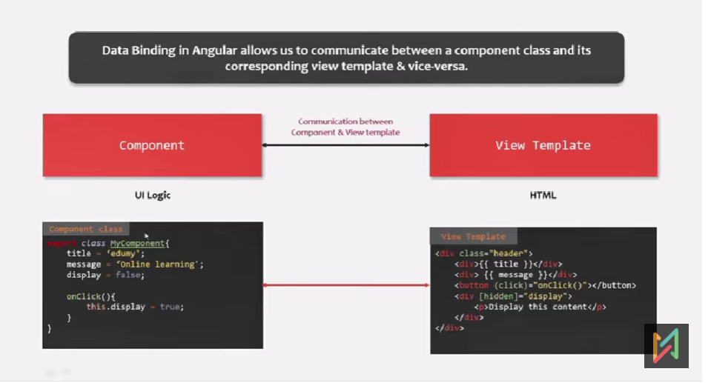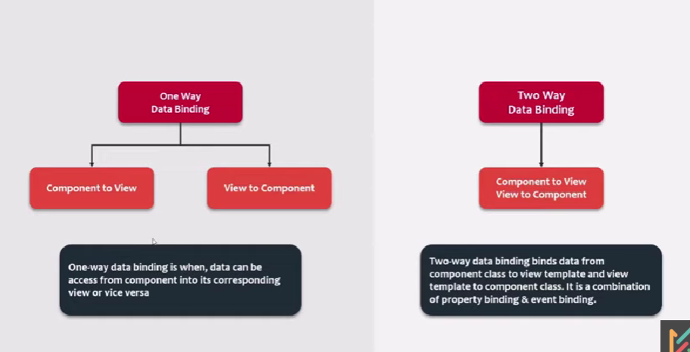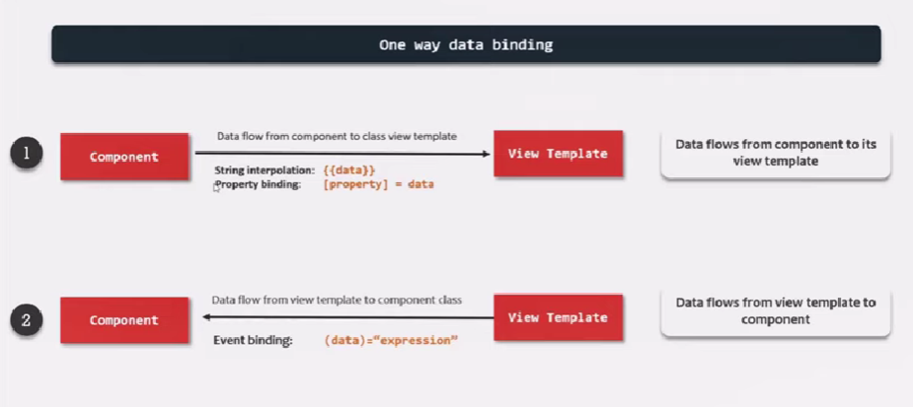V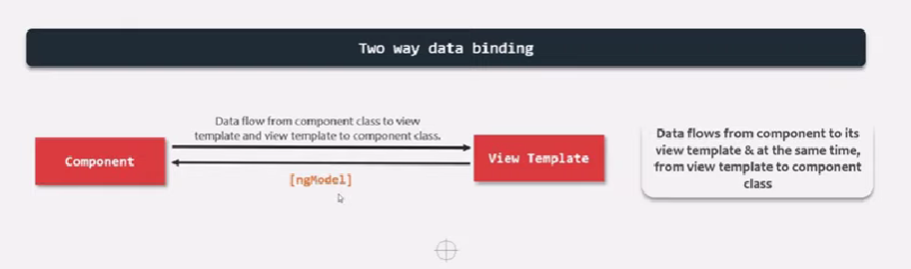

# 15 String Interpolation | Angular Components & Directives

<https://www.youtube.com/watch?v=_Kg3JMtncs4&list=PL1BztTYDF-QNlGo5-g65Xj1mINHYk_FM9&index=15&ab_channel=procademy>

create variables in component class

use in html template ,with {{}}

in {{}} we can write ts code.Eg arithmetic calculations.

Also in template {{}}we can call function (method) from ts file.

We can use inbuilt ts methods eg.toFixed(2).//show value upto 2 decimals.

Also we can use turnary operator ,eg. <p>{{product.inStock>0?'Only '+product.inStock+' items left':' Not in stock'}}</p>

# 16 Property Binding | Angular Components & Directives

<https://www.youtube.com/watch?v=LEkFi15qr1o&list=PL1BztTYDF-QNlGo5-g65Xj1mINHYk_FM9&index=16&ab_channel=procademy>

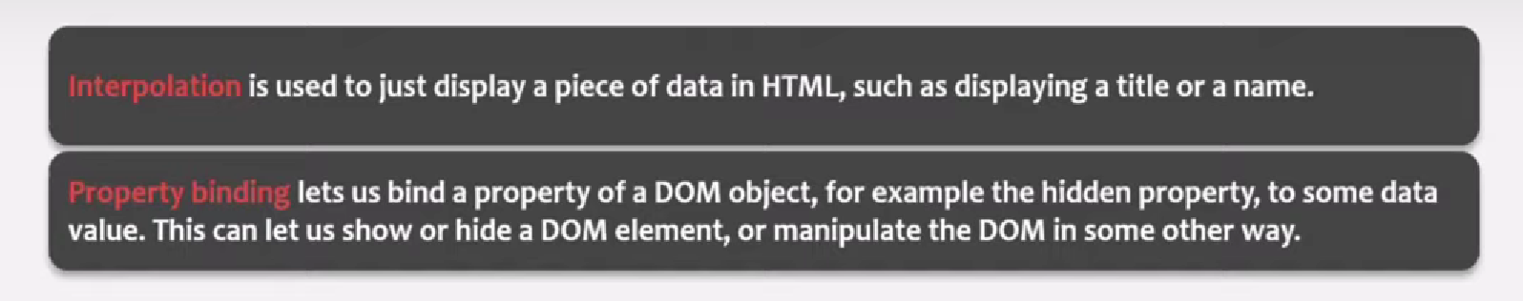

Property binding syntax **for dynamic value**

<img [src]="product.productImage">

String interpolation is not always work , so we use property binding.

e.g. html attributes disabled,hidden,checked not work with string interpolation.

Also use bind-attributeName eg <input bind-value="name">

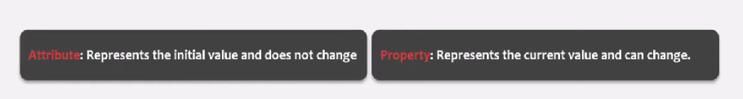

Accecibility attributes and data attributes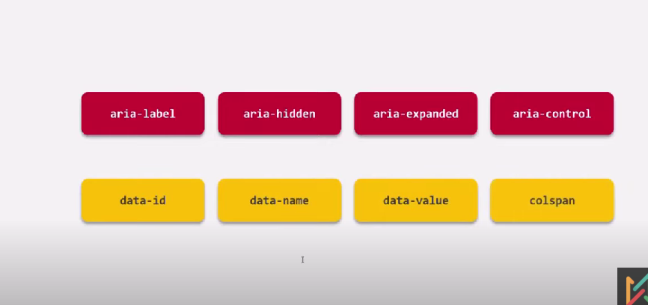

Attribute binding

<input [value]="name" [attr.aria-hidden]="">

# 17 Event Binding | Angular Components & Directives

[**https://www.youtube.com/watch?v=vGuPDWgg4Io&list=PL1BztTYDF-QNlGo5-g65Xj1mINHYk_FM9&index=17&ab_channel=procademy**](https://www.youtube.com/watch?v=vGuPDWgg4Io&list=PL1BztTYDF-QNlGo5-g65Xj1mINHYk_FM9&index=17&ab_channel=procademy)

Event Binding-data flow from view template to ts component class.i.e. reverse of string interpolation and property binding.

2:00

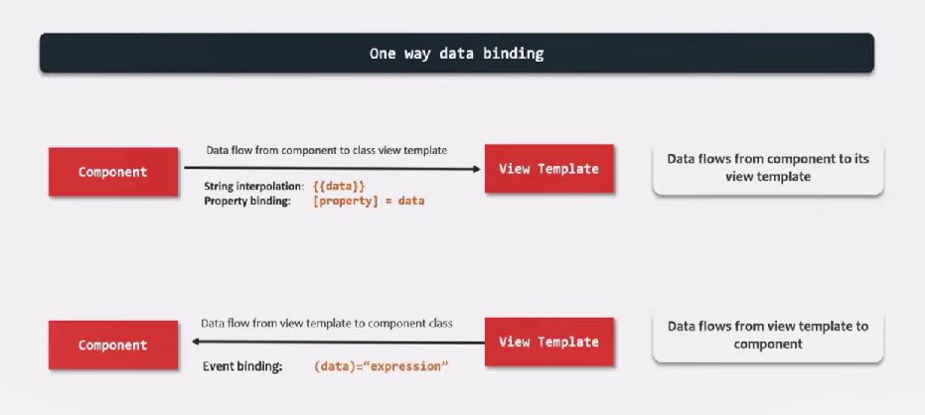

Event binding lets you listen for and respond to user actions such as keystrokes, mouse movements, clicks, and touches

# 18 Two way Data Binding | Angular Components & Directives |

<https://www.youtube.com/watch?v=THrWqRi2usg&list=PL1BztTYDF-QNlGo5-g65Xj1mINHYk_FM9&index=19&ab_channel=procademy>

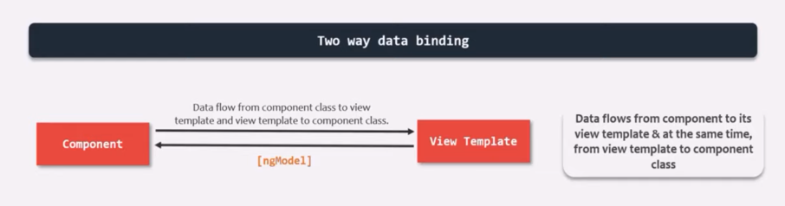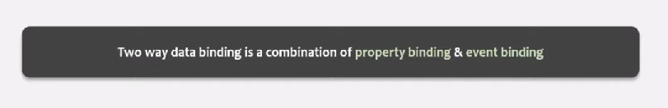

Using ngmodel 3rd party library .

Not mentioned in @component ,mention in import

# 19 Understanding Directives | Angular Components & Directives

<https://www.youtube.com/watch?v=syxyAINjP84&list=PL1BztTYDF-QNlGo5-g65Xj1mINHYk_FM9&index=19&ab_channel=procademy>

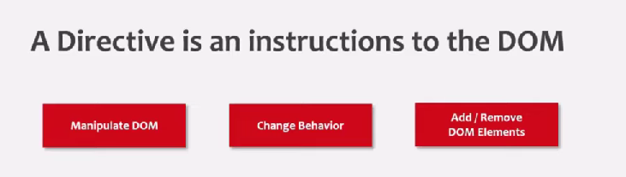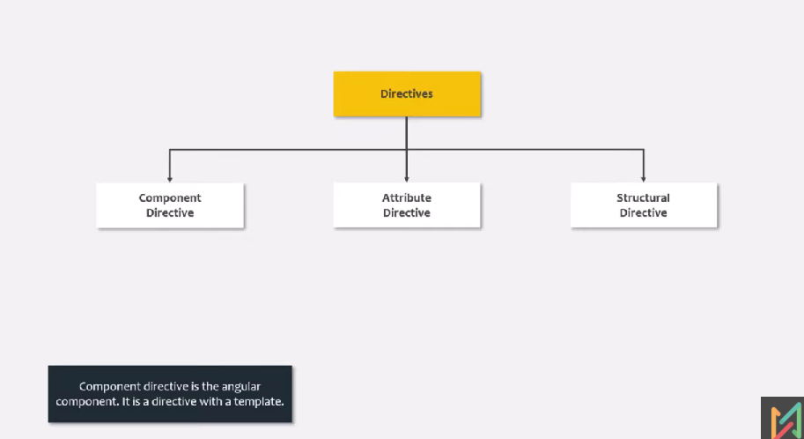

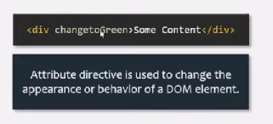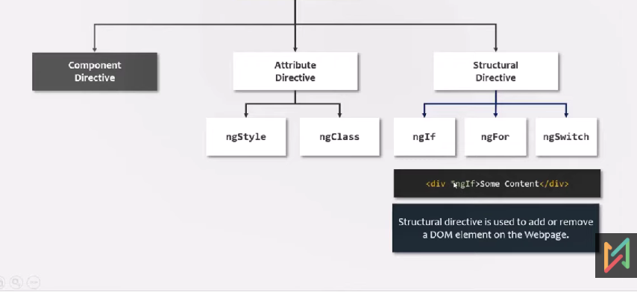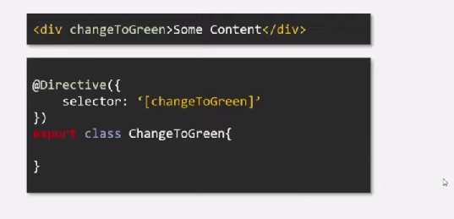

# 20 ngFor Directive | Angular Components & Directives

<https://www.youtube.com/watch?v=5D16OClJ1Cw&list=PL1BztTYDF-QNlGo5-g65Xj1mINHYk_FM9&index=20&ab_channel=procademy>

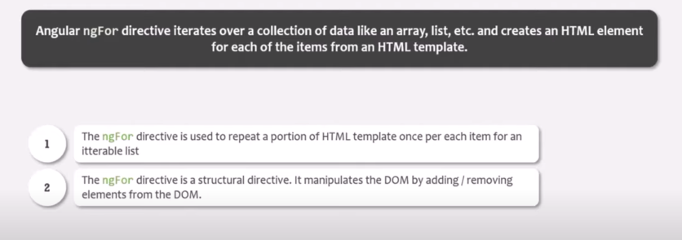

ngFor Directive is structural -use * ngFor=””

# 21 Rendering List of Complex Type | Angular Components & Directives

<https://www.youtube.com/watch?v=OuRAwzrFQm8&list=PL1BztTYDF-QNlGo5-g65Xj1mINHYk_FM9&index=21&ab_channel=procademy>