**Selenium Webdriver Java+TestNG Assignment**

**Description:** Given assignment is created using the Selenium 2 features with Java, TestNG and Maven

**Features**

1. PageFactory design Pattern
2. Object Oriented Architecture
3. TestNG test framework support.
4. Maven Support
5. Execution on firefox.
6. Logger - Logback

**Test Application:** Used Aol.com as test website.

**Prerequisites Software/Tools**

1. Maven [ <http://maven.apache.org/> ]
2. Java Development Kit 7
3. Java Runtime Environment 7
4. IDE

**Getting Started**

**Import Maven Project Into Eclipse**

1. Download project source code and unzip it into a folder location.
2. From Eclipse IDE, Project Explorer -> Right click -> Select Import Menu and Import.
3. Expand Maven menu.
4. And click Existing Maven Projects.

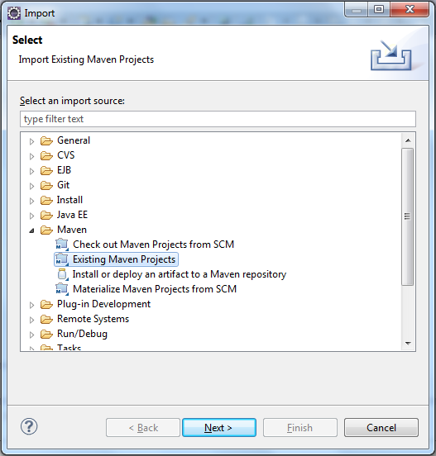

1. Click Next and browse the location where you have the Maven project source code.
2. Click Next.

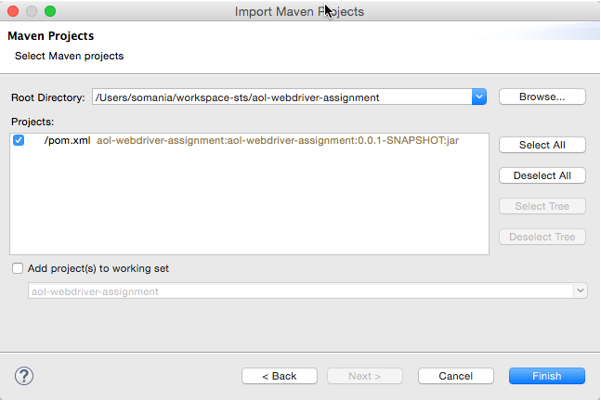

1. Select the project and click finish.

The Maven project is successfully imported into Eclipse IDE.

**Running tests:**

1. Open the command prompt (In Windows: 'cmd' and Mac : Terminal) and Navigate to the project directory ‘aol-webdriver-assignment’.
2. Run the below command to start the tests. mvn clean test

**Folder Structure:**

