DBMS ALL PRACTICALS OF PRACTICAL LIST
Practical 1
CREATE TABLE department (
Dept_ID int,
Dept_Name varchar(50),
Location varchar(30)
);
CREATE TABLE Employee (
Emp_ID INT,
Emp_Name VARCHAR(50),
Job_Title VARCHAR(30),
Salary DECIMAL(8,2),
Dept_ID INT
);
CREATE TABLE Student (
Student_ID INT,
First_Name VARCHAR(30),
Last_Name VARCHAR(30),
DOB DATE,
Gender CHAR(1)
);
CREATE TABLE Course (
Course_ID VARCHAR(10),
Course_Name VARCHAR(50),
Duration INT,
Fees DECIMAL(8,2)
);
CREATE TABLE Book (
Book_ID INT,
Title VARCHAR(100),
Author VARCHAR(50),
Price DECIMAL(6,2),
Publication_Year INT
);
CREATE TABLE Library_Member (
Member_ID INT,
Member_Name VARCHAR(50),
Join_Date DATE,
Expiry_Date DATE,
Membership_Type VARCHAR(20)
);

Practical 2

INSERT INTO Department VALUES (101, 'HR', 'Mumbai');
INSERT INTO Department VALUES (102, 'Finance', 'Delhi');
INSERT INTO Department VALUES (103, 'IT', 'Bangalore');

INSERT INTO Employee VALUES (1001, 'Anil Sharma', 'Manager', 75000.00, 101);
INSERT INTO Employee VALUES (1002, 'Sunita Rao', 'Clerk', 30000.00, 102);
INSERT INTO Employee VALUES (1003, 'Rahul Mehta', 'Developer', 60000.00, 103);

INSERT INTO Student VALUES (2001, 'Neha', 'Patel', '2000-05-21', 'F');
INSERT INTO Student VALUES (2002, 'Amit', 'Desai', '1999-11-10', 'M');
INSERT INTO Student VALUES (2003, 'Kajal', 'Rao', '2001-01-30', 'F');

INSERT INTO Library_Member VALUES (301, 'Riya Shah', '2024-01-15', '2025-01-14', 'Annual');
INSERT INTO Library_Member VALUES (302, 'Karan Joshi', '2024-03-10', '2024-09-09', 'Half-Yearly');
INSERT INTO Library_Member VALUES (303, 'Meena Patel', '2024-06-01', '2024-12-01', 'Half-Yearly');

INSERT INTO Book VALUES (401, 'SQL for Beginners', 'Ivan Bayross', 450.00, 2018);
INSERT INTO Book VALUES (402, 'Database Management Systems', 'Ramez Elmasri', 650.00, 2020);
INSERT INTO Book VALUES (403, 'PL/SQL Programming', 'Steven Feuerstein', 550.00, 2019);

INSERT INTO Course VALUES ('C101', 'Database Systems', 4, 15000.00);
INSERT INTO Course VALUES ('C102', 'Data Structures', 3, 12000.00);
INSERT INTO Course VALUES ('C103', 'Web Development', 6, 20000.00);

Practical 3

1. Add a new column Email to Student table
ALTER TABLE Student
ADD Email VARCHAR(50);
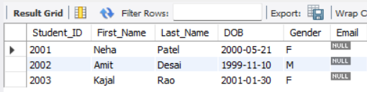

2. Add a new column Publisher to Book table
ALTER TABLE Book
ADD Publisher VARCHAR(50);
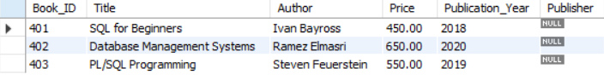

3. Add two new columns Start_Date and Instructor to Course table
ALTER TABLE Course
ADD Start_Date DATE,
ADD Instructor VARCHAR(40);
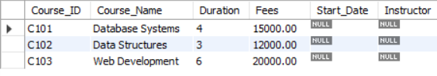

4. Drop the column Salary from Employee table
ALTER TABLE Employee
DROP COLUMN Salary;
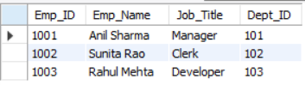

5. Drop the column Location from Department table
ALTER TABLE Department
DROP COLUMN Location;
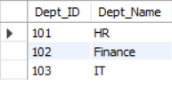

Practical 4
8. Modify the size of Emp_Name column in Employee table to 100 characters
ALTER TABLE Employee MODIFY Emp_Name VARCHAR(100);
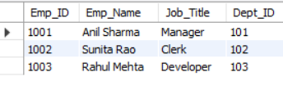
9. Change the data type of Fees column in Course table to DECIMAL(10,2)
ALTER TABLE Course MODIFY Fees DECIMAL(10,2);
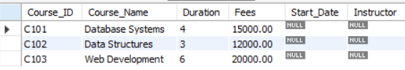

10. Rename the column Course_Name to Title in Course table
ALTER TABLE Course CHANGE Course_Name Title VARCHAR(50);
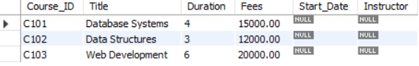

11. Rename the table Student to Students
RENAME TABLE Student TO Students;
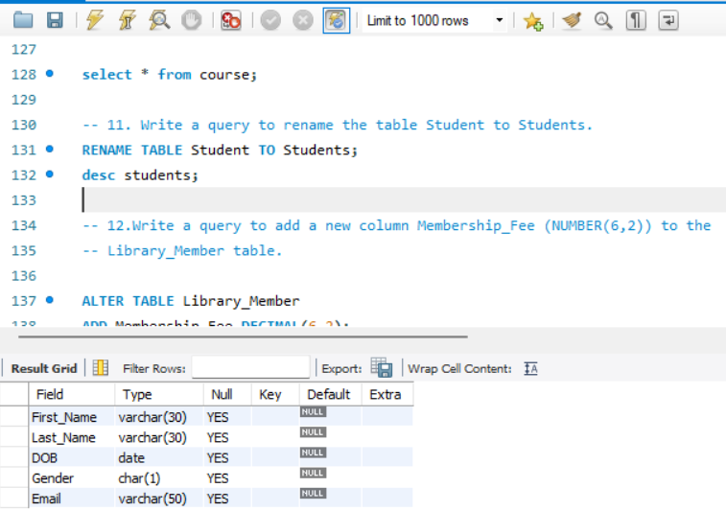

12. Add a new column Membership_Fee (DECIMAL(6,2)) to Library_Member table
ALTER TABLE Library_Member
ADD Membership_Fee DECIMAL(6,2);
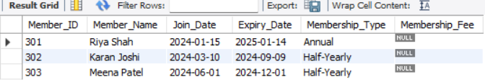

Practical 5
1. Create Faculty table
CREATE TABLE Faculty (
Faculty_ID INT PRIMARY KEY,
Faculty_Name VARCHAR(50) NOT NULL,
Department VARCHAR(30),
Email VARCHAR(50) UNIQUE
);

2. Create Subject table
CREATE TABLE Subject (
Subject_Code VARCHAR(10) PRIMARY KEY,
Subject_Name VARCHAR(50) NOT NULL,
Credits INT CHECK (Credits BETWEEN 1 AND 6),
Faculty_ID INT,
FOREIGN KEY (Faculty_ID) REFERENCES Faculty(Faculty_ID)
);

3. Create Registration table
CREATE TABLE Registration (
Reg_ID INT PRIMARY KEY,
Student_ID INT NOT NULL,
Course_ID VARCHAR(10) NOT NULL,
Registration_Date DATE,
UNIQUE (Student_ID, Course_ID)
);

4. Create Login table
CREATE TABLE Login (
Username VARCHAR(20) PRIMARY KEY,
Password VARCHAR(20) NOT NULL,
Role VARCHAR(15) CHECK (Role IN ('Admin', 'Student', 'Faculty')),
Status CHAR(1) DEFAULT 'A'
);

ALTER TABLE Students
ADD PRIMARY KEY (Student_ID);

Practical 6

1. Create Exam_Result table
CREATE TABLE Exam_Result (
Result_ID INT PRIMARY KEY,
Student_ID INT,
Subject_Code VARCHAR(10),
Marks_Obtained INT CHECK (Marks_Obtained BETWEEN 0 AND 100),
Grade CHAR(1),
FOREIGN KEY (Student_ID) REFERENCES Students(Student_ID),
FOREIGN KEY (Subject_Code) REFERENCES Subject(Subject_Code)
);

2. Create Vendor table
CREATE TABLE Vendor (
Vendor_ID INT PRIMARY KEY,
Vendor_Name VARCHAR(50) NOT NULL,
City VARCHAR(30),
Contact_Number VARCHAR(15) UNIQUE,
Rating INT CHECK (Rating BETWEEN 1 AND 5)
);

3. Create Product table
CREATE TABLE Product (
Product_ID INT PRIMARY KEY,
Product_Name VARCHAR(50) NOT NULL,
Price DECIMAL(10,2) CHECK (Price > 0),
Quantity_Available INT,
Vendor_ID INT,
FOREIGN KEY (Vendor_ID) REFERENCES Vendor(Vendor_ID)
);

ALTER TABLE Students ADD UNIQUE (Student_ID);

4. Create Attendance table
CREATE TABLE Attendance (
Attendance_ID INT PRIMARY KEY,
Student_ID INT,
Attendance_Date DATE,
Status CHAR(1) CHECK (Status IN ('P', 'A', 'L')),
UNIQUE (Student_ID, Attendance_Date),
FOREIGN KEY (Student_ID) REFERENCES Students(Student_ID)
);

Practical 7

1.Insert records into Faculty table
INSERT INTO Faculty (Faculty_ID, Faculty_Name, Department, Email) VALUES
(101, 'Nidhi Patel', 'IT', 'nidhi.p@university.edu'),
(102, 'Raj Mehta', 'Finance', 'raj.m@university.edu'),
(103, 'Sneha Shah', 'Marketing', 'sneha.s@university.edu');

2.Insert records into Subject table
INSERT INTO Subject (Subject_Code, Subject_Name, Credits, Faculty_ID) VALUES
('DBMS101', 'Database Systems', 4, 101),
('MKT102', 'Marketing Basics', 3, 103),
('FIN103', 'Financial Accounting', 5, 102);

3.Insert records into Login table
INSERT INTO Login (Username, Password, Role) VALUES
('admin01', 'adminpass', 'Admin'),
('student01', 'studpass', 'Student'),
('faculty01', 'facpass', 'Faculty');

4.Insert records into Registration table
INSERT INTO Registration (Reg_ID, Student_ID, Course_ID, Registration_Date) VALUES
(1, 2001, 'C101', '2024-06-01'),
(2, 2002, 'C102', '2024-06-05'),
(3, 2001, 'C102', '2024-06-08');

Practical 8

5.Insert records into Exam_Result table
INSERT INTO Exam_Result (Result_ID, Student_ID, Subject_Code, Marks_Obtained, Grade) VALUES
(1, 2001, 'DBMS101', 85, 'A'),
(2, 2002, 'FIN103', 68, 'B'),
(3, 2003, 'MKT102', 90, 'A');

6.Insert records into Vendor table
INSERT INTO Vendor (Vendor_ID, Vendor_Name, City, Contact_Number, Rating) VALUES
('001', 'TechBooks', 'Mumbai', '9876543210', 5),
('002', 'EduSupply', 'Delhi', '9123456789', 4),
('003', 'PrintMart', 'Pune', '9988776655', 3);

7.Insert records into Product table
INSERT INTO Product (Product_ID, Product_Name, Price, Quantity_Available, Vendor_ID) VALUES
('101', 'Oracle Textbook', 500, 50, '001'),
('102', 'Ledger Book', 300, 80, '002'),
('103', 'Marketing Handbook', 450, 60, '003');

8.Insert records into Attendance table
INSERT INTO Attendance (Attendance_ID, Student_ID, Attendance_Date, Status) VALUES
(1, 2001, '2024-07-01', 'P'),
(2, 2002, '2024-07-01', 'A'),
(3, 2003, '2024-07-01', 'L');

Practical 9

1. Display all records from the Faculty table
SELECT * FROM Faculty;
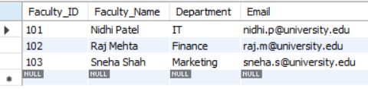

2. Display the names and emails of all faculty members
SELECT Faculty_Name, Email FROM Faculty;
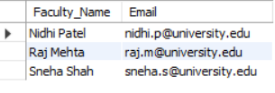

3. List all faculty members from the "IT" department
SELECT * FROM Faculty WHERE Department = 'IT';
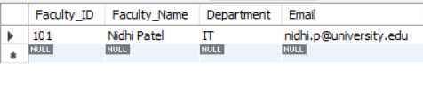
4. Find the faculty member whose email is 'nidhi.p@university.edu'
SELECT * FROM Faculty WHERE Email = 'nidhi.p@university.edu';
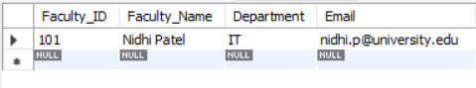

5. Show the subject name and credits for all subjects
SELECT Subject_Name, Credits FROM Subject;
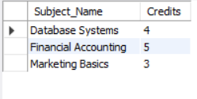

6. Display details of all subjects taught by faculty with Faculty_ID = 101
SELECT * FROM Subject WHERE Faculty_ID = 101;
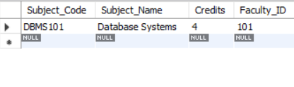
7. List subjects where the credits are greater than 3
SELECT * FROM Subject WHERE Credits > 3;
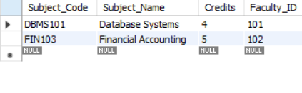
8. Display all records from the Registration table
SELECT * FROM Registration;
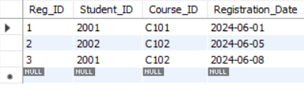

9. Show all course registrations made by student with Student_ID = 2001
SELECT * FROM Registration WHERE Student_ID = 2001;
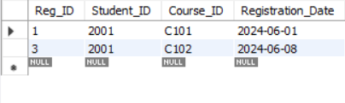

10. Find all students who registered for course C102
SELECT * FROM Registration WHERE Course_ID = 'C102';
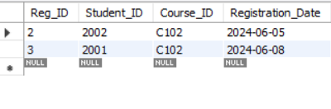

Practical 10
11. Display usernames and roles
SELECT username, role FROM Login
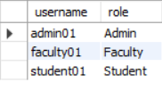
12. List all users with role 'Student'
SELECT * FROM Login WHERE role = 'Student';
13. Show all active users (Status = 'A')
SELECT * FROM Login WHERE status = 'A';
14. Show all results where marks obtained are greater than 80
SELECT * FROM Exam_Result WHERE marks_obtained > 80;
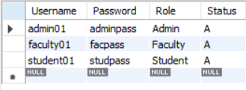

15. List student IDs and grades for subject DBMS101
SELECT student_id, grade FROM Exam_Result WHERE subject_code = 'DBMS101';
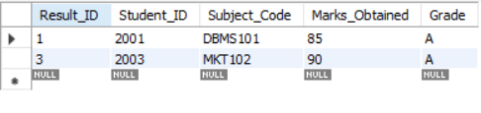
16. Find students who got grade 'A'
SELECT * FROM Exam_Result WHERE grade = 'A';
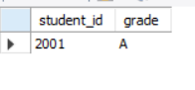
17. List all vendors located in 'Mumbai'
SELECT * FROM Vendor WHERE city = 'Mumbai';
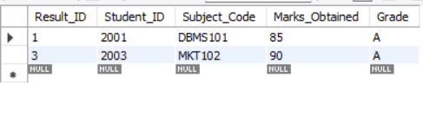

18. Display vendor names with a rating of 4 or higher
SELECT vendor_name, rating FROM Vendor WHERE rating >= 4;
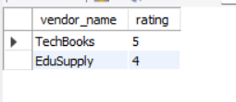

19. Show contact numbers of all vendors
SELECT contact_number FROM Vendor;
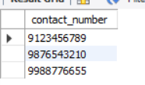

Practical 11

20. Display all products with a price greater than 400
SELECT * FROM Product WHERE Price > 400;
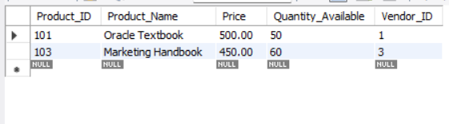
21. List all products supplied by vendor V001
SELECT * FROM Product WHERE Vendor_ID = 'V001';
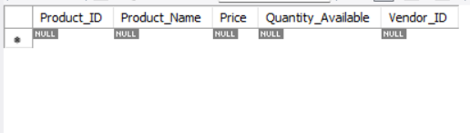
22. Show product names and quantities where quantity is less than 70
SELECT Product_Name, Quantity_Available FROM Product WHERE Quantity_Available < 70;
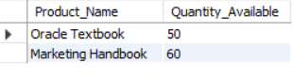

23. Display all attendance records for 2024-07-01
SELECT * FROM Attendance WHERE Attendance_Date = '2024-07-01';
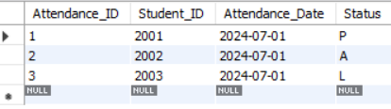

24. Find all students who were marked 'P' (Present)
SELECT Student_ID, Student_ID FROM Attendance WHERE Status = 'P';
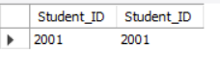

25. Show the attendance status of student 2003
SELECT * FROM Attendance WHERE Student_ID = 2003;
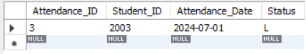

Practical 12

-- 26. List all attendance records in alphabetical order of status
SELECT * FROM Attendance
ORDER BY Status ASC;
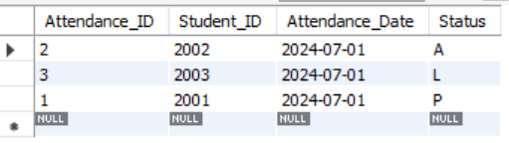

-- 27. List all products sorted by price in ascending order
SELECT * FROM Product
ORDER BY Price ASC;
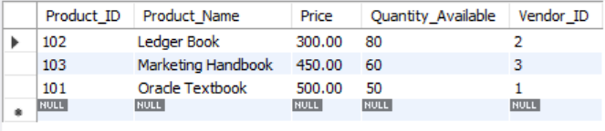

-- 28. Display all products in descending order of quantity available
SELECT * FROM Product
ORDER BY Quantity_Available DESC;
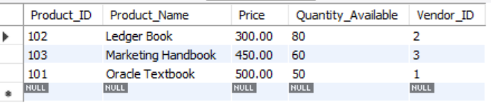

-- 29. List all products sorted first by Vendor_ID and then by Price in ascending order
SELECT * FROM Product
ORDER BY Vendor_ID ASC, Price ASC;
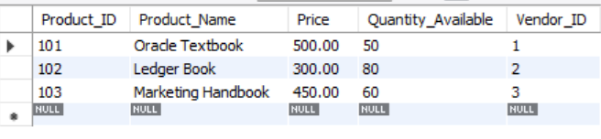

-- 30. List products with price more than 400, sorted by Product_Name
SELECT * FROM Product
WHERE Price > 400
ORDER BY Product_Name ASC;
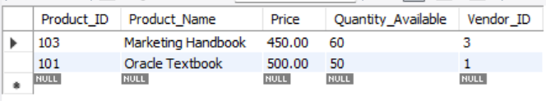

-- 31. Display all products from vendor V002 sorted by quantity available in ascending orders
SELECT * FROM Product
WHERE Vendor_ID = 'V002'
ORDER BY Quantity_Available ASC;

PRACTICAL 13
-- Q32. Display the absolute difference between 75 and Marks_Obtained for each student

SELECT Student_ID,Marks_Obtained,
ABS(75 - Marks_Obtained) AS Difference_From_75
FROM Exam_Result;
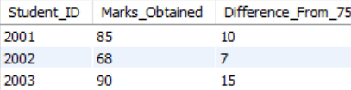

-- Q33. List students with their Marks_Obtained, and display the ceiling of Marks_Obtained divided by 7

SELECT Student_ID,Marks_Obtained, CEIL(Marks_Obtained / 7)
AS Ceiling_Value FROM Exam_Result;
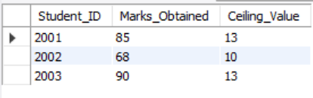

-- Q34. Display Subject_Code in uppercase and lowercase

SELECT UPPER(Subject_Code) AS Uppercase_Code,
LOWER(Subject_Code) AS Lowercase_Code
FROM Exam_Result;
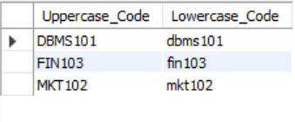

-- Q35. Show the first 3 characters of each Subject_Name

SELECT Subject_Name,
LEFT(Subject_Name, 3) AS First_Three_Characters
FROM subject;
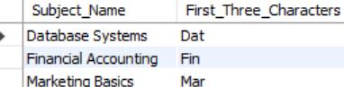

-- Q36. Display student IDs and their Grades in lowercase

SELECT Student_ID,
LOWER(Grade) AS Grade_Lowercase
FROM Exam_Result;
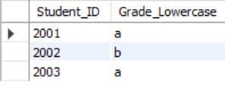

-- Q37. Convert the string '2024-07-11' to a proper date format

SELECT STR_TO_DATE('2024-07-11', '%Y-%m-%d') AS Proper_Date_Format;
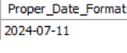

-- Q38. Show registration dates in DD-MM-YYYY format for each student
SELECT Student_ID,
DATE_FORMAT(Registration_Date, '%d-%m-%Y')
AS Formatted_Registration_Date
FROM registration;
