SKIPS University
School of Computer Science


Bachelor of Computer Applications (Hons.) - Batch 2024- 28

SOCS030301

Java Programming

Project Title: University Admission System

Date:11-11-25
[Submission Date]
Submitted By: Submitted To: Mr. Akshay Nagar
Yug Somani
[2428010] [Instructor/Guide Name]
[Designation]

Abstract
The below java implement is a simple one which takes the students marks and verifies its eligibility for attending an university. It's been written using simple OOP techniques like inheritance and interfaces. The program begins with the details of each student: name, age, application ID and marks in three subjects Maths, Physics and Chemistry. Then, it averages the percentage and declares whether or not a student is up to admission standard

The project encompasses three Java files. The class Person stores the common details of a person, which includes the name and age. The Eligibility interface defines a rule that must be implemented by every class using it: the method to check eligibility. The Student class extends the class Person and implements the Eligibility interface, hence combining the two concepts of inheritance and interface. The main file is the Uni_admission, which handles the user's input and displays the eligibility results for all students. This project will explain how inheritance and interfaces can work together in a Java program, making it more organized and reusable. It aids in understanding how real-life systems, like university admissions, can be represented with the help of programming in a simplified and organized way.

Index
Sr No. | Content | Page No.
1. | Introduction  - Objective of the Project  - Overview of java programming in Project Development  [ Give overview of the topics given in the project] | 1-2
2. | Project Requirements  - Requirements (given in the project) | 3
3. | Design and Architecture  - Flow Chart | 4
4. | Implementation  - Key Functions and Features | 5
5. | Results  - Output Screenshots with description | 6-7
6. | Challenges Faced  - How They Were Resolved | 8
7. | Conclusion  - Learning Outcomes | 8

Introduction
- Objective of the project
The project entails designing a straightforward Java system to determine a prospective student’s qualification for admission in a university based on their grades. The whole idea of this project is to implement the fundamentals of Object-Oriented Programming theory in a rational manner using real-life situations. The fundamentals to be implemented includes classes, objects, inheritance and interfaces.
This project is intended to cement one’s knowledge on the collection of data, processing the data, and implementing logical programming to derive a solution. It aims to build one’s skills in working with multiple classes to solve a problem, and how inheritance is in code reusability and interfaces in the design of the system to solve a problem.

- Overview of java programming in Project Development
Java stands out as a popular choice for programming. It gets that way thanks to its straightforward nature, the way it runs on different platforms, and solid backing for object-oriented ideas. This project takes advantage of those Java strengths to build a simple application. This shows how something from everyday life, such as getting into university, turns into code through clear logic and OOP principles.
The work touches on key parts of Java. Classes and objects come up first. The Person class and Student class stand for actual things in the world. They group data with actions in one place.

- Inheritance plays a role too. The Student class builds on the Person class. That lets it reuse code without starting over each time.

- Interfaces add another layer. The Eligibility interface sets a standard rule. Any class that uses it has to include the isEligible method. This keeps things organized and uniform.

- Method overriding shows up in the Student class. It changes the isEligible method to fit its own needs for checking if someone qualifies for admission.

- Encapsulation keeps data secure. Constructors and methods make sure each object manages its information without issues.

- An ArrayList holds student details and lets the program handle them as needed.

- User input gets handled through the Scanner class. It pulls in what people type, so the program feels responsive and straightforward.

In the end, Java helps sort out code nicely. It promotes reusing parts and creating programs that reflect real systems in a solid way.

Project Requirements

This project uses Java and basic OOP principles. It uses classes, objects, constructors, inheritance, and interfaces. The Person.java class contains general information, while the Student extends it, implementing the Eligibility interface to check for admission eligibility.
The Scanner class is used for user input, and the ArrayList class is used to manage multiple students. The project runs in any Java supported IDE ,sublime text or CMD.

Design and Architecture
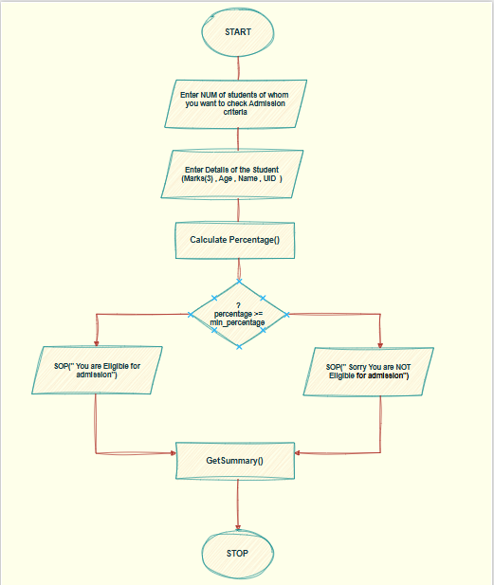

Implementation
This project is made by taking the input from the user on real time for multiple students as it uses arraylist , it includes the name, age, and marks in three subjects of each student registered. It then further calculates the percentage of individual student and then checks it against the minimum percentage requirement of 60%. The project also employs inheritance, wherein the Person class is extended to reuse basic details such as name and age, uses an interface (Eligibility) to define a common method for admission eligibility, and the main class, Uni_admission, manages the whole process by using an ArrayList to store all the students and using the Scanner class for input. Finally, it displays each student’s information along with whether they are eligible or not for admission in a neat manner.
• User Input Handling: This uses the Scanner class to take input for name, age, and marks of multiple students.
• Dynamic Data Storage: This will store all the student records in an ArrayList to make access and iteration easy.
• Inheritance: The Student class is inherited from the Person class(Person.java) by reusing the name and age attributes declared in Person.java .
• Interface Implementation: The eligibility interface is made to define the isEligible() method, that is implemented in the Student to check whether the admission eligibility is met or not .
• Percentage Calculation: The method calculates the percentage of each student from the marks of Maths, Physics, and Chemistry inputed by the user .
• Eligibility Check: The total percentage of each student is compared with the minimum requirement for the admission , 60%.
• Result Display: Prints detailed information of each and every student, including student name, marks, percentage, and eligibility.

Results

Compilation of the files of the project :

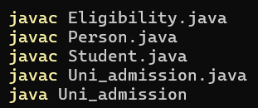

Asking for user input for the number of students :

Entering the basic necessary details :

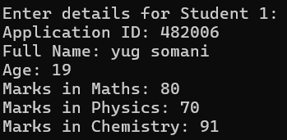

Calculating the Percentage and granting Admission according to the Predecided Criteria (60%) :

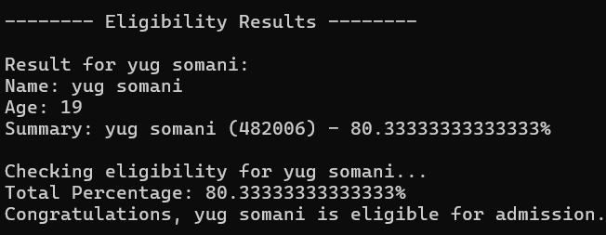

Challenges Faced

I had to make sure that I make no mistakes in taking the input from the user . It was mainly tricky when switching from numbers to text using the Scanner class. We resolved that by inserting an additional nextLine() to clear the buffer.
That worked just fine. The next challenge was to create this program with inheritance and interfaces. We wanted it to be simple and clear. The solution came with the creation of a straightforward class structure. The Person class handled all the basic information. Then the Student class added in the extra details. It also handled the eligibility check.

Conclusion

During this project, I understood the benefit of using Java for creating a simple but useful application. I studied my first course on how to structure and design a program using the Object-Oriented Programming basics: classes, objects, inheritance, interfaces. By creating a class Person then subclassing it into Student I was able to see how inheritance reduces duplicate code. Implementing the Eligibility interface made evident that interfaces specify parameters that could be applied to different classes.
I also learned how to take user input via the Scanner class, store multiple records via ArrayLists, and apply conditional statements in the form of logical checks for eligibility. It taught me patience , focus and accuracy in the java writing code, as finding those small mistakes debugging them and solving then took many brainstorming sessions . This project also helped me enhance my technical knowledge of Java basic while providing practical experience in building a program that feels organized, efficient, and realistic.

