School of Computer Science



Bachelor of Computer Applications
Batch 2024- 29

Course Code : SOCS030304
BASIC OF STATISTICS

Project Title: Correlation between GitHub Contributions & Project Success Rate in Open Source Software.

Date:
9th October , 2025
Submitted By: Yug Somani
Submitted To: Mr. Vivek Bhut (Professor)
ABSTRACT

In this project, I have analyzed the contributions and success rates of contributors in an open-source GitHub projects. The main motive was to understand whether contributing more or giving more pull requests in a project leads to success of their pull requests. I collected data of 50 contributors from the GitHub including their total contributions, success rates, total PRs, and merged PRs.

I calculated the basic statistical measures like mean, median, mode, standard deviation and also correlation to know the accuracy and effectiveness of the dataset I collected. Then, I did the correlation between contributions made and success rate of an individual to see if there is any relationship or correlation in between them. I have also created a scatter plot for better understanding and also implemented it to visualize this relationship.

So from the analysis, I got to know that contributors with more contributions mostly have higher success rates as compared to contributors with low contributions, but it is not always this way, there were also contributors who only contributed in a few projects but still the success rate was high. Basically, project helps in understanding: Correlation between GitHub Contributions & Project Success Rate.

Sr No. | Content | Page No.
1. | Introduction | 1
2. | Methodology | 2
3. | Data Analysis | 5
4. | Conclusion | 8
5. | References and Bibliography | 9

INTRODUCTION

Background of the Topic:
Platforms like GitHub generally depends on the contributions made by the developers all over the world using this platform. The contributors, contribute there pull requests ( ex:- ideas) to the project (ex:- working business) to make the changes in the project. Not each and every pull request is accepted into the project and merged. The success rate of a contributor can define him at certain stages.
Studying this data allows me to understand how success rate is dependent on the number of contributions.
Objectives:
- Is there a relationship between the number of contributors and the success rate of them.
- To calculate and compare values such as mean, median, mode, and standard deviation for a better understanding of the dataset.
- To use the correlation and implement scatter plot to show the relation in between contribution and the success rate.
Importance of the Project:
- This project tells us that, the people who contributes more and on regular basis , it is better for the projects. So by looking at this we can say that contributors who work more, better helps the project succeed.

METHODOLODGY

Overview:
To explore the connection between contributor activity and their rate of success, I conducted a correlation analysis. The main goal was to find out if the people who tend to contribute more on GitHub also get the more PR’s are accepted. So in order to know this we collected the Data and used Statistical approach to find out the results.
Dataset Description:
The dataset for this was taken from GitHub of 50 Contributors. We collected data by jotting down – how many times they have contributed, how many times there pull requests got accepted and etc. this collection of dataset helped me to understand how each contributor contributed and how much useful work he did which affected his/her success rate.
A glimpse of the dataset:-
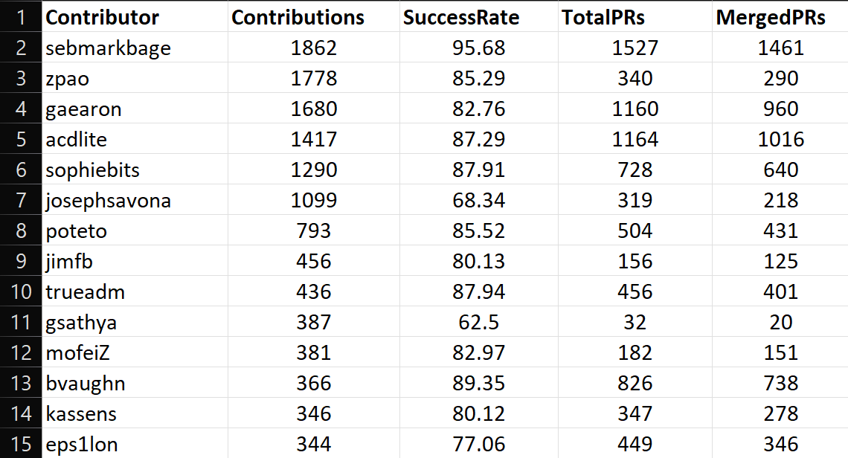
Data Cleaning & Preparation:

Before any analyses were performed, as I saw and was looking for the data, I realized that the data I am collecting is a primary data made by myself, so each and every data in the dataset Is clean and avoids repetition of data. and it also avails variety of data. But while making it I also had to remove Unnecessary columns making sure that all the data was organized appropriately. The final dataset only has essential fields like - Contributions, Success Rate, Total PRs, and Merged PRs.

Techniques & Tools Used:

- Scatter Diagram → to be able to graphically observe the relationship between Contribution and Success Rate.
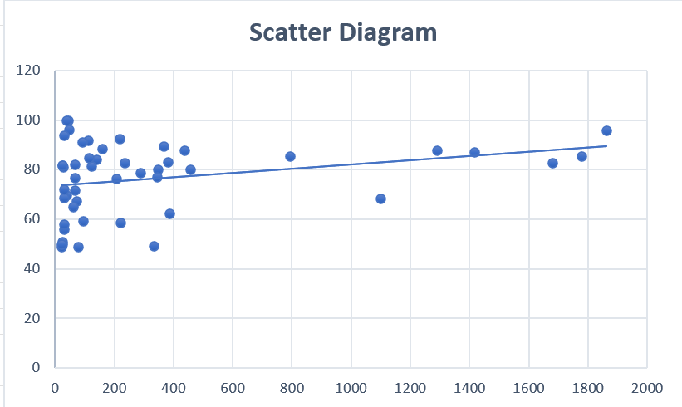

- Karl Pearson's Correlation →
Correlation between Contributions and Success Rate

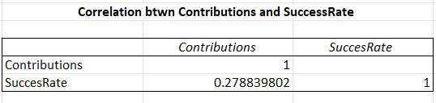

- Mean, Median, Mode, Standard Deviation

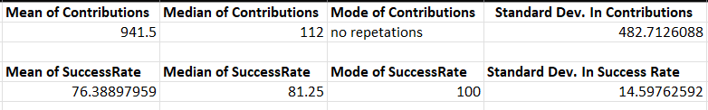

DATA ANALYSIS AND INTERPRETATION
Dataset for Analysis:
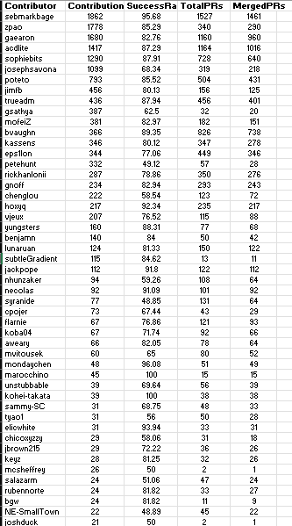

Calculation Method of Karl Pearson’s Correlation:

Therefore,
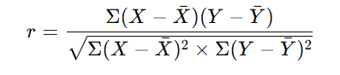

Interpretation :
The calculation of Correlation shows the correlation between the number of contributions made to the project by the contributor and the success rate of the project. There is a correlation of 0.28 and it shows a moderate positive relationship in between contributions and success rate. It rationally means that the contributors who have more contributions in more projects tends to have higher success rate. i.e more contributions lead’s to higher success rate.
The scatter plot also shows the slightly upward trend.

Key Observations:

- Higher number of contributions leads to higher success rate.
- There are also few contributors who have less contributions but they still have higher success rate and more merged PR’s, it shows that quality contributions also matter not only quantity.
- The relation is not perfectly linear, but there is a general observation that contributor with higher contributions tends to have better success rate.

Patterns & Insights:

- Contributors who keep on submitting more pull requests to multiple projects seem to have more work experience and better understanding of the needs of the project. Hence better understanding of requirement and more experience leads to higher success rate.

- More pull requests means that more work done and higher applications in the project, this increases the chances of the pull requests to get converted into merged pull requests.

- The analysis states that regular contribution made to multiple projects helps to increase the visibility and success rate, it is an important factor in terms of growth.

CONCLUSION

Summary:
- The analysis revealed a moderate positive correlation between the number of contributions and the success rate of the contributors This suggests that contributors who make more contributions tend to have a higher success rate for their pull requests. The scatter plot also said the same thing, the points were going upward gradually, meaning there was a positive link. In laymens terms people who contribute regularly generally tend to do better work and contribute to fullfill the needs of the project.
Limitations:
- One of the drawback of this project was that , the data set only had 50 contributors and focuses mainly on few things only. Like how much they have contributed and how many pull requests have been accepted , there success rate and etc.. there are other important factors that could be taken into consideration like - what kind of work they did, how complex the projects were, or how active the reviewers were.

Suggestions for Future:
- The future study can be improved by using a large number of dataset from different OS projects. bgWe can also contribute more by adding regression model or machine learning, to know and understand the data. Doing this would make it easier to analyze that on what factors some contributors are more successful then others.

REFERENCES AND BIBLIOGRAPHY

- Data is collected from the GitHub.
- Formulas and calculations are done from the Data Analysis pack provided in Excel.
- Understanding of terms as Contributions, Pull requests, Push requests, Merge requests, Contributions etc. are understood directly from the GitHub documentation provided in the site itself.

