**PIZZA SHOP MANAGEMENT SYSTEM**

**(PSMS)**

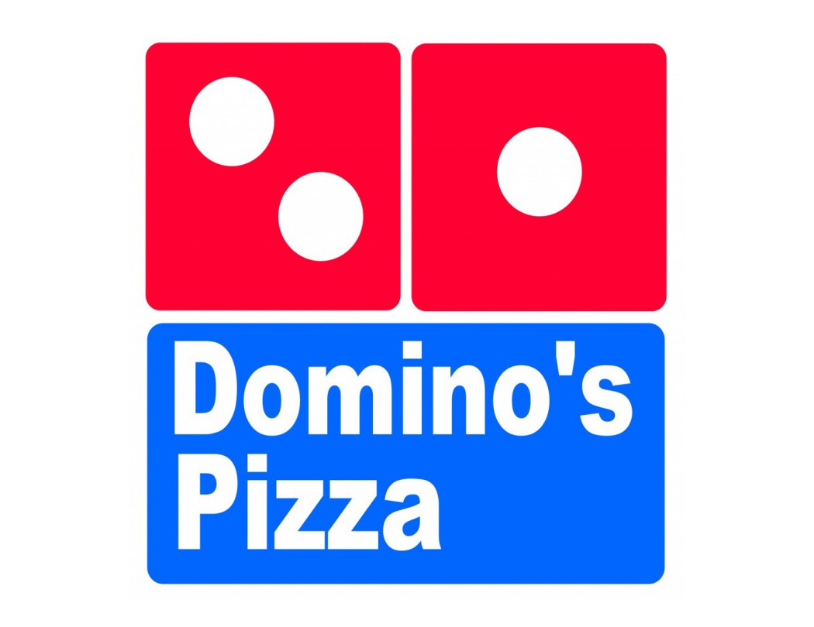

**TEAM DETAILS**

***TEAM MEMBER***

***NAME -Somansh Garg***

***B.Tech CSE-CCVT 2nd year,***

***SOCS, UPES.***

INTRODUCTION

This case study looks at the problem of managing a Pizza Shop. The basic problem in the Shop management software is the lack of flexibility in taking order along with restricted control over the employees. Security is another issue in this type of software. Every Pizza Shop has some employees to take the order, but the amount of time taken by them for generating the order is quite high. Our product is not only aimed to decrease the order time significantly but also provide a greater flexibility while taking orders. Also, access of the account to different designated employees is different thereby having a better control and check on the employees by the higher authorities, hence to solve these problems and to provide a better and efficient mechanism we plan to design a **“Pizza Shop Management System (PSMS).”**

Our PSMS will be equipped with a user-friendly Input screen, having functionality ranging from ordering a Pizza to edit profile and to change/edit employee details based on the designation of the user. For this System there will be a System Administrator, Shop Manager, Shop Cashiers and Customers entering in the shop. System Administrator will be having full view and edit rights over other employees whereas the Manager will be having some restricted rights over the Cashier. Cashier on the other hand will be having rights only on his account. All of the employees will be provided with a unique ID and a secured password to enter the system.

The purpose of the project is to build an application program to reduce the manual work for managing the Customer and Employees, Order Status, and Redeem Points. It tracks all the details about the Sales, Menu, Orders, Employees and Customer.

Now when the customer enters the restaurant, he will tell his order to the cashier. Cashier with the help of the input screen using the intuitive graphical user interface, will ask for customer mobile number and starts taking up the order. If customer is a new customer then his account will be created by the cashier during the process of taking the order and not disrupting the flow of functioning of the software. While taking order cashier will be having many functions to work with, which can be used at any time during the process such as “view menu”, “view order details”, “cancel order” along with some others. Orders can be placed in more than one way by either specifying the “name” or “ID” or “shortcut” associated with the product. In case of any wrong item placed or customer does not wants it, only the last item can be withdrawn from the order using “last” command without discarding or cancelling the whole order. After the order is confirmed, the customer will be asked to redeem his points or not, if having any. The customer will then pay for his order and after confirmation by the cashier; system will “print” the order into a text file and save the state of the transaction into the database.

Customer if wants while waiting for his order can check his account to view his order and details of his points.

SPECIFICATIONS

We will be having 2 types of users interacting with the system –

* Customer
* Employee – Employee can be a “CASHIER” or “MANAGER” or an “ADMINISTRATOR”

Every user will be having different interface to interact with the system and to restrict their access control over other accounts and the system.

Some major specification for users will be –

**CUSTOMER**

* Can know the details of his last order
* Can know his order history
* Can view his points
* Can view his profile
* Can view the menu

**CASHIER**

* Can take the customer order
* Can create customer account
* Can view customer profile and orders
* Can view the menu
* Can change his account password
* Can edit some details of his account
* Can view all the details of his account

**MANAGER**

* Can take the customer order
* Can create customer account
* Can view customer profile and orders
* Can view the menu
* Can edit the menu
* Can apply the offers on the menu
* Can create a new item for the menu
* Can view cashier account details
* Can edit some details of the cashier account
* Can lock or unlock the account of the cashier
* Can view the sales of the shop
* Can view the sales done by any employee
* Can change his account password
* Can edit some details of his account
* Can view all the details of his account

**ADMINISTRATOR**

* Can take the customer order
* Can create customer account
* Can view customer profile and orders
* Can view the menu
* Can edit the menu
* Can apply the offers on the menu
* Can create a new item for the menu
* Can view any employee account details
* Can edit all details of any employee account
* Can lock or unlock the account of the cashier or manager
* Can hire a new employee
* Can fire an existing employee
* Can rehire an old employee
* Can view the sales of the shop
* Can view the sales done by any employee
* Can change his account password
* Can edit some details of his account
* Can view all the details of his account

**LOGIN FEATURES**

* A fired employee cannot access his account
* After 3 consecutive failed authentication of the employee account , account will be locked
* A employee cannot access his account, if locked
* ADMINISTARTOR account cannot be locked
* CUSTOMER account cannot be locked
* CASHIER account can be unlocked by either MANAGER or ADMINISTARTOR
* MANAGER cannot can be unlocked by only ADMINISTRATOR

**USER INTERFACE FEATURES**

* UI of main menu will be accessible only by successful login by the user
* UI will be immune to wrong input
* UI/System shall not exit after implementation of an feature until the user logs out of his account
* UI will have a special feature for path tracking and back tracking
* Path Tracking – User Account will be tracked for the path which he selects in the UI in order to facilitate back tracking of the UI
* Back Tracking – UI should be directed to the previous menu after the completion of a particular function, a choice would also be given for the redirection to the main menu

MODULE DESCRIPTIONS

The software will be consisting of many modules each performing some particular task thereby providing features to the system.

Some the main modules of our PSMS are –

* **validation –** Consist of functions needed to validate data items and some inputs such as date of birth, name, password, mobile number and others. It is used by other modules to validate their input. Each function of this module returns either true or false and may print some error message if necessary.
* **view –** It is used to view sales figures, employee details, order details , basically everything that needs to be viewed from an account. Consist of functions which also restrict the view access of different employees over the data.
* **change –** It changes the existing data values. Functions to edit profile, menu, employees along with others is contained in it. It will give different access to different employees as per their designation, which ensures security of the data items.
* **create –** Used for creation of employees and customer. Customer can be created by any employee whereas employee can be hired by the ADMINISTRATOR only.
* **menu –** Contains all menu that will consist the user interface. Different menus are there for different types of account.
* **order –** It contains the main machinery for processing an order by an employee. It consists of all functions required during the processing of order ranging from creation of bill to redemption of points.
* **employee –** Will be having class model for employee i.e. CASHIER, MANAGER and ADMIN. Each class will be using other modules to perform functions specific to the class.
* **login –** It would our “main” module responsible for authentication of the user and handling the control of program by using other modules.

**USE CASE DIAGRAM**

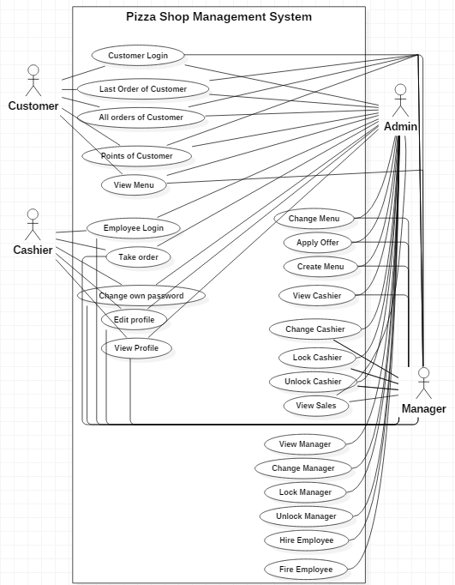

**END**