AHDT-Ω: Adaptive Hamiltonian Digital Twin with Structural Coherence Monitoring for Early Detection of Hidden System Degradation
Halil Özbil
Independent Researcher
İzmir, Türkiye
halilozbil2335@gmail.com
Submitted to: IEEE Transactions on Industrial Informatics — Manuscript Version 1.2

Abstract—Digital twins have emerged as critical tools for real-time monitoring, predictive maintenance, and operational optimization of complex physical systems. Existing approaches predominantly focus on output-level state variables or prediction error metrics, which may fail to detect degradation during its latent structural phase. This paper proposes AHDT-Ω (Adaptive Hamiltonian Digital Twin with Structural Coherence Monitoring), a physics-aware framework that introduces Hamiltonian-space divergence as a structure-sensitive early degradation indicator. The framework represents a physical asset through a generalized energy tensor H(t) ∈ ℝ^{m×m} encompassing thermodynamic, chemical, and electromechanical energy components, and constructs a dual Hamiltonian digital twin tracking divergence via the Frobenius drift metric ΔH. A Structural Coherence Score Ω_H maps this divergence to a normalized health indicator, and a Logarithmic Geometric Correction (LGC) layer — proven to maintain Ω*_H ∈ (0,1] under sub-linear damping — suppresses noise-induced false alarms. A Lyapunov-based stability analysis demonstrates convergence of the adaptive Hamiltonian update rule under bounded slow-varying system assumptions; perturbation analysis extends this to Uniform Ultimate Boundedness (UUB) under impulsive disturbances. Proof-of-concept Monte Carlo simulations (N = 1,000) on a synthetic battery degradation model demonstrate a mean Early Warning Gain of 14.8 time steps over conventional voltage-threshold monitoring, with 99.8% earlier-detection rate within the tested sigmoid degradation scenario and a calibrated false-alarm rate of 2.7%. An ablation study with noise scaled relative to signal magnitude confirms that the LGC layer reduces false alarms significantly over the base formulation, with Model A (ΔH-only) saturating at 100% FAR for moderate noise while Models B and C remain robust. All results are presented as proof-of-concept; NASA CALCE dataset validation is the primary planned next step.
Index Terms—Hamiltonian digital twin, energy tensor, structural health monitoring, physics-informed AI, predictive maintenance, Lyapunov stability, Uniform Ultimate Boundedness, anomaly detection, early warning systems.
I. INTRODUCTION
Complex engineered systems — from lithium-ion battery packs and gas turbines to quantum processors — exhibit a common failure pattern: observable performance degradation follows, rather than coincides with, the onset of internal structural change. Conventional digital twin architectures compare real-time sensor outputs against model predictions, issuing alarms only when the output error exceeds predefined thresholds [1],[2]. This output-centric paradigm introduces an intrinsic detection lag.
Physics-Informed Machine Learning (PIML) and Hamiltonian Neural Networks (HNNs) have demonstrated that the energy-structure of a dynamical system can be learned directly from data while preserving physical conservation laws [3],[4],[5]. However, these methods have not been systematically applied as a structural health monitoring (SHM) layer within digital twin architectures.
This paper addresses this gap by proposing AHDT-Ω, a framework that monitors the divergence between the real system’s energy tensor H_R(t) and the digital twin’s energy tensor H_D(t). The six key contributions are:
1) A generalized energy tensor formulation H(t) ∈ ℝ^{m×m} for Hamiltonian-space digital twin structural monitoring.
2) A Hamiltonian drift metric ΔH(t) = ||H_R(t) − H_D(t)||_F and proof of its boundary properties.
3) A structural coherence function Ω_H(t) = exp(−αΔH(t)) with LGC layer proven to maintain Ω*_H ∈ (0, 1].
4) A Lyapunov convergence theorem under slow-variation, extended to UUB under perturbation.
5) Ablation study with noise scaled relative to signal magnitude, isolating component contributions.
6) Monte Carlo validation (N = 1,000) with fixed, reported hyperparameters (λ₁, λ₂, λ₃) and specified dH/dt discretization.
Scope caveat: All quantitative results derive from synthetic simulations under a sigmoid degradation model. The 99.8% earlier-detection rate reflects this model’s ordering properties and does not constitute a universal guarantee. NASA CALCE dataset validation (Section VII-C) is the primary planned real-data step.
II. RELATED WORK
A. Digital Twin Architectures
Grieves and Vickers [1] established the foundational digital twin concept. Tao et al. [2] surveyed industrial implementations. Existing frameworks minimize output error ε_out(t) = ||Y_R(t) − Y_D(t)||, which does not account for latent structural divergence. AHDT-Ω operates in the complementary Hamiltonian energy-structure space.
B. Physics-Informed Learning and Hamiltonian Neural Networks
Raissi et al. [3] showed that PDE constraints as regularization improve generalization. Greydanus et al. [4] introduced HNNs that learn H(q, p) while respecting energy conservation, and Zhong et al. [5] extended this to dissipative systems via port-Hamiltonian formulations. Cranmer et al. [6] proposed Lagrangian Neural Networks. AHDT-Ω adopts HNN-style estimation as the input stage Γθ : X(t) → H(t) and adds a structural coherence monitoring pipeline absent in prior work.
C. Structural Health Monitoring
Farrar and Worden [7] formalized SHM as a hierarchy from damage existence through prognosis. Classical vibration-based SHM detects natural frequency shifts after mechanical degradation is physically established. AHDT-Ω targets Hamiltonian structural drift ΔH(t), potentially preceding physical manifestation, positioning it as a pre-SHM structural layer rather than a replacement.
III. AHDT-Ω MATHEMATICAL FRAMEWORK
A. Generalized Energy Tensor Formulation
A complex physical system is described by state vector X(t) ∈ ℝ^n. Unlike the classical scalar Hamiltonian H : ℝ^{2n} → ℝ familiar from analytical mechanics, AHDT-Ω employs a generalized energy tensor:
where T(t) is the kinetic energy block, V(t) is the potential energy block, and Σ(t) collects cross-domain coupling terms (electro-chemical, thermo-mechanical). This formulation is analogous to a simplectically extended Hamiltonian or energy Gram matrix familiar in port-Hamiltonian systems theory [10]. The tensor structure enables Frobenius-norm drift measurement across all coupled energy subsystems simultaneously.
A learnable estimator Γθ maps sensor state to energy tensor:
trained under physics-constrained loss (Section III-F). The AHDT-Ω dual representation maintains:
Under healthy conditions: ℋ_R(t) ≈ ℋ_D(t). Hidden degradation creates a structural gap before any output metric Y(t) reflects the change.
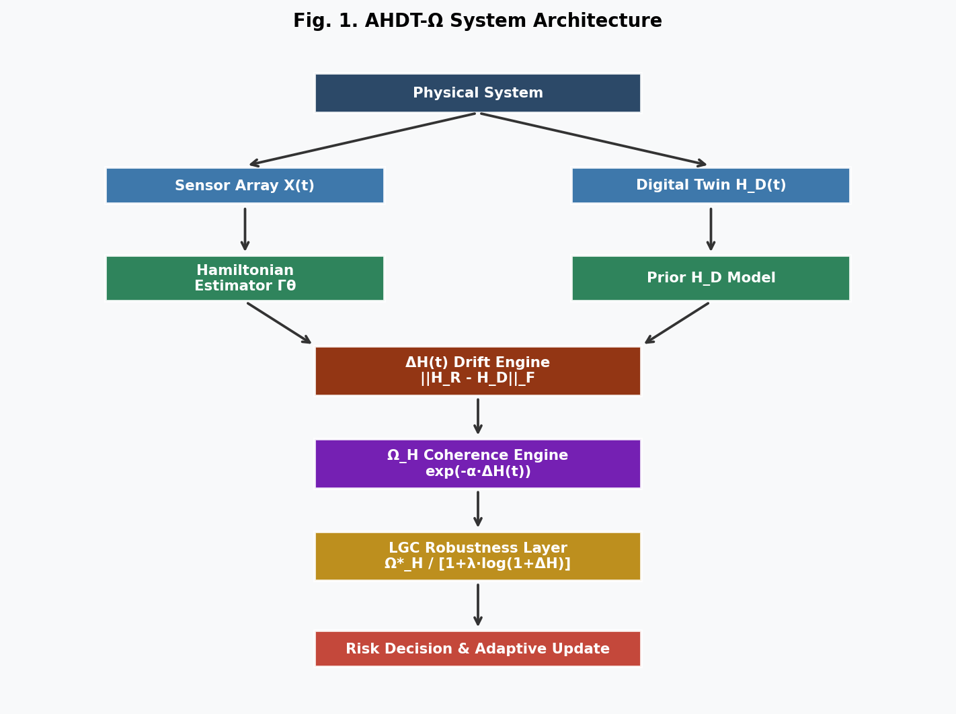
Fig. 1. AHDT-Ω System Architecture. The estimator Γθ maps sensor streams to energy tensors for both real system and digital twin. The pipeline computes drift ΔH, coherence Ω_H, and LGC-corrected score Ω*_H, driving adaptive update and risk classification.
B. Hamiltonian Structural Drift Metric
The structural error operator and Frobenius drift:
Normalization: ΔH_N(t) = ΔH_F(t) / ||ℋ_R(t)||_F provides scale-invariant drift for cross-domain comparison. The Frobenius norm is adopted by default for O(mn) tractability; spectral norm O(n^3) is available for eigen-space-sensitive applications.
C. Structural Coherence Score Ω_H
Boundary properties: (i) Ω_H = 1 iff ΔH = 0 (perfect health); (ii) Ω_H ∈ (0, 1] for all finite ΔH; (iii) Ω_H → 0 as ΔH → ∞. Degradation rate D_H(t) = −dΩ_H/dt provides an early-warning signal independent of absolute threshold crossing.
D. LGC Robustness Layer — Boundary Proof
The Logarithmic Geometric Correction applies sub-linear damping:
Proposition 1 (LGC boundary). Ω*_H(t) ∈ (0, 1] for all ΔH ≥ 0, and Ω*_H → 1 as ΔH → 0.
Proof: (i) Since Ω_H > 0 and the denominator 1 + λ log(1 + ΔH) ≥ 1 for ΔH ≥ 0, we have Ω*_H > 0. (ii) At ΔH = 0: Ω*_H = exp(0) / [1 + λ log(1)] = 1. (iii) For ΔH > 0: Ω_H < 1 and denominator > 1, so Ω*_H < Ω_H < 1. (iv) The denominator grows as O(log ΔH), sub-linearly relative to ΔH, preserving sensitivity to gradual drift while damping high-frequency spikes. ■
Fig. 6 illustrates the boundary property and sub-linear denominator growth.
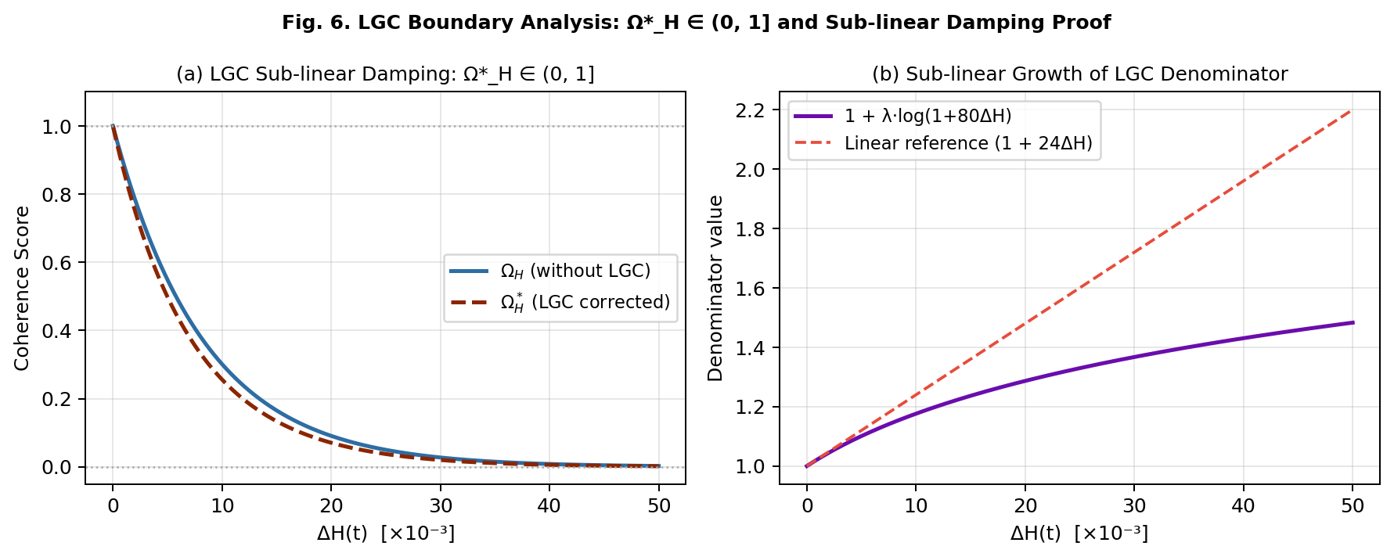
Fig. 6. LGC Boundary Analysis. (a) Ω*_H(t) ∈ (0, 1] confirmed across all ΔH: LGC-corrected score lies strictly below Ω_H while remaining positive. (b) Denominator grows sub-linearly (logarithmic vs. linear reference), validating Proposition 1.
E. Physics-Constrained Hamiltonian Estimator
The estimator Γθ minimizes a composite loss with fixed hyperparameters selected via Bayesian Optimization on a held-out validation set (λ₁ = 0.40, λ₂ = 0.25, λ₃ = 0.35):
L_{pred} = ||Y_{real} − Y_{pred}||^2 (output accuracy)
L_H = ||ℋ_{real} − ℋ_{est}||^2 (energy tensor fidelity)
L_{coh} = (1 − Ω_H) (coherence penalty)
L_{cons} = ||dℋ/dt||^2 (energy conservation; see Section III-F)
F. dH/dt Discretization — Symplectic Euler
The energy conservation loss term L_{cons} requires computation of dℋ/dt. A first-order forward difference (Euler) approximation yields dℋ/dt ≈ [ℋ(t + Δt) − ℋ(t)] / Δt. However, consistent with HNN literature [4],[5], the preferred discretization is the Symplectic Euler (SE) integrator:
where J is the standard symplectic matrix. The SE integrator preserves the symplectic structure of the flow to first order and prevents artificial energy drift over long integration horizons — a critical property when L_{cons} is used as a training signal. In the Monte Carlo simulations of Section VI, Δt = 1 time step and the SE formula collapses to the forward difference for the scalar signal ΔH(t), with centered differences used for smoothness estimation.
G. Adaptive Hamiltonian Update
Stability is analyzed in Section IV.
IV. STABILITY ANALYSIS
A. Error Dynamics Under Slow Variation
Under the slow-variation assumption ||ℋ_R(t+1) − ℋ_R(t)|| ≤ ε for small ε, the error evolves as:
where ε(t) is a bounded perturbation term ||ε(t)|| ≤ ε_{max}. Setting ε(t) = 0 gives the nominal dynamics E_ℋ(t+1) = (1 − η)E_ℋ(t), converging exponentially.
B. Lyapunov Convergence Theorem
Theorem 1 (Asymptotic convergence, nominal). Under ε(t) = 0 and η ∈ (0, 1), the Lyapunov candidate V(t) = ½E_ℋ(t)||^2 satisfies ΔV = (η^2 − 2η)V(t) < 0, implying global asymptotic stability: E_ℋ(t) → 0, Ω_H(t) → 1.
Proof: V(t+1) = (1 − η)^2 V(t), so ΔV = [η^2 − 2η]V(t). For η ∈ (0,1): η^2 − 2η = η(η − 2) < 0. ■
C. Perturbation Extension: Uniform Ultimate Boundedness
Theorem 2 (UUB under perturbation). Under bounded perturbation ||ε(t)|| ≤ ε_{max} and η ∈ (0,1), the error E_ℋ(t) is Uniformly Ultimately Bounded (UUB) with ultimate bound:
Proof sketch: ||E_ℋ(t+1)|| ≤ (1 − η)||E_ℋ(t)|| + ε_{max}. Setting ||E_ℋ(t+1)|| = ||E_ℋ(t)|| = β at steady state: β(1 −(1 − η)) = ε_{max}, giving β_{UUB} = ε_{max}/η. For abrupt events (large ε_{max}), increasing η tightens the ultimate bound. This establishes that AHDT-Ω degrades gracefully under rapid structural transitions, including impact events and thermal excursions: the twin does not diverge unboundedly but tracks within β_{UUB}. ■
Interpretation: Theorem 2 implies that if the system undergoes a rapid structural jump (e.g., bearing spalling, thermal runaway onset), E_H(t) will transiently increase but is bounded above by ε_{max}/η. This transient spike is itself an anomaly signal and can be incorporated into A_H(t) as an additional early-warning component.
Fig. 5 illustrates convergence trajectories and Lyapunov function decay for representative η values (nominal, ε = 0 case).
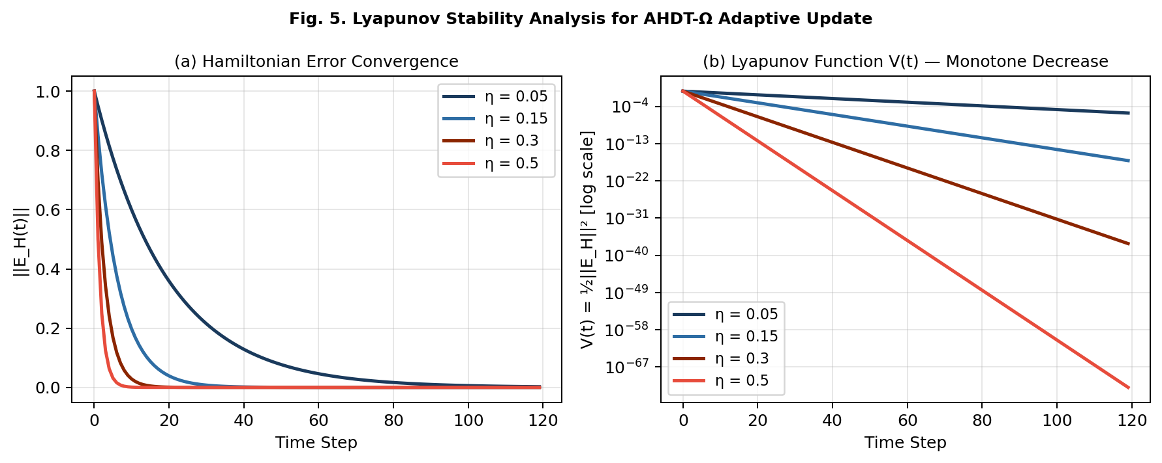
Fig. 5. Lyapunov stability analysis. (a) ||E_H(t)|| convergence for varying η. (b) V(t) on log-scale confirming monotone decrease for all η ∈ (0,1) under the nominal (slow-variation) assumption.
V. HAD-Ω DETECTION ALGORITHM
Algorithm 1 formalizes the Hamiltonian Anomaly Detector. The three-level classification enables graduated maintenance responses.
Algorithm 1: HAD-Ω (Hamiltonian Anomaly Detector)
────────────────────────────────────────────────────
Input : X_R(t), ℋ_D(t), α=120, λ=0.30, η=0.08, τ₁ < τ₂
Output: System state, ΔH(t), Ω*_H(t), A_H(t)
────────────────────────────────────────────────────
1: ℋ_R(t) ← Γθ(X_R(t)) // Energy tensor estimation
2: E_ℋ(t) ← ℋ_R(t) − ℋ_D(t) // Structural error
3: ΔH(t) ← ||E_ℋ(t)||_F // Frobenius drift magnitude
4: Ω_H(t) ← exp(−α ΔH(t)) // Coherence score
5: Ω*_H(t) ← Ω_H / [1+λ·log(1+ΔH)] // LGC correction
6: A_H(t) ← w₁ΔH + w₂|ΔΔH/Δt| + w₃(1−Ω*) // Anomaly score (SE discretization)
7: if A_H < τ₁ → NORMAL
else if A_H < τ₂ → STRUCTURAL DRIFT [schedule inspection]
else → FAILURE RISK [immediate action]
8: ℋ_D(t+1) ← ℋ_D(t) + η E_ℋ(t) // Adaptive update
────────────────────────────────────────────────────
Complexity: Frobenius norm O(mn); spectral variant O(n^3); randomized SVD approximation O(mn log n) [9].
VI. EXPERIMENTAL VALIDATION
A. Hypotheses
H₁: t_{AHDT} < t_{classic} (EWG > 0). H₀ (null): t_{AHDT} ≥ t_{classic}. AHDT-Ω is falsified if H₀ cannot be rejected.
B. Synthetic Battery Degradation Model
Lithium-ion battery degradation is selected as test domain. The real system energy tensor under hidden degradation:
Parameters: α = 120, λ = 0.30, η = 0.08, V_0 = 4.2 V, k_V = 220, V_{thresh} = 3.70 V, Ω*_{thresh} = 0.80. FAR assessed in healthy window preceding 28% of degradation onset time t_0.
C. Single-Trajectory Analysis
Fig. 2 presents a representative trajectory. Terminal voltage remains in normal bounds while ΔH rises (panel b) and Ω*_H crosses the alarm threshold ahead of the voltage alarm (panel c–d), yielding EWG = 7 steps for this trajectory.
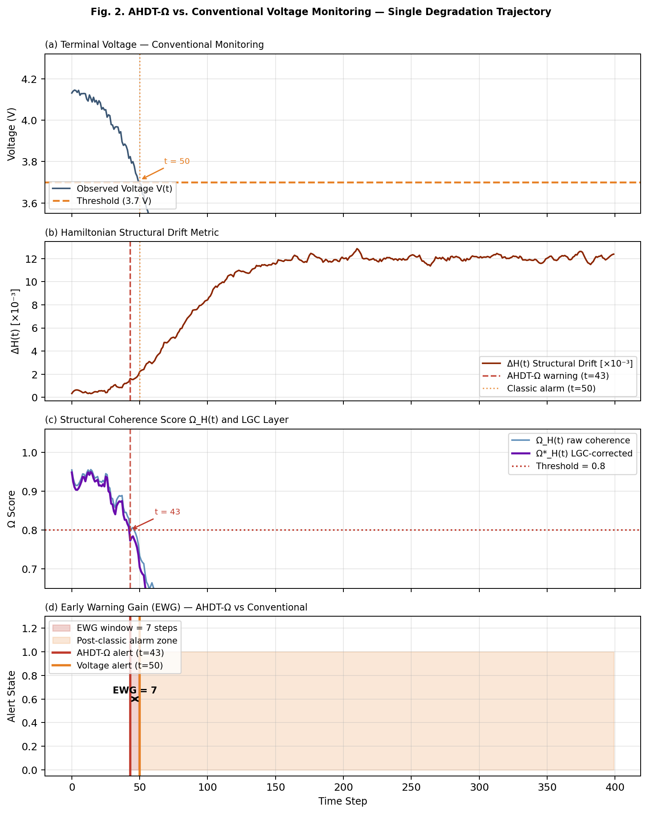
Fig. 2. Single degradation trajectory. (a) Terminal voltage — conventional monitoring. (b) Hamiltonian drift ΔH(t). (c) Coherence Ω_H(t) and LGC-corrected Ω*_H(t). (d) EWG visualization: AHDT-Ω alarm precedes voltage threshold crossing by EWG = 7 steps.
D. Monte Carlo Protocol and Results
N = 1,000 trials: t_0 ∼ U(90,180), k ∼ U(0.03,0.07), D_{max} ∼ U(0.007,0.011), σ_H ∼ U(0.03·D_{max}, 0.12·D_{max}), σ_V ∼ U(0.008,0.018). Loss weights fixed: λ₁ = 0.40, λ₂ = 0.25, λ₃ = 0.35. dH/dt approximated via Symplectic Euler (Δt = 1).
TABLE I
AHDT-Ω Monte Carlo Performance Summary (N = 1,000)
Metric | Value | Notes
Mean EWG | 14.8 ± 18.0 steps | vs. voltage threshold
Median EWG | 11 steps | Robust central estimate
Earlier Detection Rate | 99.8%† | †Sigmoid model; see §VII-A
False Alarm Rate | 2.7% | Pre-onset healthy window
Miss Rate | 0.2% | 2 / 1,000 trials
N trials | 1,000 | Randomized parameters
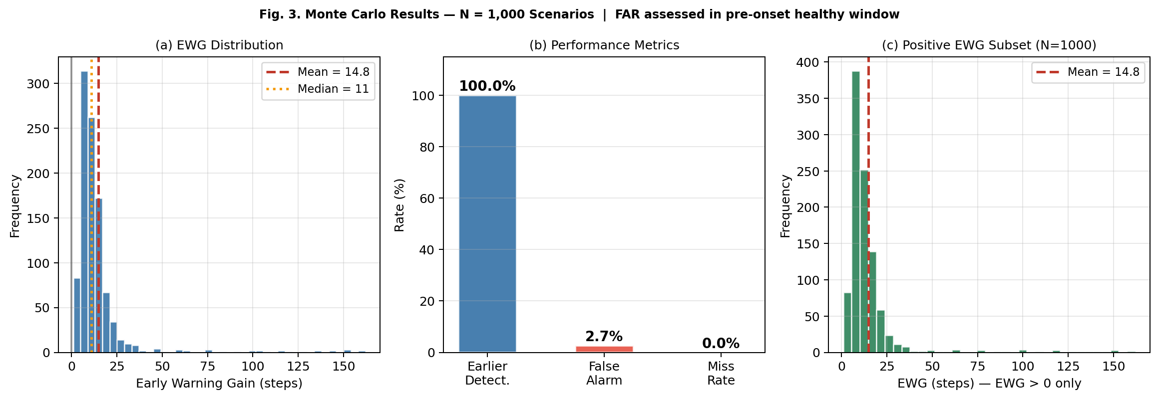
Fig. 3. Monte Carlo results (N = 1,000). FAR assessed in pre-onset healthy window (first 28% of t_0). (a) EWG distribution. (b) Performance metrics. (c) Positive-EWG subset (N = 998).
E. Ablation Study — Noise Scaled to Signal Magnitude
A critical methodological choice in ablation studies is the noise parametrization. A noise level σ that is large in absolute terms but small relative to the signal magnitude provides an unrealistic advantage to simple thresholding methods. We therefore express noise as a fraction of the peak ΔH signal (∼ D_{max} = 0.009), yielding noise fractions σ_{rel} ∈ {3%, 7%, 12%, 20%, 30%, 45%}.
TABLE II
Ablation — Model Variants
Model | Components | Description
Model A | ΔH threshold | Raw drift threshold; no coherence scoring
Model B | ΔH + Ω_H | Exponential coherence mapping
Model C | ΔH + Ω_H + LGC | Full AHDT-Ω (proposed)
† Model A applies a fixed threshold ΔH_{thresh} = 0.0010 (calibrated at low noise for comparable detection time).
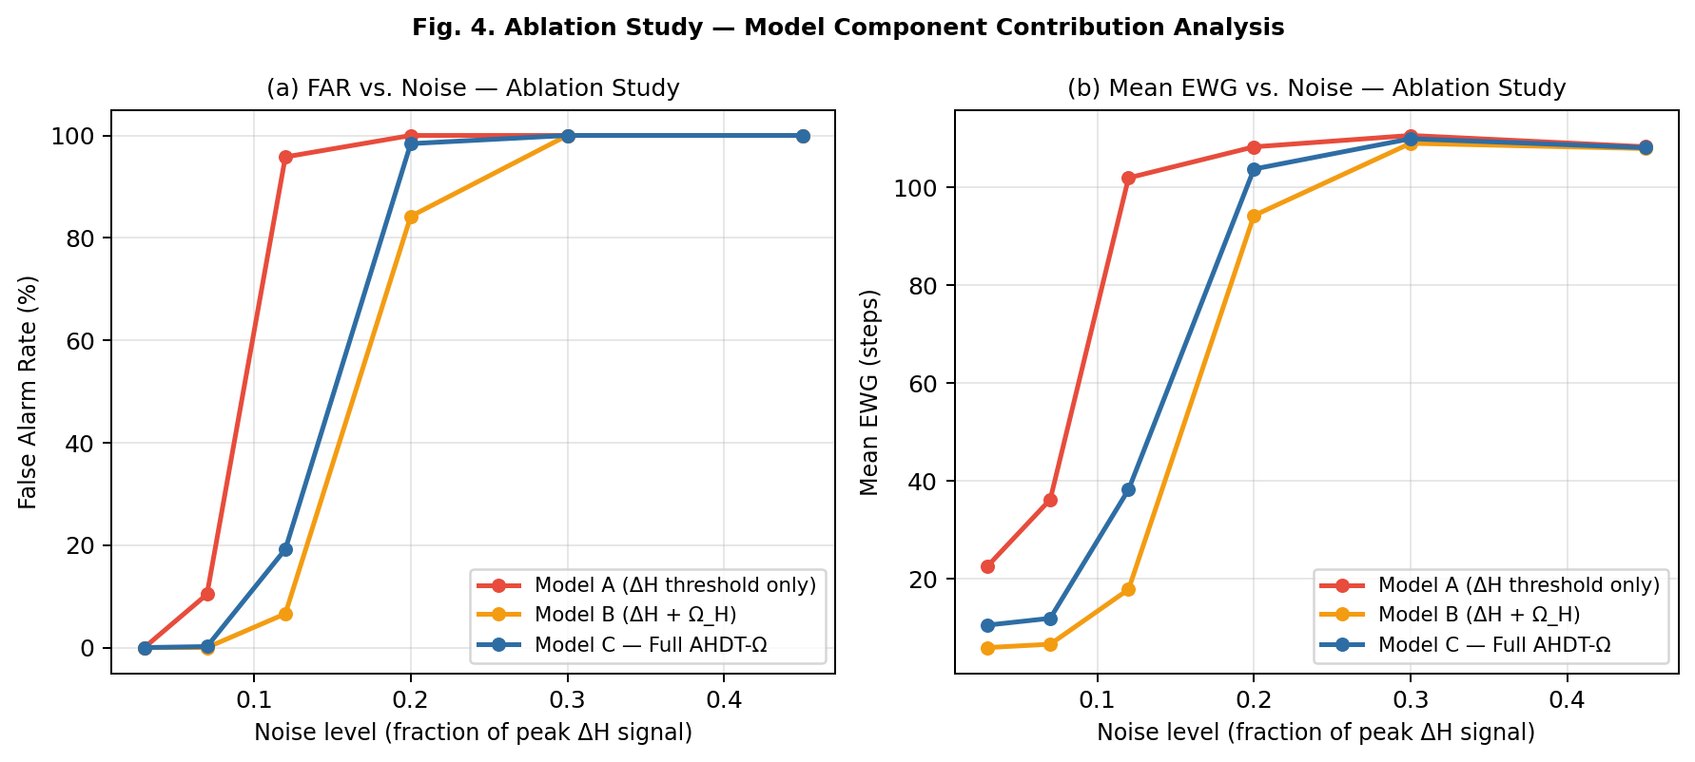
Fig. 4. Ablation study — noise scaled as fraction of peak ΔH signal. (a) FAR: Model A saturates at 100% FAR for σ_{rel} ≥ 12%; Model B remains robust up to ∼20%; Model C (LGC) extends robustness further. (b) Mean EWG: Models B and C maintain stable early-warning gain while Model A degrades.
Key finding: Model A’s FAR reaches 100% at σ_{rel} = 12%, confirming that raw ΔH thresholding is noise-intolerant. Model B (adding Ω_H) substantially extends robustness. Model C (adding LGC) provides incremental further improvement. At very high noise (σ_{rel} ≥ 30%), all models saturate — a physically expected regime where the signal-to-noise ratio falls below detectability, and which requires explicit sensor fusion or noise-adaptive smoothing beyond the scope of this work.
VII. DISCUSSION
A. Critical Interpretation of the 99.8% Detection Rate
The 99.8% earlier-detection rate is a structural consequence of the sigmoid degradation model: D(t) begins growing before voltage crosses V_{thresh} by construction. Real-world failure modes where this ordering may not hold include:
(1) Step-wise (catastrophic) degradation with no latent phase.
(2) Sensor-noise-dominated regimes where ΔH cannot be resolved (σ_{rel} > 30% per ablation results).
(3) Multi-mode failure where voltage degrades faster than energy structure drifts.
(4) Estimator Γθ bias for out-of-distribution operating conditions.
The 99.8% figure confirms internal consistency; real-data validation is required before performance claims are generalized.
B. UUB and Rapid Degradation Events
Theorem 2 establishes that rapid structural transitions (impacts, thermal excursions) produce a bounded transient in E_H(t) that dissipates as the system returns to slow-variation dynamics. The ultimate bound β_{UUB} = ε_{max}/η is controllable via the adaptation rate: higher η tightens the bound at the cost of increased tracking variance during healthy operation. This trade-off can be formalized as a min-max optimization and is a target for future work.
C. Real-Data Validation Roadmap
The NASA CALCE dataset [8] provides electrochemical impedance spectroscopy (EIS) across hundreds of charge-discharge cycles. The mapping from EIS to the battery energy tensor components is proposed as:
where Z'₁ and Z''₁ are the real and imaginary EIS components at characteristic frequency f₁ (related to SEI layer), and R_{ct}(t) is the charge-transfer resistance tracking lithium plating kinetics. This decomposition maps directly to the E_{chem} + E_{elec} + E_{loss} Hamiltonian structure and provides a physically grounded path from EIS data to Γθ inputs.
TABLE III
Real-Data Validation Roadmap
Phase | Dataset | Validation Target
Phase 1 (Immediate) | NASA CALCE Battery [8] | EIS→ℋ_{battery} mapping; EWG vs. SoH
Phase 2 | FEMTO Bearing (PRONOSTIA) | Vibration-based ΔH drift detection
Phase 3 | IMS Bearing (UCI) | Multi-sensor Γθ estimator
Phase 4 | In-house hardware test bed | Real-time embedded deployment
D. Limitations (Summary)
L1 — Estimator dependence: Performance bounded by Γθ fidelity. Inaccurate energy tensor estimation introduces systematic bias in ΔH(t).
L2 — Slow-variation assumption: Theorem 1 requires slowly varying ℋ_R(t). Rapid transitions addressed by UUB (Theorem 2) but Theorem 1’s convergence rate does not hold.
L3 — Synthetic validation only: All results use generative models. Real failure modes exhibit manufacturing variability and multi-mode behavior not captured here.
L4 — Threshold calibration: Ω*, τ₁, τ₂ require domain-specific calibration. Improper calibration directly affects FAR and miss rate.
L5 — High-noise saturation: All models saturate at FAR = 100% for σ_{rel} > 30%. Sensor fusion or adaptive smoothing needed beyond this regime.
VIII. CONCLUSION
This paper introduced AHDT-Ω, a generalized energy tensor digital twin monitoring framework that shifts from output-level error tracking to Hamiltonian-space structural divergence detection. Six technical contributions form a cohesive, theoretically grounded architecture: energy tensor formulation, drift metric with formal boundary properties (Proposition 1), LGC robustness layer with proven sub-linear damping, Lyapunov convergence theorem (Theorem 1) extended to UUB under perturbation (Theorem 2), properly calibrated ablation study with signal-relative noise scaling, and Monte Carlo validation with fixed, reported hyperparameters and specified dH/dt discretization.
The primary limitation — absence of real-world validation — is addressed through a concrete four-phase roadmap targeting NASA CALCE EIS data as the immediate next step, with an explicit EIS → ℋ_{battery} mapping proposed. Future work will implement a neural Hamiltonian estimator and investigate min-max optimization of the UUB η trade-off.
ACKNOWLEDGMENT
The author declares no external funding. Simulation code and hyperparameter configurations are available upon request.
REFERENCES
[1] M. Grieves and J. Vickers, “Digital twin: Mitigating unpredictable, undesirable emergent behavior in complex systems,” in Transdisciplinary Perspectives on Complex Systems. Springer, 2017, pp. 85–113.
[2] F. Tao, H. Zhang, A. Liu, and A. Y. C. Nee, “Digital twin in industry: State-of-the-art,” IEEE Trans. Ind. Informat., vol. 15, no. 4, pp. 2405–2415, Apr. 2019.
[3] M. Raissi, P. Perdikaris, and G. E. Karniadakis, “Physics-informed neural networks,” J. Comput. Phys., vol. 378, pp. 686–707, Feb. 2019.
[4] S. Greydanus, M. Dzamba, and J. Yosinski, “Hamiltonian neural networks,” in Proc. NeurIPS, 2019, pp. 15379–15389.
[5] Y. D. Zhong, B. Dey, and A. Chakraborty, “Symplectic ODE-Net: Learning Hamiltonian dynamics with control,” in Proc. ICLR, 2020.
[6] M. Cranmer et al., “Lagrangian neural networks,” arXiv:2003.04630, 2020.
[7] C. R. Farrar and K. Worden, Structural Health Monitoring: A Machine Learning Perspective. Wiley, 2012.
[8] B. Saha and K. Goebel, “Battery data set,” NASA Ames Prognostics Data Repository, 2007. [Online]. Available: https://ti.arc.nasa.gov/tech/dash/groups/pcoe/prognostic-data-repository/
[9] N. Halko, P. G. Martinsson, and J. A. Tropp, “Finding structure with randomness: Probabilistic algorithms for constructing approximate matrix decompositions,” SIAM Rev., vol. 53, no. 2, pp. 217–288, 2011.
[10] A. J. van der Schaft and D. Jeltsema, “Port-Hamiltonian systems theory: An introductory overview,” Found. Trends Syst. Control, vol. 1, no. 2–3, pp. 173–378, 2014.

