**AIDA (Artificial Intelligence Diet Assistant)**

**Overview**

AIDA represents an innovative approach to diabetes and weight loss management, combining AI, personalized guidance, and data-driven insights. By empowering patients and healthcare professionals, AIDA aims to improve outcomes and enhance the quality of life. The platform offers personalized meal plans and grocery lists tailored to individuals with specific health goals, such as managing diabetes or weight loss.. Leveraging advanced AI models and seamless integration with Nvidia's powerful computing capabilities, this app aims to enhance dietary management through intelligent recommendations and precise grocery planning.

**Key Features**

**Goal-Oriented Recommendations**

The app supports two primary health goals:

* **Diabetes Management**: Tailored meal plans focus on controlling blood sugar levels, incorporating appropriate dietary recommendations to manage diabetes effectively.
* **Weight Loss**: Customized plans are designed to support weight loss by considering dietary requirements, BMI, and preferred cuisines.

**Personalized Meal Plans**

The app provides customized meal plans based on patient data, dietary preferences, and health goals. By analyzing individual requirements such as blood sugar levels and BMI, the app ensures that each meal plan is not only nutritionally balanced but also aligns with the patient's specific health objectives.

**Intelligent Grocery List Generation**

Once a meal plan is established, the app generates a detailed grocery list, including quantities, to streamline shopping and ensure that all necessary ingredients are readily available. This feature minimizes the hassle of meal preparation and supports adherence to the recommended diet.

**Data-Driven Insights**

AIDA analyzes patient data (glucose levels, dietary habits, exercise patterns) to identify trends and provides data driven insights/recommendations.

**Problem Statement: Enhancing Diabetes/Weightloss Management with AI Agents**

**Background**

Diabetes and Obesity are a global health challenge affecting millions of people. Effective management requires personalized care, access to accurate information, and collaboration between patients, dietitians, and healthcare providers. To address this, we propose an AI-based solution that combines conversational agents and data-driven insights.

* **Analyze dietary habits and blood glucose levels** based on user input.
* **Recommend personalized meal plans** considering nutritional needs, preferences, and health goals.
* **Track progress**, adjust plans, and provide real-time feedback and grocery procurement Assistance to help with inventory.
* **Educate users** about healthy eating and portion control.

**Problem Description**

1. **Lack of Personalized Support:**
   * Many diabetes patients and Over Weights struggle with self-management due to the absence of personalized guidance.
   * Dietitians and doctors face challenges in providing timely assistance to a large number of patients.
2. **Complexity of Diabetes & Weight Control Care:**
   * Diabetes management/Weight Control involves monitoring blood glucose levels, adhering to dietary restrictions, and understanding medication regimens.
   * Patients need continuous support to prevent complications and improve their quality of life.
3. **Obesity is a** **chronic complex disease** defined by excessive fat deposits that can impair health. It leads to increased risk of **type 2 diabetes**, heart disease, certain cancers, and affects bone health and reproduction. Obesity also influences quality of life, such as sleep and mobility.

**Relevant Charts:**

1. **Diabetes Prevalence Worldwide:**
   * [According to the IDF Diabetes Atlas, approximately 537 million adults (20-79 years) live with diabetes globally](https://diabetesatlas.org/)[1](https://diabetesatlas.org/).
   * The prevalence is predicted to rise to 643 million by 2030 and 783 million by 2045.
2. A map of the world with colorful circles

   Description automatically generated

1. In 2022, **1 in 8 people** globally were living with obesity.
   * **Worldwide adult obesity** has more than **doubled** since 1990, and **adolescent obesity** has **quadrupled**.
   * [In 2022, **2.5 billion adults** (18 years and older) were **overweight**, with **890 million** living with obesity1](https://www.who.int/news-room/fact-sheets/detail/obesity-and-overweight).**37 million children** under the age of 5 were overweight, and over **390 million children and adolescents** aged 5–19 years were overweight in 2022, including **160 million** with obesity.
2. **U.S. Diabetes Statistics (2024):**
   * Total U.S. population with diabetes: 38.4 million (11.6% of the population).
   * Diagnosed cases: 29.7 million adults.
   * [Undiagnosed cases: 8.7 million adults (22.8% of those with diabetes remain undiagnosed)](https://diabetesatlas.org/)[2](https://www.cdc.gov/diabetes/php/data-research/index.html).

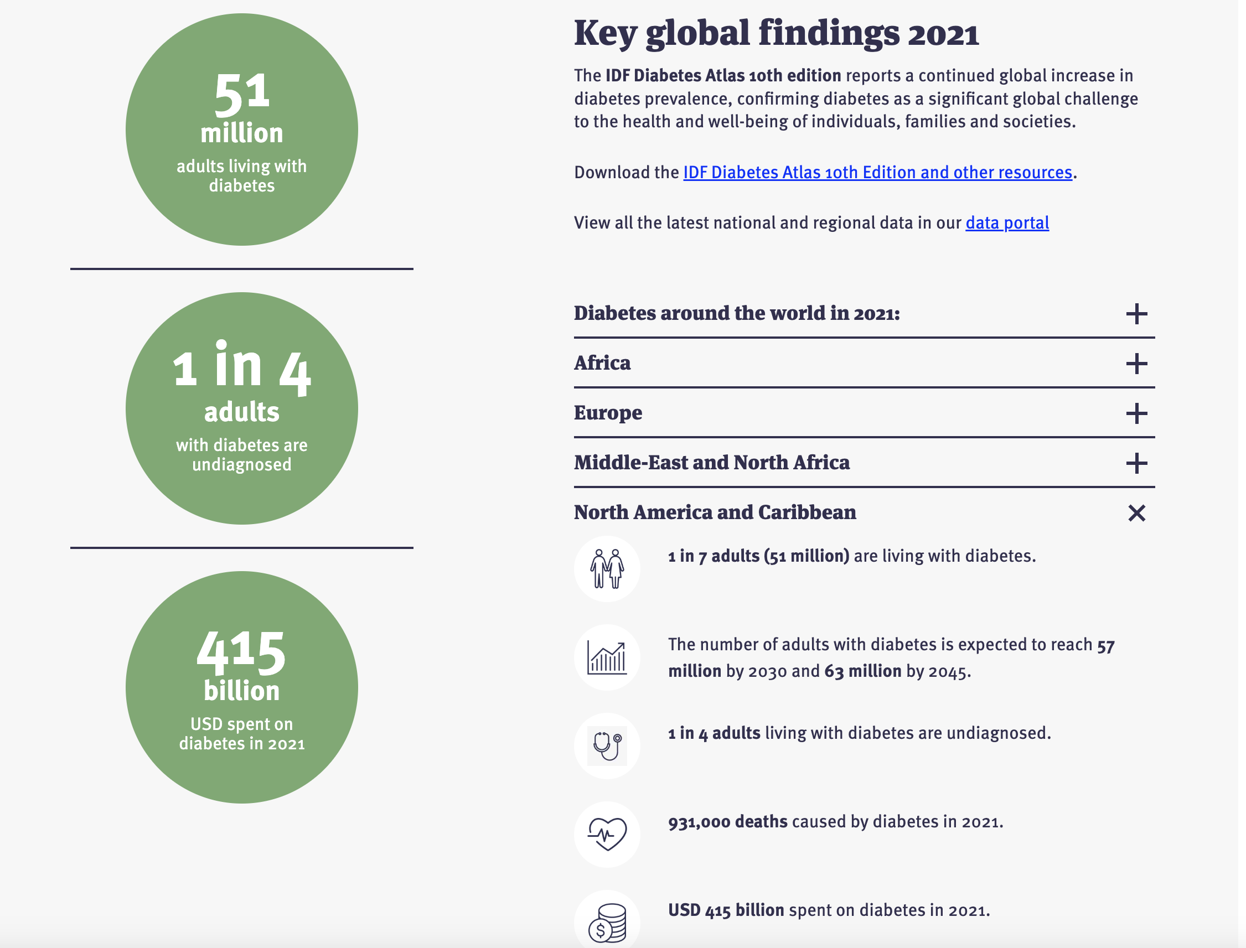

**Technical Implementation**

The application utilizes the following technologies and methodologies:

**AI Model Integration**

* **Nvidia AI Endpoints**: The app employs Nvidia's meta/llama3-70b-instruct model for generating meal plans and grocery lists. This model is accessed through the ChatNVIDIA interface, ensuring high performance and accuracy.

**Streamlit Framework**

The app is built using Streamlit, a powerful framework for creating interactive web applications. Streamlit facilitates user input collection and displays the generated meal plans and grocery lists efficiently.

**Workflow Orchestration**

The application utilizes a graph-based workflow to manage the sequence of operations. The workflow consists of the following nodes:

* **Patient Goal Identification**: Determines whether the patient's goal is to manage diabetes or weight loss.
* **Diabetes Meal Plan Generation**: Creates a meal plan specifically for diabetes management.
* **Weight Loss Meal Plan Generation**: Develops a meal plan tailored for weight loss.
* **Grocery List Generation**: Produces a detailed grocery list based on the selected meal plan.

**Conditional Routing**

The app uses conditional routing to direct the workflow based on the patient's goal. This ensures that the appropriate meal plan generation logic is executed, resulting in accurate and relevant recommendations.

**User Interface**

**Input Forms**

The app provides an intuitive interface where users can input their meal data, sugar data, and patient information. Users also specify their health goal (diabetes or weight loss) to tailor the recommendations.

**Output Display**

Upon submission, the app displays the following:

* **Goal Identification**: Confirms the identified goal (diabetes or weight loss).
* **Meal Plan**: Presents a detailed, weekly meal plan tailored to the user's needs.
* **Grocery List**: Lists the groceries required for the meal plan, including quantities, to facilitate easy shopping.

Here's an extended end-to-end flow for a diabetic/Obesity/Weight Control patient using the health dietitian agent, incorporating meal tracking, sugar monitoring, and dynamic meal plan adjustments:

1. **User Onboarding**: The user downloads the app and provides initial information about their diabetic/Health condition, food preference, and health goals.
2. **Baseline Meal Plan Generation**: The dietitian agent, using its knowledge base and the user's information, generates a baseline meal plan with recipes tailored for managing diabetes/Weight
3. **Meal Logging**: Throughout the day, the user logs their meals by taking photos of the food or selecting from a database of recipes and portion sizes. The agent analyzes the images and logs the nutritional information.
4. **Continuous Glucose Monitoring**: The app integrates with the user's continuous glucose monitoring (CGM) device or a companion app that tracks blood sugar levels from periodic finger-prick tests.
5. **Sugar Level Analysis**: The dietitian agent continuously analyzes the user's glucose data, looking for patterns and deviations from the expected range based on the meal logs.
6. **Dynamic Meal Plan Adjustments**: If the agent detects abnormal sugar levels, it adjusts the meal plan in real-time, suggesting alternative recipes or tweaking portion sizes to better manage the user's glucose levels.
7. **Personalized Recommendations**: Based on the user's preferences, activity levels (integrated from fitness trackers), and medical history, the agent provides personalized recommendations for snacks, exercises, or lifestyle changes to improve diabetes management.
8. **Multi-Modal Interaction**: The user can interact with the agent through voice, text, or by uploading images of food items or ingredients for analysis and recommendations.
9. **Knowledge Grounding**: The agent stays up-to-date by integrating with authoritative sources like diabetes research, clinical guidelines, and nutrition databases, ensuring its recommendations are safe and evidence-based.
10. **Collaboration with Healthcare Team**: Grocery procurement assistant With the user's consent, the agent can share reports and insights with their healthcare team (doctors, dietitians, etc.) for better coordinated care.
11. **Continuous Learning**: The agent learns from the user's feedback, meal logs, and glucose data, refining its understanding of the user's specific needs and improving its recommendation accuracy over time.
12. **Reminders and Alerts**: The app sends reminders for logging meals, taking medications, or scheduling medical appointments, and alerts the user or healthcare team if significant issues are detected (e.g., prolonged high glucose levels).

By leveraging NVIDIA's AI technologies, the LangChain framework, and integrations with various data sources and devices, this solution provides a comprehensive and personalized approach to diabetes management, empowering users with real-time monitoring, dynamic meal planning, and continuous learning for better health outcomes

## Here's an architecture diagram illustrating the flow and components for the diabetic health dietitian agent solution, incorporating LangChain, LangGraph, multi-modal input handling, base model, domain-specific fine-tuning, optimization with TensorRT-LLM, and safety with NeMo Guardrai

## **Note**: Even though the entire Architecture cover is design to with the all the module for a an end to end application , the implementation of the MVP is Limited to Text Based Input/output , Nividia’s End points( Llama3 Model), Lang Chain’s LangGrpah Multiagent Fraework.

**AIDA Future and Conclusion**

The AIDA App harnesses the power of Nvidia's AI models to deliver personalized dietary recommendations and grocery lists, making it a valuable tool for individuals aiming to manage their diabetes or achieve weight loss. Through intelligent analysis and seamless user interaction, the app empowers users to take control of their health with confidence.

The app can be extended by adding additional agents, such as a Personal Trainer, and an Online Ordering and Tracking Agent, to collaborate with the Diet Agent to create a comprehensive healthcare app by extending the LangGraph Agent model. The model can also be fine-tuned using specific patient data and ethnic/location-specific meal requirements using TensorRT LLM to improve accuracy.