Project Task 1: Dashboard

DSC640-T301 Data Presentation & Visualization (2233-1)

Soma Shekar Vayuvegula

01/08/2023

**DASHBOARD SUMMARY**

This dashboard has different visualizations which provide details about the fatalities and incidents which occurred during 1985-1999 and 2000-2014. These visualizations are created from the airline safety datasets.

These visualizations will provide insights to the Internal team and Data Science team to analyze the cause and other details of airline fatalities during 1985-2014 (1985-1999 and 2000-2014). Using these visualizations, the Data Science team can help the Business team in making decisions related to improving airline safety standards and making air travel much safer.

**Visualizations:**

I have used the below color coding in the visualizations to make the analysis easier:

1. Red – Fatalities
2. Orange – Incidents
3. Blue – Revenue generation

I have used below visualizations:

1. Bar Graph – I have mostly used Bar Graphs as they are the most common and easy to understand and make understanding easier for the audience.
2. Line Graph – I have used a Line graph to show information that changes over time.
3. Map – To show data per country, I have chosen Map.
4. **Airlines vs Fatalities:**

This visualization is plotted Airlines vs Fatalities (1985-1999 and 2000-2014). This visualization is as to which Airline had the most fatalities during the late 90s and early 2000s. This will help us analyze which airline has improved on its safety standards.

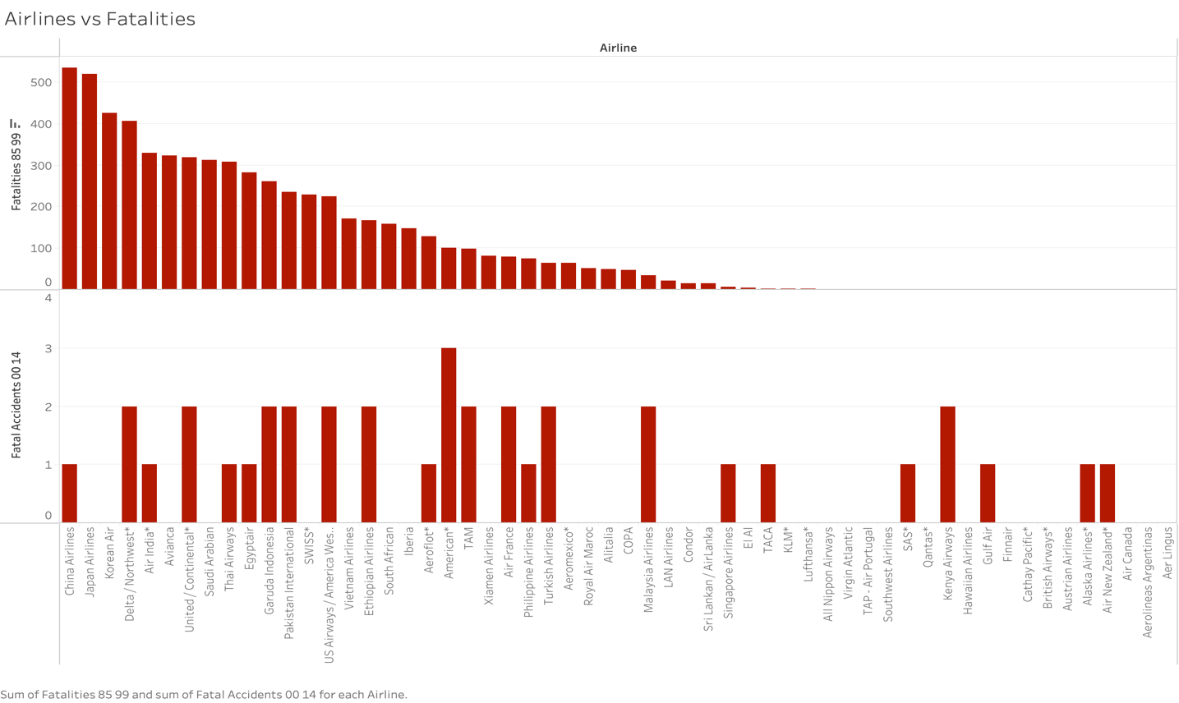

1. **Fatalities by Year**

This visualization will provide details about fatalities per year. This will help us analyze the reason behind the spike the fatalities compared to the earlier year.

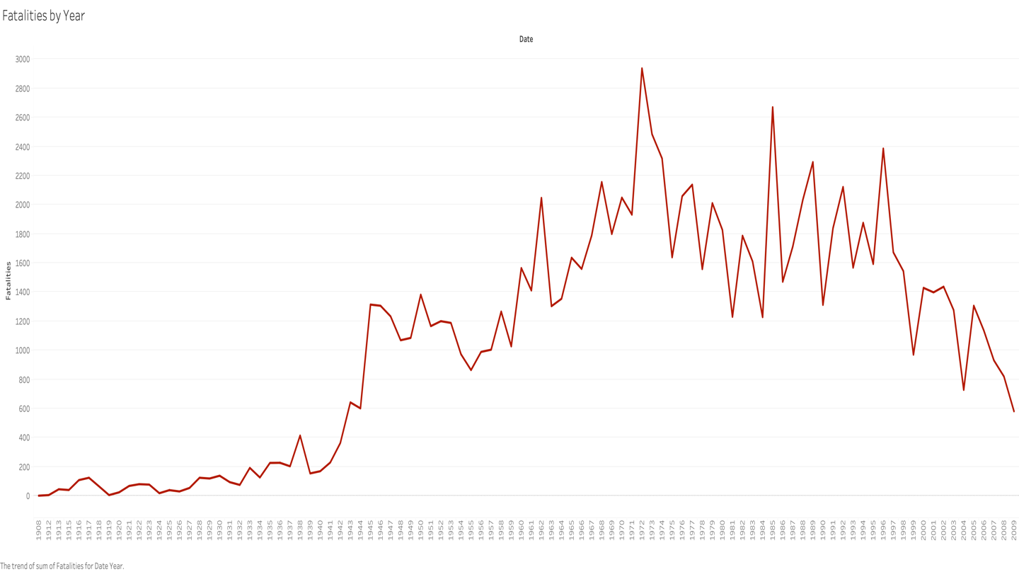

1. **Fatalities by Country:**

This visualization will provide details about fatalities by country. This helps us analyze which country has the most fatalities and least fatalities. Countries can analyze the measures taken by the country with the least fatalities.

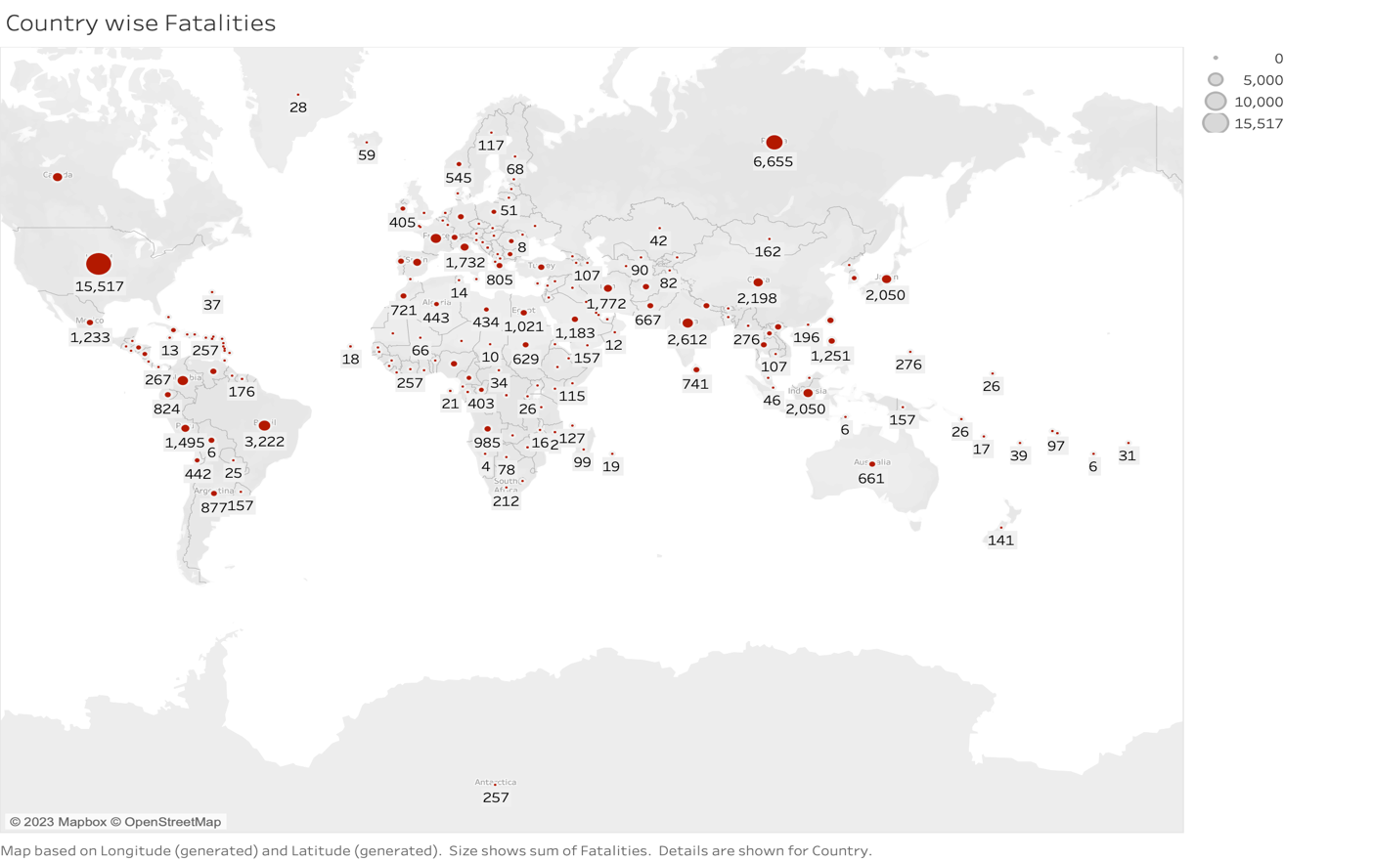

1. **Fatal Accidents and Incidents by Airline during 2000-2014 by Airline:**

This visualization provides a comparison between incidents and fatal accidents during 2000-2014. This will help us analyze how bad the incident was.

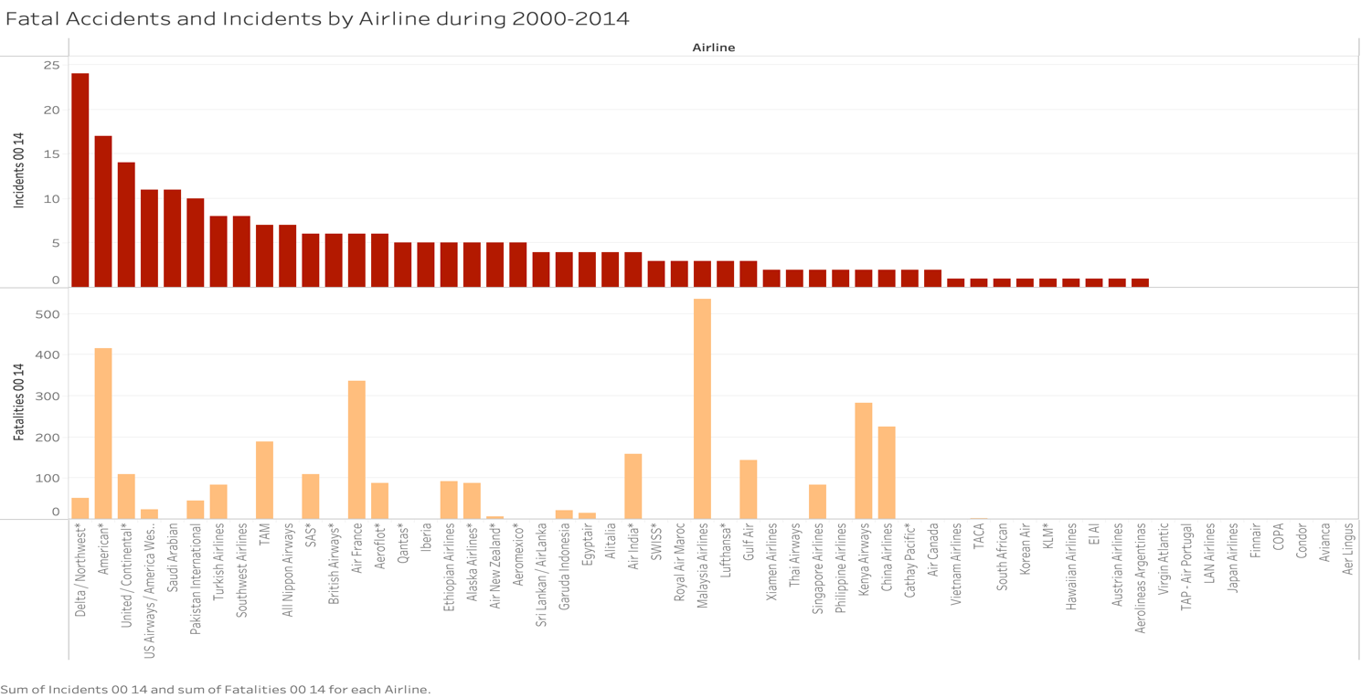

1. **Fatal Accidents and Incidents by Airline during 1985-1999 by Airline:**

This visualization provides a comparison between incidents and fatal accidents during 2000-2014. This will help us analyze how bad the incident was.

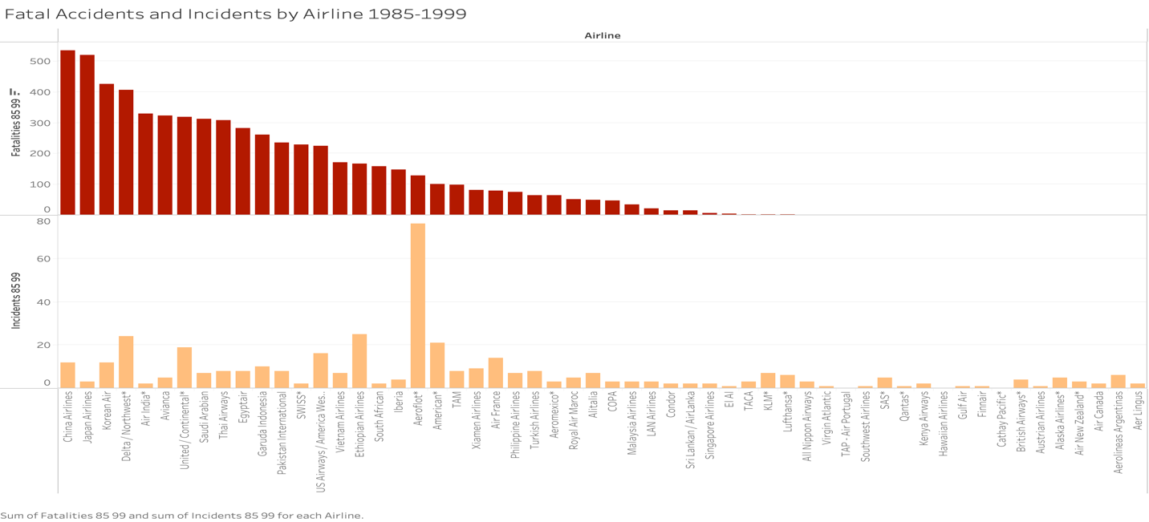

1. **Available Seat Kilometers per week By Airline:**

This visualization shows seats available per kilometer flown per week by Airline. This visualization is very important for revenue generation.

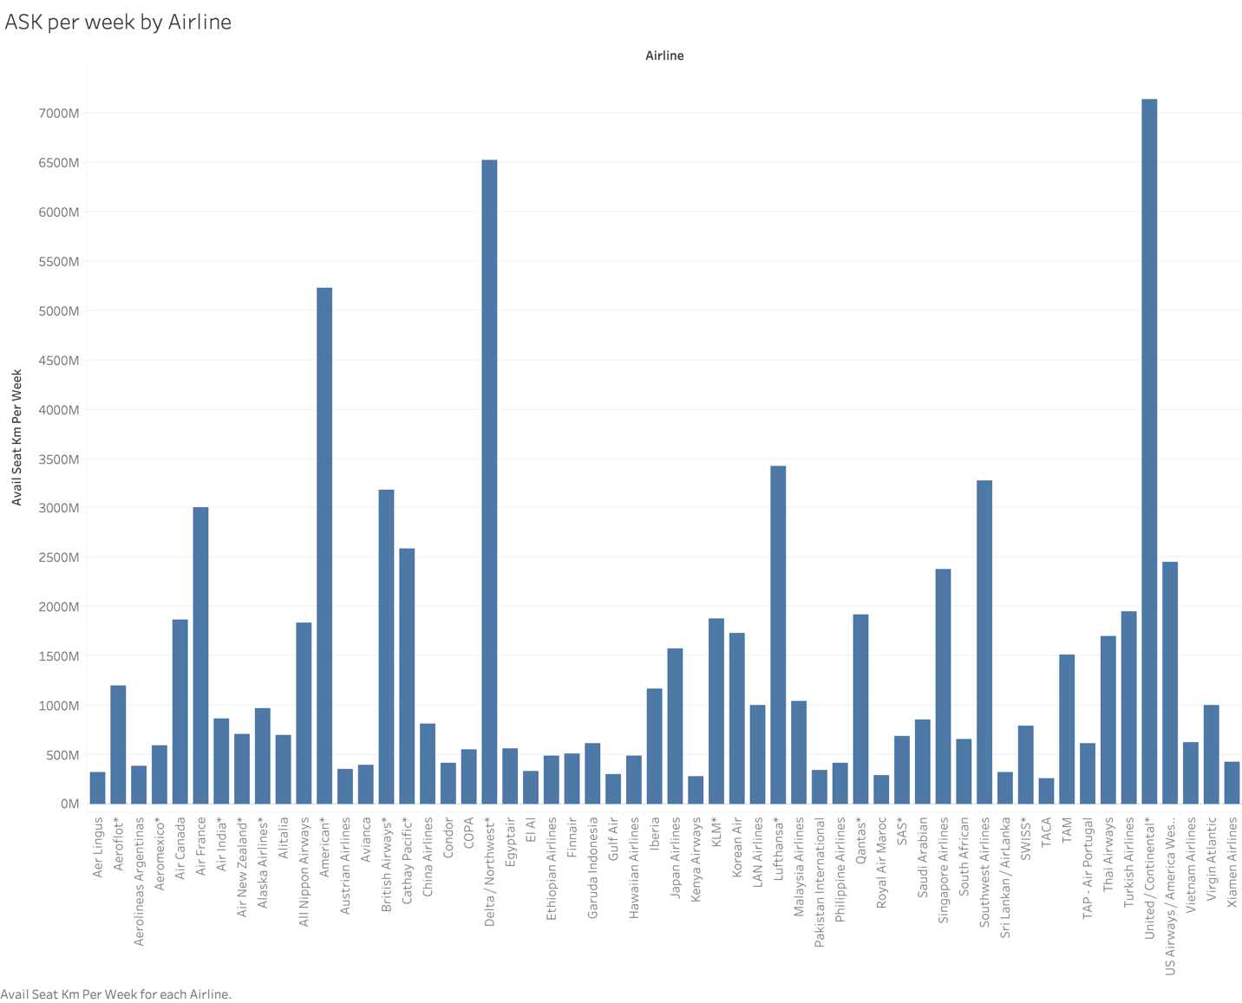

**Ethical Implications:**

1. Data accuracy is a very important implication as we are not sure if the data is accurate as this data is sourced from a public website and not airline related website.
2. We are not sure if the data per airline per year provided is accurate and not sure if all the fatalities have been reported in the dataset.
3. Analysis can go wrong if a major incident has not been reported in the dataset as we are unsure if the dataset is accurate and complete.