|  |  |
| --- | --- |
| Executive summary  Recommendations to avoid Airline fatalities | Abstract  I am hereby presenting summary to the leadership with recommendations to avaoid airline fatalities  Soma Shekar Vayuvegula |

**Recommendations to avoid airline fatalities**

**Dashboard:**

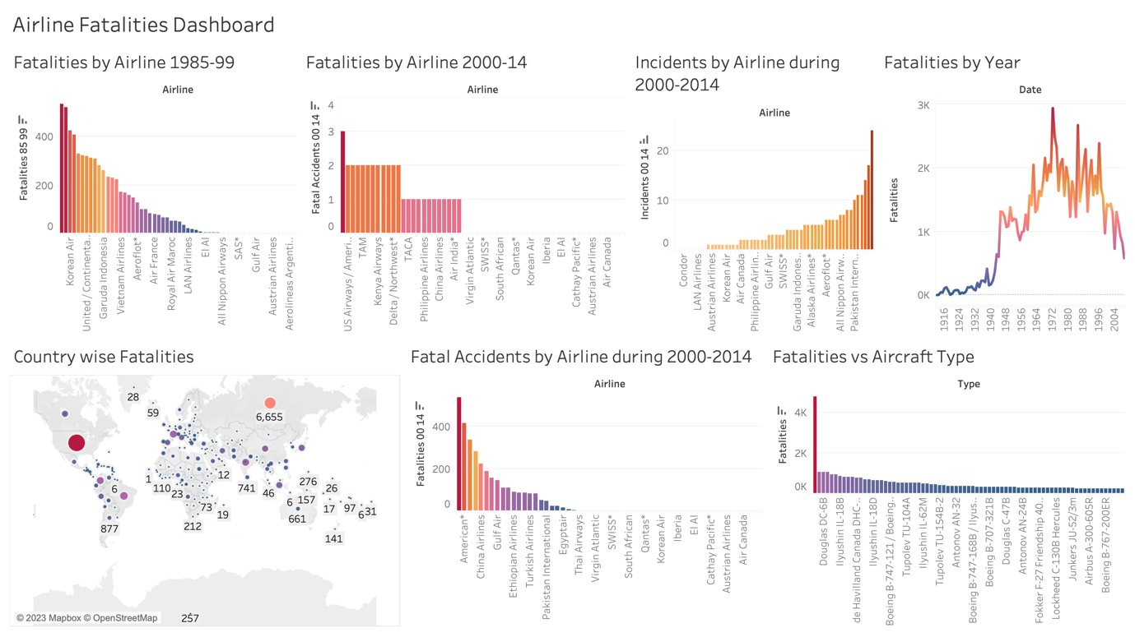

**Plan and Findings:**

I have used Tableau to create the visualizations for the Airline Fatalities dashboard. My goal on this dashboard is to give recommendations to airlines to avoid fatalities.

As part of this summary, I have included six visualizations. After analyzing the visualizations, below are my recommendations to reduce the fatalities:

1. From the first and second charts, we can observe the relationship between fatalities type and airlines. From the charts, we can find the Fatalities during 2000-14 reduced compared to 1985-99. Fatalities during 1985-99 are very high. Thus, we can recommend that airlines enhance their safety procedures to reduce the fatality rate.
2. From the number of incidents vs. airline chart, it's clearly shown that Delta/Northwest airlines have way higher incidents than others. We can ask the third-party agency to audit the airline maintenance and operations of the top 10 airlines and list the reasons behind these incidents. Once the causes are known, we can prepare steps to improve safety and ask all the airlines to implement them without fail.
3. In the Fatalities by Year chart, it is evident that the fatalities have reduced in recent years, which can be due to advancements in technologies implemented in aircraft manufacturing and operations. Further implementation of the latest technologies can reduce the fatalities and bring down the numbers further.
4. The Country-wise Fatalities chart shows the relationship between the countries and the number of fatalities. Most of the fatalities occur in the USA and Russia. The main reason behind this is the air traffic and the country's area. However, this can not be a reason to have a higher number of fatalities. We need to investigate the reason behind these fatalities and implement the recommendations provided after the investigation.
5. From the Fatal Accidents by Airlines chart, we can see that American airlines have the most number of fatal accidents. We need an investigation to be done on American Airlines and find out the reasons behind those accidents. Once the investigation report is provided, we must deliver upgraded safety measures to all airlines.
6. From Fatalities by Aircraft Type, We should ask aircraft design experts to conduct design reviews on the Douglas Dc-3 aircraft as it has way higher fatalities than other aircraft.

**Ethical Considerations:**

The important thing which needs to consider is that the data we have is almost a decade old, if we can get the latest data, we might have a different analysis depending on the fatalities over this decade.

We can not trust this data as this is not provided by Aviation agencies and this is from a public website.

The last thing to consider is that the data reported by Airlines or other companies might not be accurate and there is no way to validate that the reported fatalities or incidents are accurate.