**Introduction:**

        Due to globalization and outspread of internet services and multiple search engines, people are getting to know the world much better and showing interest in visiting different countries and learning about other cultures as part of this air travel has gained prominence.

        Not just international travel, air travel is being used a lot for domestic travel, so save travel time and use it in a better way.

        When air travel has increased, airline or aircraft safety is of utmost importance to save the lives of people using airlines for their travel needs. Airlines and Air traffic authorities must revisit their safety features every year or so and make safety features upgradation to make air travel safe.

        Depending on the data available from 1985-2004, this blog details airline crashes and how to make air travel safe.

**Fatalities per country:**

[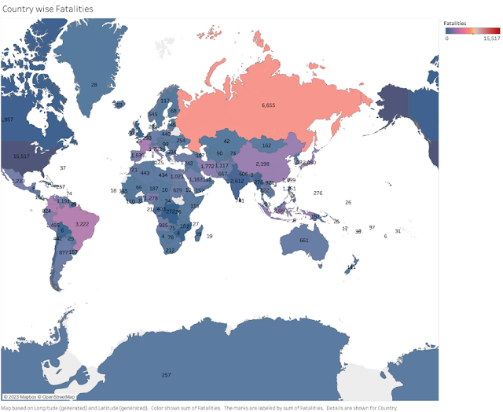](NULL)

    The above visualization shows that more crashes are taking place in developed countries. This can be mainly due to heavy air traffic. To avoid crashes, we need to plan our travel in such a way that we travel off-peak hours and off-season.

**Fatalities per year:**

[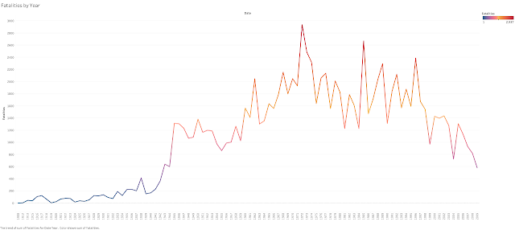](NULL)

    The above visualization shows that air crashes were at their worst during 1972. However, the situation has improved due to the implementation of technology in air traffic controls and aircraft manufacturing. This a promising sign for passengers to have a safe flight.

**Fatalities and Incidents per Airline:**

](NULL)

    This visualization is a combination of different plots which indicate fatalities and incidents from 1985 - 2004. This needs to give us a clearer picture of which airline has issues with the safety standard. With this, we can't say which airline to avoid. We need to check the airline website before we book to understand the safety measures undertaken by the airline.

**Fatalities by Aircraft Type:**

[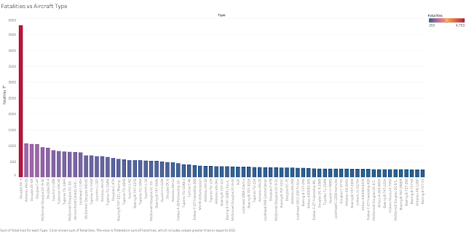](NULL)

The above visualization shows the aircraft which has more crashes. This shows Douglas Dc-3 has more fatalities than others. When booking an airline ticket, you must check the aircraft type. If the airline is not providing the details during booking, you can always check the previous day's route arrivals for that airline to get the details :D.

**Sources:**

Airline Safety:[https://github.com/fivethirtyeight/data/tree/master/airline-safety](NULL)

Air crashes since 1908: [https://www.kaggle.com/datasets/saurograndi/airplane-crashes-since-1908](NULL)

**Note:**As we have sourced data from the above public sites, we can not confirm that this data is accurate and current.