ASSIGNMENT 4

Soma Shekar Vayuvegula

2022-07-14

# Markdown Basics

## Favorite Foods

1. Biryani
2. Kulfi
3. Rosagolla

## Images

image: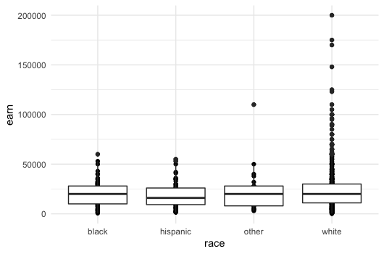

## Add a Quote

You must be the change you wish to see in the world

## Add an Equation

$${\left(a+b\right)}^{2}=a^{2}+b^{2}+2ab$$

## Add a Footnote

Woolf, "Modern Fiction," 11 [^1]

## Add Citations

* R for Everyone (Lander 2014)
* Discovering Statistics Using R (Field, Miles, and Field 2012)

# Inline Code

library(ggplot2)  
theme_set(theme_minimal())  
covid_df <- read.csv("/Users/somashekarvayuvegula/Documents/Workspace/dsc520/data/nytimes/covid-19-data/us-states.csv")  
heights_df <- read.csv("/Users/somashekarvayuvegula/Documents/Workspace/dsc520/data/r4ds/heights.csv")  
ggplot(heights_df, aes(x=sex, y=earn)) + geom_point()+ geom_boxplot()

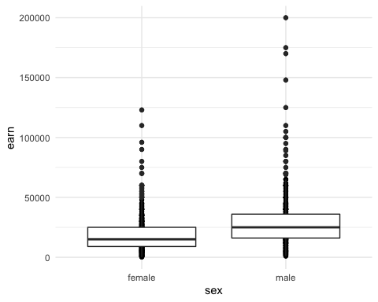

covid_df <- read.csv("/Users/somashekarvayuvegula/Documents/Workspace/dsc520/data/nytimes/covid-19-data/us-states.csv")  
covid_df$date <- as.Date(covid_df$date)  
california_df <- covid_df[ which( covid_df$state == "California"), ]  
ny_df <- covid_df[ which( covid_df$state == "New York"), ]  
florida_df <- covid_df[ which( covid_df$state == "Florida"), ]

## NY Times COVID-19 Data

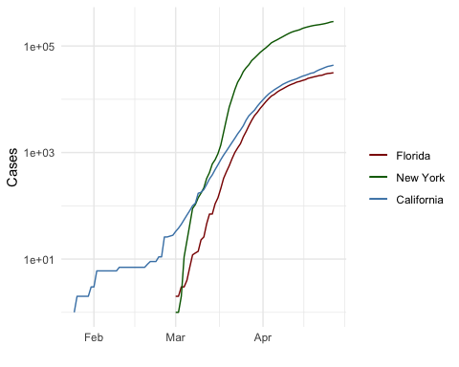

## R4DS Height vs Earnings

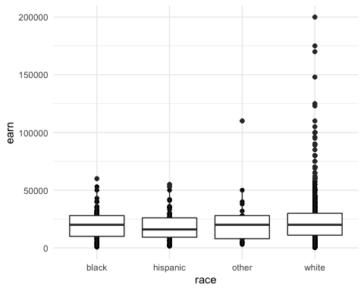

# Tables

## Knitr Table with Kable

One Ring to Rule Them All

| name | race | in_fellowship | ring_bearer | age |
| --- | --- | --- | --- | --- |
| Aragon | Men | TRUE | FALSE | 88 |
| Bilbo | Hobbit | FALSE | TRUE | 129 |
| Frodo | Hobbit | TRUE | TRUE | 51 |
| Galadriel | Elf | FALSE | FALSE | 7000 |
| Sam | Hobbit | TRUE | TRUE | 36 |
| Gandalf | Maia | TRUE | TRUE | 2019 |
| Legolas | Elf | TRUE | FALSE | 2931 |
| Sauron | Maia | FALSE | TRUE | 7052 |
| Gollum | Hobbit | FALSE | TRUE | 589 |

## Pandoc Table

##   
## Attaching package: 'pander'

## The following object is masked from 'package:latexpdf':  
##   
## wrap

##   
## --------------------------------------------------------------  
## Name Race In Fellowship? Is Ring Bearer? Age   
## ----------- -------- ---------------- ----------------- ------  
## Aragon Men TRUE FALSE 88   
##   
## Bilbo Hobbit FALSE TRUE 129   
##   
## Frodo Hobbit TRUE TRUE 51   
##   
## Galadriel Elf FALSE FALSE 7000   
##   
## Sam Hobbit TRUE TRUE 36   
##   
## Gandalf Maia TRUE TRUE 2019   
##   
## Legolas Elf TRUE FALSE 2931   
##   
## Sauron Maia FALSE TRUE 7052   
##   
## Gollum Hobbit FALSE TRUE 589   
## --------------------------------------------------------------  
##   
## Table: One Ring to Rule Them All

# References

Field, A., J. Miles, and Z. Field. 2012. *Discovering Statistics Using r*. SAGE Publications. <https://books.google.com/books?id=wd2K2zC3swIC>.

Lander, J. P. 2014. *R for Everyone: Advanced Analytics and Graphics*. Addison-Wesley Data and Analytics Series. Addison-Wesley. <https://books.google.com/books?id=3eBVAgAAQBAJ>.