EXPERIMENT – 5
AIM:
Create a simple cloud software application for Library book reservation system for SIMATS library using any Cloud Service Provider to demonstrate SaaS.
PROCEDURE:
- The previously created SIMATS Library Book Reservation System is accessed through a web browser.
- The Book Details, Student Details, and Book Reservation modules are integrated to support the reservation process.
- Lookup fields are configured to link student details with book details during reservation.
- Dropdown fields are used to select book category, department, and reservation status to ensure data consistency.
- The reservation process allows students to select an available book and submit a reservation request.
- The system updates the reservation status and stores the transaction details securely in the cloud.
- Authorized users such as librarians can view, update, or manage reservations through the same cloud application.
- The complete reservation workflow is executed without installing any local software, demonstrating the SaaS model.

RESULTS:
1. 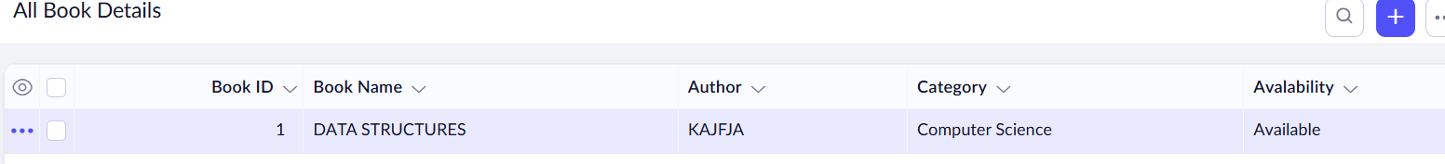
2.
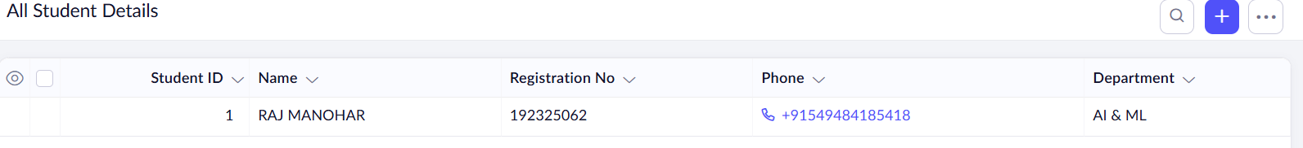
3.
