Assessment 2
LearningApps Activity Report
Pairing Game & Word Grid (Machine Learning)

Activity 1: Pairing Game

1. General Information
Student Name | K. Saisomasekhar reddy
Register Number | 192324134
Department | CSE (AI&DS)
Course Code & Name | CSA4708 -  DEEP LEARNING
Activity Name | Pairing Game (Learning Apps)
Date of Completion | 16/10/2026

2. Activity Description
- Title: Machine Learning Pairing Game (LearningApps)
- Objective: To reinforce understanding of core machine learning terms by matching each concept with its correct definition.
- Concepts covered: Supervised Learning, Unsupervised Learning, Reinforcement Learning, Classification, Regression, Clustering, Overfitting, Underfitting, Feature Selection and Hyperparameter Tuning.
- Description: The game shows a grid of 20 cards: 10 machine learning terms and 10 matching descriptions. The learner flips two cards at a time; if the term and description belong together, the pair stays matched, otherwise the cards turn back. A turn counter records the number of attempts.
- Rules and instructions followed: Select two cards per turn; match each term with its definition (for example, Regression with 'Predicts continuous numerical values'); continue until all cards are matched. The aim is to finish in as few turns as possible.

3. Procedure
- Opened the Google Classroom (GCR) assignment and clicked the LearningApps PairingGame link.
- Read the instructions and started the game; the turn counter began at 0.
- Flipped two cards at a time and checked whether they formed a correct term-definition pair.
- Continued until every pair was matched. The game finished with 59 turns.
Matching process used: I matched terms to definitions using their meaning, for example
Classification with 'Predicts categories or classes', Clustering with 'Groups similar data points', Overfitting with 'Performs well on training data but poorly on new data', and Hyperparameter Tuning with 'Adjusts model settings before training'. I also remembered the card positions seen in earlier turns to avoid repeated mistakes.
Challenges faced and how they were resolved: [Edit to your real experience. Example: remembering card positions and telling apart similar pairs such as Supervised vs Unsupervised Learning, and Overfitting vs Underfitting. I resolved this by recalling each concept's definition and noting card positions.]

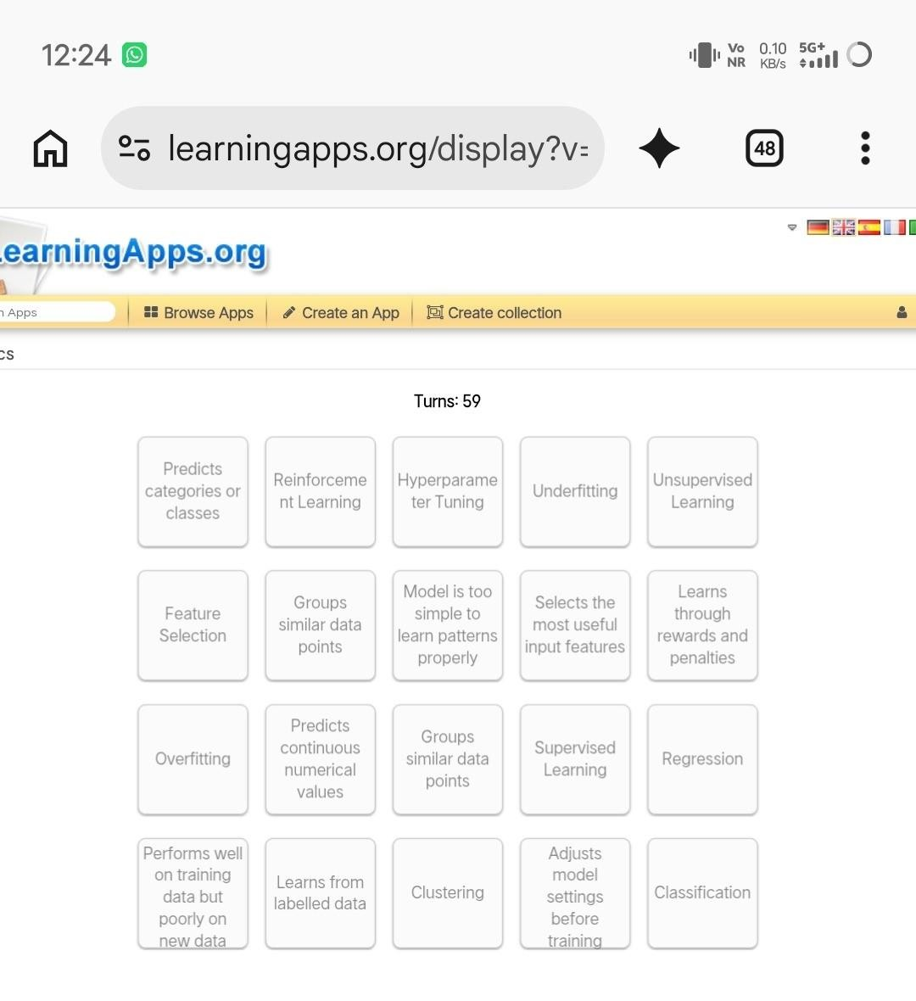
4
. Evidence of Completion

Figure 1: Completed Pairing Game (all pairs matched, Turns: 59)

Activity 2: Word Grid

1. General Information
Student Name | [Your Name]
Register Number | [Your Register No.]
Department and Year | [Department, Year]
Course Code & Name | [Course Code - Course Name]
Activity Name | Word Grid (LearningApps)
Date of Completion | [DD/MM/YYYY]

2. Activity Description
- Title: Machine Learning Word Find
- Objective: To recognise and recall machine learning vocabulary by locating hidden words in a letter grid using the clues provided.
- Concepts covered: Supervised, Unsupervised, Machine Learning, Image Recognition, Classification, Regression, Training, Speech Recognition, Text Recognition and Forecast Outcomes.
- Description: A grid of letters hides 10 machine learning terms. A numbered clue list on the right gives a short hint for each word (for example, 'how ai learns' for Machine Learning and 'pictures' for Image Recognition). Words found are highlighted in green.
- Rules and instructions followed: Words are written without spaces and can run horizontally or vertically; select the first and last letters of a word to mark it; use the clues to find all the words.

3. Procedure
- Opened the Google Classroom (GCR) assignment and clicked the LearningApps Word
Gridlink.
- Read the numbered clues on the right side of the grid.
- Searched the grid for each word and selected it from its first letter to its last letter.
- Scrolled down to confirm that all the words were highlighted in green.
Word identification process used: I read each clue, guessed the term, then scanned the rows for its first letter. Long words such as UNSUPERVISED, IMAGERECOGNITION, SPEECHRECOGNITION and TEXTRECOGNITION were easiest to spot by looking for repeated letter patterns, and I confirmed each word letter by letter before selecting it.
Challenges faced and how they were resolved: [Edit to your real experience. Example: the terms are written without spaces and several share the ending RECOGNITION, which made them easy to confuse; I resolved this by using the clues and checking each row carefully. Long
words were cut off in the clue list on a phone screen, so I scrolled.]

4. Evidence of Completion
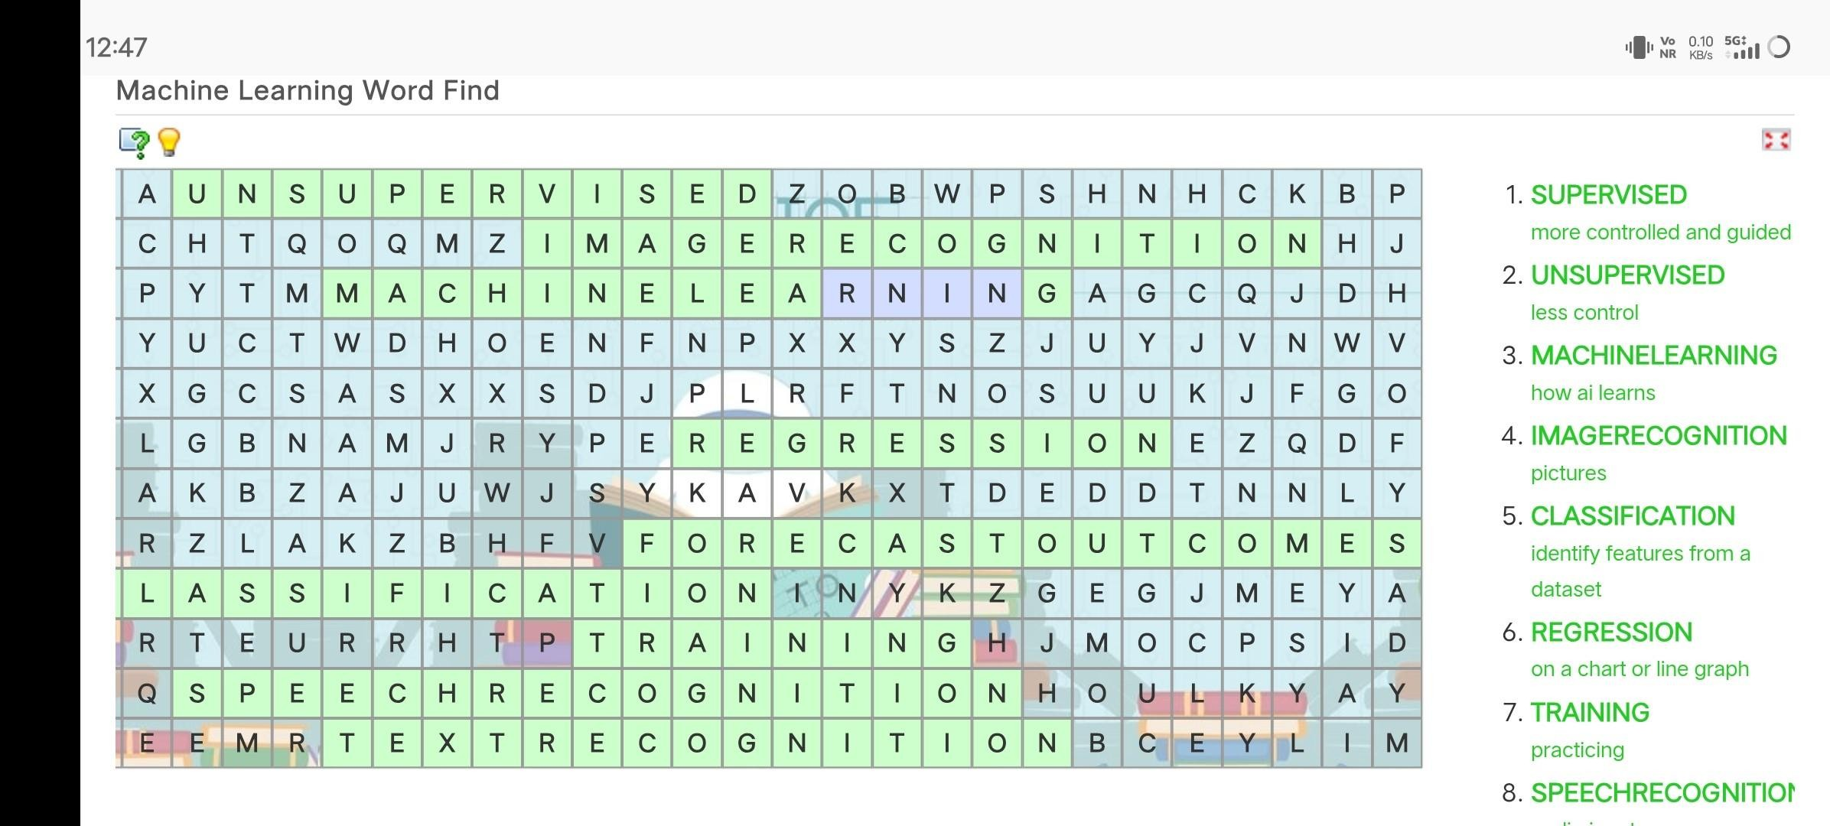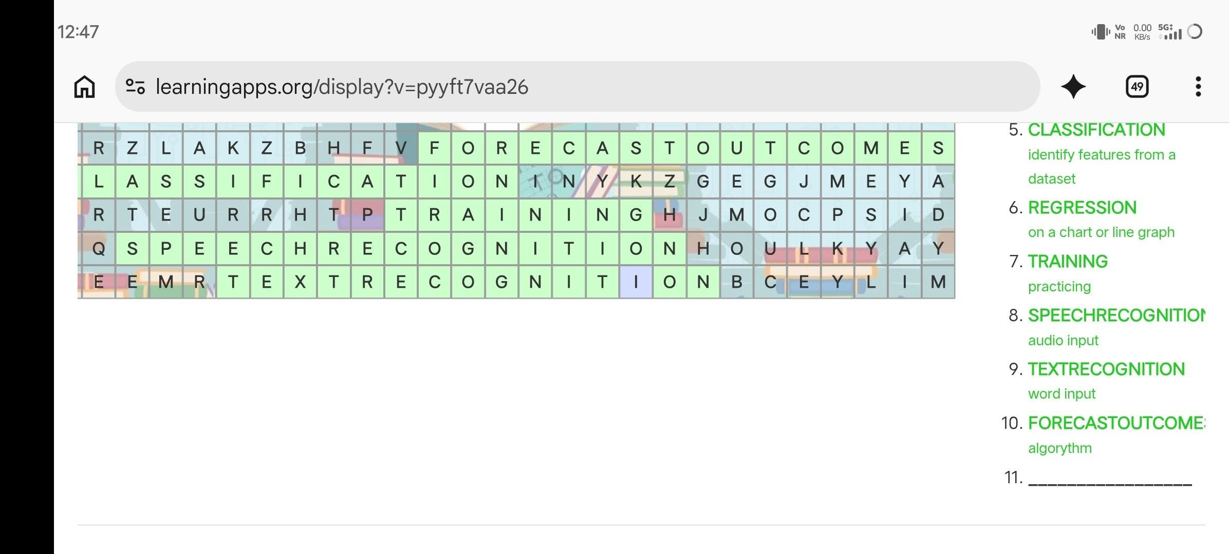

Figure 2: Word Grid with the found words highlighted in green (top of the grid and clues 1
-
8)

Figure 3: Completed Word Grid, lower part of the grid and remaining clues (5-10)

5. Conclusion
- Summary of the learning experience: Completing the Pairing Game and the Machine Learning Word Find made revision of basic machine learning terms active and enjoyable.
Immediate feedback in both activities helped me spot and correct mistakes.
- Knowledge gained: A clearer understanding of the difference between supervised, unsupervised and reinforcement learning; classification versus regression; overfitting versus underfitting; and applications such as image, speech and text recognition.
- Skills gained: Memory and recall, pattern recognition, attention to detail, and confidence in using an online learning platform through Google Classroom.
- Overall reflection: The activities are useful for self-paced revision because they turn passive reading into practice and reinforce terminology. I would use similar interactive activities to prepare for tests.

