ASSESSMENT-3
Machine Learning Basics – Millionaire Game & Cloze Text
Learning Apps Activity Report
1. General Information
Student Name | K. Saisomasekhar Reddy
Register Number | 192324134
Department and Year | CSE(AI&DS)
Course Code & Name | CSA4708-DEP LEARNING
Activity Name | Machine Learning Basics – Millionaire  Game & Cloze Text
Date of Completion | 23/10/24
2. Activity Description

Activity 1: Machine Learning Basics – Millionaire Game
Objective: To revise and strengthen understanding of fundamental machine learning concepts through a question-and-answer game.
Concepts covered: Basic machine learning terminology, model training, data, algorithms, prediction, and evaluation concepts relevant to the questions presented in the game.
Brief description: The Millionaire Game presents questions with answer choices. The learner reads each question, selects the most appropriate answer, and uses the feedback to check understanding.
Rules and instructions followed: Read each question carefully, review the available options, select the best answer, and continue through the activity while checking the feedback.

Activity 2: Machine Learning Basics – Cloze Text
Objective: To identify and place the correct machine learning terms in sentences about neural networks and their operation.
Concepts covered: Feedforward networks, XOR and linear separability, multilayer perceptrons (MLPs), ReLU, Softmax, mean squared error (MSE), backpropagation, learning rate, the Universal Approximation Theorem, and forward propagation.
Brief description: The Cloze Text activity contains sentences with missing words. The learner chooses the correct term for each blank to complete the statements.
Rules and instructions followed: Read each statement, identify the concept being described, select the matching word, and review the completed sentences.
3. Procedure

Steps followed
- Opened the Learning Apps activity links provided in the assessment instructions.
- Read the instructions displayed for each activity.
- Completed the Millionaire Game by answering the questions and checking the feedback.
- Completed the Cloze Text by matching each blank with the appropriate machine learning term.
- Reviewed the completed sentences and captured a screenshot as evidence.

Matching and word-identification process
For the Millionaire Game, each question was considered individually and the answer was chosen based on the relevant machine learning concept. For the Cloze Text, the meaning of each sentence was used to identify the missing term. For example, a deep feedforward network passes information in the forward direction, ReLU converts negative inputs to zero, and backpropagation calculates gradients of the loss with respect to network weights.

Challenges faced and how they were resolved
Some terms may be similar or unfamiliar at first. This was addressed by reading the full sentence, connecting it to the relevant machine learning concept, and checking that the selected term made the statement meaningful.

Evidence of Completion
The screenshot below shows the completed Cloze Text activity. The supplied images do not include a completion screenshot for the Millionaire Game; insert that screenshot here before submitting if it is required by your instructor.
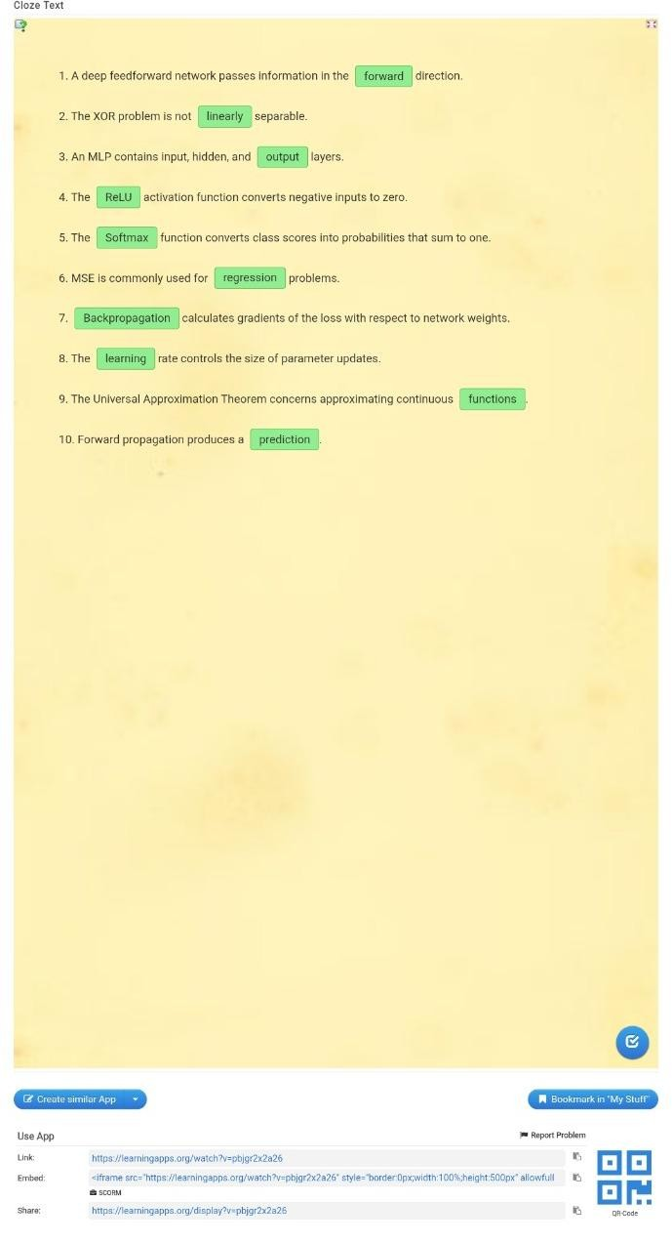
Figure 1. Completed Machine Learning Basics – Cloze Text activity.

Results
The Machine Learning Basics activities helped reinforce important concepts related to machine learning and neural networks through interactive learning. The Millionaire Game provided an opportunity to test conceptual knowledge by answering questions, while the Cloze Text activity helped identify and apply the correct technical terms in the given statements.
In the Cloze Text activity, all ten blanks were completed with the appropriate terms:
- Forward: A deep feedforward neural network passes information in the forward direction, from the input layer toward the output layer.
- Linearly: The XOR problem is not linearly separable, meaning it cannot be solved using a single linear decision boundary.
- Output: A Multilayer Perceptron (MLP) consists of input, hidden, and output layers.
- ReLU: The Rectified Linear Unit (ReLU) activation function converts negative input values to zero while retaining positive values.
- Softmax: The Softmax function converts class scores into probabilities that sum to one, making it useful for multiclass classification.
- Regression: Mean Squared Error (MSE) is commonly used as a loss function for regression problems by calculating the average squared difference between actual and predicted values.
- Backpropagation: Backpropagation calculates gradients of the loss with respect network weights, helping the model learn during training.
- Learning: The learning rate determines the size of parameter updates during model training.
- Functions: The Universal Approximation Theorem explains the ability of suitable neural networks to approximate continuous functions under appropriate conditions.
- Prediction: Forward propagation processes input data through the network to produce an output or prediction.
The completed Cloze Text screenshot confirms that all ten answers were filled in. These results demonstrate an improved understanding of neural network architecture, activation functions, loss functions, and the learning process. The Millionaire Game results should also be recorded separately if a score or completion screen is available.

Conclusion
The Machine Learning Basics activities provided a useful opportunity to understand and revise fundamental concepts in machine learning through interactive exercises. The Millionaire Game encouraged logical thinking, quick decision-making, and the application of theoretical knowledge to questions. The Cloze Text activity strengthened the ability to recognize technical terms and understand their meanings in the context of neural networks.
Through these activities, I gained a clearer understanding of the structure of a Multilayer Perceptron, the role of activation functions such as ReLU and Softmax, and the importance of loss functions such as Mean Squared Error. I also learned how backpropagation calculates gradients, how the learning rate influences parameter updates, and how forward propagation generates predictions.
Furthermore, the activities helped me distinguish between concepts such as classification and regression and understand why the XOR problem cannot be solved using a single linear decision boundary. These concepts form an important foundation for studying more advanced machine learning algorithms and deep learning models.
Overall, the activities made learning more engaging and helped reinforce theoretical knowledge through practice. They also highlighted the importance of understanding the purpose of each component in a neural network rather than simply memorizing definitions. This knowledge will be useful in future coursework, practical machine learning implementations, and AI-related projects.

