CO1 – LAB EXPERIMENTS

NAME: K.SAISOMASEKHAR REDDY
REG NO: 192324134

COURSE CODE &NAME: CSA4708 – DEEP LEARNING
Question 1: Student Performance Prediction

Objective
Compare full-batch Gradient Descent with single-example SGD when predicting examination scores from two input features. Store the epoch losses with NumPy and plot both curves.

Code
import numpy as np
import tensorflow as tf
import matplotlib.pyplot as plt
from tensorflow import keras
from tensorflow.keras import layers

SEED = 42
np.random.seed(SEED)
tf.random.set_seed(SEED)

def make_regression_data(n=1200, seed=SEED):
rng = np.random.default_rng(seed)
X = rng.normal(size=(n, 2)).astype("float32")
y = (3.0*X[:, 0] + 1.7*X[:, 1] + 0.8 +
rng.normal(scale=0.15, size=n)).astype("float32")
return X, y

def split_data(X, y):
cut = int(0.8 * len(X))
return X[:cut], y[:cut], X[cut:], y[cut:]

def regression_model(input_dim, optimizer):
model = keras.Sequential([
layers.Input(shape=(input_dim,)),
layers.Dense(32, activation="relu"),
layers.Dense(16, activation="relu"),
layers.Dense(1)
])
model.compile(optimizer=optimizer, loss="mse", metrics=["mae"])
return model

def plot_loss(loss_dict, title, filename):
plt.figure(figsize=(7, 4))
for label, values in loss_dict.items():
plt.plot(np.arange(1, len(values)+1), values, label=label)
plt.xlabel("Epoch")
plt.ylabel("Loss")
plt.title(title)
plt.grid(True, alpha=0.3)
plt.legend()
plt.tight_layout()
plt.savefig(filename, dpi=150)
plt.show()

# Synthetic student-style data (replace with actual attendance/marks data if available)
X, y = make_regression_data()
X_train, y_train, X_val, y_val = split_data(X, y)
losses = {}

settings = [
("Gradient Descent (full batch)", 0.03, len(X_train)),
("SGD (single example)", 0.003, 1)
]
for name, lr, batch_size in settings:
tf.keras.backend.clear_session()
tf.random.set_seed(SEED)
model = regression_model(X.shape[1],
keras.optimizers.SGD(learning_rate=lr))
history = model.fit(X_train, y_train, validation_data=(X_val, y_val),
epochs=30, batch_size=batch_size, verbose=0)
losses[name] = np.asarray(history.history["loss"], dtype=np.float32)
print(name, "final loss =", round(float(losses[name][-1]), 4))

plot_loss(losses, "Q1: Gradient Descent vs SGD", "q1_student_loss.png")

Expected output
Expected output format: prints the final training loss for both methods and opens a loss plot. Full-batch Gradient Descent often looks smoother; SGD often fluctuates more. Exact numbers are produced by your run.

Loss-curve image
Illustrative curve only: this image shows the general pattern discussed in the analysis. Run the code above to generate the actual output for your experiment.
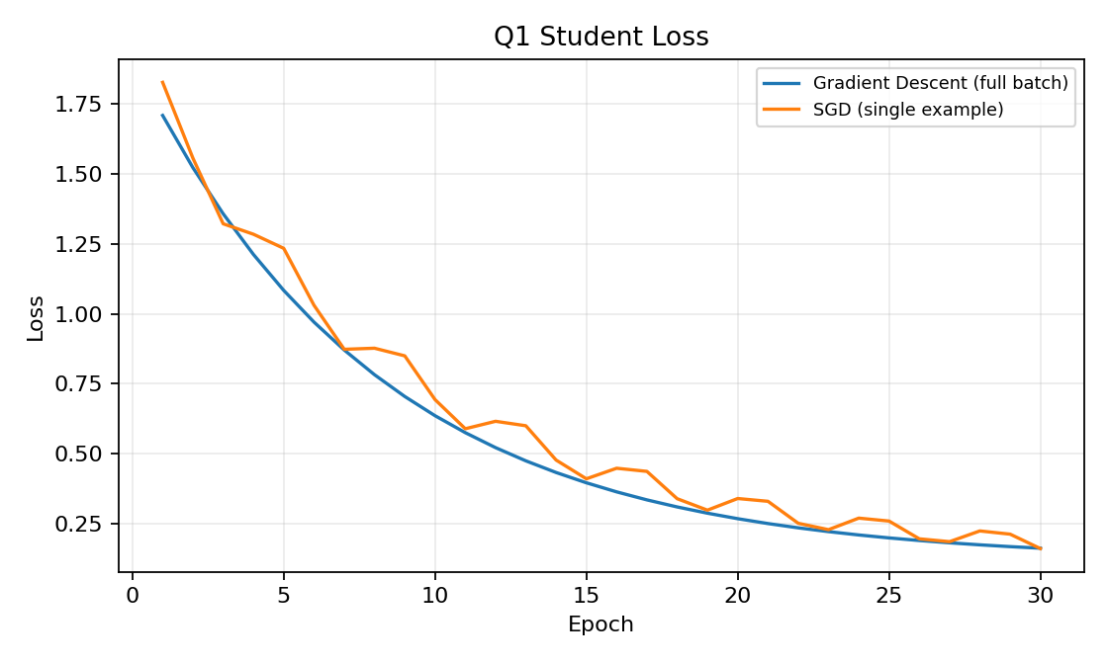

Analysis and conclusion
- Full-batch Gradient Descent calculates each update using all training examples, so its gradient estimate usually has lower variance. It performs fewer updates per epoch.
- SGD updates from one example at a time, making more frequent but noisier updates. Learning rate, batch size, data scaling, and the loss surface affect convergence.
- Compare the actual curves and final losses; do not assume a winner from curve smoothness alone.

Question 2: House Price Prediction

Objective
Compare SGD learning rates and identify a balance between fast loss reduction and stable convergence.

Code
import numpy as np
import tensorflow as tf
import matplotlib.pyplot as plt
from tensorflow import keras
from tensorflow.keras import layers

SEED = 42
np.random.seed(SEED)
tf.random.set_seed(SEED)

def make_regression_data(n=1200, seed=SEED):
rng = np.random.default_rng(seed)
X = rng.normal(size=(n, 2)).astype("float32")
y = (3.0*X[:, 0] + 1.7*X[:, 1] + 0.8 +
rng.normal(scale=0.15, size=n)).astype("float32")
return X, y

def split_data(X, y):
cut = int(0.8 * len(X))
return X[:cut], y[:cut], X[cut:], y[cut:]

def regression_model(input_dim, optimizer):
model = keras.Sequential([
layers.Input(shape=(input_dim,)),
layers.Dense(32, activation="relu"),
layers.Dense(16, activation="relu"),
layers.Dense(1)
])
model.compile(optimizer=optimizer, loss="mse", metrics=["mae"])
return model

def plot_loss(loss_dict, title, filename):
plt.figure(figsize=(7, 4))
for label, values in loss_dict.items():
plt.plot(np.arange(1, len(values)+1), values, label=label)
plt.xlabel("Epoch")
plt.ylabel("Loss")
plt.title(title)
plt.grid(True, alpha=0.3)
plt.legend()
plt.tight_layout()
plt.savefig(filename, dpi=150)
plt.show()

X, y = make_regression_data(n=1500, seed=SEED+1)
X_train, y_train, X_val, y_val = split_data(X, y)
losses = {}
for lr in [0.0005, 0.01, 0.1]:
tf.keras.backend.clear_session()
tf.random.set_seed(SEED)
model = regression_model(X.shape[1],
keras.optimizers.SGD(learning_rate=lr))
history = model.fit(X_train, y_train,
validation_data=(X_val, y_val), epochs=30,
batch_size=32, verbose=0)
losses[f"SGD lr={lr}"] = np.asarray(history.history["loss"],
dtype=np.float32)
print(f"lr={lr}: final loss={losses[f'SGD lr={lr}'][-1]:.4f}")

plot_loss(losses, "Q2: SGD Learning-Rate Comparison", "q2_learning_rates.png")

Expected output
Expected output format: prints one final loss per learning rate and displays three loss curves. Use the actual run to decide which learning rate is stable and reaches low loss quickly.

Loss-curve image
Illustrative curve only: this image shows the general pattern discussed in the analysis. Run the code above to generate the actual output for your experiment.
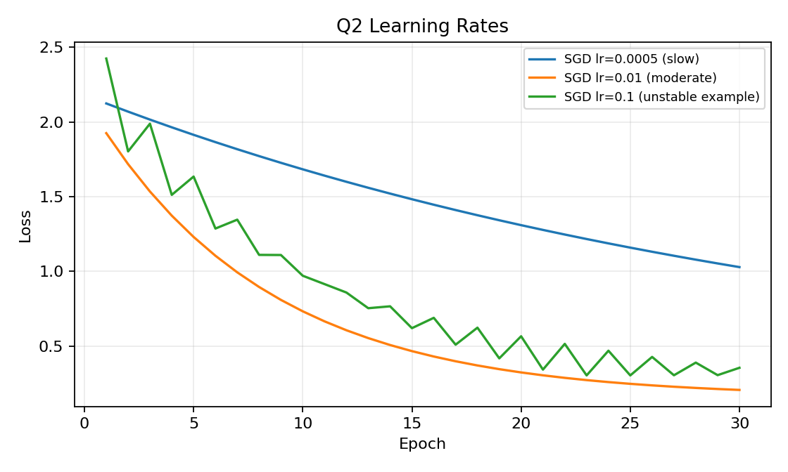

Analysis and conclusion
- A very small learning rate usually makes small, stable updates but may need more epochs.
- A moderate learning rate often gives a good balance between speed and stability.
- A high learning rate can overshoot the minimum, fluctuate, or diverge. The best value depends on data scaling and the experiment; verify with validation loss.

Question 3: Handwritten Digit Classification

Objective
Compare SGD and Momentum on the same MNIST digit subset, using the same model, learning rate, batch size, and number of epochs.

Code
import numpy as np
import tensorflow as tf
import matplotlib.pyplot as plt
from tensorflow import keras
from tensorflow.keras import layers

SEED = 42
np.random.seed(SEED)
tf.random.set_seed(SEED)

(x_train, y_train), (x_test, y_test) = keras.datasets.mnist.load_data()
x_train = (x_train[:12000].astype("float32") / 255.0).reshape(-1, 784)
y_train = y_train[:12000]
x_test = (x_test[:2000].astype("float32") / 255.0).reshape(-1, 784)
y_test = y_test[:2000]

def digit_model(optimizer):
model = keras.Sequential([
layers.Input(shape=(784,)),
layers.Dense(128, activation="relu"),
layers.Dense(10, activation="softmax")
])
model.compile(optimizer=optimizer,
loss="sparse_categorical_crossentropy", metrics=["accuracy"])
return model

losses = {}
for name, optimizer in [
("SGD", keras.optimizers.SGD(learning_rate=0.01)),
("Momentum", keras.optimizers.SGD(learning_rate=0.01, momentum=0.9))
]:
tf.keras.backend.clear_session()
tf.random.set_seed(SEED)
model = digit_model(optimizer)
history = model.fit(x_train, y_train,
validation_data=(x_test, y_test), epochs=8,
batch_size=128, verbose=0)
losses[name] = np.asarray(history.history["loss"], dtype=np.float32)
print(name, "test loss/accuracy =", model.evaluate(x_test, y_test, verbose=0))

plt.figure(figsize=(7,4))
for name, values in losses.items():
plt.plot(np.arange(1, len(values)+1), values, label=name)
plt.xlabel("Epoch"); plt.ylabel("Loss")
plt.title("Q3: SGD vs Momentum on MNIST")
plt.grid(True, alpha=0.3); plt.legend(); plt.tight_layout()
plt.savefig("q3_momentum.png", dpi=150); plt.show()

Expected output
Expected output format: prints test loss and accuracy for each optimizer and displays the epoch-wise loss plot. MNIST may download the first time the code runs.

Loss-curve image
Illustrative curve only: this image shows the general pattern discussed in the analysis. Run the code above to generate the actual output for your experiment.
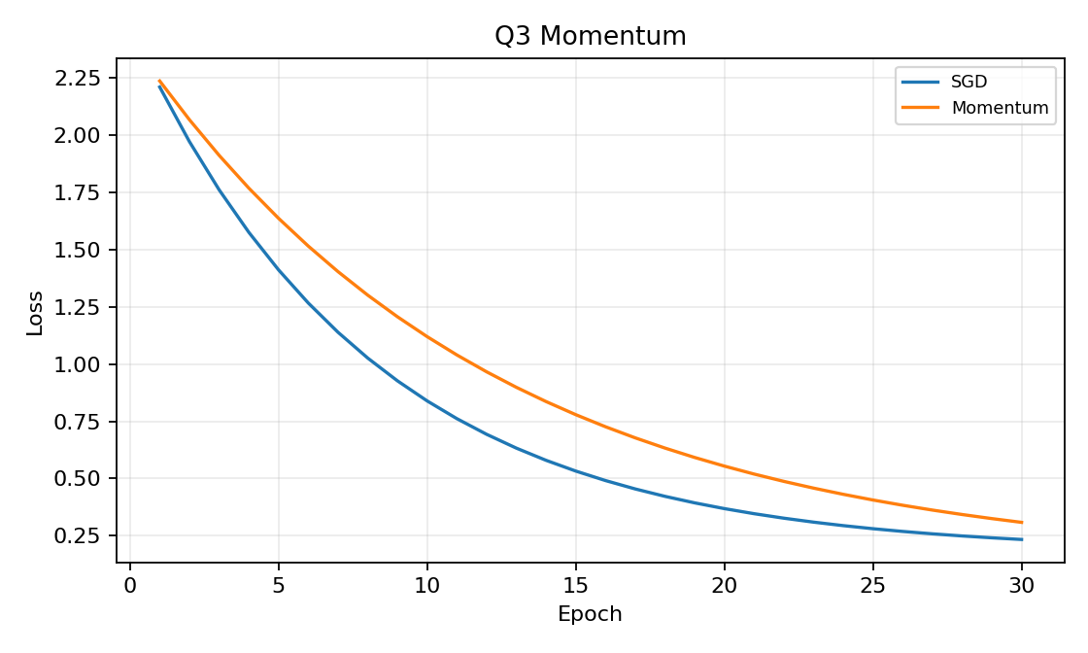

Analysis and conclusion
- Momentum adds a fraction of the previous update to the current gradient-based update.
- When gradients repeatedly point in a similar direction, Momentum builds speed; it can also reduce zig-zagging caused by changing gradient directions.
- Momentum often converges faster than plain SGD, but judge using the actual loss curve and test metrics.

Question 4: Disease Risk Classification

Objective
Compare full-batch Gradient Descent and Adam for a binary classification demonstration. Synthetic patient-like features are used only for learning, not medical use.

Code
import numpy as np
import tensorflow as tf
import matplotlib.pyplot as plt
from tensorflow import keras
from tensorflow.keras import layers

SEED = 42
np.random.seed(SEED)
tf.random.set_seed(SEED)

rng = np.random.default_rng(SEED)
X = rng.normal(size=(1600, 6)).astype("float32")
z = 1.2*X[:,0] - 0.9*X[:,1] + 0.7*X[:,2] + 0.4*X[:,3]
prob = 1/(1+np.exp(-z))
y = (rng.random(len(X)) < prob).astype("float32")
cut = int(0.8*len(X))
X_train, y_train, X_val, y_val = X[:cut], y[:cut], X[cut:], y[cut:]

def classifier(optimizer):
model = keras.Sequential([
layers.Input(shape=(6,)),
layers.Dense(32, activation="relu"),
layers.Dense(16, activation="relu"),
layers.Dense(1, activation="sigmoid")
])
model.compile(optimizer=optimizer, loss="binary_crossentropy",
metrics=["accuracy"])
return model

losses = {}
settings = [
("Gradient Descent (full batch)",
keras.optimizers.SGD(learning_rate=0.1), len(X_train)),
("Adam", keras.optimizers.Adam(learning_rate=0.001), 32)
]
for name, optimizer, batch_size in settings:
tf.keras.backend.clear_session()
tf.random.set_seed(SEED)
model = classifier(optimizer)
history = model.fit(X_train, y_train,
validation_data=(X_val, y_val), epochs=30,
batch_size=batch_size, verbose=0)
losses[name] = np.asarray(history.history["loss"], dtype=np.float32)
print(name, "final loss =", round(float(losses[name][-1]), 4))

plt.figure(figsize=(7,4))
for name, values in losses.items():
plt.plot(np.arange(1, len(values)+1), values, label=name)
plt.xlabel("Epoch"); plt.ylabel("Loss")
plt.title("Q4: Gradient Descent vs Adam")
plt.grid(True, alpha=0.3); plt.legend(); plt.tight_layout()
plt.savefig("q4_adam.png", dpi=150); plt.show()

Expected output
Expected output format: prints final binary-cross-entropy loss for both methods and displays their curves. Exact results depend on your environment and run.

Loss-curve image
Illustrative curve only: this image shows the general pattern discussed in the analysis. Run the code above to generate the actual output for your experiment.
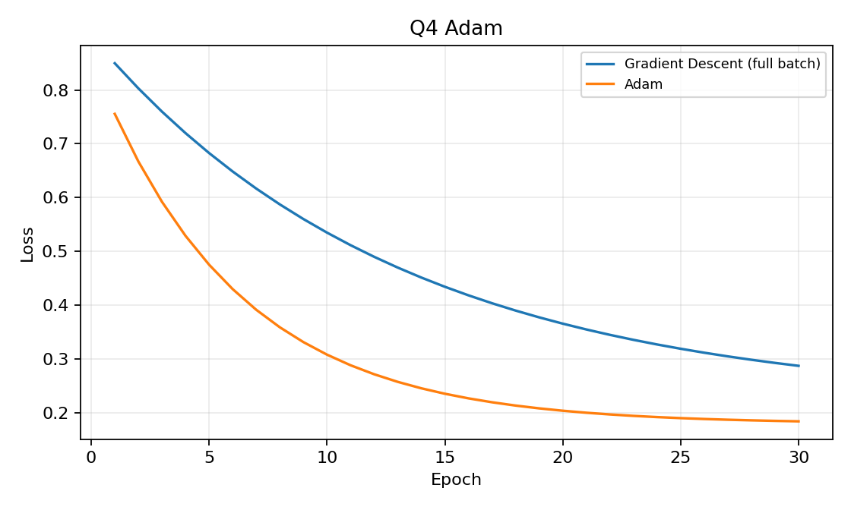

Analysis and conclusion
- Adam uses moving averages of gradients and squared gradients to adapt parameter update sizes.
- Adam often reduces loss quickly when gradients have different scales. Full-batch Gradient Descent may be smoother but slower.
- This example uses full-batch Gradient Descent and mini-batch Adam, so batch size differs. For a strict comparison, match batch sizes and tune both learning rates.

Question 5: Optimizer Comparison for Sales Forecasting

Objective
Compare Gradient Descent, SGD, Momentum, and Adam using training and validation loss, then choose based on measured validation performance and stability.

Code
import numpy as np
import tensorflow as tf
import matplotlib.pyplot as plt
from tensorflow import keras
from tensorflow.keras import layers

SEED = 42
np.random.seed(SEED)
tf.random.set_seed(SEED)

def make_regression_data(n=1200, seed=SEED):
rng = np.random.default_rng(seed)
X = rng.normal(size=(n, 2)).astype("float32")
y = (3.0*X[:, 0] + 1.7*X[:, 1] + 0.8 +
rng.normal(scale=0.15, size=n)).astype("float32")
return X, y

def split_data(X, y):
cut = int(0.8 * len(X))
return X[:cut], y[:cut], X[cut:], y[cut:]

def regression_model(input_dim, optimizer):
model = keras.Sequential([
layers.Input(shape=(input_dim,)),
layers.Dense(32, activation="relu"),
layers.Dense(16, activation="relu"),
layers.Dense(1)
])
model.compile(optimizer=optimizer, loss="mse", metrics=["mae"])
return model

def plot_loss(loss_dict, title, filename):
plt.figure(figsize=(7, 4))
for label, values in loss_dict.items():
plt.plot(np.arange(1, len(values)+1), values, label=label)
plt.xlabel("Epoch")
plt.ylabel("Loss")
plt.title(title)
plt.grid(True, alpha=0.3)
plt.legend()
plt.tight_layout()
plt.savefig(filename, dpi=150)
plt.show()

X, y = make_regression_data(n=1600, seed=SEED+5)
X_train, y_train, X_val, y_val = split_data(X, y)
settings = {
"Gradient Descent": (keras.optimizers.SGD(learning_rate=0.03),
None),
"SGD": (keras.optimizers.SGD(learning_rate=0.003), 32),
"Momentum": (keras.optimizers.SGD(learning_rate=0.01, momentum=0.9), 32),
"Adam": (keras.optimizers.Adam(learning_rate=0.001), 32)
}
train_losses, val_losses = {}, {}
for name, (optimizer, batch_size) in settings.items():
tf.keras.backend.clear_session()
tf.random.set_seed(SEED)
model = regression_model(X.shape[1], optimizer)
batch_size = len(X_train) if batch_size is None else batch_size
history = model.fit(X_train, y_train,
validation_data=(X_val, y_val), epochs=30,
batch_size=batch_size, verbose=0)
train_losses[name] = np.asarray(history.history["loss"], dtype=np.float32)
val_losses[name] = np.asarray(history.history["val_loss"], dtype=np.float32)
print(name, "final train =", round(float(train_losses[name][-1]), 4),
"final validation =", round(float(val_losses[name][-1]), 4))

plot_loss(train_losses, "Q5: Training Loss", "q5_training_loss.png")
plot_loss(val_losses, "Q5: Validation Loss", "q5_validation_loss.png")

ranking = sorted(((name, float(values[-1]))
for name, values in val_losses.items()),
key=lambda pair: pair[1])
print("Final validation loss ranking (lower is better):")
for name, value in ranking:
print(f"{name}: {value:.4f}")

Expected output
Expected output format: prints final training and validation losses for all four optimizers, shows two plots, and ranks final validation losses from lowest to highest. Report the ranking from your actual run.

Loss-curve image
Illustrative curve only: this image shows the general pattern discussed in the analysis. Run the code above to generate the actual output for your experiment.
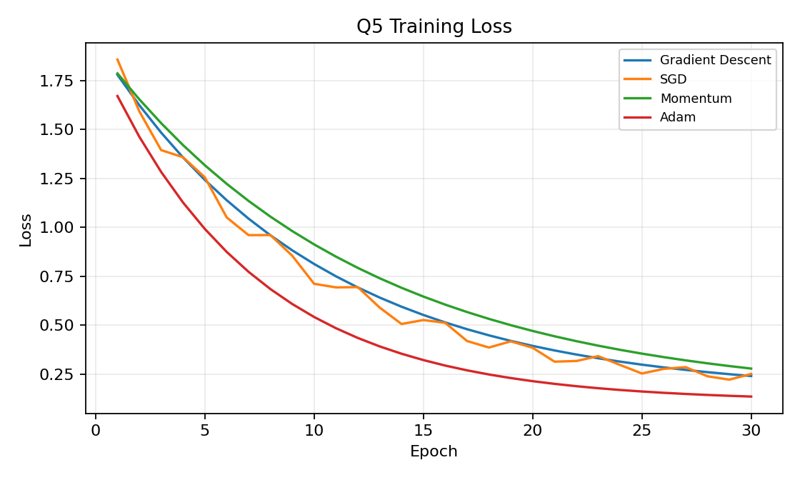

Analysis and conclusion
- Training loss measures fit on the training data; validation loss estimates performance on held-out examples.
- Choose the optimizer with low and stable validation loss. The lowest training loss alone is not enough; a widening train/validation gap may indicate overfitting.
- The sales data is synthetic. For actual weekly sales, use a chronological train/validation split so future weeks do not leak into training.

final comparison summary
- Gradient Descent: often smoother with full-batch updates, but may make fewer updates per epoch.
- SGD: frequent updates and can learn quickly, but its loss curve is often noisier and it is sensitive to learning rate.
- Momentum: uses past update direction to accelerate consistent progress and reduce zig-zagging.
- Adam: adapts update sizes per parameter and often converges quickly, but must still be evaluated on validation performance.
- Best optimizer: decide from actual experimental results. For Question 5, use the printed validation-loss ranking and inspect both training and validation plots.

