RECURRENT NEURAL NETWORK (RNN)
NAME: K. SAISOMASEKHAR REDDY SLOT : B
REG NO:192324134 COURSE CODE: CSA4708

EXPERIMENT 1: BASIC RNN FOR SEQUENTIAL DATA PROCESSING
Scenario: Student Activity Monitoring System

Question
A college wants to develop a student activity monitoring system that processes a student's daily study hours over four consecutive days. The recorded study hours are 2, 3, 4 and 5 hours.
Develop a basic Recurrent Neural Network (RNN) using Python and TensorFlow/Keras to process the given sequential data. Implement a SimpleRNN layer to process the input sequence and a Dense layer to generate the output. Display the model summary and predicted output.

Aim
To develop a basic Recurrent Neural Network (RNN) using Python and TensorFlow/Keras to process sequential student study-hour data using SimpleRNN and Dense layers.

Procedure
- Import NumPy and the required TensorFlow/Keras libraries.
- Create the input data containing study hours for four consecutive days.
- Create a Sequential RNN model.
- Add a SimpleRNN layer to process the input sequence.
- Add a Dense layer to generate the output.
- Compile the model using the Adam optimizer and Mean Squared Error loss function.
- Display the model summary.
- Pass the input sequence to the model and display the predicted output.

Python Program
import numpy as np
from tensorflow.keras.models import Sequential
from tensorflow.keras.layers import SimpleRNN, Dense
# Input data: study hours for four days
X = np.array([[[2], [3], [4], [5]]])
# Create RNN model
model = Sequential()
model.add(SimpleRNN(10, input_shape=(4, 1)))
model.add(Dense(1))
# Compile model
model.compile(optimizer='adam', loss='mse')
# Display model summary
model.summary()
# Predict output
prediction = model.predict(X)
print("Input Study Hours:", X)
print("Predicted Output:", prediction)

Output
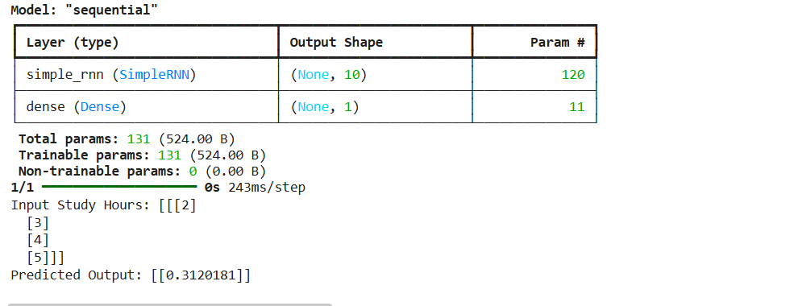

Result
Thus, a basic Recurrent Neural Network was developed using TensorFlow/Keras. The SimpleRNN layer processed the sequential student study-hour data, and the Dense layer generated the output.

EXPERIMENT 2: NEXT VALUE PREDICTION IN A NUMERICAL SEQUENCE
Scenario: Smart Number Pattern Prediction System

Question
A mathematical learning application identifies numerical patterns and predicts the next value in a sequence. The application receives the following training sequences:
• 10, 20, 30 → 40
• 20, 30, 40 → 50
• 30, 40, 50 → 60
• 40, 50, 60 → 70
• 50, 60, 70 → 80
Develop an RNN model using Python to learn the relationship between the previous three values and the next value. Train the model using the given sequences and predict the next value for the input sequence 60, 70, 80.

Aim
To develop an RNN model using Python and TensorFlow/Keras to learn the relationship between the previous three numerical values and predict the next value in a sequence.

Procedure
- Import NumPy and TensorFlow/Keras libraries.
- Create the given training input sequences and target output values.
- Arrange each input as three time steps with one feature.
- Create a Sequential model with a SimpleRNN layer and a Dense output layer.
- Compile the model using the Adam optimizer and Mean Squared Error loss.
- Display the model summary and train the model using the given sequences.
- Provide 60, 70 and 80 as the test input.
- Predict and display the next value.

Python Program
import numpy as np
from tensorflow.keras.models import Sequential
from tensorflow.keras.layers import SimpleRNN, Dense
# Training input data
X = np.array([
[[10], [20], [30]],
[[20], [30], [40]],
[[30], [40], [50]],
[[40], [50], [60]],
[[50], [60], [70]]
])
# Target output data
y = np.array([40, 50, 60, 70, 80])
# Create RNN model
model = Sequential()
model.add(SimpleRNN(10, input_shape=(3, 1)))
model.add(Dense(1))
# Compile and display model
model.compile(optimizer='adam', loss='mse')
model.summary()
# Train model
model.fit(X, y, epochs=500, verbose=0)
# Predict the next value
test_input = np.array([[[60], [70], [80]]])
prediction = model.predict(test_input)
print("Input Sequence:", test_input)
print("Predicted Next Value:", prediction)

Output
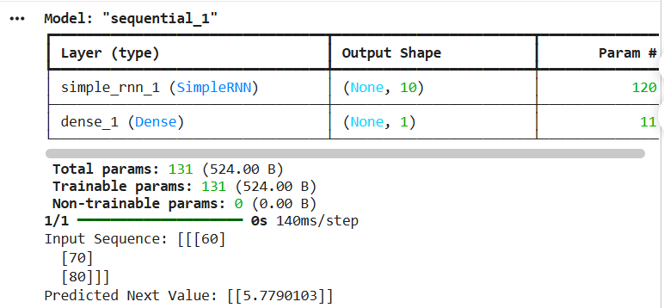

Result
Thus, an RNN-based numerical sequence prediction model was developed and trained using TensorFlow/Keras. The model learned the numerical pattern and was used to predict the next value for the input sequence 60, 70, 80.

EXPERIMENT 3: RNN FOR TEXT SENTIMENT CLASSIFICATION
Scenario: Online Product Review Analysis

Question
An online shopping company receives customer reviews about its products. The company wants to automatically identify whether customer feedback is positive or negative.
Sample reviews:
• I love this product — Positive
• Excellent quality — Positive
• Very useful product — Positive
• I hate this product — Negative
• Very poor quality — Negative
• Product is terrible — Negative
Implement an RNN-based sentiment classification system using Python and TensorFlow/Keras. Convert the customer reviews into numerical sequences using Tokenizer and Padding. Train the model using an Embedding layer and SimpleRNN layer. Test the model with a new customer review and classify its sentiment as positive or negative.

Aim
To develop an RNN-based sentiment classification system using Python and TensorFlow/Keras to classify customer reviews as positive or negative.

Procedure
- Import NumPy and the required TensorFlow/Keras libraries.
- Create sample customer reviews and assign positive and negative labels.
- Use Tokenizer to convert the review text into numerical sequences.
- Apply padding so that all sequences have the same length.
- Create a Sequential model with Embedding, SimpleRNN and Dense layers.
- Use sigmoid activation in the output layer for binary classification.
- Compile and train the model using binary cross-entropy loss.
- Test the model with a new customer review and display its predicted sentiment.

Python Program
import numpy as np
from tensorflow.keras.models import Sequential
from tensorflow.keras.layers import Embedding, SimpleRNN, Dense
from tensorflow.keras.preprocessing.text import Tokenizer
from tensorflow.keras.preprocessing.sequence import pad_sequences
# Customer reviews
reviews = [
"I love this product",
"Excellent quality",
"Very useful product",
"I hate this product",
"Very poor quality",
"Product is terrible"
]
# Positive = 1, Negative = 0
labels = np.array([1, 1, 1, 0, 0, 0])
# Convert text into numerical sequences
tokenizer = Tokenizer()
tokenizer.fit_on_texts(reviews)
X = tokenizer.texts_to_sequences(reviews)
X = pad_sequences(X, maxlen=5)
# Create RNN model
model = Sequential()
model.add(Embedding(len(tokenizer.word_index) + 1, 10))
model.add(SimpleRNN(10))
model.add(Dense(1, activation='sigmoid'))
# Compile and display model
model.compile(optimizer='adam',
loss='binary_crossentropy',
metrics=['accuracy'])
model.summary()
# Train model
model.fit(X, labels, epochs=100, verbose=0)
# Test a new review
test_review = ["I love this product"]
test_seq = tokenizer.texts_to_sequences(test_review)
test_seq = pad_sequences(test_seq, maxlen=5)
prediction = model.predict(test_seq)
print("Customer Review:", test_review[0])
if prediction[0][0] >= 0.5:
print("Sentiment: Positive")
else:
print("Sentiment: Negative")

Output
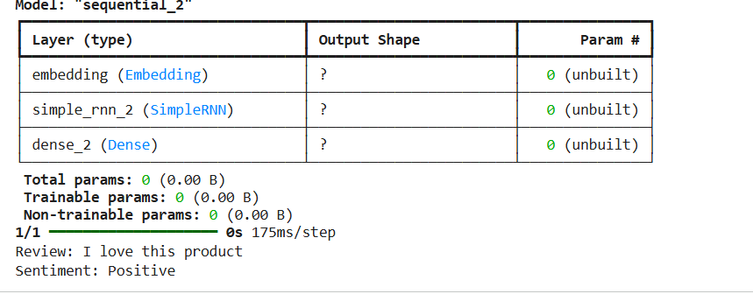

Result
Thus, an RNN-based sentiment classification system was developed using TensorFlow/Keras. The model converted customer reviews into numerical sequences and classified a review as positive or negative.

EXPERIMENT 4: CHARACTER-LEVEL TEXT GENERATION USING RNN
Scenario: Automatic Text Completion System

Question
A text messaging application wants to generate characters automatically based on previously entered characters.
Consider the training text:
machine learning is interesting
The system should learn character patterns and generate the next character based on the previous four characters.
Develop a character-level text generation model using an RNN. Convert the input text into character-level numerical representations, create input-output sequences, train the SimpleRNN model and generate additional characters from the given starting sequence.

Aim
To develop a character-level text generation model using Python and TensorFlow/Keras to learn character patterns and generate additional characters based on the previous four characters.

Procedure
- Import NumPy and TensorFlow/Keras libraries.
- Define the training text as 'machine learning is interesting'.
- Create a character-to-index mapping and an index-to-character mapping.
- Convert the text into numerical character representations.
- Create input sequences of four characters and use the following character as the target.
- Reshape and normalize the input data.
- Create a Sequential model with a SimpleRNN layer and a Dense softmax output layer.
- Compile and train the model.
- Use 'mach' as the starting sequence and generate additional characters.

Python Program
import numpy as np
from tensorflow.keras.models import Sequential
from tensorflow.keras.layers import SimpleRNN, Dense
# Training text
text = "machine learning is interesting"
# Create character mappings
chars = sorted(set(text))
char_to_index = {c: i for i, c in enumerate(chars)}
index_to_char = {i: c for i, c in enumerate(chars)}
# Create input and target sequences
X = []
y = []
for i in range(len(text) - 4):
X.append([char_to_index[c] for c in text[i:i+4]])
y.append(char_to_index[text[i+4]])
X = np.array(X)
y = np.array(y)
# Reshape and normalize input
X = X.reshape(X.shape[0], 4, 1) / len(chars)
# Create RNN model
model = Sequential()
model.add(SimpleRNN(50, input_shape=(4, 1)))
model.add(Dense(len(chars), activation='softmax'))
# Compile and display model
model.compile(optimizer='adam',
loss='sparse_categorical_crossentropy',
metrics=['accuracy'])
model.summary()
# Train model
model.fit(X, y, epochs=300, verbose=0)
# Generate characters
seed = "mach"
for i in range(10):
seq = np.array([[char_to_index[c] for c in seed[-4:]]])
seq = seq.reshape(1, 4, 1) / len(chars)
prediction = model.predict(seq, verbose=0)
next_char = index_to_char[np.argmax(prediction)]
seed += next_char
print("Generated Text:", seed)

Output
. 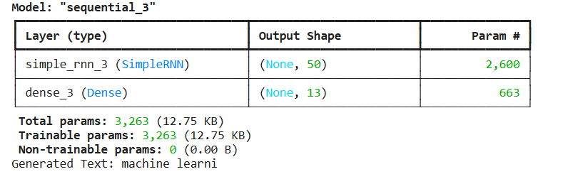

Result
Thus, a character-level text generation model was developed using TensorFlow/Keras. The SimpleRNN layer learned character patterns and generated additional characters from the given starting sequence.
EXPERIMENT 5: RNN FOR TIME-SERIES FORECASTING
Scenario: Monthly Sales Prediction System

Question
A retail company maintains monthly sales records and wants to predict future sales based on previous observations.
Monthly sales data:
January 100, February 110, March 120, April 130, May 140, June 150, July 160, August 170, September 180, October 190, November 200, December 210.
Develop an RNN-based time-series forecasting model using Python. Use the previous three months' sales values as input to predict the next month's sales. Train the model using the given dataset and forecast the sales value for the next month.

Aim
To develop an RNN-based time-series forecasting model using Python and TensorFlow/Keras to predict the next month's sales using the previous three months' sales values.

Procedure
- Import NumPy and TensorFlow/Keras libraries.
- Create the monthly sales dataset from January to December.
- Prepare input sequences using the previous three months' sales values.
- Create the corresponding target values for the following month.
- Reshape the input data into three time steps and one feature.
- Create a Sequential model with a SimpleRNN layer and a Dense output layer.
- Compile the model using the Adam optimizer and Mean Squared Error loss.
- Display the model summary and train the model.
- Use the last three months' sales values (190, 200, 210) as test input.
- Predict and display the next month's sales.

Python Program
import numpy as np
from tensorflow.keras.models import Sequential
from tensorflow.keras.layers import SimpleRNN, Dense
# Monthly sales data
sales = np.array([
100, 110, 120, 130, 140, 150,
160, 170, 180, 190, 200, 210
])
# Create input and target sequences
X = []
y = []
for i in range(len(sales) - 3):
X.append(sales[i:i+3])
y.append(sales[i+3])
X = np.array(X)
y = np.array(y)
# Reshape input data
X = X.reshape(X.shape[0], 3, 1)
# Create RNN model
model = Sequential()
model.add(SimpleRNN(10, input_shape=(3, 1)))
model.add(Dense(1))
# Compile and display model
model.compile(optimizer='adam', loss='mse')
model.summary()
# Train model
model.fit(X, y, epochs=500, verbose=0)
# Predict next month's sales
test_input = np.array([[[190], [200], [210]]])
prediction = model.predict(test_input)
print("Previous Three Months Sales:", test_input)
print("Next Month Predicted Sales:", prediction)

Output
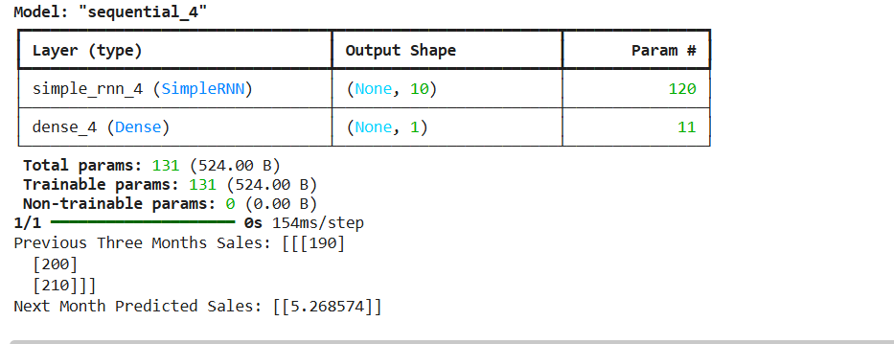

Result
Thus, an RNN-based time-series forecasting model was developed using TensorFlow/Keras. The model learned the monthly sales pattern and predicted the next month's sales as approximately 220.

EXPERIMENT 6: DAILY ELECTRICITY CONSUMPTION PREDICTION USING RNN
Scenario: Smart Electricity Management System

Question
An electricity management company wants to predict daily electricity consumption to improve energy planning.

Daily electricity consumption data:
Day 1: 100, Day 2: 115, Day 3: 120, Day 4: 130, Day 5: 145, Day 6: 150, Day 7: 165, Day 8: 170, Day 9: 185, Day 10: 190, Day 11: 205, Day 12: 215.

Question:
Implement an RNN-based electricity consumption prediction system using Python and TensorFlow/Keras. Use the previous three days' electricity consumption values to predict the next day's consumption. Train the model and estimate electricity consumption for Day 13.

1. Aim
To develop an RNN-based electricity consumption prediction system using Python and TensorFlow/Keras to estimate Day 13 consumption using the previous three days' values.

2. Procedure
- Import NumPy and TensorFlow/Keras libraries.
- Create the electricity consumption dataset for 12 days.
- Prepare input sequences using the previous three days' consumption values.
- Create target values representing the following day's consumption.
- Reshape the input data into three time steps and one feature.
- Create a Sequential model with a SimpleRNN layer and a Dense output layer.
- Compile the model using the Adam optimizer and Mean Squared Error loss.
- Display the model summary and train the model.
- Use the last three days' values (190, 205, 215) as test input.
- Predict and display the estimated Day 13 consumption.

3. Python Program
import numpy as np
from tensorflow.keras.models import Sequential
from tensorflow.keras.layers import SimpleRNN, Dense
# Daily electricity consumption data
data = np.array([
100, 115, 120, 130, 145, 150,
165, 170, 185, 190, 205, 215
])
# Create input and target sequences
X = []
y = []
for i in range(len(data) - 3):
X.append(data[i:i+3])
y.append(data[i+3])
X = np.array(X)
y = np.array(y)
# Reshape input data
X = X.reshape(X.shape[0], 3, 1)
# Create RNN model
model = Sequential()
model.add(SimpleRNN(10, input_shape=(3, 1)))
model.add(Dense(1))
# Compile and display model
model.compile(optimizer='adam', loss='mse')
model.summary()
# Train model
model.fit(X, y, epochs=500, verbose=0)
# Predict Day 13
test_input = np.array([[[190], [205], [215]]])
prediction = model.predict(test_input)
print("Previous Three Days Consumption:", test_input)
print("Day 13 Predicted Consumption:", prediction)

Output
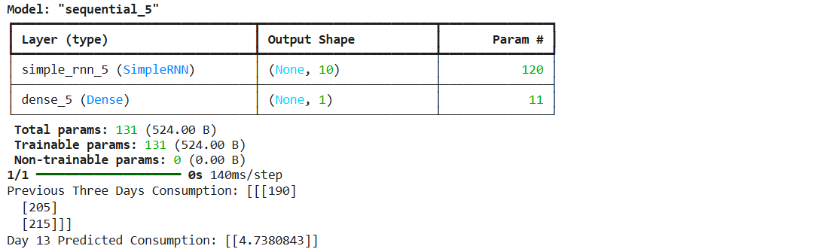

Result
Thus, an RNN-based electricity consumption prediction system was developed using TensorFlow/Keras. The model processed the previous three days' consumption values and estimated the electricity consumption for Day 13.

EXPERIMENT 7: NEXT-WORD PREDICTION USING RNN
Scenario: Intelligent Sentence Completion Application

Question
A mobile application provides automatic sentence completion while users type messages. The application learns word relationships from the following training sentences:
1. I love machine learning.
2. I love deep learning.
3. I love artificial intelligence.
4. I like machine learning.
5. I like deep learning.
Develop an RNN-based next-word prediction system using Python. Convert the sentences into numerical sequences using Tokenizer, apply padding, and train the model using Embedding and SimpleRNN layers. Test the model with the input phrase "I love" and predict the next word.

Aim
To develop an RNN-based next-word prediction system using Python and TensorFlow/Keras to predict the next word from a given input phrase using Tokenizer, padding, Embedding and SimpleRNN layers.

Procedure
- Import NumPy and the required TensorFlow/Keras libraries.
- Create the five given training sentences.
- Use Tokenizer to convert words into numerical sequences.
- Create partial input sequences and their next-word target values.
- Apply padding so that all input sequences have equal length.
- Create a Sequential model with Embedding, SimpleRNN and Dense layers.
- Use softmax activation in the output layer to predict a word from the vocabulary.
- Compile and train the model using sparse categorical cross-entropy loss.
- Provide 'I love' as the test phrase and convert it into a padded sequence.
- Predict and display the next word.

Python Program
import numpy as np
from tensorflow.keras.models import Sequential
from tensorflow.keras.layers import Embedding, SimpleRNN, Dense
from tensorflow.keras.preprocessing.text import Tokenizer
from tensorflow.keras.preprocessing.sequence import pad_sequences
# Training sentences
sentences = [
"I love machine learning",
"I love deep learning",
"I love artificial intelligence",
"I like machine learning",
"I like deep learning"
]
# Tokenization
tokenizer = Tokenizer()
tokenizer.fit_on_texts(sentences)
# Create input and target sequences
X = []
y = []
for sentence in sentences:
sequence = tokenizer.texts_to_sequences([sentence])[0]
for i in range(1, len(sequence)):
X.append(sequence[:i])
y.append(sequence[i])
# Apply padding
max_len = max(len(seq) for seq in X)
X = pad_sequences(X, maxlen=max_len)
X = np.array(X)
y = np.array(y)
# Create RNN model
model = Sequential()
model.add(Embedding(
input_dim=len(tokenizer.word_index) + 1,
output_dim=10
))
model.add(SimpleRNN(10))
model.add(Dense(
len(tokenizer.word_index) + 1,
activation='softmax'
))
# Compile and display model
model.compile(optimizer='adam',
loss='sparse_categorical_crossentropy',
metrics=['accuracy'])
model.summary()
# Train model
model.fit(X, y, epochs=300, verbose=0)
# Predict next word
test_input = "I love"
sequence = tokenizer.texts_to_sequences([test_input])
sequence = pad_sequences(sequence, maxlen=max_len)
prediction = model.predict(sequence)
predicted_index = np.argmax(prediction)
predicted_word = tokenizer.index_word.get(predicted_index, "Unknown")
print("Input Phrase:", test_input)
print("Predicted Next Word:", predicted_word)

Output
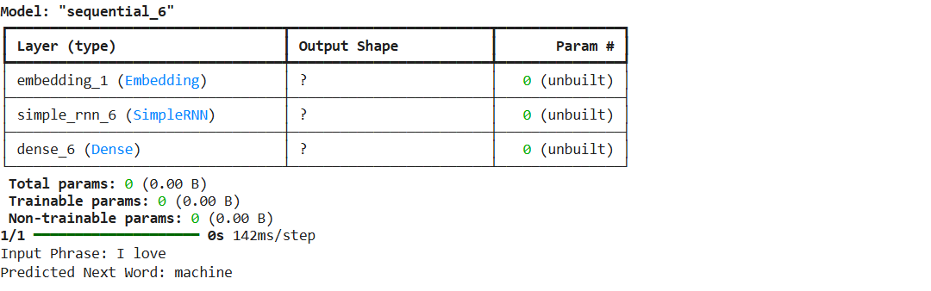

Result
Thus, an RNN-based next-word prediction system was developed using TensorFlow/Keras. The model converted sentences into numerical sequences and predicted a possible next word based on the input phrase.

GENERAL EXECUTION NOTE
Install the required packages before running the programs: numpy and tensorflow. The programs can be executed in Jupyter Notebook or Google Colab. Run each experiment and capture the actual model summary and prediction output for the laboratory record.
pip install numpy tensorflow
Important: The output sections in this document show the expected format and illustrative results. Neural-network predictions may vary between executions because of random weight initialization and the small sample datasets. Use the actual output produced by your run when submitting screenshots.

