Visualization Evaluation Exercise — Worked Solutions

Question 1 — Individual Time Series & Moving-Average Smoothing
R Solution:
nile_df <- read.csv("Nile.csv")
nile_ts <- ts(nile_df$flow, start = 1871, frequency = 1)
# 5-year centered moving average
ma5 <- stats::filter(nile_ts, filter = rep(1/5, 5), sides = 2)
# equivalently: zoo::rollmean(nile_ts, k = 5, fill = NA)
plot(nile_ts, col = "steelblue", lwd = 1.2,
main = "Annual flow of the Nile at Aswan, 1871-1960",
ylab = "Flow (10^8 m^3)", xlab = "Year")
lines(ma5, col = "firebrick", lwd = 2)
legend("topright", legend = c("Raw", "5-yr moving average"),
col = c("steelblue","firebrick"), lty = 1)
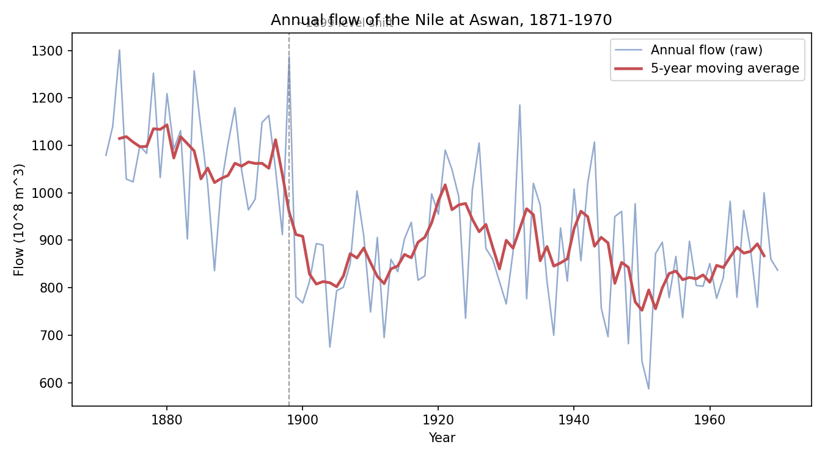
Mean flow before 1899: ~1088; mean flow from 1899 onward: ~868 (a drop of roughly 20%).
Observation: The moving average makes a clear downward level shift visible around 1898-1899 — the series sits noticeably higher and more volatile before this point than after. This matches the well-documented historical change linked to the start of the Aswan (old) dam's construction and regional hydrological/climatic shifts around that time, which altered the river's flow regime rather than a single one-off event. Variability (spread of the raw series around the average) also looks somewhat tighter after the shift, suggesting both the mean and the variance changed together.

Question 2 — Multiple Time Series Comparison & Dose-Response Curve
Part a — Multiple Time Series
library(ggplot2)
library(tidyr)
library(dplyr)
eu <- read.csv("EuStockMarkets.csv")
eu$date <- as.Date(eu$date)
eu_norm <- eu %>%
mutate(across(c(DAX, SMI, CAC, FTSE), ~ .x / first(.x) * 100))
eu_long <- eu_norm %>%
pivot_longer(cols = c(DAX, SMI, CAC, FTSE), names_to = "index", values_to = "value")
ggplot(eu_long, aes(x = date, y = value, color = index)) +
geom_line() +
geom_hline(yintercept = 100, linetype = "dotted", color = "grey40") +
labs(title = "European stock indices re-indexed to 100 at first observation",
x = "Date", y = "Index (start = 100)", color = "Index") +
theme_minimal()
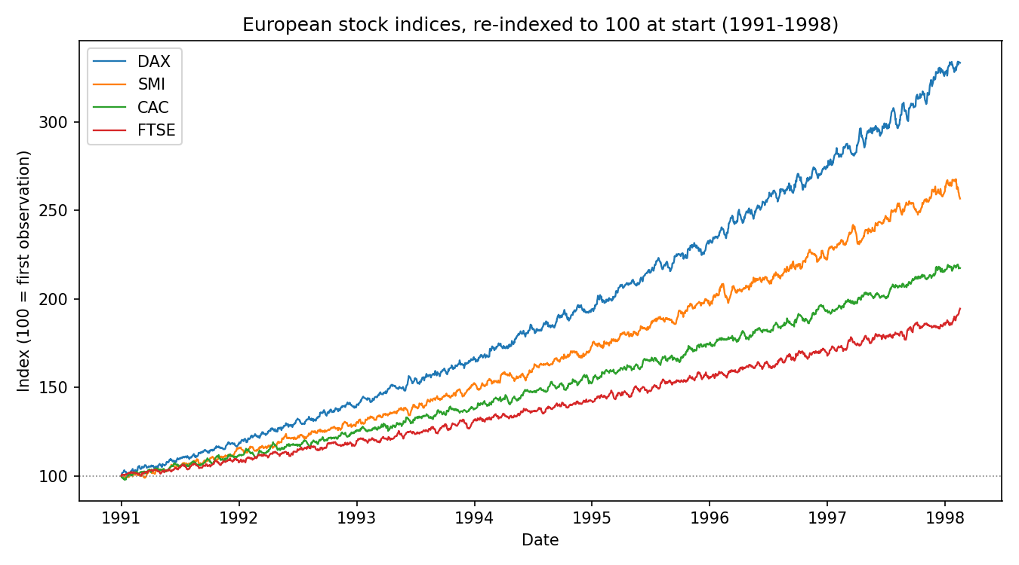
Strongest overall growth: DAX, closing near 330 on the re-indexed scale (roughly a 3.3x gain) versus SMI (~257), CAC (~217) and FTSE (~195). Comment: once re-indexed, the four indices are directly comparable in percentage terms despite starting at very different price levels (DAX ~1600 vs FTSE ~2450) — the German index shows the steepest, most sustained climb over the period, while FTSE trails as the slowest grower, consistent with the strong mid-to-late-1990s German equity rally.
Part b — Dose-Response Curve
library(drc)
rye <- read.csv("ryegrass_doseresponse.csv")
model <- drm(root_length ~ concentration, data = rye,
fct = LL.4(names = c("Slope","Lower","Upper","ED50")))
summary(model)
ED(model, 50) # concentration giving 50% reduction from control
plot(model, type = "all", log = "x",
main = "Ryegrass root length vs herbicide concentration",
xlab = "Concentration", ylab = "Root length")
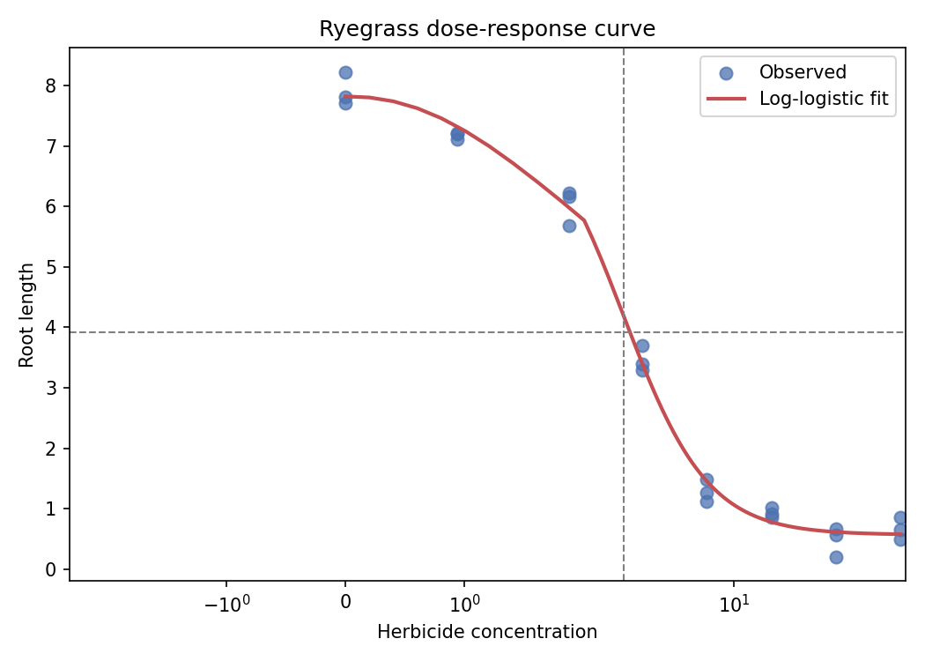
Shape & ED50: The relationship follows the classic S-shaped (sigmoidal) log-logistic dose-response curve — root length stays near the control level (~7.9) at very low concentrations, falls steeply through a middle range, then flattens out near a lower asymptote (~0.6) at high concentrations. The fitted curve puts the ED50 (50% reduction point) at a concentration of approximately 3.0, meaning root length drops to about half its control value (~3.95) around that dose.

Question 3 — Seasonal Decomposition of Time Series (STL)
R Solution:
ap_df <- read.csv("AirPassengers.csv")
ap_ts <- ts(ap_df$passengers, start = c(1949,1), frequency = 12)
stl_fit <- stl(ap_ts, s.window = "periodic")
plot(stl_fit, main = "STL decomposition of AirPassengers")
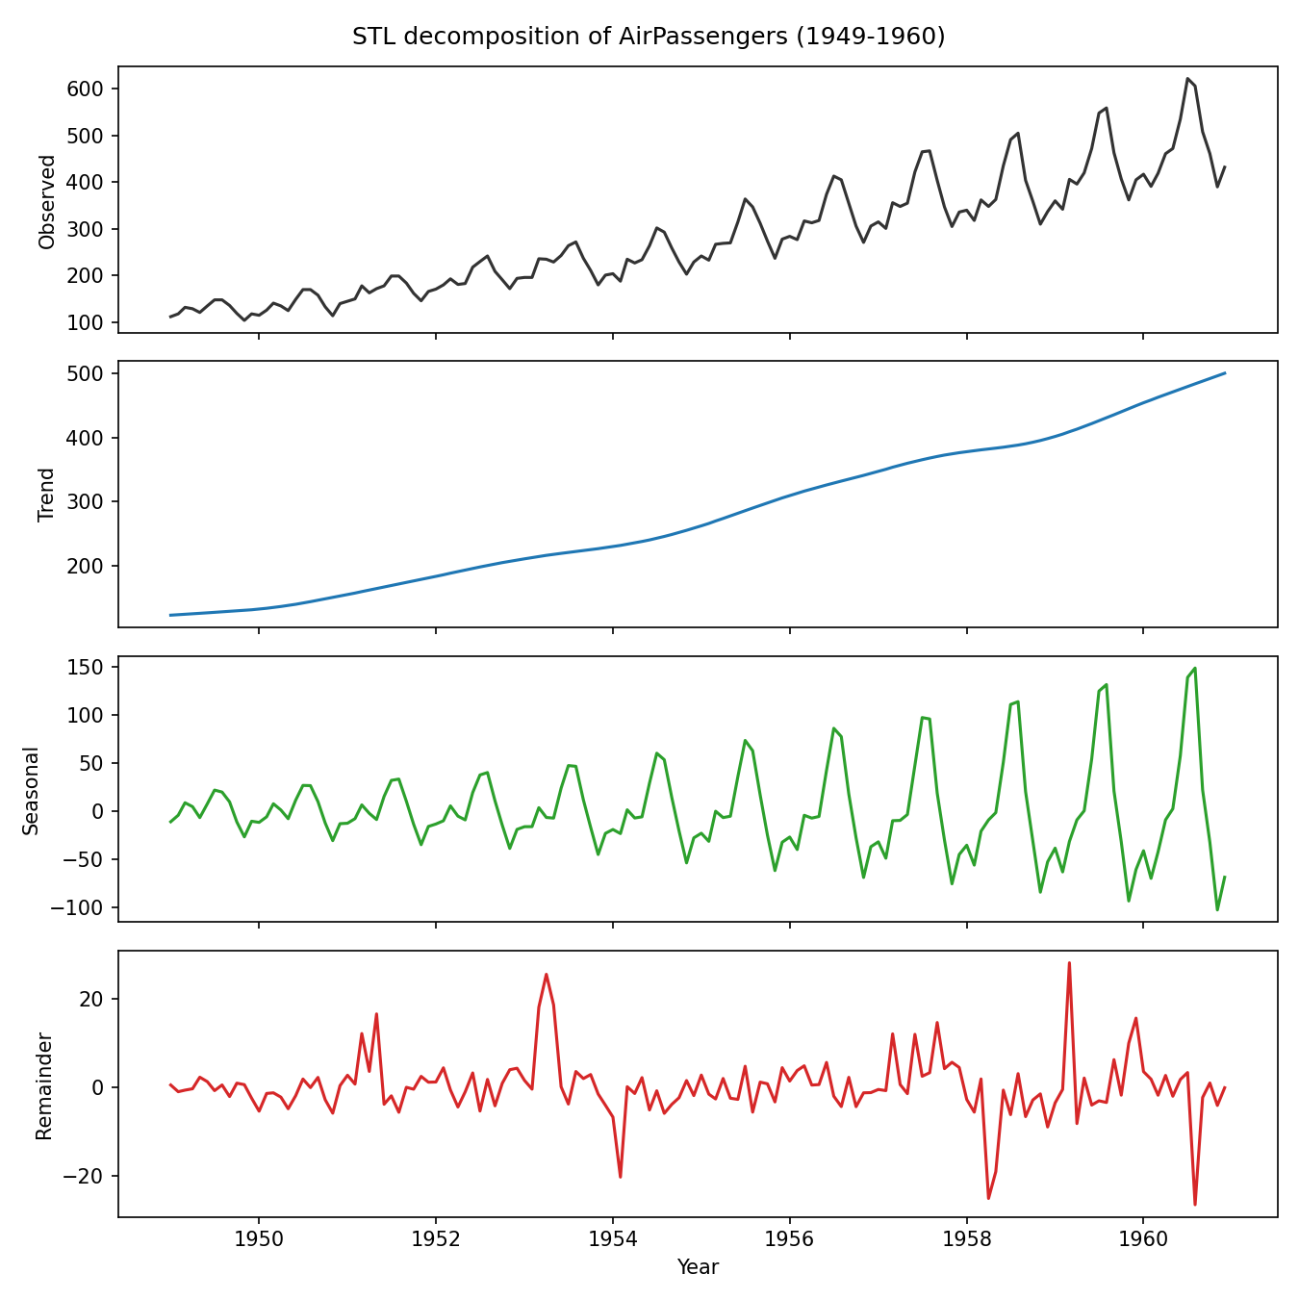
Additive vs multiplicative: A multiplicative decomposition is more appropriate here. In the STL plot, the seasonal swing grows from roughly ±35 passengers (thousands) in the early 1950s to roughly ±125 by 1960 — the amplitude visibly scales up together with the rising trend rather than staying constant. That's the signature of multiplicative seasonality (seasonal effect proportional to the level), so this series is normally modeled either after a log transform (turning it into an additive problem on the log scale) or directly with multiplicative decomposition/exponential smoothing, rather than plain additive decomposition.

Question 4 — Detrending and Residual Analysis
R Solution:
co2_df <- read.csv("co2_mauna_loa.csv")
co2_df$date <- as.Date(co2_df$date)
co2_df$t <- as.numeric(co2_df$date - min(co2_df$date))
fit <- lm(co2_ppm ~ t, data = co2_df)
co2_df$trend <- fitted(fit)
co2_df$resid <- residuals(fit)
par(mfrow = c(2,1))
plot(co2_df$date, co2_df$co2_ppm, type = "l", col = "steelblue",
main = "Mauna Loa CO2 with fitted linear trend", xlab = "Date", ylab = "CO2 (ppm)")
lines(co2_df$date, co2_df$trend, col = "firebrick", lwd = 2)
plot(co2_df$date, co2_df$resid, type = "l", col = "forestgreen",
main = "Detrended residuals", xlab = "Date", ylab = "Residual (ppm)")
abline(h = 0, lty = 2, col = "grey40")
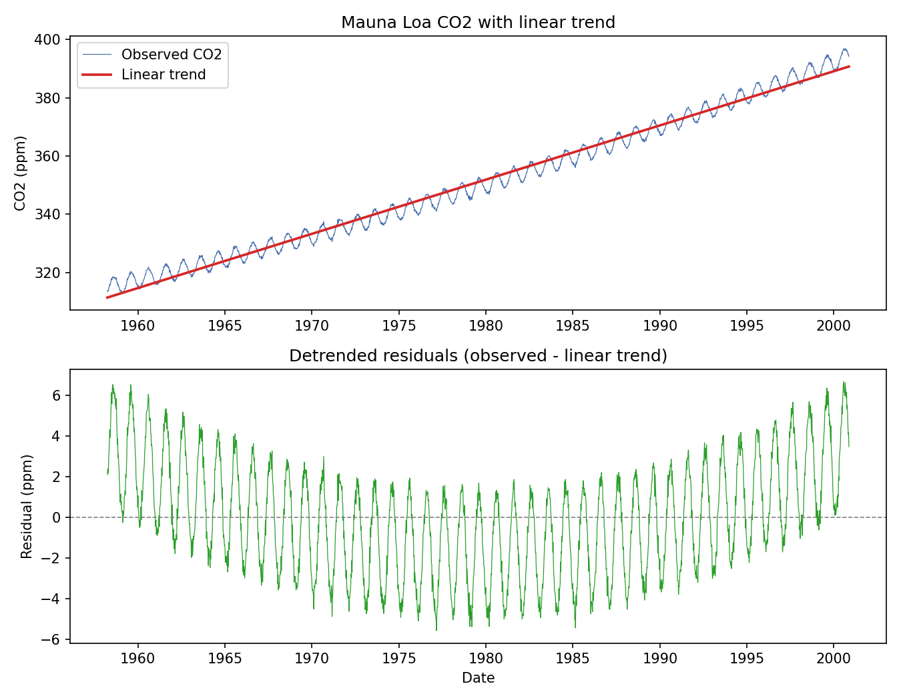
Fitted linear trend: ~1.86 ppm/year. Residual range: roughly -5.6 to +6.7 ppm (SD ≈ 2.7 ppm).
What remains: The detrended residuals show a strong, regular oscillation with roughly a 1-year period — the well-known seasonal cycle driven by Northern Hemisphere plant photosynthesis and respiration (CO2 falls through spring/summer growth, rises through autumn/winter decay), which a straight line can't capture. Simple linear detrending is not sufficient here for two reasons: (1) it leaves this large, regular seasonal structure fully intact in the residuals, and (2) real long-run CO2 growth is itself slightly accelerating (concave upward) rather than perfectly linear, so even the long-term trend fit is a slight underfit at both ends. A more complete model would remove both a smooth non-linear trend (e.g. a polynomial or loess trend) and a 12-month seasonal component, e.g. via STL or a harmonic regression.

Question 5 — Forecasting Trends and Cycle/Seasonality Detection
Part a — Forecasting Trends
library(forecast)
ap_df <- read.csv("AirPassengers.csv")
ap_ts <- ts(ap_df$passengers, start = c(1949,1), frequency = 12)
fit <- ets(ap_ts) # or: auto.arima(ap_ts)
fc <- forecast(fit, h = 24) # 24-month-ahead forecast
autoplot(fc) +
labs(title = "AirPassengers: 24-month ETS forecast with prediction interval",
x = "Year", y = "Passengers (thousands)")
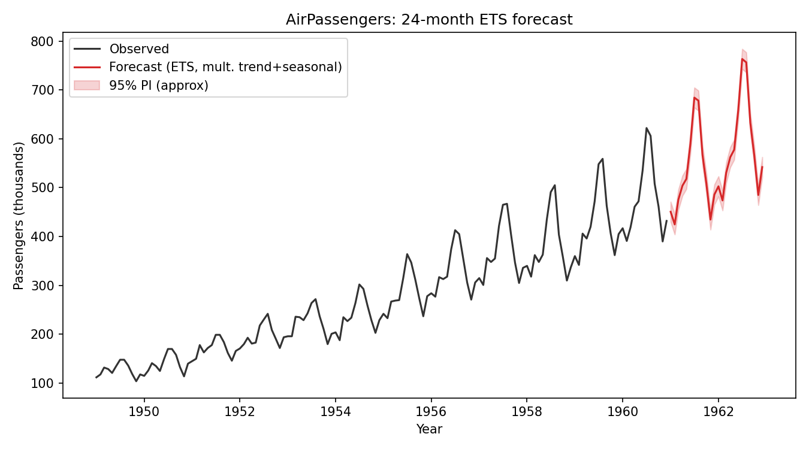
Comment: The forecast (red) continues both the upward trend and the same 12-month seasonal shape seen historically — peaks in mid-summer and a trough in the low season repeat at the same relative amplitude scaling with the (still-rising) trend level. This is exactly the consistency we'd expect from a multiplicative ETS model fit to a series with multiplicative seasonality (per Q3): the widening prediction interval reflects growing forecast uncertainty further out, but the seasonal pattern itself doesn't distort or dampen — it looks like a direct continuation of the historical rhythm.
Part b — Cycle and Seasonality Detection
sun_df <- read.csv("sunspots.csv")
sun_ts <- ts(sun_df$sunspots, start = 1700, frequency = 1)
acf(sun_ts, lag.max = 40, main = "ACF of annual sunspot counts")
spec <- spectrum(sun_ts, main = "Periodogram of annual sunspot counts")
peak_freq <- spec$freq[which.max(spec$spec)]
cycle_length <- 1 / peak_freq
cycle_length # dominant cycle length, in years
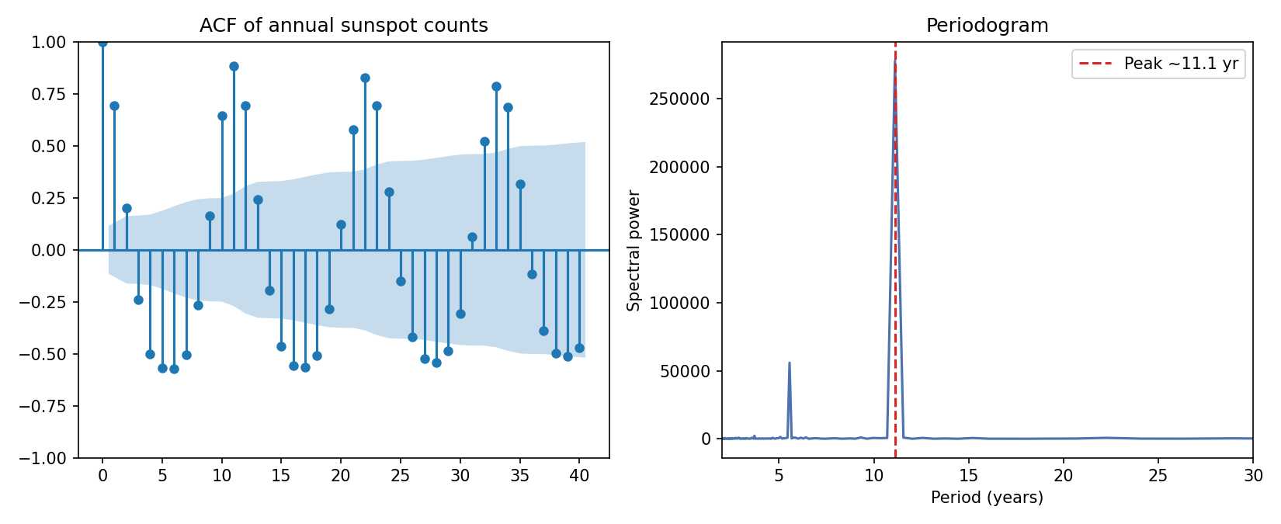
Detected cycle length: ~11.1 years.
Interpretation: The ACF shows a damped oscillating pattern with peaks recurring roughly every 11 lags, and the periodogram shows its dominant spectral peak at a period of about 11.1 years — both point to the same cyclical structure. This lines up closely with the commonly cited ~11-year solar (sunspot) cycle, confirming that the series' fluctuations are driven by a genuine quasi-periodic physical process rather than noise, even though the cycle length and amplitude vary somewhat from one cycle to the next (which is also true of the real solar cycle).

