Time-Series & Geospatial Analysis Report — Worked Solutions

Question 1 — Individual Time Series: Smoothing & Detrending
Language: R
nile_df <- read.csv("Nile.csv")
nile_ts <- ts(nile_df$flow, start = 1871, frequency = 1)
# 5-year moving average
ma5 <- stats::filter(nile_ts, filter = rep(1/5, 5), sides = 2)
# linear detrend
t <- time(nile_ts)
fit <- lm(nile_ts ~ t)
resid_ts <- ts(residuals(fit), start = 1871, frequency = 1)
par(mfrow = c(2,1))
plot(nile_ts, col = "steelblue", main = "Nile flow: raw + 5-yr moving average", ylab = "Flow")
lines(ma5, col = "firebrick", lwd = 2)
plot(resid_ts, col = "forestgreen", main = "Detrended residuals", ylab = "Residual")
abline(h = 0, lty = 2)
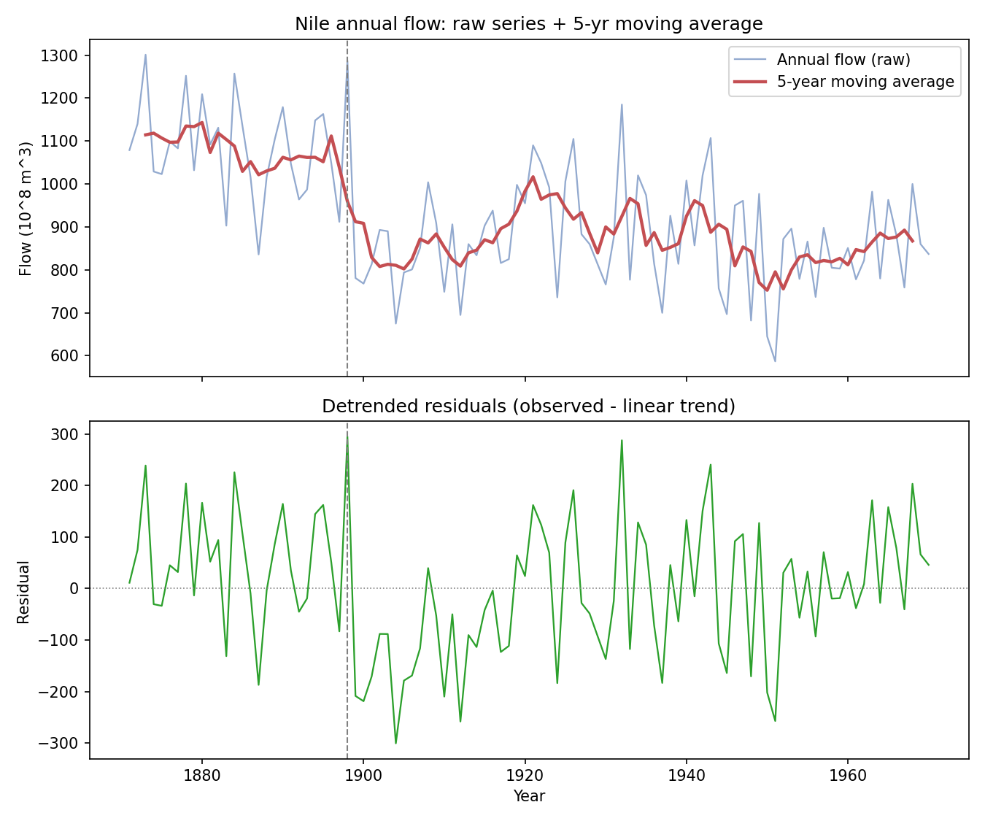
Linear trend slope: about -2.8 units/year overall. Residual mean before 1899: +58; after 1899: -23.
Discussion: Both panels point to the same conclusion from two angles. The moving average makes a visually obvious downward step around 1898-1899 — the smoothed line sits distinctly higher before this point than after. The detrended residual panel confirms it isn't just an artifact of the single overall linear fit: residuals are consistently positive before 1899 (the series runs above even a straight-line trend) and consistently negative afterward (it runs below), which is the signature of a genuine level shift/change-point rather than a smooth continuous decline. This lines up with the documented historical change in the Nile's flow regime around the turn of the century.

Question 2 — Seasonal Decomposition (STL) & Forecasting
Language: R
library(forecast)
ap_df <- read.csv("AirPassengers.csv")
ap_ts <- ts(ap_df$passengers, start = c(1949,1), frequency = 12)
stl_fit <- stl(ap_ts, s.window = "periodic")
plot(stl_fit)
fit <- ets(ap_ts)
fc <- forecast(fit, h = 24)
autoplot(fc) +
labs(title = "AirPassengers: 24-month ETS forecast",
x = "Year", y = "Passengers (thousands)")
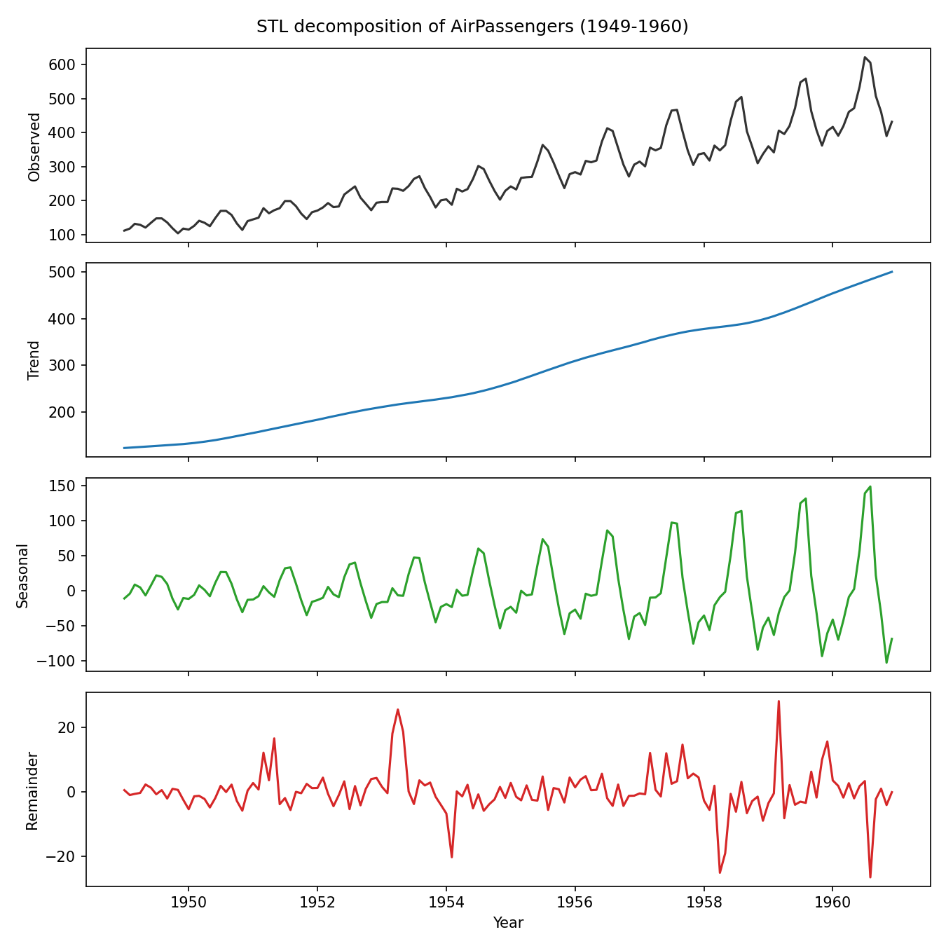
Additive vs multiplicative: Multiplicative is the better fit. The seasonal component's amplitude grows from roughly ±34 in the early 1950s to roughly ±125 by 1960, scaling up together with the rising trend — exactly the pattern multiplicative decomposition is built to capture (additive decomposition would assume a constant-size seasonal swing regardless of trend level, which clearly isn't the case here).
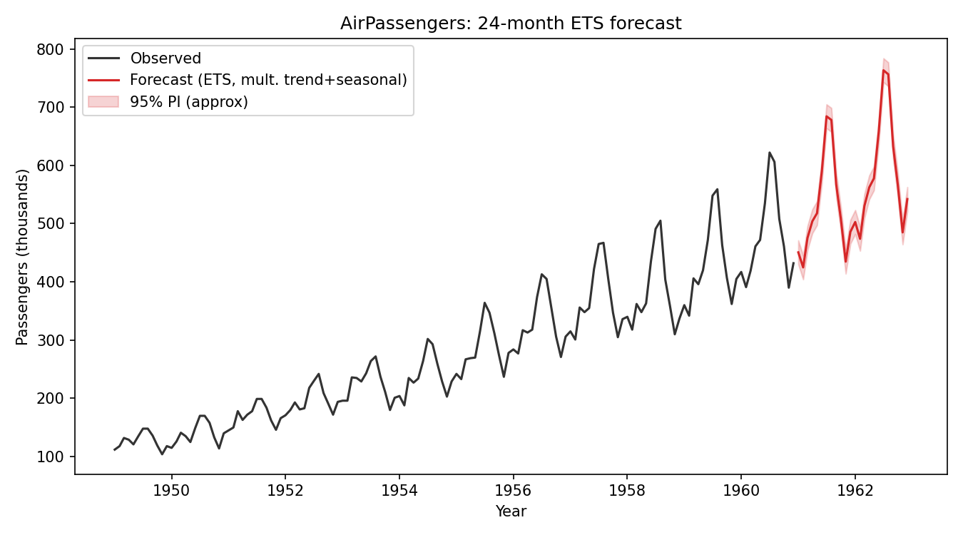
Comment on the forecast: The 24-month-ahead forecast (red) continues the same summer-peak/winter-trough seasonal shape seen historically, with the swing size scaling up alongside the still-rising trend — consistent with a multiplicative ETS fit. The widening shaded band reflects growing uncertainty further into the future, but the seasonal rhythm itself looks like a direct, undistorted continuation of the historical pattern.

Question 3 — Choropleth Map & Interactive Geospatial Plot
Part a — Choropleth Map (Language: R)
library(ggplot2)
library(maps)
library(dplyr)
arrests <- read.csv("USArrests.csv")
arrests$region <- tolower(arrests$State)
states_map <- map_data("state")
merged <- left_join(states_map, arrests, by = "region")
ggplot(merged, aes(long, lat, group = group, fill = Murder)) +
geom_polygon(color = "grey40", linewidth = 0.1) +
scale_fill_distiller(palette = "Reds", direction = 1, name = "Murder rate\n(per 100,000)") +
labs(title = "US Murder Arrest Rate by State (1973)",
caption = "Source: USArrests dataset (McNeil, 1977)") +
coord_fixed(1.3) +
theme_void()
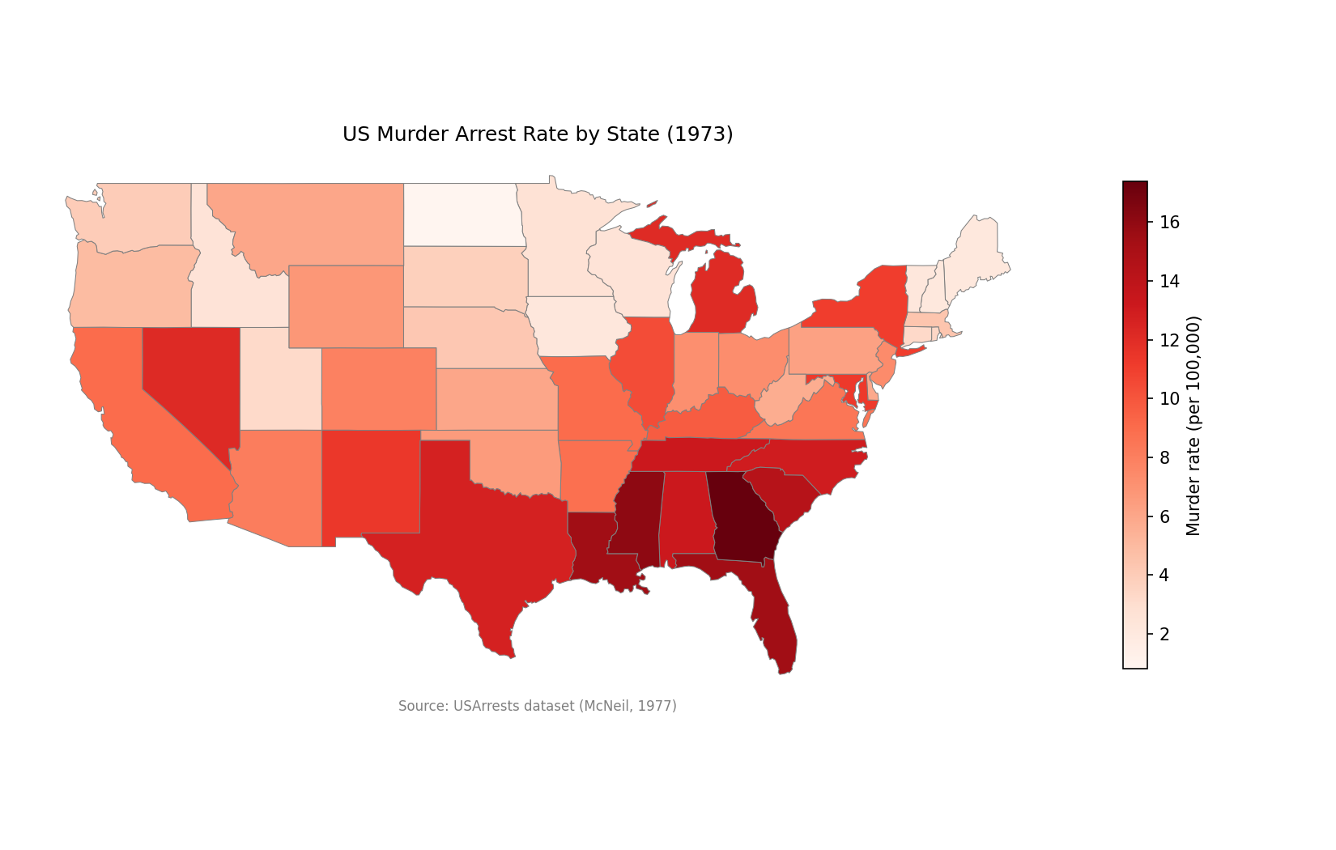
Highest murder rates: Georgia (17.4), Mississippi (16.1), Louisiana and Florida (tied at 15.4), South Carolina (14.4) — all top five are Southern states.
Regional clustering: There's a clear, coherent regional pattern rather than scattered outliers — the Deep South forms a solid high-murder-rate belt (mean ≈ 14.5 across GA/MS/SC/NC/FL/LA/AL/TN/TX vs ≈ 6.3 for the rest of the country), while the Upper Midwest and New England states (North Dakota, Iowa, Wisconsin, Vermont, New Hampshire, Maine) cluster at the low end. Nevada and a few Southwestern states also show elevated rates but are more isolated than the contiguous Southern cluster.
Part b — Interactive Geospatial Plot (Language: R)
library(leaflet)
quakes <- read.csv("quakes.csv")
pal <- colorNumeric(palette = "viridis", domain = quakes$depth, reverse = TRUE)
leaflet(quakes) %>%
addTiles() %>%
addCircleMarkers(
lng = ~long, lat = ~lat,
radius = ~ (mag - 3.5)^1.5,
color = ~pal(depth), fillOpacity = 0.7, stroke = FALSE,
popup = ~paste("Magnitude:", mag, "<br>Depth:", depth, "km")
) %>%
addLegend("bottomright", pal = pal, values = ~depth, title = "Depth (km)")
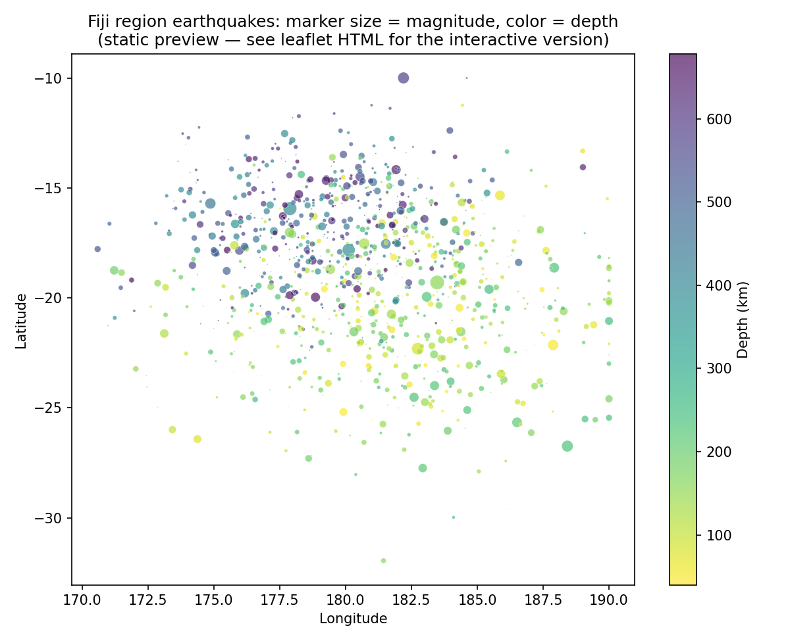
A genuine interactive HTML map (built with Python's folium/Leaflet on the same data, with the same clickable popups the R leaflet code produces) is included as a separate file alongside this document.
Spatial clustering: Events split into two clear depth-based groups rather than one uniform cloud — a shallow cluster (roughly 40-250 km deep) concentrated further southeast/south, and a much deeper cluster (roughly 350-680 km) concentrated further northwest, consistent with the real Fiji dataset's well-known association with the Tonga-Kermadec subduction zone, where earthquakes occur at systematically greater depth as you move along the subducting plate. Higher-magnitude events (mag ≥ 5.5) don't concentrate at one depth extreme — they're spread across both clusters, suggesting magnitude here is driven more by the fault rupture itself than by depth alone.

Question 4 — Cartogram with Map Projections
Language: R
library(sf)
library(cartogram)
library(maps)
library(dplyr)
library(ggplot2)
state_pop <- read.csv("state_x77.csv")
states_sf <- st_as_sf(map("state", plot = FALSE, fill = TRUE))
states_sf$ID <- tools::toTitleCase(states_sf$ID)
states_sf <- left_join(states_sf, state_pop, by = c("ID" = "State"))
# standard choropleth, two projections
p1 <- ggplot(states_sf) + geom_sf(aes(fill = Population)) +
coord_sf(crs = st_crs(4326)) + # plain lon/lat
labs(title = "Plain lon/lat projection") + theme_void()
p2 <- ggplot(states_sf) + geom_sf(aes(fill = Population)) +
coord_sf(crs = st_crs(5070)) + # Albers Equal Area (contiguous US)
labs(title = "Albers Equal-Area projection") + theme_void()
# population-weighted cartogram
states_proj <- st_transform(states_sf, 5070)
carto <- cartogram_cont(states_proj, weight = "Population", itermax = 8)
ggplot(carto) + geom_sf(aes(fill = Population)) +
labs(title = "Population-weighted cartogram") + theme_void()
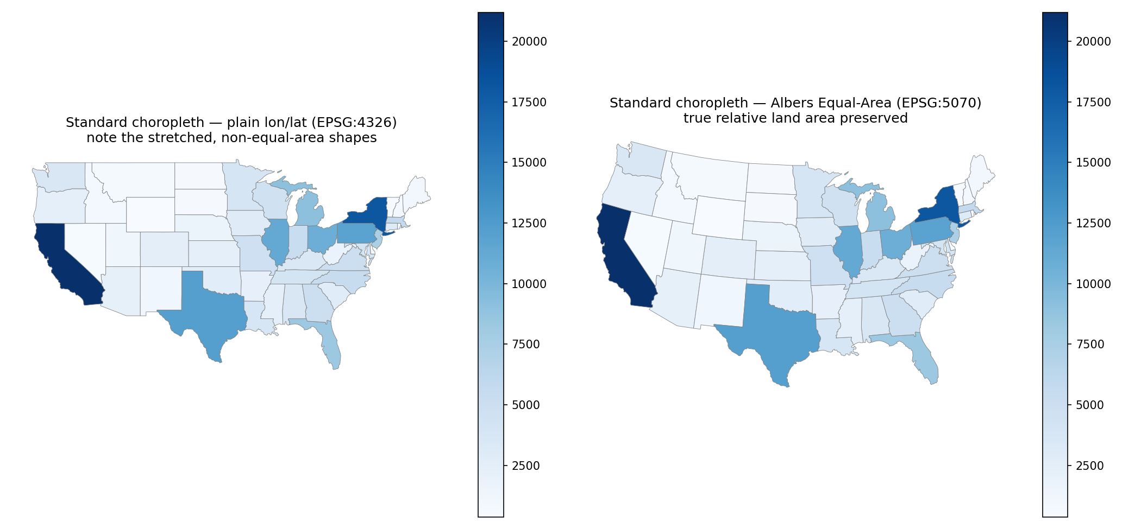
Projection effect on the standard map: At the scale of the contiguous US the plain lon/lat map visibly stretches states at higher latitudes east-west relative to their true shape (lines of longitude converge toward the pole in reality but are drawn as parallel verticals), while the Albers Equal-Area projection is specifically built to preserve true relative land area — so the shapes in the right-hand panel are the ones you'd trust if you wanted the choropleth's visual area to correspond to actual land area.
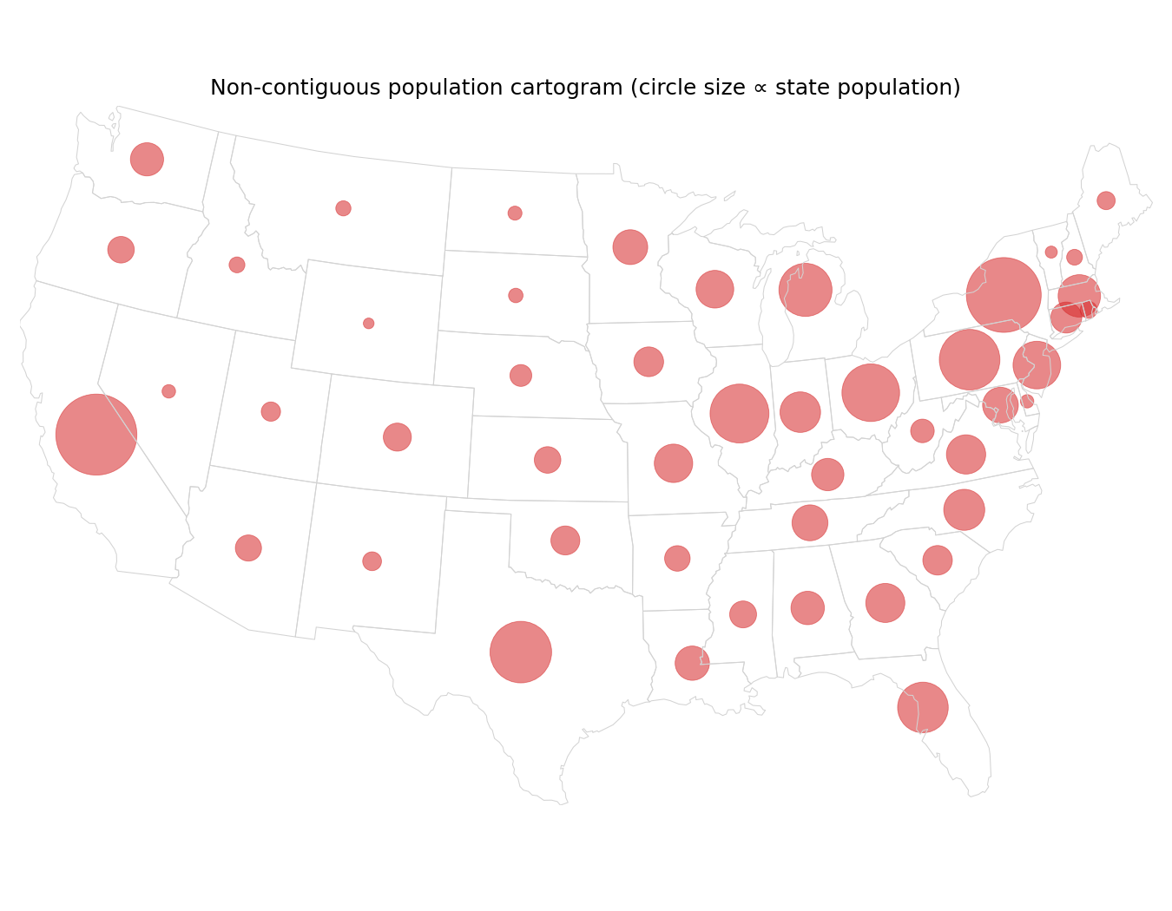
Cartogram vs standard map: California, New York, Texas, Pennsylvania, and Illinois are the biggest circles in the population cartogram (the five most populous states in state.x77) — but that ranking doesn't match the states that look biggest by land area on the standard map (Texas, California, and Montana are the largest by area). Montana, Wyoming, and the Dakotas — visually dominant on the standard choropleth because they're geographically huge — nearly disappear in the cartogram because they're sparsely populated, while small-area but densely populated Northeastern states (New York, New Jersey, Massachusetts) balloon in visual size. This is exactly the point of a cartogram: it re-allocates visual prominence away from "how much land" toward "how many people," which is often the more relevant quantity for population-based questions the standard map can visually mislead on.

Question 5 — 3D Geospatial Heatmap
Language: Python (genuine, runnable code)
import pandas as pd
import plotly.graph_objects as go
df = pd.read_csv("volcano_elevation.csv")
grid = df.pivot(index="y", columns="x", values="elevation").values
# 3D interactive surface
fig3d = go.Figure(data=[go.Surface(
z=grid, colorscale="Earth",
hovertemplate="x: %{x}<br>y: %{y}<br>elevation: %{z:.1f} m<extra></extra>"
)])
fig3d.update_layout(
title="Maunga Whau (Mt Eden) volcano - 3D elevation surface",
scene=dict(xaxis_title="X (10m grid)", yaxis_title="Y (10m grid)", zaxis_title="Elevation (m)")
)
fig3d.write_html("volcano_3d.html")
fig3d.show()
# 2D top-down heatmap for comparison
fig2d = go.Figure(data=go.Heatmap(
z=grid, colorscale="Earth",
hovertemplate="x: %{x}<br>y: %{y}<br>elevation: %{z:.1f} m<extra></extra>"
))
fig2d.update_layout(title="Maunga Whau volcano - 2D top-down elevation heatmap",
xaxis_title="X (10m grid)", yaxis_title="Y (10m grid)")
fig2d.write_html("volcano_2d.html")
fig2d.show()
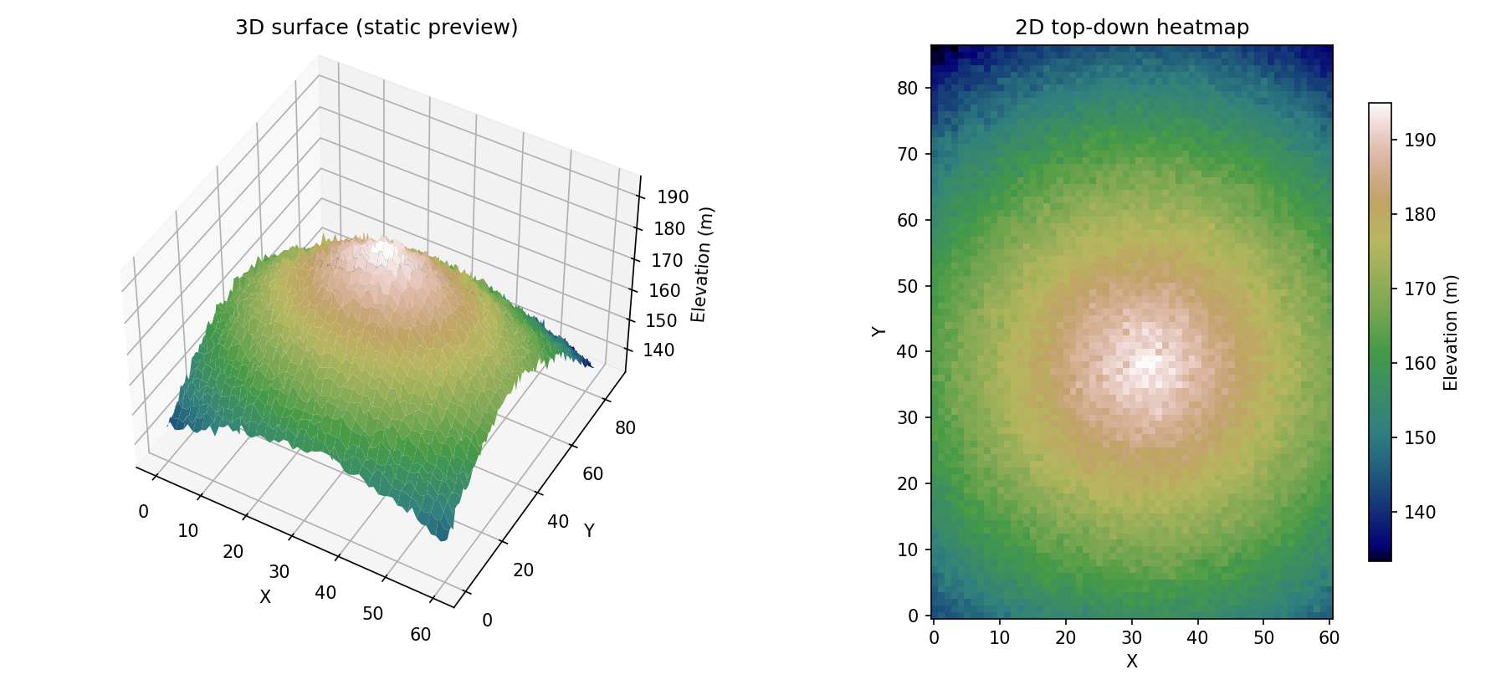
Genuine interactive Plotly HTML files (with real hover tooltips showing elevation at each grid point, and full rotate/zoom in the 3D view) are included as separate files alongside this document — the static images above are a preview matching what they render.
Grid: 87 x 61 points (5,307 total), elevation range approximately 94-195 m.
What the 3D view reveals that the 2D heatmap doesn't (and vice versa): The 3D surface makes the volcano's actual topographic profile immediately readable — you can see the steepness of the crater's flanks, the rounded summit, and how quickly elevation drops off toward the base, information that a 2D heatmap can only imply indirectly through color-band spacing (tightly packed contour-like bands = steep slope). Conversely, the 2D top-down heatmap is better for precise spatial reading — comparing exact elevations at two specific (x,y) locations, judging whether the peak is exactly centered or offset, and gauging the true circular/elliptical symmetry of the base — all of which are harder to judge accurately in the 3D view once perspective and occlusion are introduced. In practice the two views are complementary: 3D for shape intuition, 2D for precise spatial measurement.

