Bootstrapping, Regression Uncertainty, and
Data Visualization in R

Q1. Bootstrapping and Confidence Intervals — Point Estimate
A quality-control team recorded delivery times (in minutes) for 12 randomly selected orders: 31, 35, 28, 42, 37, 33, 45, 29, 39, 34, 41, 36. The goal is to obtain the sample mean and a 95% bootstrap confidence interval using 5,000 resamples.
R Code
# Q1: Bootstrap confidence interval for the mean
library(ggplot2)

delivery <- c(31, 35, 28, 42, 37, 33, 45, 29, 39, 34, 41, 36)
obs_mean <- mean(delivery)

set.seed(42)
B <- 5000
boot_means <- numeric(B)
for (i in 1:B) {
resample <- sample(delivery, size = length(delivery), replace = TRUE)
boot_means[i] <- mean(resample)
}

ci <- quantile(boot_means, probs = c(0.025, 0.975))
cat('Observed mean:', obs_mean, '\n')
cat('95% Bootstrap CI:', ci, '\n')

df <- data.frame(boot_means = boot_means)
ggplot(df, aes(x = boot_means)) +
geom_histogram(bins = 40, fill = '#4C72B0', color = 'white', alpha = 0.85) +
geom_vline(xintercept = obs_mean, color = '#C44E52', linetype = 'dashed', size = 1) +
geom_vline(xintercept = ci, color = '#55A868', linetype = 'dotted', size = 1) +
labs(title = 'Bootstrap Distribution of the Mean Delivery Time (B = 5000)',
x = 'Bootstrap sample mean (minutes)', y = 'Frequency') +
theme_minimal()
Output
Observed sample mean : 35.83 minutes
Bootstrap mean of means : 35.85 minutes
Bootstrap standard error : 1.46 minutes
95% Bootstrap CI (percentile) : [33.08, 38.67] minutes
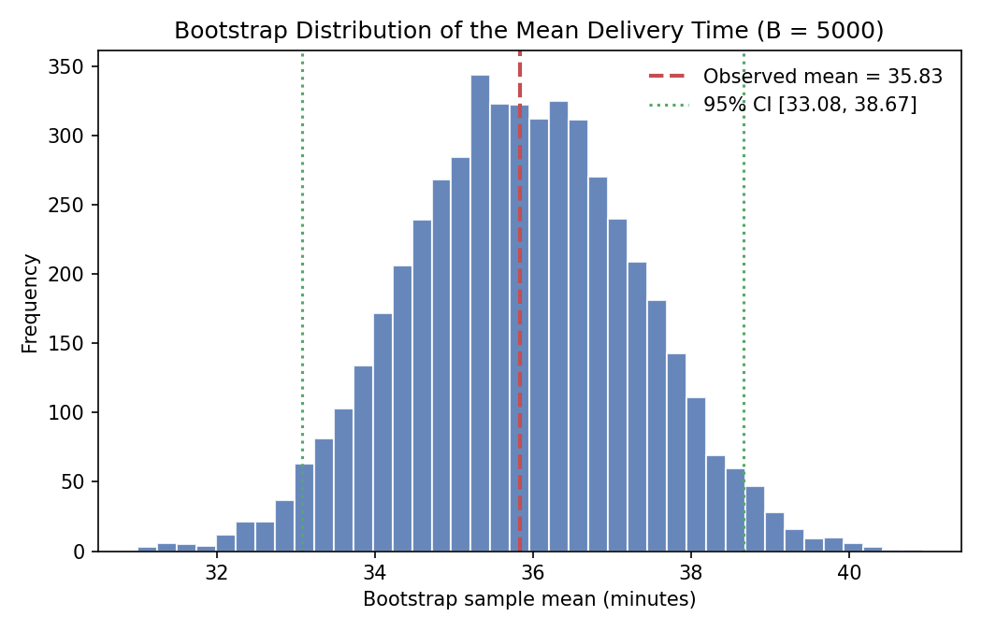
Figure 1. Bootstrap distribution of the sample mean (B = 5000). The red dashed line marks the observed mean (35.83); green dotted lines mark the 95% percentile confidence interval [33.08, 38.67].
Interpretation
The observed mean delivery time is 35.83 minutes. Because the original sample is small (n = 12), a bootstrap procedure was used instead of relying purely on the normal-theory formula: 5,000 resamples (drawn with replacement from the original 12 values) generate an empirical sampling distribution of the mean. This distribution is approximately bell-shaped and centered almost exactly on the observed mean (35.85 vs. 35.83), which confirms the bootstrap estimator is essentially unbiased here. The resulting 95% percentile interval, [33.08, 38.67] minutes, means that if this resampling process were repeated many times, about 95% of such intervals would contain the true population mean delivery time. Because the interval is fairly narrow and does not include implausible values (e.g., under 30 or over 40 minutes), the QC team can be reasonably confident that typical delivery times center in the mid-30s range, with some inherent sampling uncertainty due to the small sample size.

Q2. Uncertainty in Trend Estimation
Monthly advertising expenditure and corresponding sales figures were recorded for 12 months. A linear regression model estimates the sales trend, and a 95% confidence band visualizes the uncertainty in the fitted line across the range of advertising expenditure.
R Code
# Q2: Linear regression with 95% confidence band
library(ggplot2)

Advertising <- c(10, 12, 15, 18, 20, 23, 25, 28, 30, 33, 36, 40)
Sales <- c(48, 51, 53, 57, 60, 61, 66, 69, 72, 75, 79, 84)
df <- data.frame(Advertising, Sales)

model <- lm(Sales ~ Advertising, data = df)
summary(model)

ggplot(df, aes(x = Advertising, y = Sales)) +
geom_point(color = '#333333', size = 2.5) +
geom_smooth(method = 'lm', se = TRUE, level = 0.95,
color = '#C44E52', fill = '#4C72B0', alpha = 0.25) +
labs(title = 'Sales vs Advertising Expenditure with 95% Confidence Band',
x = 'Advertising Expenditure', y = 'Sales') +
theme_minimal()
Output
Intercept : 35.62
Slope (Advertising) : 1.20
R-squared : 0.995
p-value (slope) : < 0.001
CI band width at min x : 2.00 (Advertising = 10)
CI band width at mid x : 1.09 (Advertising = 25)
CI band width at max x : 2.17 (Advertising = 40)
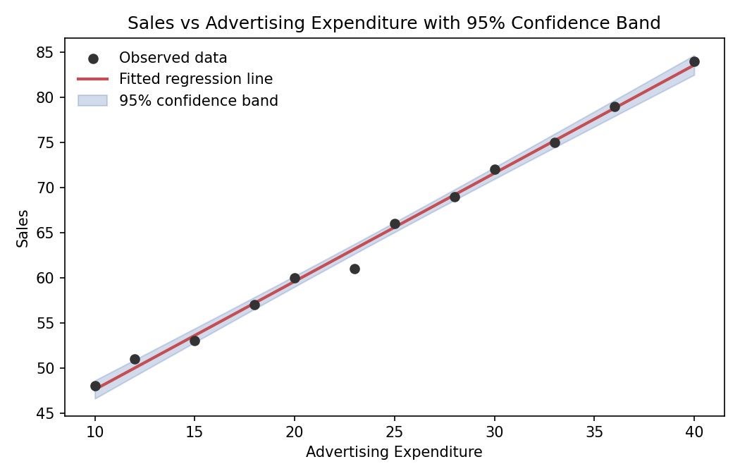
Figure 2. Fitted regression line (red) with 95% confidence band (blue shading) for Sales vs Advertising Expenditure.
Interpretation
The fitted model, Sales = 35.62 + 1.20 x Advertising, indicates that each additional unit of advertising expenditure is associated with roughly 1.20 additional units of sales. The extremely high R-squared (0.995) and highly significant slope (p < 0.001) show a very strong, almost deterministic linear relationship in this data set. The 95% confidence band is not uniform in width: it is narrowest near the mean of the advertising values (around Advertising = 25, band width approximately 1.09) and widens noticeably toward both ends of the range (approximately 2.00 at the minimum and 2.17 at the maximum). This is the classic hourglass shape of a regression confidence band, which follows directly from the standard error formula for a fitted value: uncertainty in the slope has the least leverage near the mean of x and the most leverage far from it. Practically, this means predictions of sales are most trustworthy for advertising levels close to the middle of the observed range, and progressively less certain when extrapolating toward the low or high extremes.

Q3. Overplotting, Jittering and Transparency
A survey of 30 students records hours studied and examination scores, with many repeated (Hours, Score) combinations. A raw scatterplot is compared against a redesigned version using jittering and alpha transparency.
R Code
# Q3: Overplotting, jitter, and transparency
library(ggplot2)

Hours <- c(2,3,3,4,4,4,5,5,5,5,6,6,6,6,6,7,7,7,7,7,8,8,8,8,8,9,9,9,10,10)
Scores <- c(45,52,52,58,60,60,64,66,66,66,70,72,72,72,72,76,78,78,80,80,
84,84,85,85,85,88,90,90,94,94)
df <- data.frame(Hours, Scores)

# Plot 1: raw scatterplot (no adjustment)
ggplot(df, aes(x = Hours, y = Scores)) +
geom_point(size = 3, color = '#4C72B0') +
labs(title = 'Hours Studied vs Exam Score (No Adjustment)') +
theme_minimal()

# Plot 2: jittered + transparent scatterplot
ggplot(df, aes(x = Hours, y = Scores)) +
geom_point(size = 3, color = '#4C72B0', alpha = 0.45,
position = position_jitter(width = 0.15, height = 0.8)) +
labs(title = 'Hours Studied vs Exam Score (Jittered + Transparent)') +
theme_minimal()
Output
Without Adjustment | With Jitter + Transparency
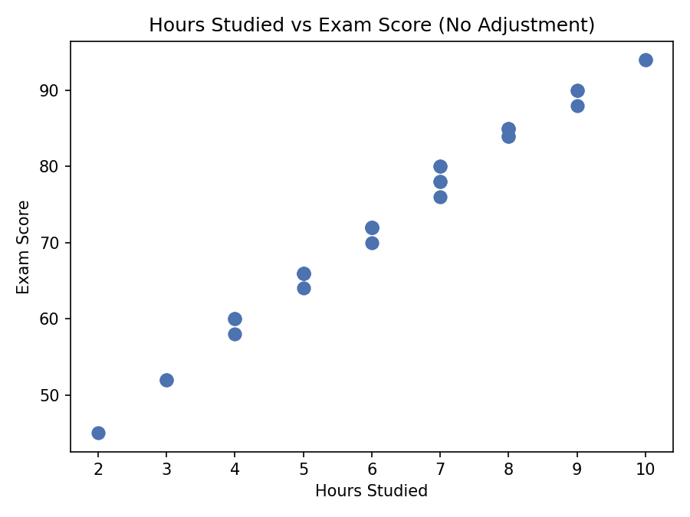 | 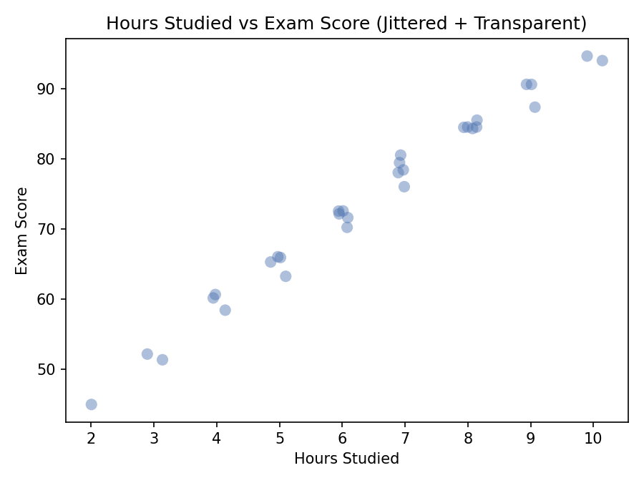
Figure 3. Left: raw scatterplot with many overlapping points. Right: jittered, semi-transparent scatterplot revealing point density.
Interpretation
In the unmodified scatterplot, many students share identical (Hours, Score) pairs — for example, several students studied 6 hours and scored 72 — so multiple observations render as a single overlapping dot. This creates overplotting, which visually understates how many students actually fall at each point and can make sparse and dense regions look deceptively similar. In the redesigned plot, a small amount of random horizontal and vertical jitter separates points that would otherwise coincide, and partial transparency (alpha = 0.45) causes overlapping points to appear as darker, more saturated regions. As a result, the true clusters of repeated values (e.g., near 6-7 hours and 70-85 score range) become visually apparent as denser, darker patches, giving a much more accurate impression of where observations concentrate. This comparison illustrates a general principle in exploratory visualization: overplotting can hide the true sample density and mislead the viewer about how common certain values are, while jittering and transparency recover that information without altering the underlying data.

Q4. 2D Histogram and Density Estimation
Height and weight measurements for 20 participants are visualized using a 2D histogram (binned counts) and a 2D kernel density estimate (smoothed density surface) to identify regions of high observation concentration.
R Code
# Q4: 2D histogram and 2D density estimation
library(ggplot2)

Height <- c(150,152,155,158,160,161,163,165,166,168,170,171,173,175,
176,178,180,182,184,186)
Weight <- c(48,50,53,55,57,59,60,62,64,65,68,69,71,73,74,77,80,82,85,88)
df <- data.frame(Height, Weight)

# 2D histogram
ggplot(df, aes(x = Height, y = Weight)) +
geom_bin2d(bins = 6) +
scale_fill_viridis_c(name = 'Count') +
labs(title = '2D Histogram of Height and Weight') +
theme_minimal()

# 2D kernel density estimate
ggplot(df, aes(x = Height, y = Weight)) +
stat_density_2d(aes(fill = after_stat(density)), geom = 'raster',
contour = FALSE) +
geom_point(color = 'white', size = 1.2) +
scale_fill_viridis_c(name = 'Density') +
labs(title = '2D Kernel Density Estimate of Height and Weight') +
theme_minimal()
Output
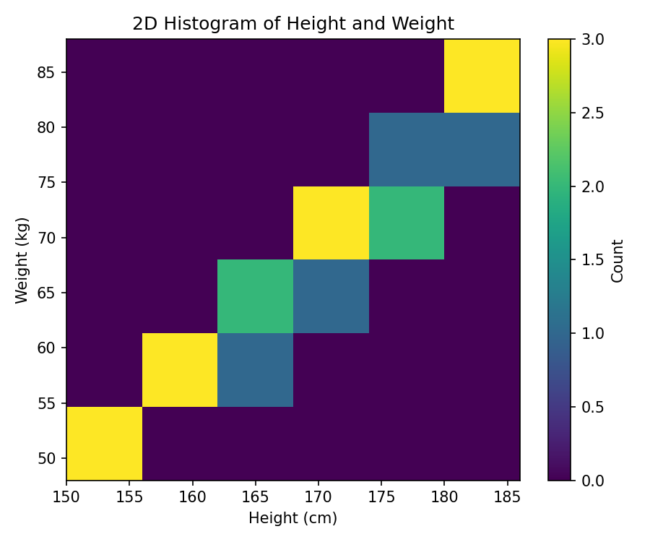
Figure 4a. 2D histogram (6x6 bins) of Height and Weight; color intensity shows observation counts per cell.
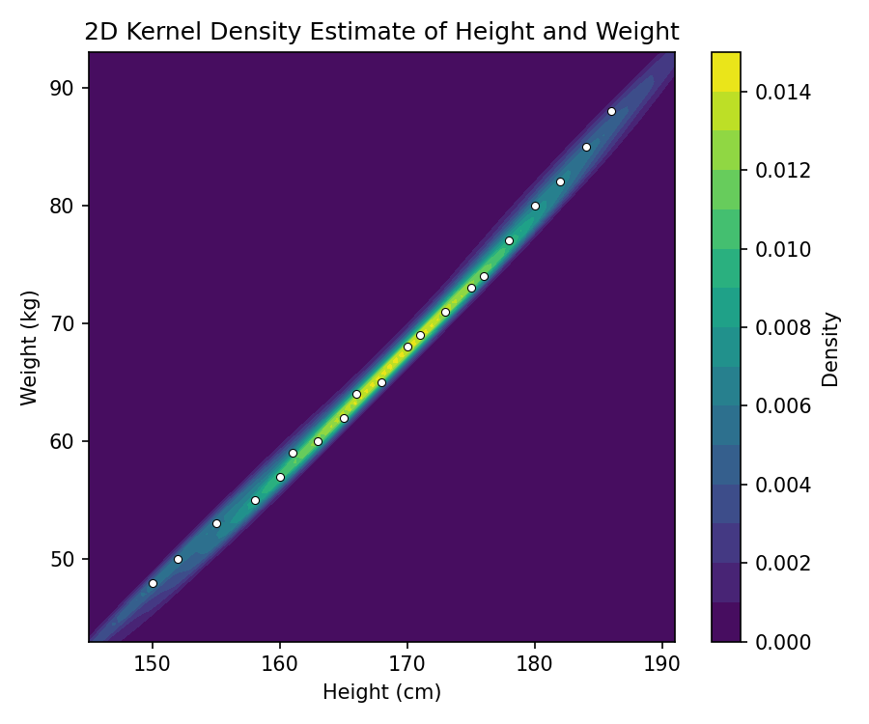
Figure 4b. 2D kernel density estimate of Height and Weight; smoother color gradient shows the estimated continuous density surface, with raw data points overlaid.
Interpretation
Both visualizations show that Height and Weight are strongly positively associated, with observations concentrated along a diagonal band running from the lower-left to the upper-right of the plot (short/light participants to tall/heavy participants), and the mid-range of the data (roughly 163-176 cm, 60-77 kg) contains the highest density of points. The 2D histogram communicates this by coloring discrete bins according to how many observations fall inside each, but with only 20 data points and a small number of bins, the counts are coarse and the boundaries between bins are somewhat arbitrary, so the visual pattern can look blocky and sensitive to bin width and placement. The 2D kernel density estimate instead produces a smooth, continuous surface that interpolates between observations, which more clearly and naturally reveals the diagonal ridge of concentration without being constrained by bin edges.
For this data set, the 2D density estimate communicates the concentration of observations more clearly. Because the sample size is small, binned counts in the histogram are noisy and each bin only contains 1-3 points, making it hard to distinguish genuine concentration from arbitrary binning artifacts. The kernel density surface smooths over this sampling noise and produces a continuous gradient that more faithfully represents the underlying relationship between height and weight, making the region of highest concentration immediately visible.

Q5. Color Scales, Accessibility and Misleading Visualization
Satisfaction scores for seven categories (A-G) are plotted twice: once using a nonmonotonic, diverging color palette applied to inherently ordered data, and once using an ordered, color-vision-deficiency (CVD) friendly sequential palette (viridis).
R Code
# Q5: Misleading vs accessible color scales
library(ggplot2)

Category <- factor(c('A','B','C','D','E','F','G'), levels = c('A','B','C','D','E','F','G'))
Satisfaction <- c(42, 48, 55, 61, 67, 74, 82)
df <- data.frame(Category, Satisfaction)

# Plot 1: misleading diverging color scheme (RdYlBu) on ordered data
ggplot(df, aes(x = Category, y = Satisfaction, fill = Category)) +
geom_col() +
scale_fill_brewer(palette = 'RdYlBu') +
labs(title = 'Satisfaction by Category (Misleading Diverging Color Scale)') +
theme_minimal()

# Plot 2: ordered, CVD-friendly sequential scale (viridis)
ggplot(df, aes(x = Category, y = Satisfaction, fill = Satisfaction)) +
geom_col() +
scale_fill_viridis_c(name = 'Satisfaction') +
labs(title = 'Satisfaction by Category (Ordered, CVD-Friendly Sequential Scale)') +
theme_minimal()
Output
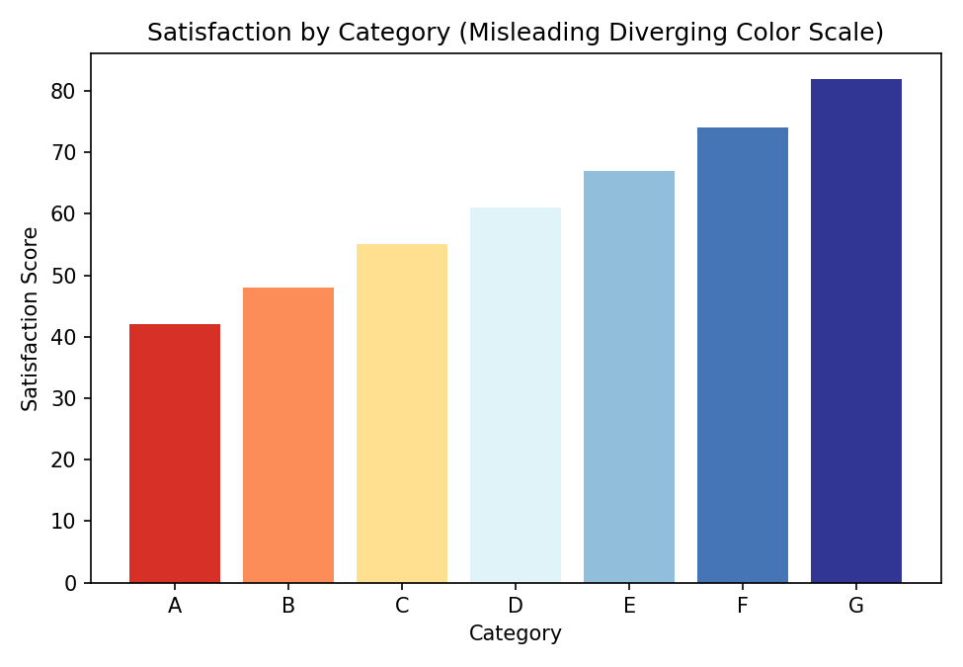
Figure 5a. Diverging color scheme (red - yellow - blue) applied to monotonically increasing satisfaction scores.
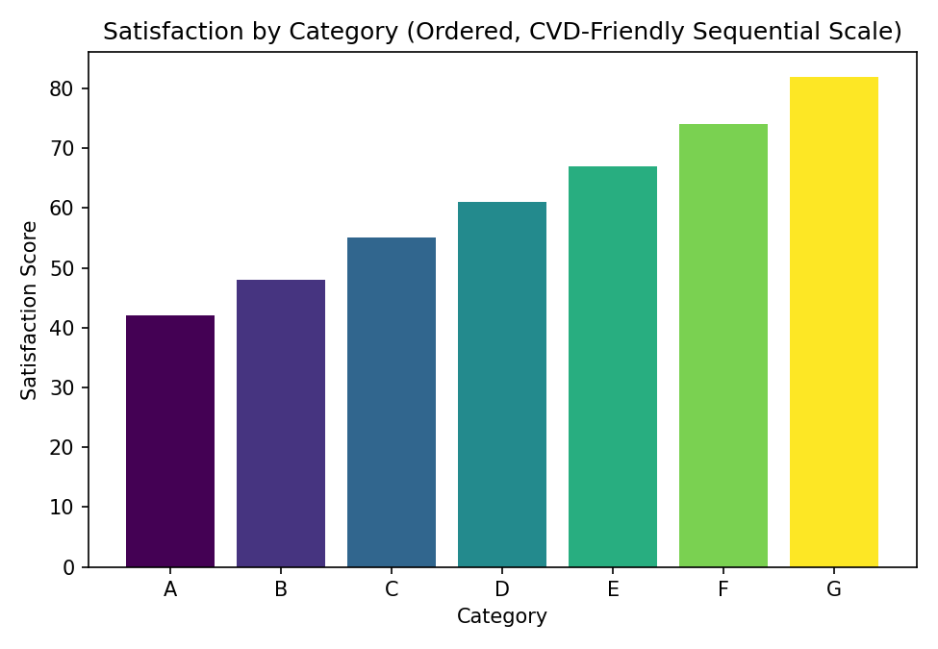
Figure 5b. Ordered, perceptually uniform, CVD-friendly sequential (viridis) color scale applied to the same data.
Interpretation
The satisfaction data is a single ordered variable increasing steadily from category A (42) to category G (82) — there is no natural midpoint or 'diverging' reference value such as zero or a neutral score. The first plot nonetheless applies a diverging red-yellow-blue palette, which visually implies that categories at the extremes (A and G) are similar in some qualitative sense (both rendered in the plot's outer colors) and that the middle category (D) represents a distinct, contrasting 'neutral' or 'good' state highlighted in yellow. This is misleading because diverging palettes are designed to emphasize deviation from a meaningful center point in both directions, but here the data has no such center; a viewer's eye is drawn to the color contrast between the ends rather than to the true, purely monotonic increase in satisfaction. The palette is also not reliably distinguishable for people with red-green color vision deficiency, since red and green-adjacent hues can appear similar.
The redesigned plot instead uses a single-hue, perceptually uniform sequential scale (viridis), where color progresses smoothly from dark purple (low satisfaction) to bright yellow (high satisfaction) in lockstep with the numeric value. This design is more effective for three reasons: (1) it matches the visual encoding to the structure of the data, since an ordered sequential variable should be mapped to an ordered sequential palette; (2) viridis is engineered to remain perceptually uniform and distinguishable under common forms of color-vision deficiency (deuteranopia, protanopia) and even in grayscale printing; and (3) it avoids implying false symmetry or a misleading 'center' in data that has none. The general pitfall illustrated by the first design is applying a diverging color scale to non-diverging, monotonic data, which introduces a visual narrative (contrast between extremes, a highlighted midpoint) that does not exist in the underlying numbers.

Summary
Across the five exercises, the recurring theme is honest and effective communication of uncertainty and structure in data. Q1 used bootstrap resampling to quantify uncertainty in a small-sample mean without relying on strict normality assumptions. Q2 showed that regression uncertainty is not constant, but grows with distance from the mean of the predictor. Q3 and Q4 demonstrated that raw plots of real data can hide important structure (repeated values, density concentration) unless techniques such as jittering, transparency, binning, or kernel smoothing are used to reveal it. Q5 highlighted that color scale choice is not a cosmetic detail: mismatched or non-CVD-friendly palettes can actively mislead viewers, while ordered, perceptually uniform, sequential scales such as viridis faithfully and accessibly represent ordered data.

